Apigateway

1.api is the acronym for application programming interface.

2.which is a software intermediately that allows two applications to talk to each other.

3.api gateway is a service provided by amazon that used to create,publish,maintain,monitor and and secure various api’s such as

REST,HTTP and WEBSOCKET

4.In rest api’s user send request to database and it send response to the user.

5.rest is known as representational state transfer.

FEATURES OF AMZON GATEWAY

1.stateful(websocket)and stateless(rest,http)api’s.

2.powerful.flexible authentication mechanism.

3.it is also provides canary release deployments.cloudtraillogging and monitoring of api usage and api changes.

4.cloudwatch access logging and execution logging

5.ability to use cloud formation template and enable api creation

6.supports custom domain names.

BENFITS

1.provides efficient api development by allowing you to run multiple versions of same api simultaneously

2.rubust performance at any scale with low latency.

3.cost saving with tiered pricing model

4.easy to monitor the api’s using cloudwatch.

5.restful api’s can be created both rest and http api’s.

Creating rest api

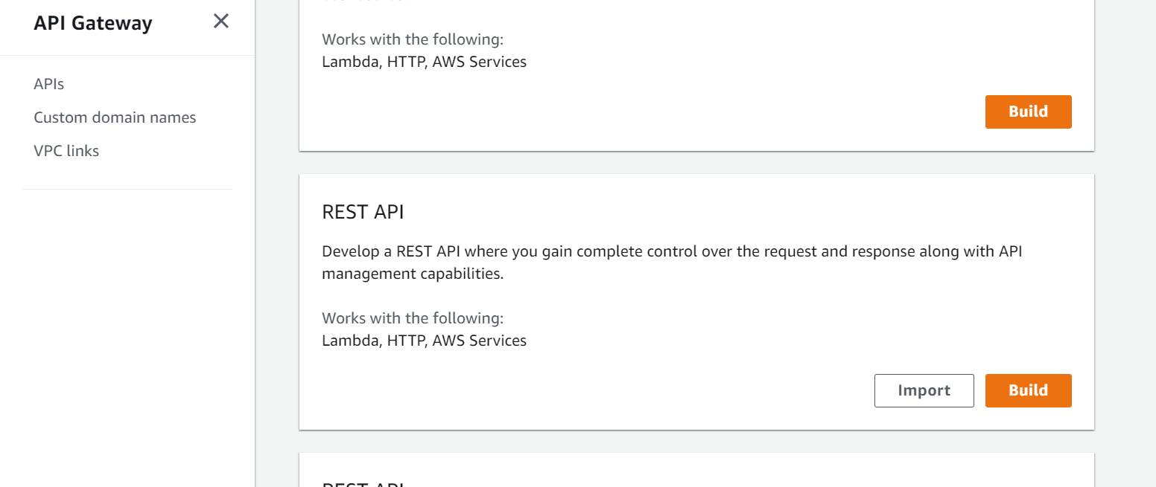

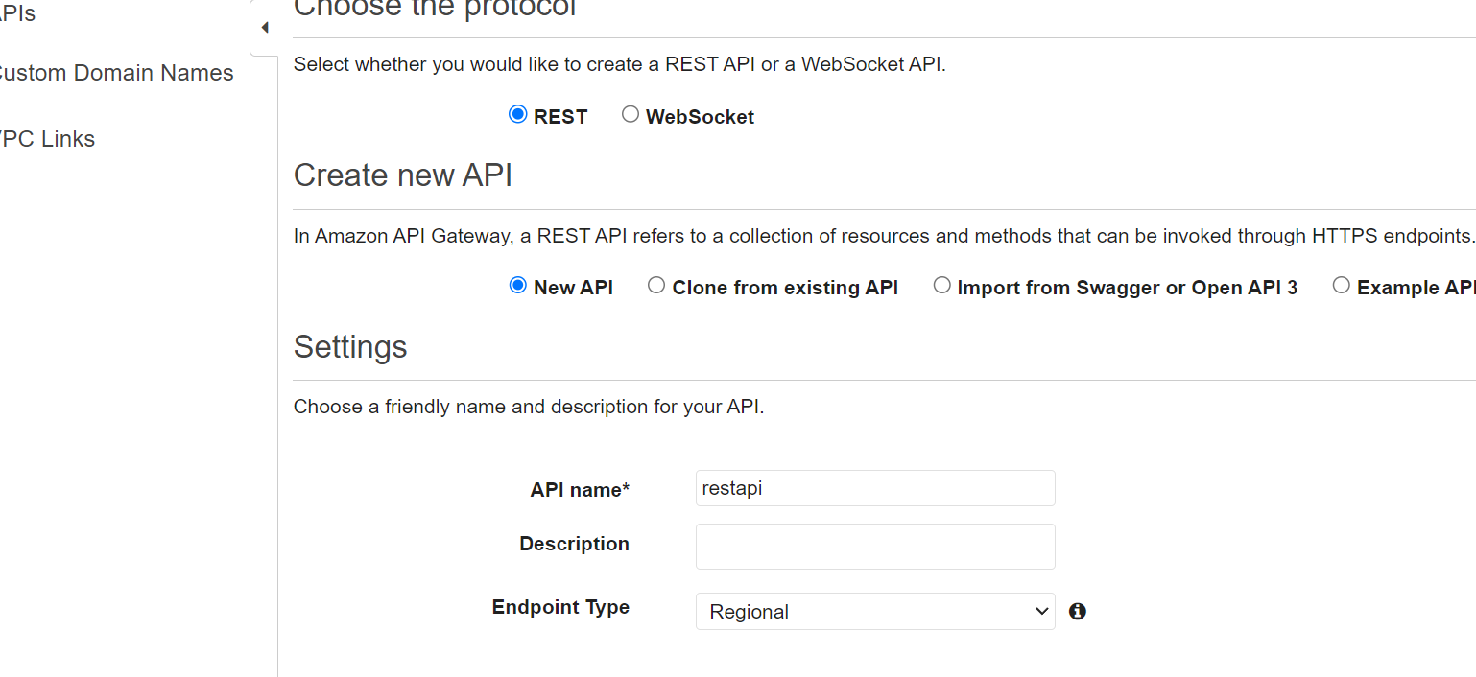

Create resource .

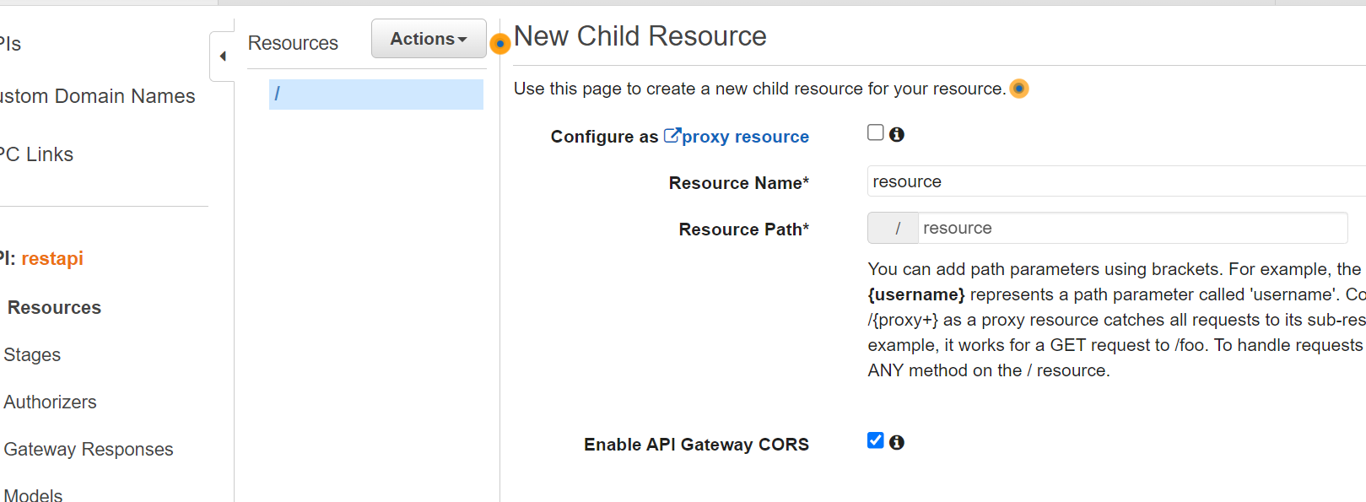

Create method

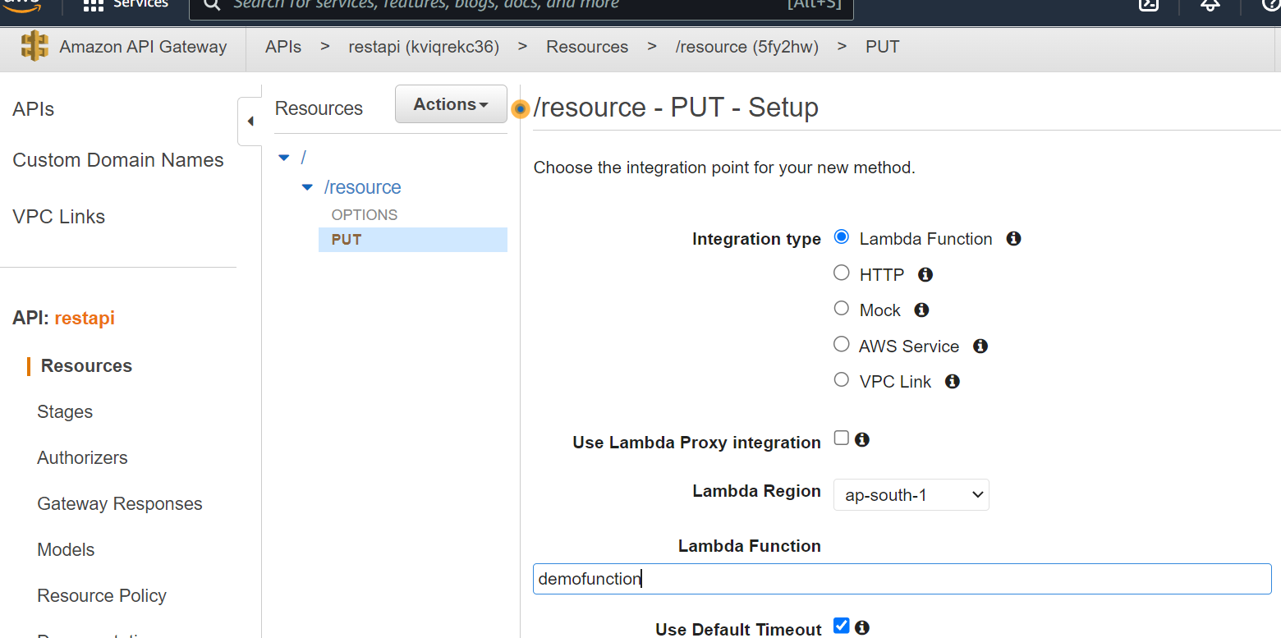

Deploy In dev statge.

