* Autoscalling

1.We have 2 types of autoscaling

Scheduled based—we should mention timings

Mon-fri---- 10 servers should launch

St-sun---2 servers should launch

Policy based--- load reaches 50% -- launch one server

---- load reaches 20%-- remove one server

2.we have to configure launch configuration template to launch autoscaling.

3. we need a elb to work with auto scalling.

4.below are the autoscaling types.

a.horizontal—same type of configuration

b.vertical—instead of new server it will remove old and launch new server with new configuration.

Creating autoscaling group

Before creating autoscaling we need to create launch configuration template.

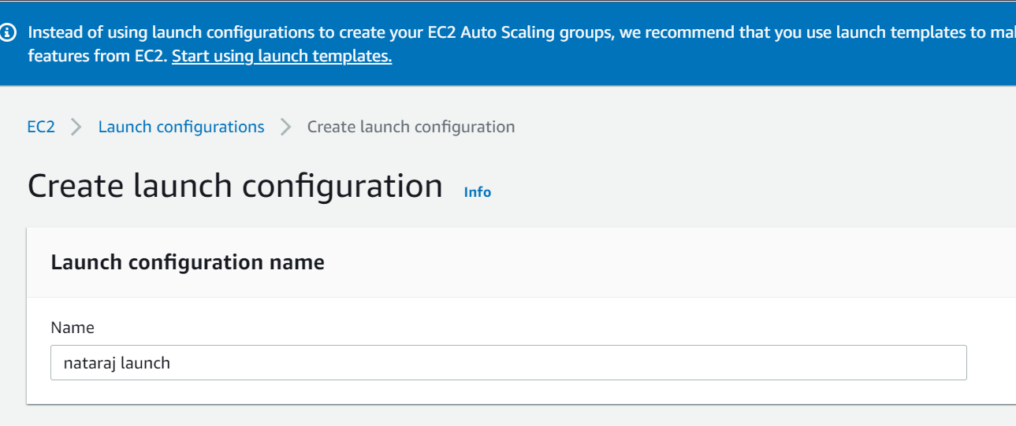

After creating launch configuration we should create autoscaling group.

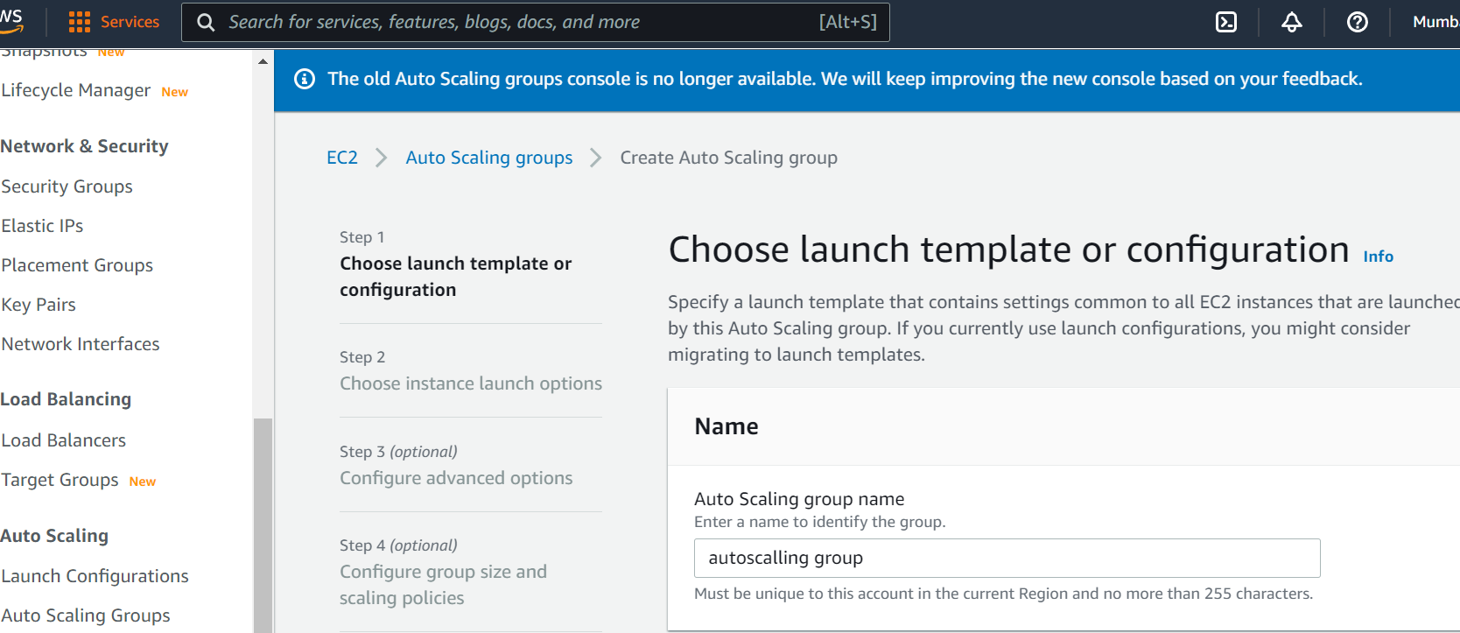

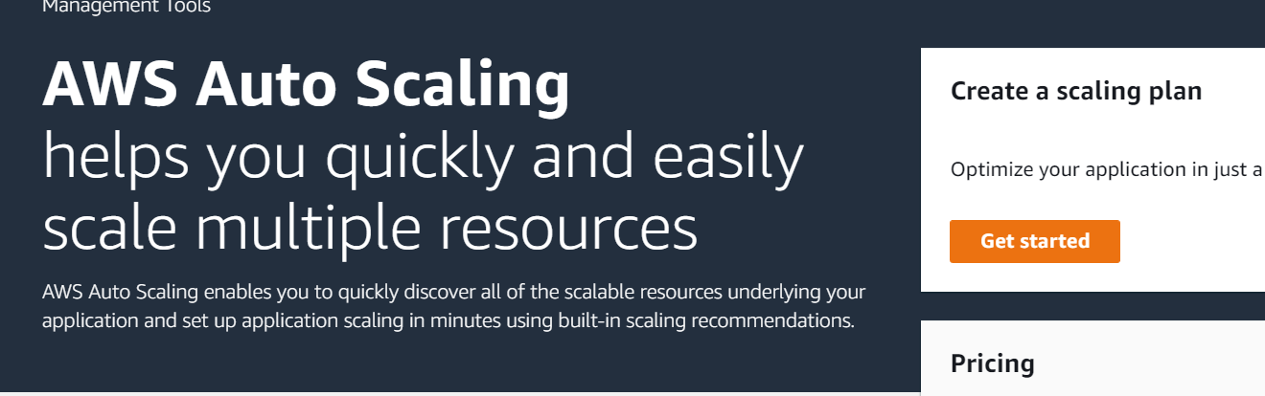

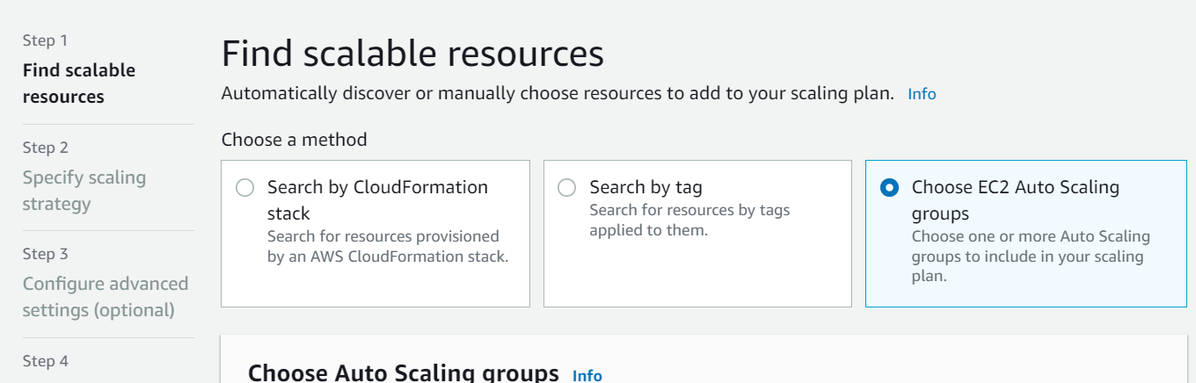

Autoscalling has been created successfully.

