Cloudwatch

1.To monitor the servers cpu utilization we enable cloud watch monitoring

2.to reduce unnecessary operating costs in case of unreasonable pricing.

3.dectect problems early to prevent disasters. Also prevents downtime and business losses

4.monitor the end users experience and create reports which helps to make improvements.

5.provide a catalogue of standard reports that you can use to analyse trends and monitor system performance.

AMZON CLOUD WATCH

Amazon cloudwatch is the component of amazon web service that provides real time monitoring of aws resources and customer applications running on amazon infrastructure.

Types of monitoring offered by amazon cloud watch

Basic monitoring –its free ,polls every 5min very few metrics.

Detailed monitoring—its charged polls every 1 min wide range metrics.

What does amazon cloud watch do?

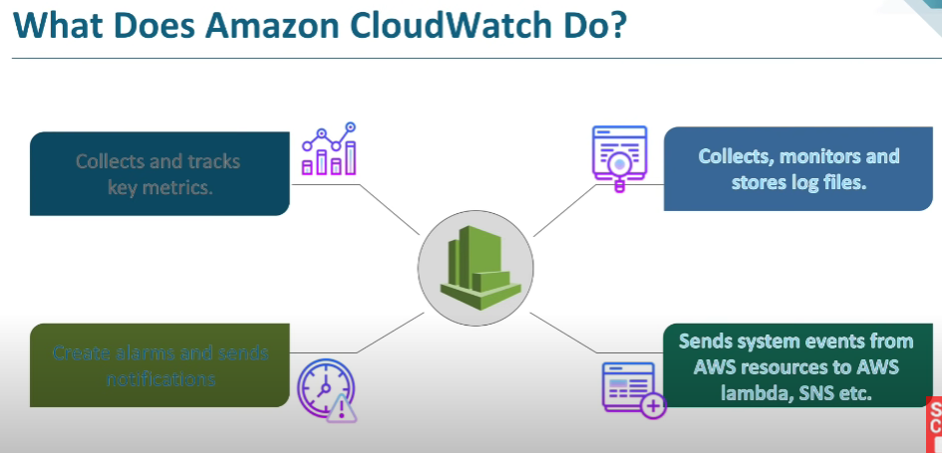

Collects and tracks key metrics

Collects, monitors and stores log files

Create alarm and sends notifications

Sends system events from aws resources to ambda,sns etc

CLoudwatch concepts

Metrics—a metric represents a time ordered set of data points that are published to cloud watch

Dimensions—a dimension is name /value pair that uniquely identifies a metric.

Statistic—statistics are metric data aggregations over specific periods of time.

Alarm—an alarm can be used to automatically initiate actions on you behalf

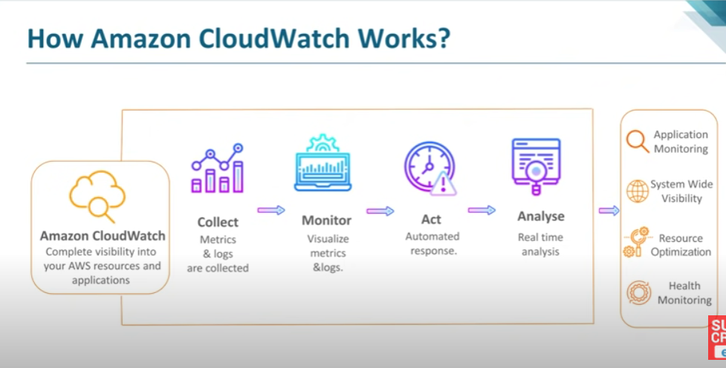

Enabling cloudwatch for ec2 instance.

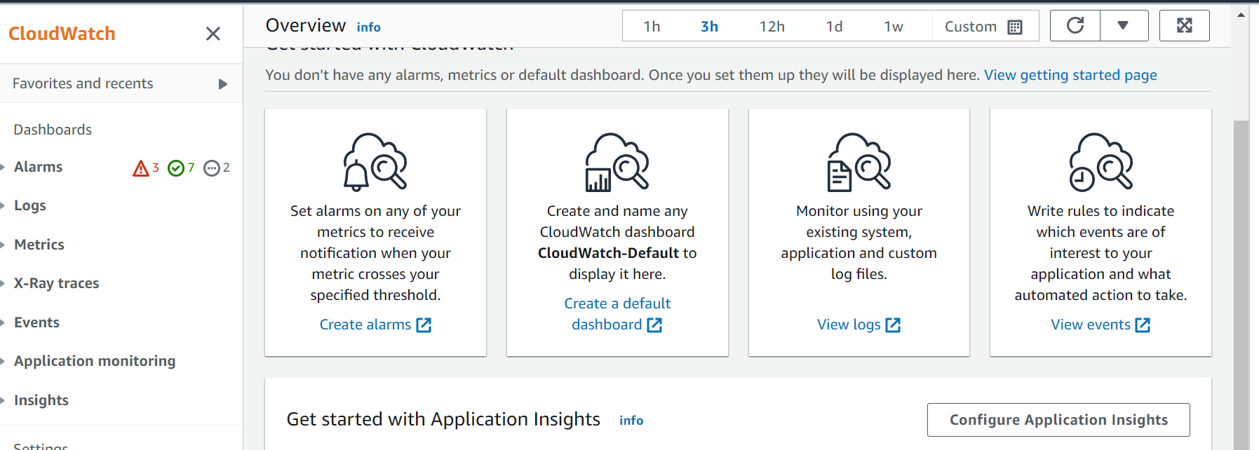

Go to metrics tab

