LOADBALANCER

1.it will distributed the traffic to all the registered instances.

2.across the availability zones with in the region which are healthy.

3.it is distributed in round robin mechanism.

4. we have 4 types of load balancers.

a. classic load balancer

b. application load balancer

c. network load balancer

d .gateway loadbalancer

5. we need two subnets to create a load balancer.

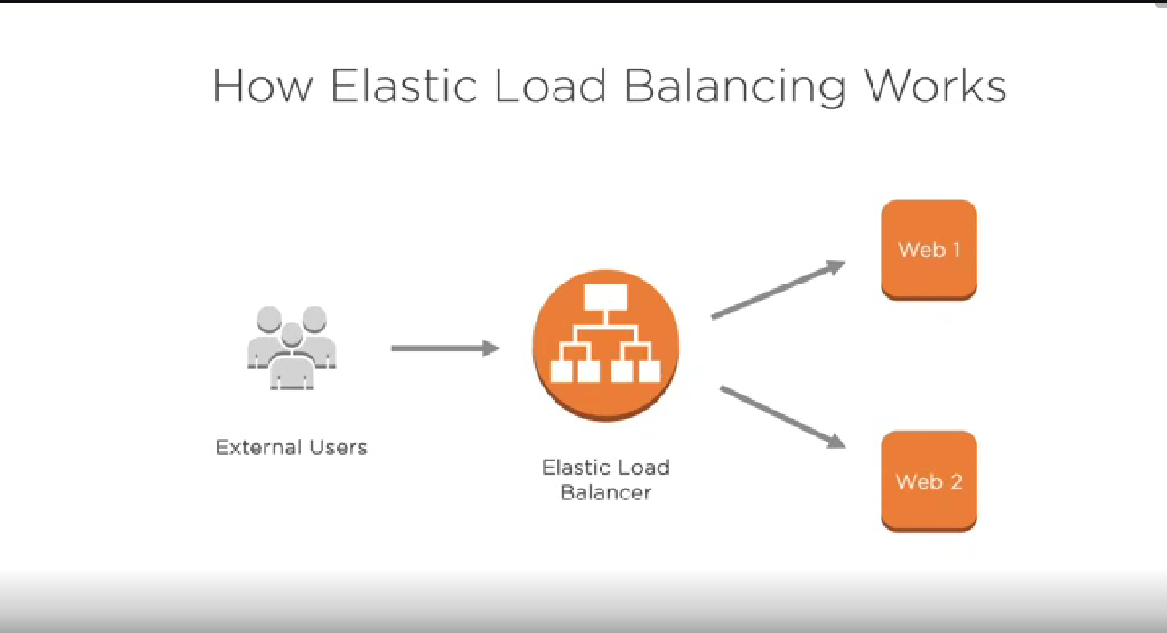

It will check the health of the registered instances.

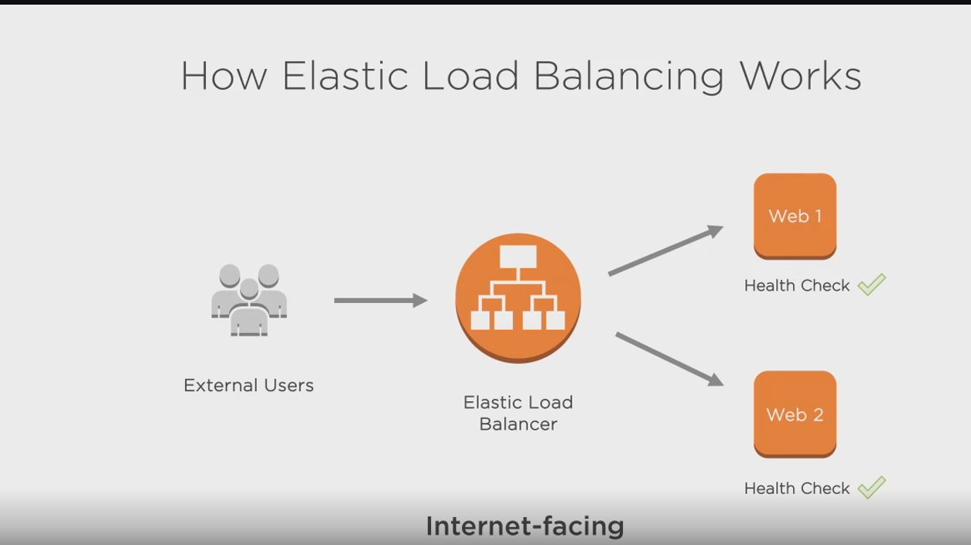

DNS has been provided by the aws to elastic load balancer.

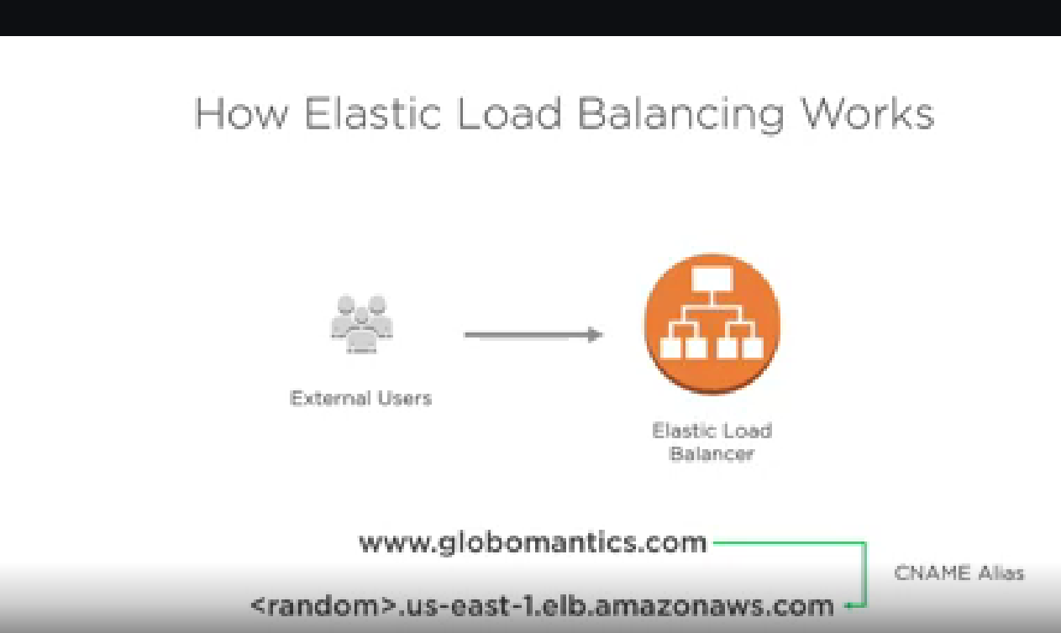

Benefits of load balancing.

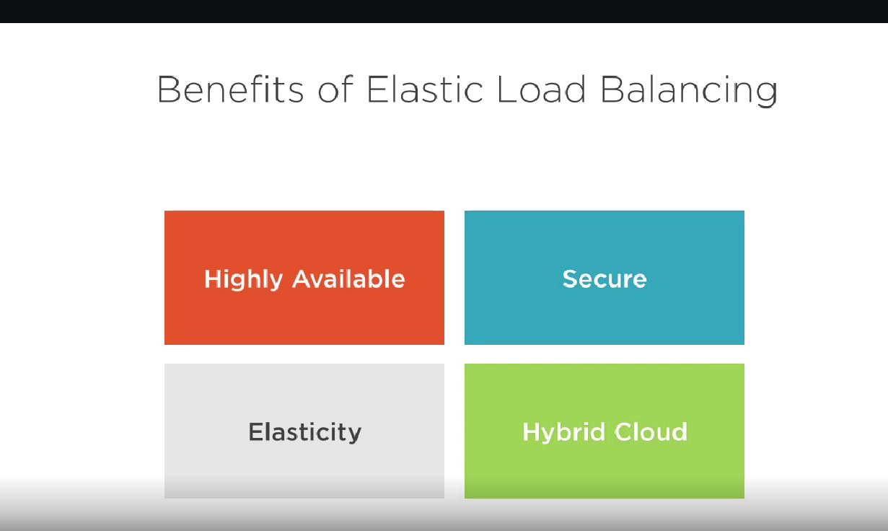

Application load balancer

Choose an Application Load Balancer when you need a flexible feature set for your applications with HTTP and HTTPS traffic. Operating at the request level, Application Load Balancers provide advanced routing and visibility features targeted at application architectures, including microservices and containers.

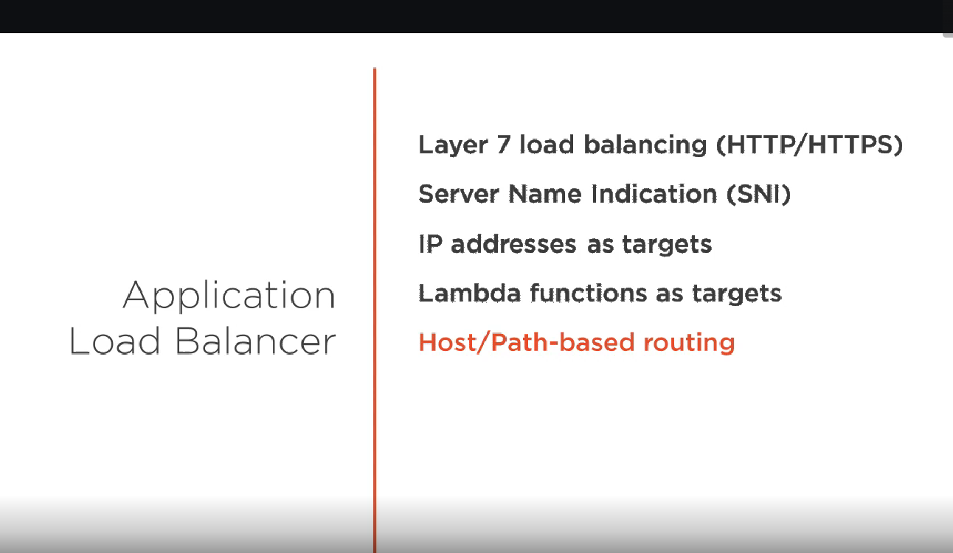

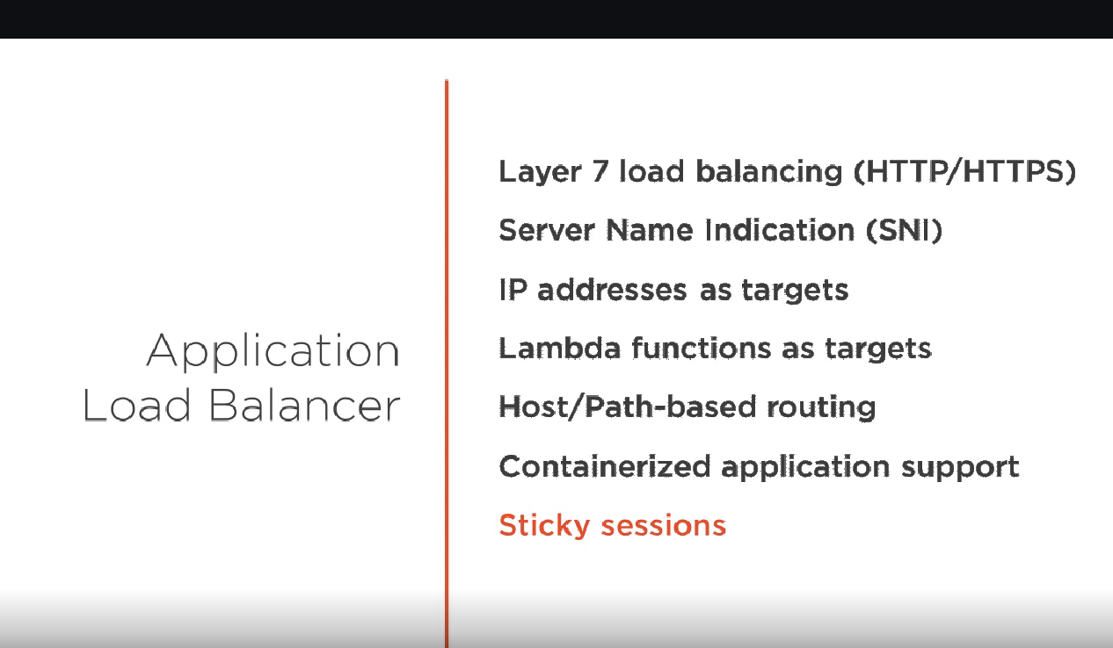

Network loadbalancer

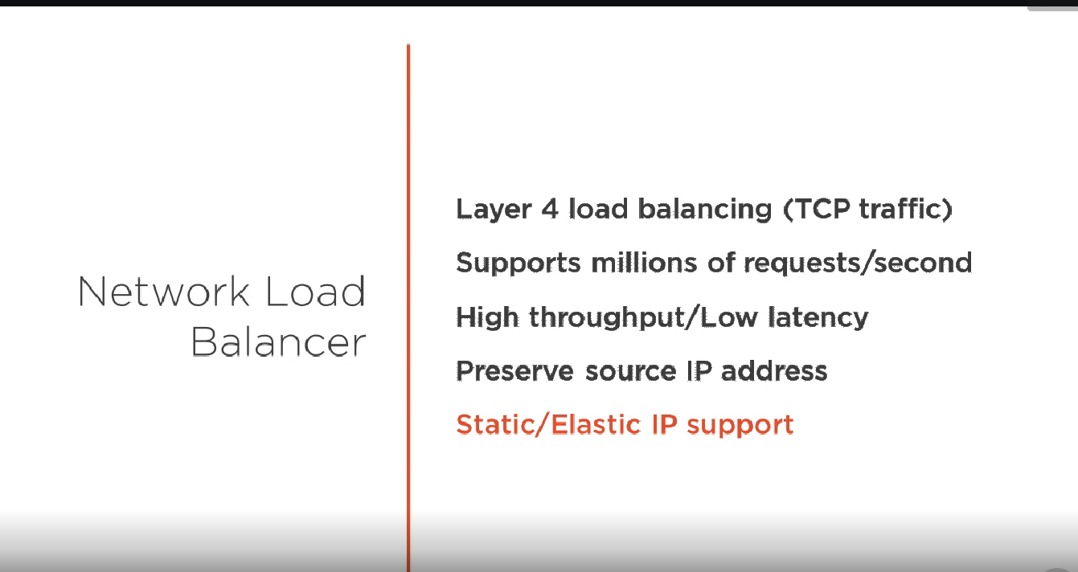

Classic loadbalancer

