RDS

1.Rds is web service that makes it easier to setup ,operate and scale a relational database in the cloud.

2.creating and configuring below databases

Mariadb

Sqlserver

Mysql

Oracle

Postgresql

3.some features in rds

Read replicas

Snapshots

Monitoring/notifications

5.creating mysql database in rds.

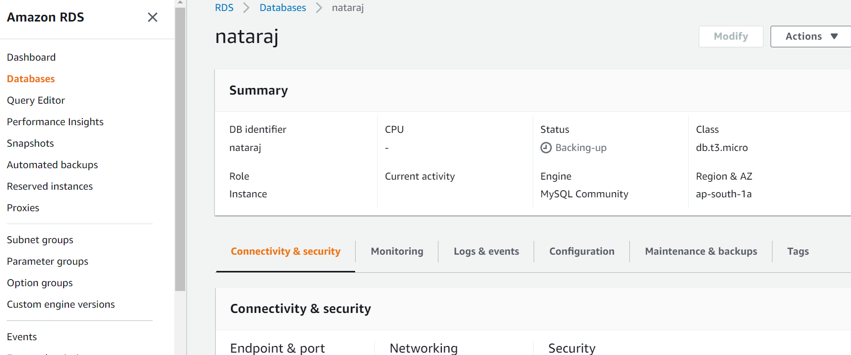

For connecting mysql db using ec2, we need provide port 3306 in ec2 security groups.

Command to connect sql ------mysql -h mysql–instance1.123456789012.us-east-1.rds.amazonaws.com -P 3306 -u mymasteruser -p

