SQS

1.Sqs- simple queue service

2.message queueing service that allows users to separate and scale the microservices distributed system and severless application.

3.it is scale individually without effecting other application.

4.it send /receive the data between software components at any volume.

5. Message will not loss and it reaches the messages on time.

SQS ARCHITECTURE

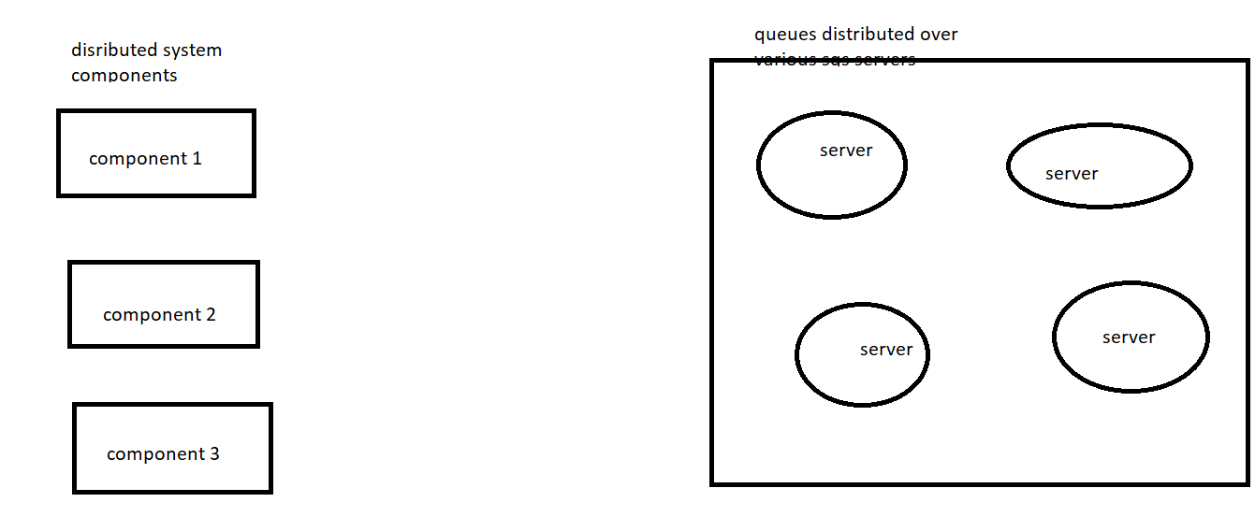

Left hand side components which performs different task and right side sqs service store data at various sqs servers.

Component 1 sends the messages to the queue and it is the producer and componet2 is the consumer of the queue.

SQS BENFITS

1.ensures safety of messages

2.keep sensitive data secure

3.reliability delivery of messages.

4.scale elastically and cost effectively

Creating sqs queue

