Ec2 instance

1.EC2 – elastic cloud computing

2.we have 3 types of instances

On demand instances—

Spot instances

Reserved instances

3.we have regions and every region we have atleast 2 avalibility zones.

4.we can create 3 ways to create instances

Console mode

Command line

Sdk

5.creating instance using aws console

We need to provide name for ec2 instance after that we have to select machine image.

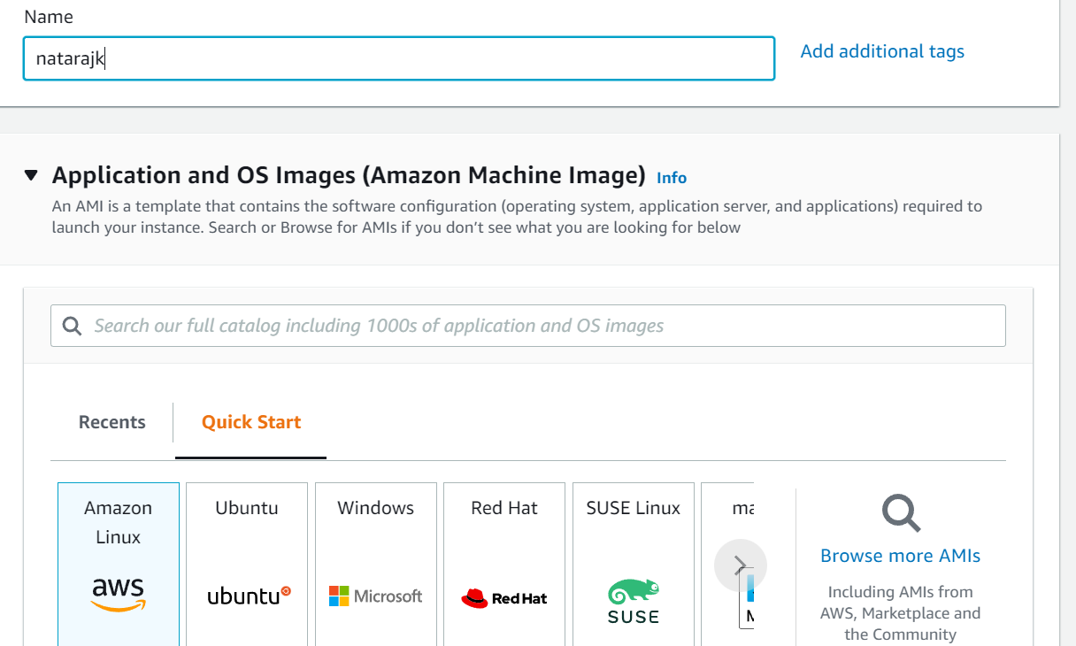

After choosing ami we have to select instance type based on our requirement.

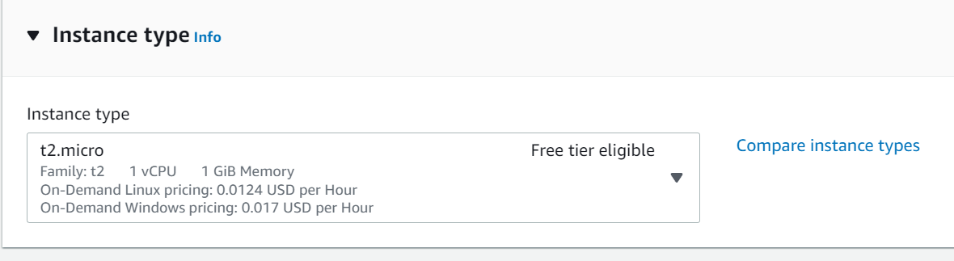

We need to select storage volumes and tags

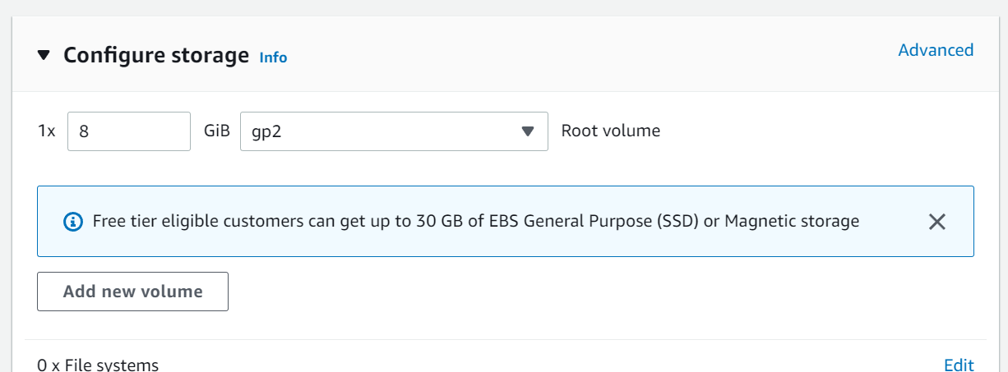

We should provide keypair name to create a pemp key.

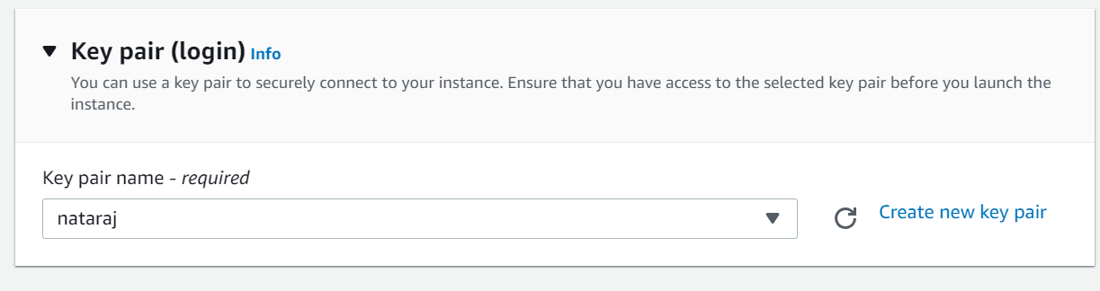

Launch instance.

