Elatsic Beanstack

1.it is a development centric application

2.everthing managed by amazon

3.platform as service

4.allows quick deployment of your applications

5.reduces management complexity

5.keeps control on your hands

6.it supports large range of platforms

7.it provides below service

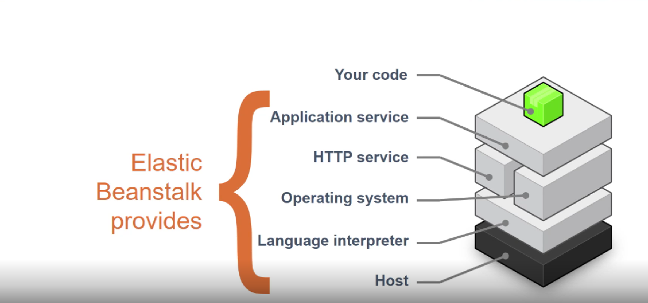

8.update ur application as easily as you deploy it

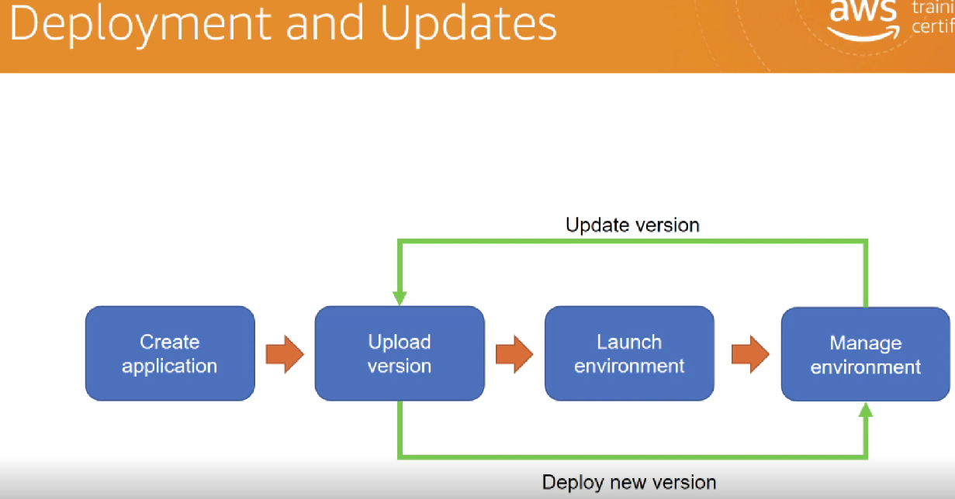

Creating elastic beanstack

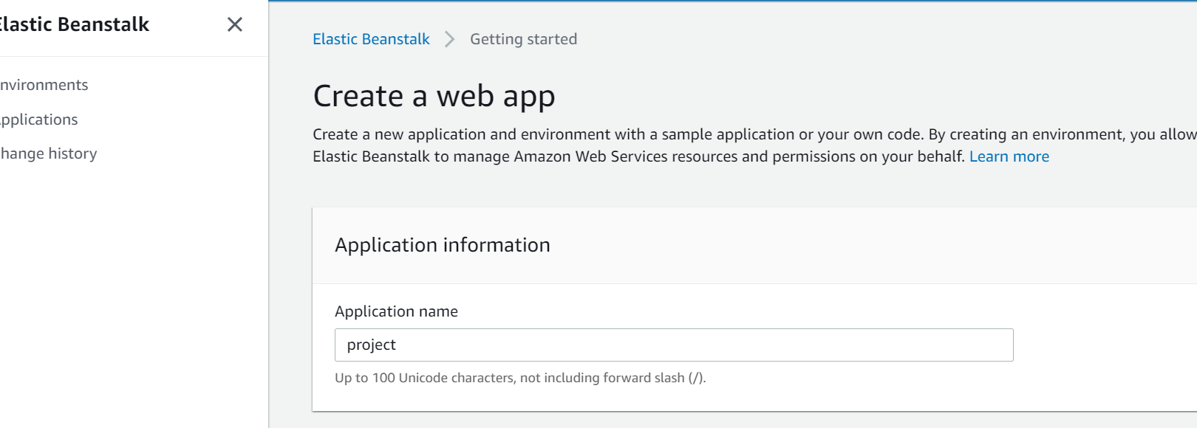

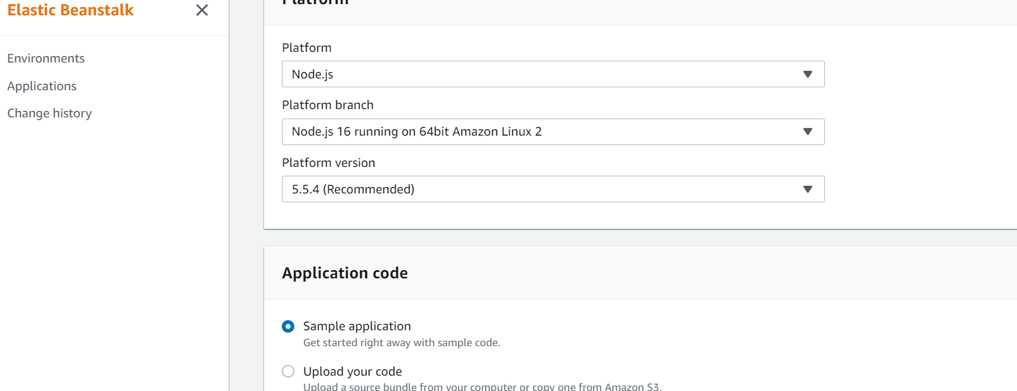

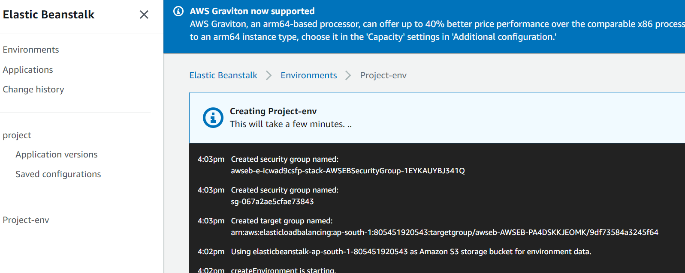

Once stack has been created we can modify the configuration by using configuration tab

