IAM

1.Iam means identity access management

2.Every user and group have unique arn name

3.we can create user,group and roles in iam.

4.we have multi factor authentication for users.

5.we have iam policies to restrict the permisssions.

6.how to create user in iam with mfa.

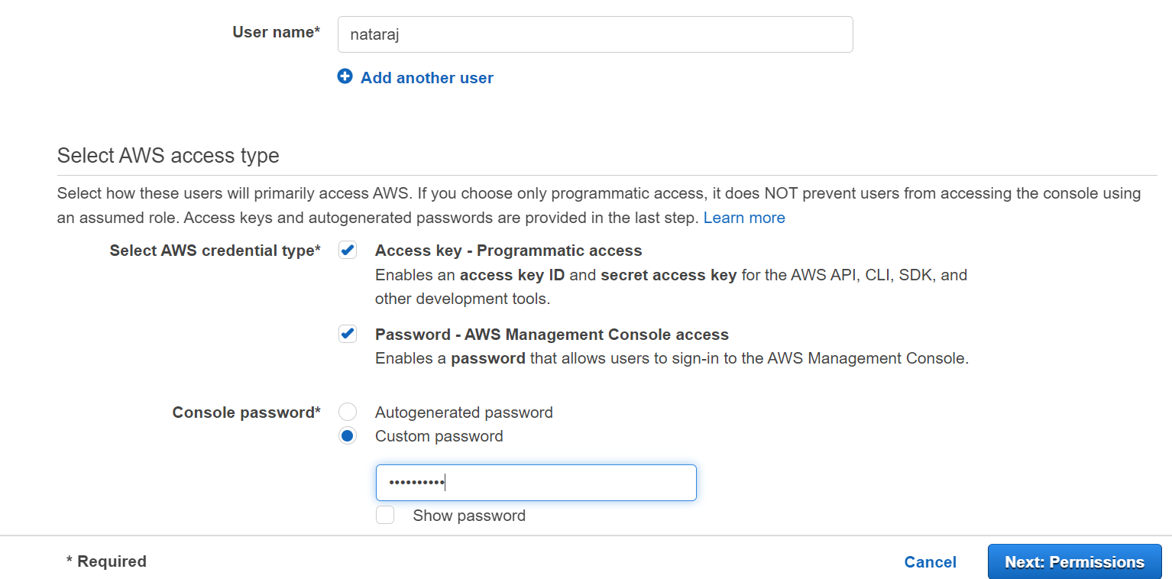

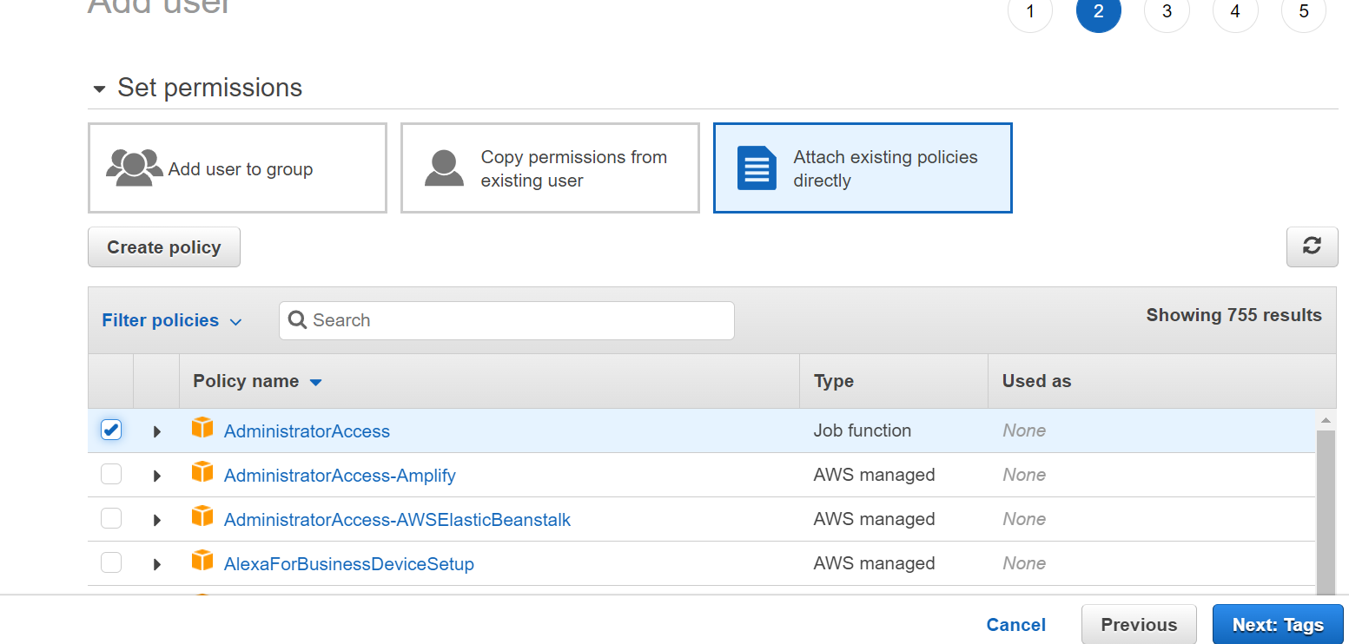

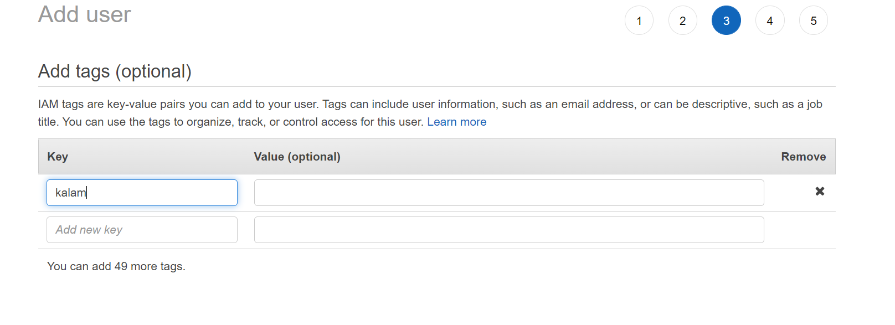

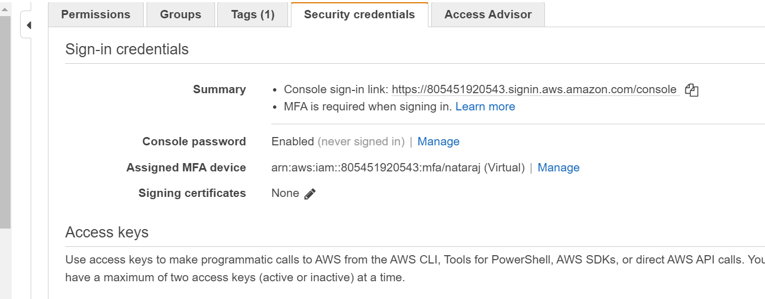

6.6666lll

6666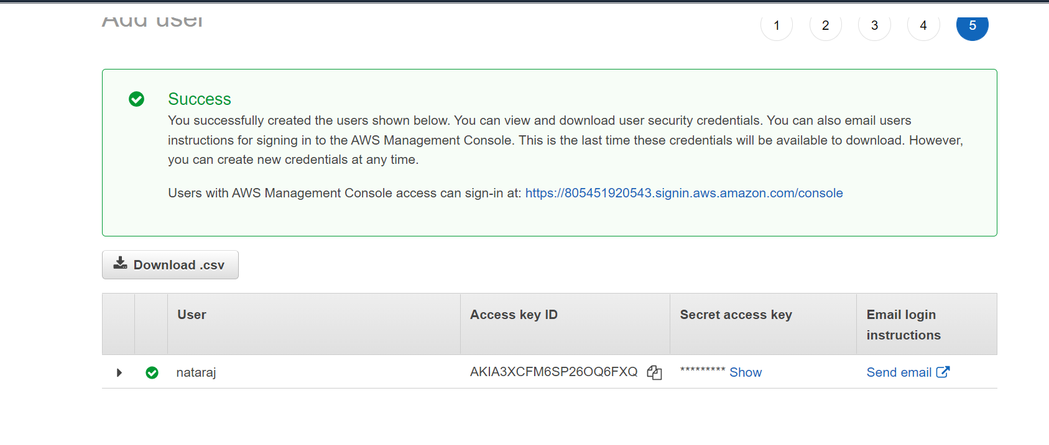

7..how to add user to group.

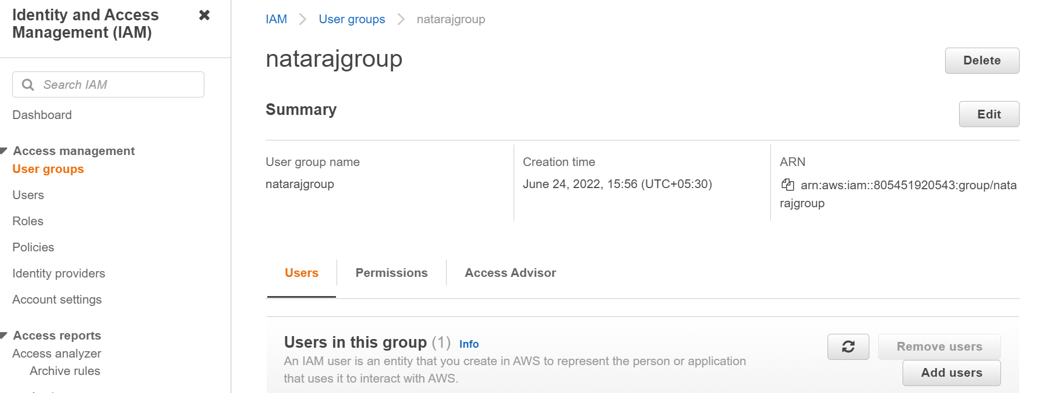

8. creating role in iam.

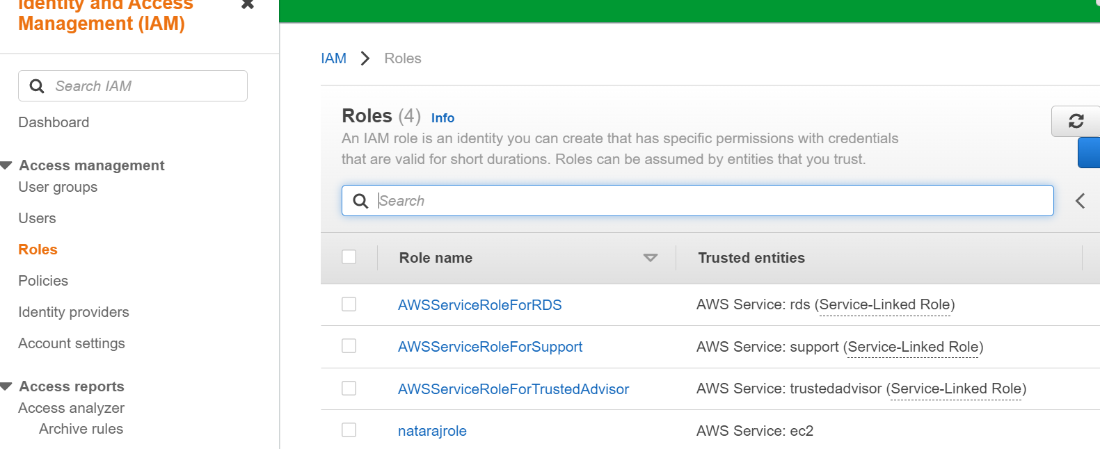

9.creating policies in iam.

