Vpc

1.logical isolated private network in cloud

2.enhached network or our own network

3.by default we can create 5 vpc’s in a region

4.we can work with other organizations

5.it is hybrid cloud

6.vpc is a single tenet

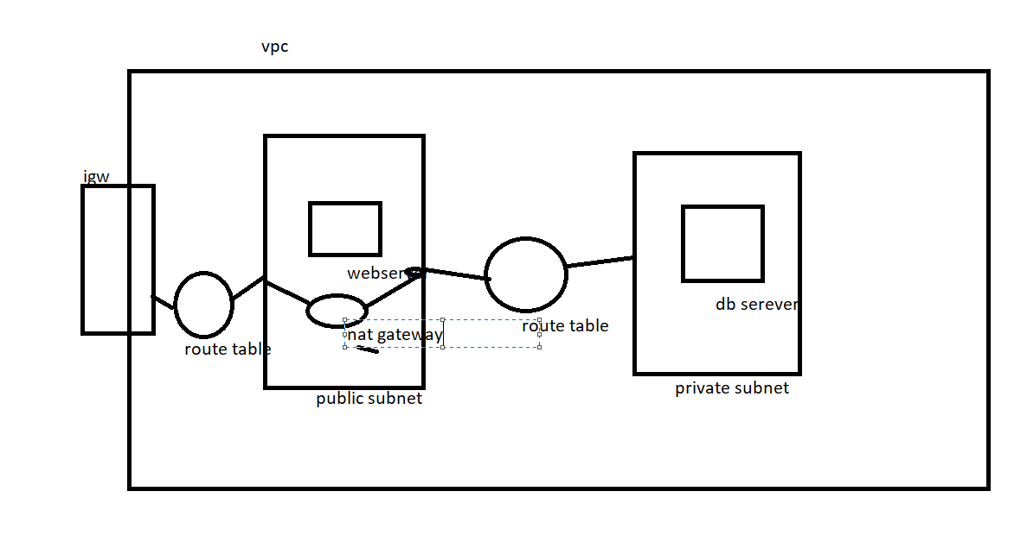

7.public subnet which associated to routing table which has a internet gateway information

8.to create vpc we need below components

Vpc cidr block

Internet gateway

Subnets

Route tables

Security groups

Nacl

Nat gateway

8.creating vpc

