VPC

1.logical isolated private network in cloud

2.enhached network or our own network

3.by default we can create 5 vpc’s in a region

4.we can work with other organizations

5.it is hybrid cloud

6.vpc is a single tenet

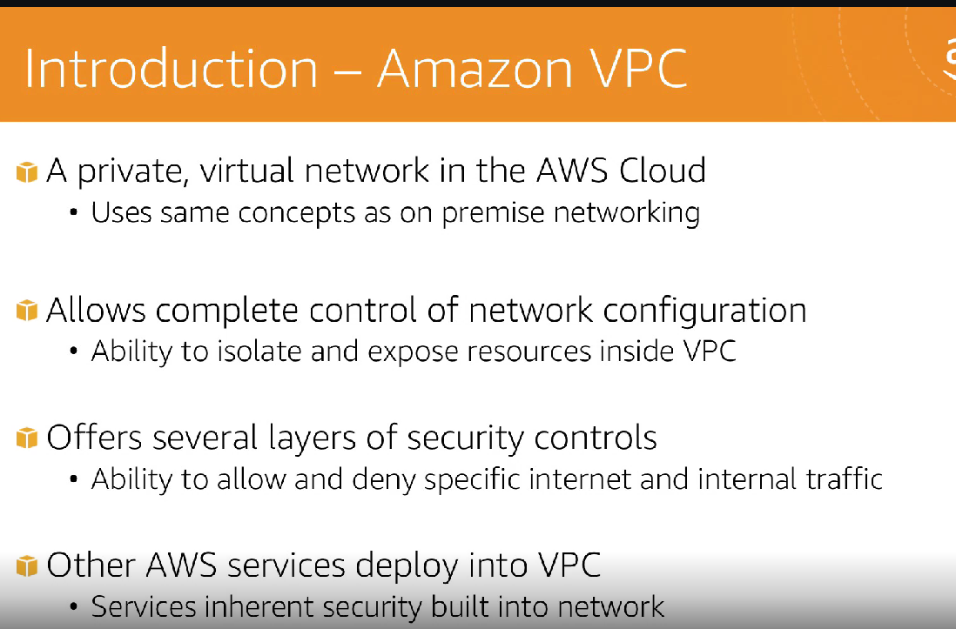

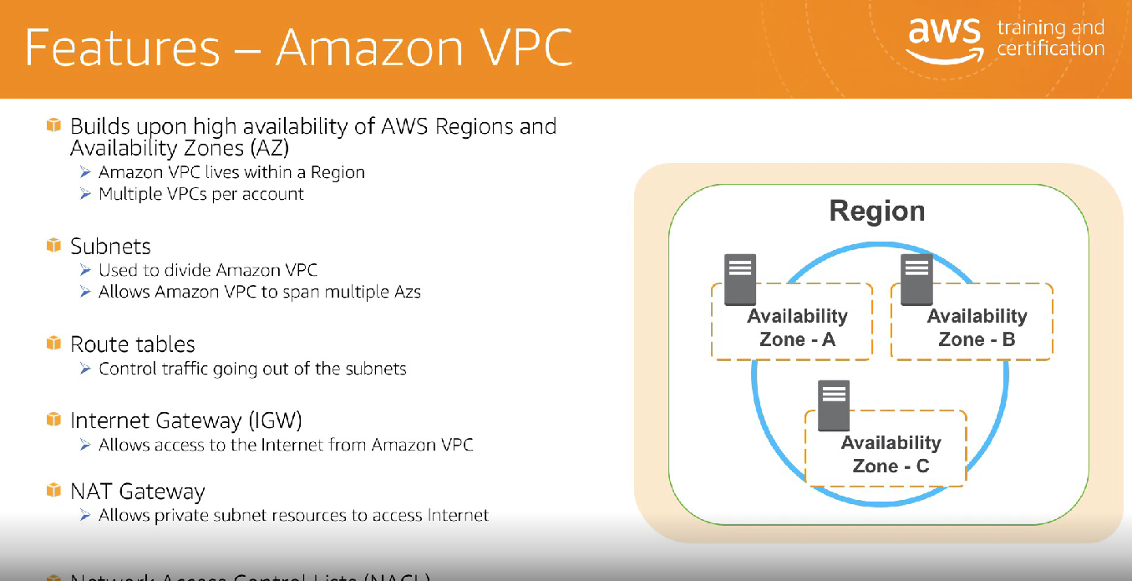

VPC Arichetecture

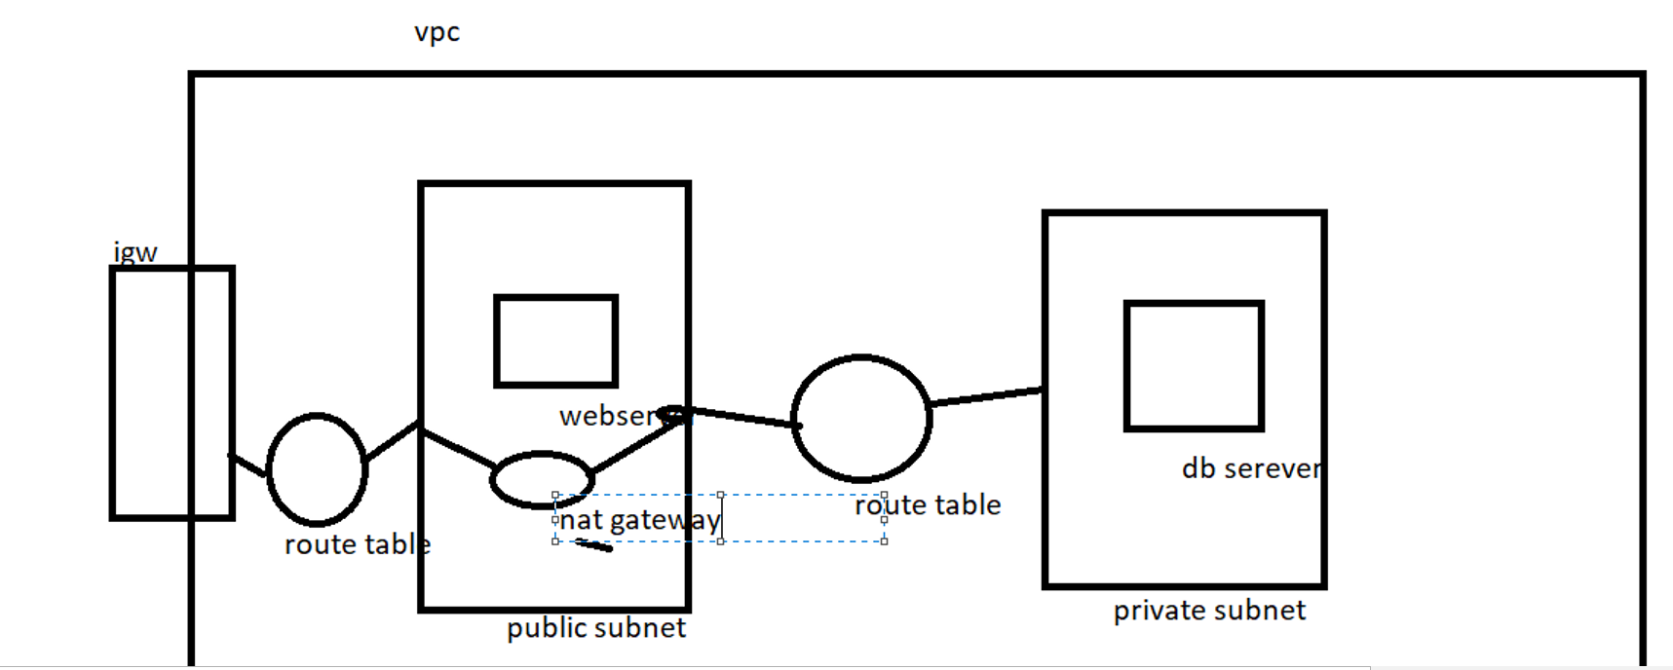

7.public subnet which associated to routing table which has a internet gateway information

8.to create vpc we need below components

Vpc cidr block

Internet gateway

Subnets

Route tables

Security groups

Nacl

Nat gateway

8.creating vpc

Creating VPC

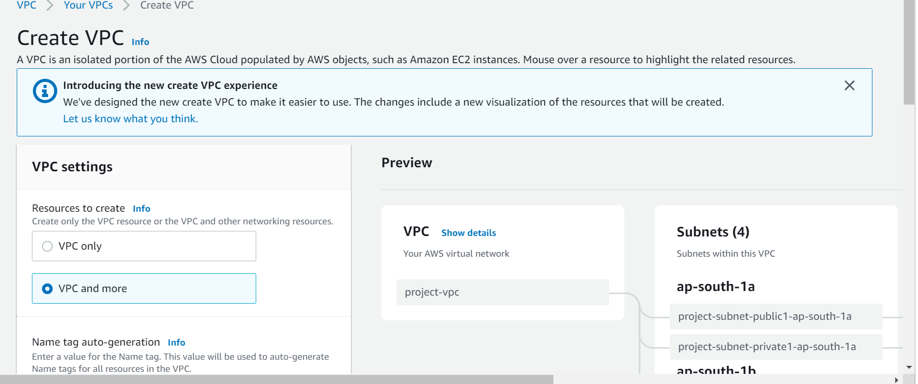

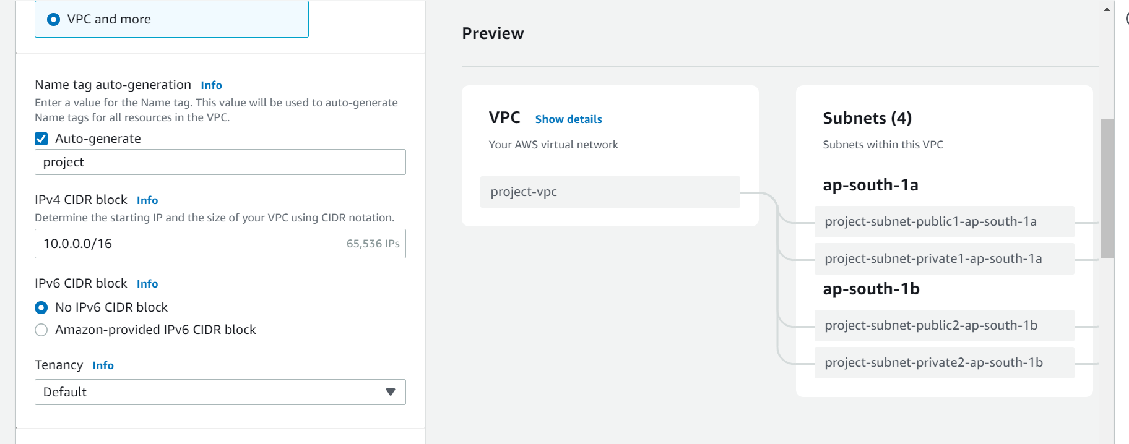

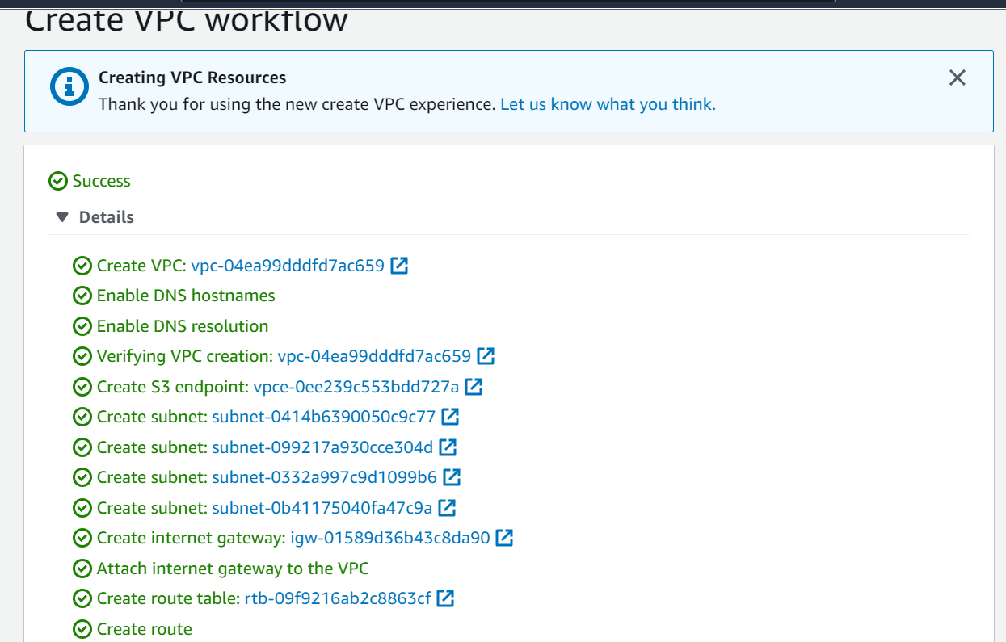

VPC Peering

CIDR range should not overlap

Transitive is not working in vpc peering.

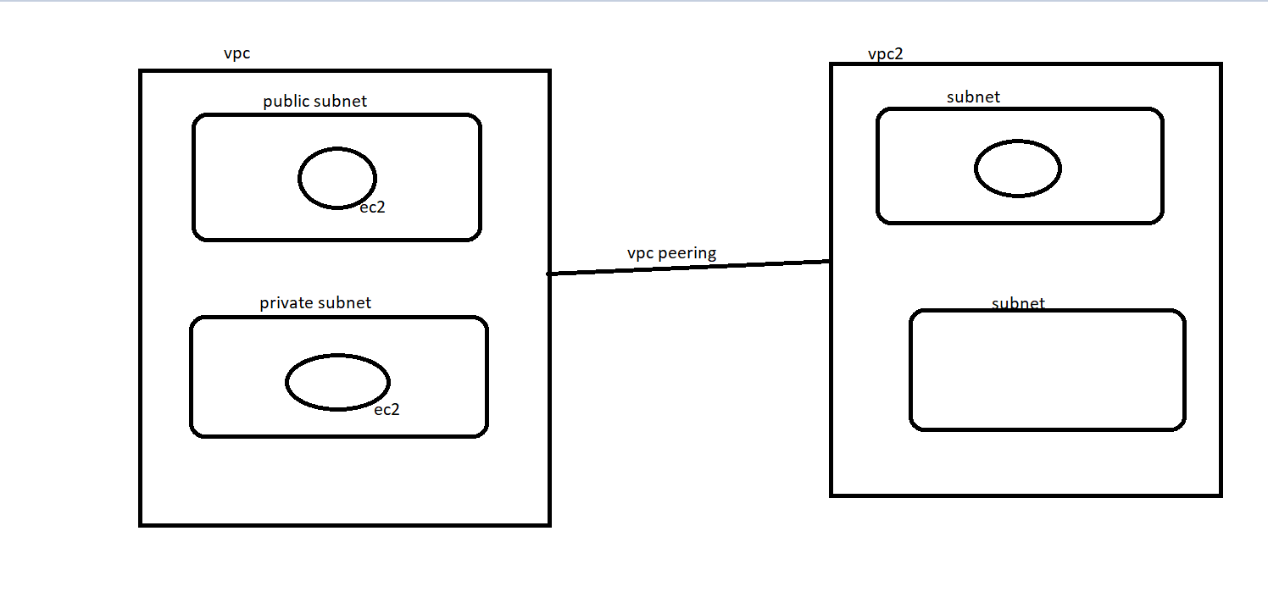

Creating vpc’s for vpc peering

