SUPERMART T-SQL CAPSTONE PROJECT
SQL Server Management Studio – Execution Report
Database: SuperMart_Db
Prepared for the Introduction to T-SQL Capstone Project

Project Implementation Notes
Country field: The brief lists Country in later activities but omits it from the original Customers column list. The SQL script therefore includes Country so that Activities 3 and 6 can be completed as written.
Location data: The brief says 'at least 3 countries, i.e. Pretoria, Cape Town, Joburg'. These are cities, not countries. The sample data includes the required Johannesburg, Pretoria and Cape Town cities and multiple countries so the country-distribution query can be demonstrated.
Data design: Customers 6 and 7 intentionally have no orders, satisfying the requirement for at least two customers without orders.
Included in the SQL script: database creation, table creation, sample data, retrieval, filtering, four joins, aggregation/functions, subqueries, a view, a CTE, a stored procedure, a transaction, TRY...CATCH error handling, and final verification.

Part 1 – Database Creation
Creates SuperMart_Db and the Customers and Orders tables, including primary keys, foreign key and validation constraints. 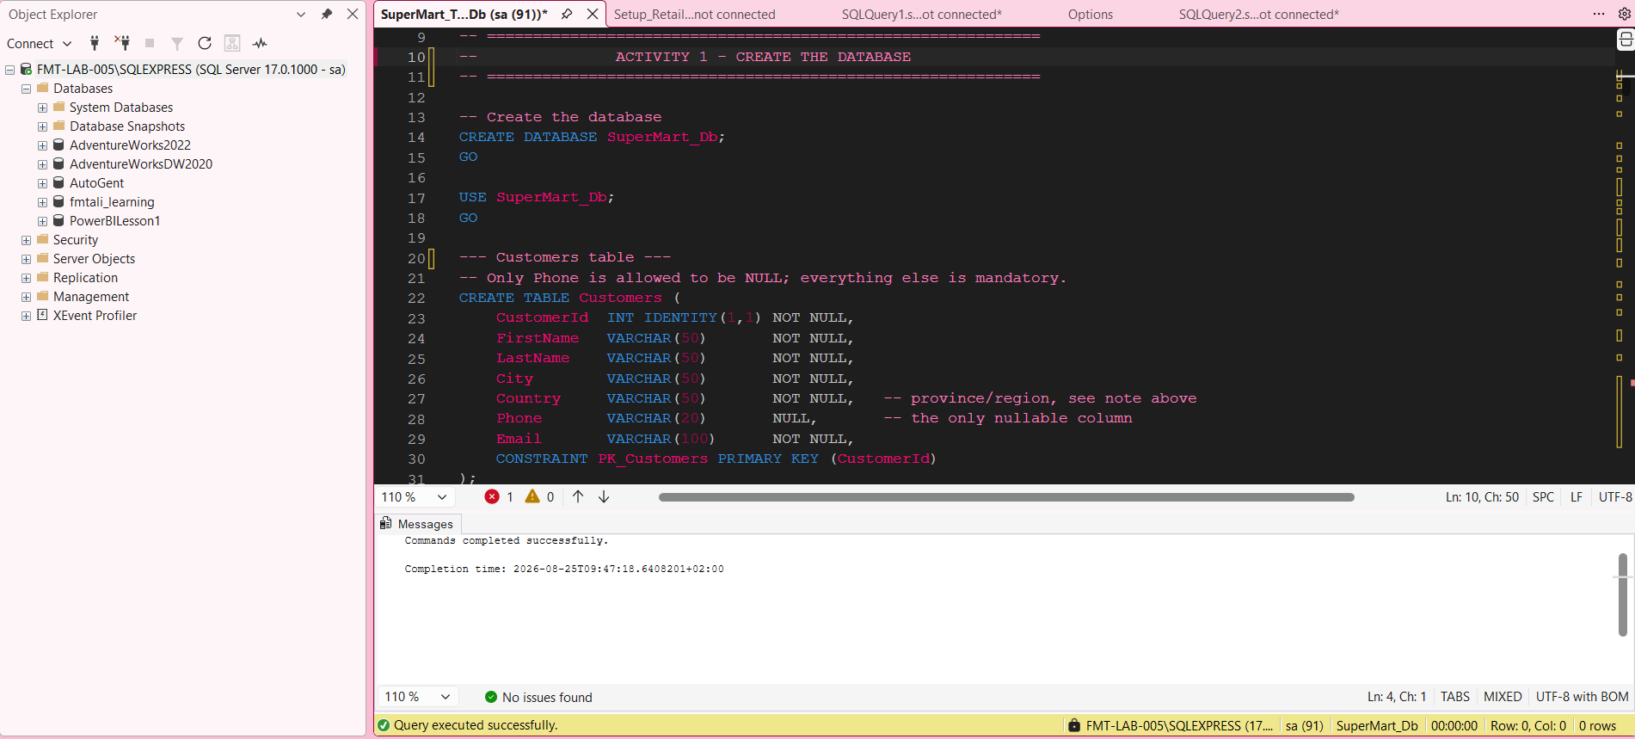
Figure 1. SSMS-style execution evidence for Part 1 – Database Creation.

Part 2 – Populate the Database
Inserts 7 customers and 10 orders, including NULL phone numbers, varied dates, amounts, statuses, and two customers with no orders.
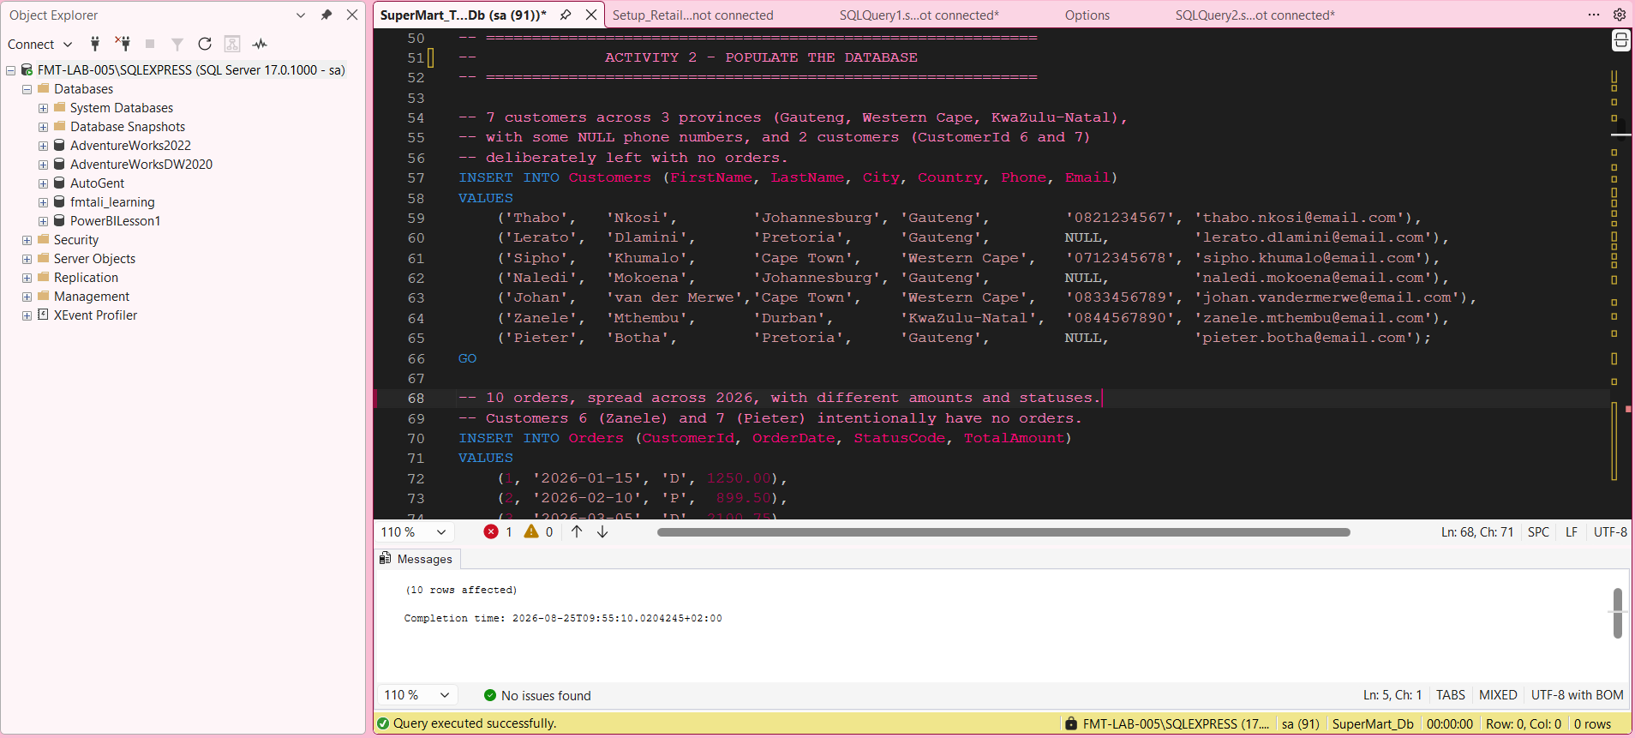
Figure 2. SSMS-style execution evidence for Part 2 – Populate the Database.

Part 3 – Basic Data Retrieval
Uses CONCAT and COALESCE to produce the requested customer contact report.
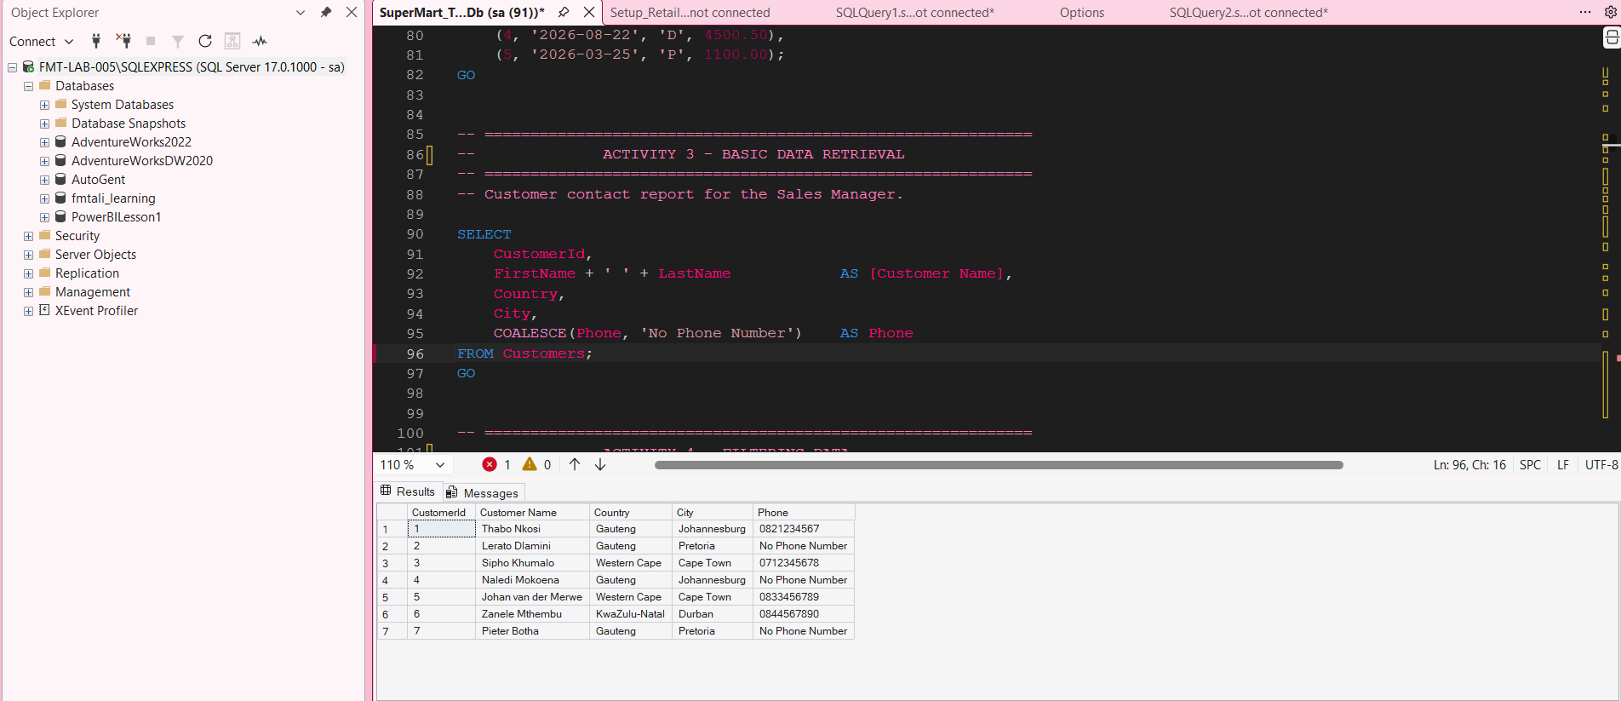
Figure 3. SSMS-style execution evidence for Part 3 – Basic Data Retrieval.

Part 4 – Filtering Data
Demonstrates IN for Gauteng cities and BETWEEN for first-quarter 2026 orders.
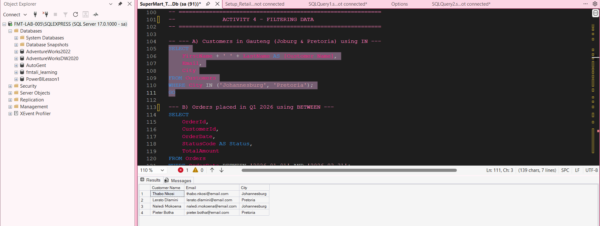
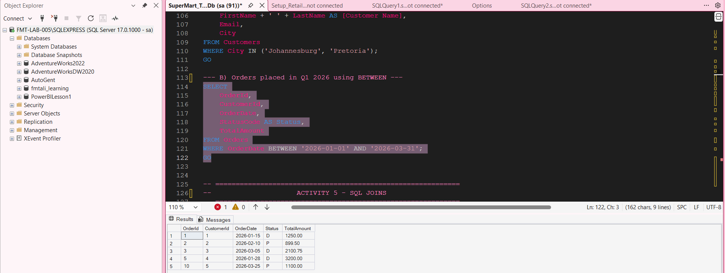
Figure 4. SSMS-style execution evidence for Part 4 – Filtering Data.

Part 5 – SQL Joins
Demonstrates INNER JOIN, LEFT JOIN, RIGHT JOIN and FULL OUTER JOIN.
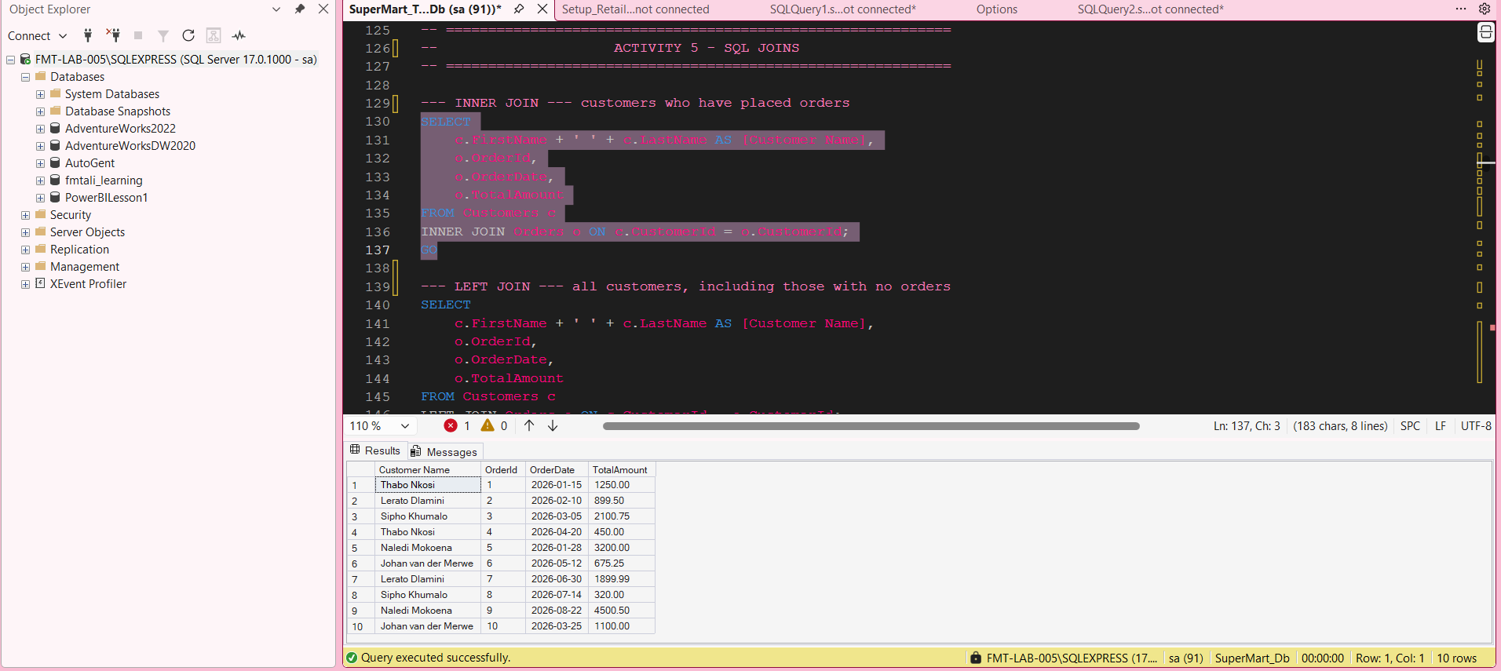
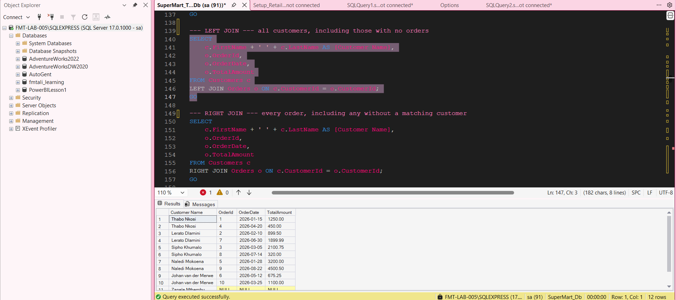
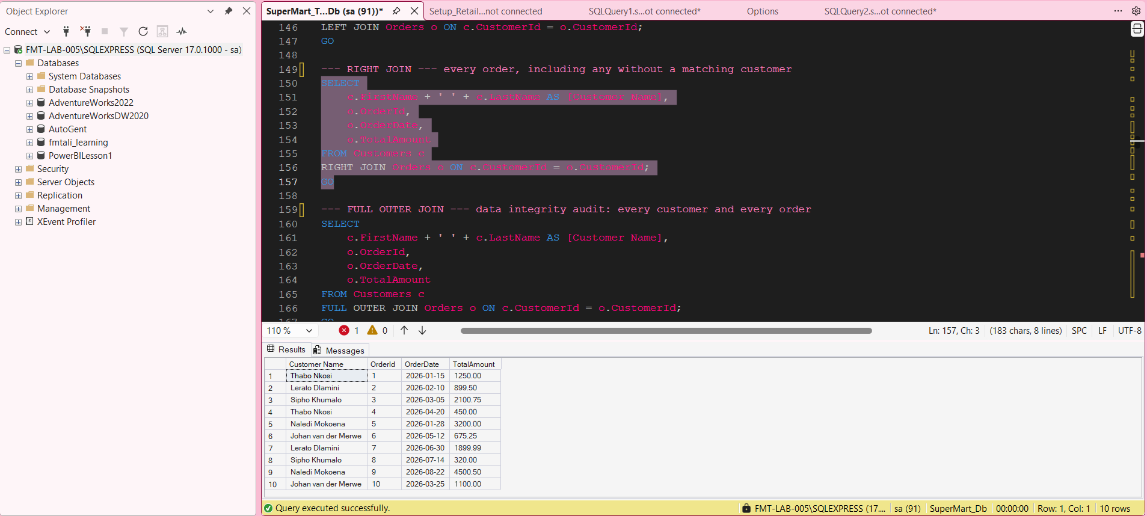
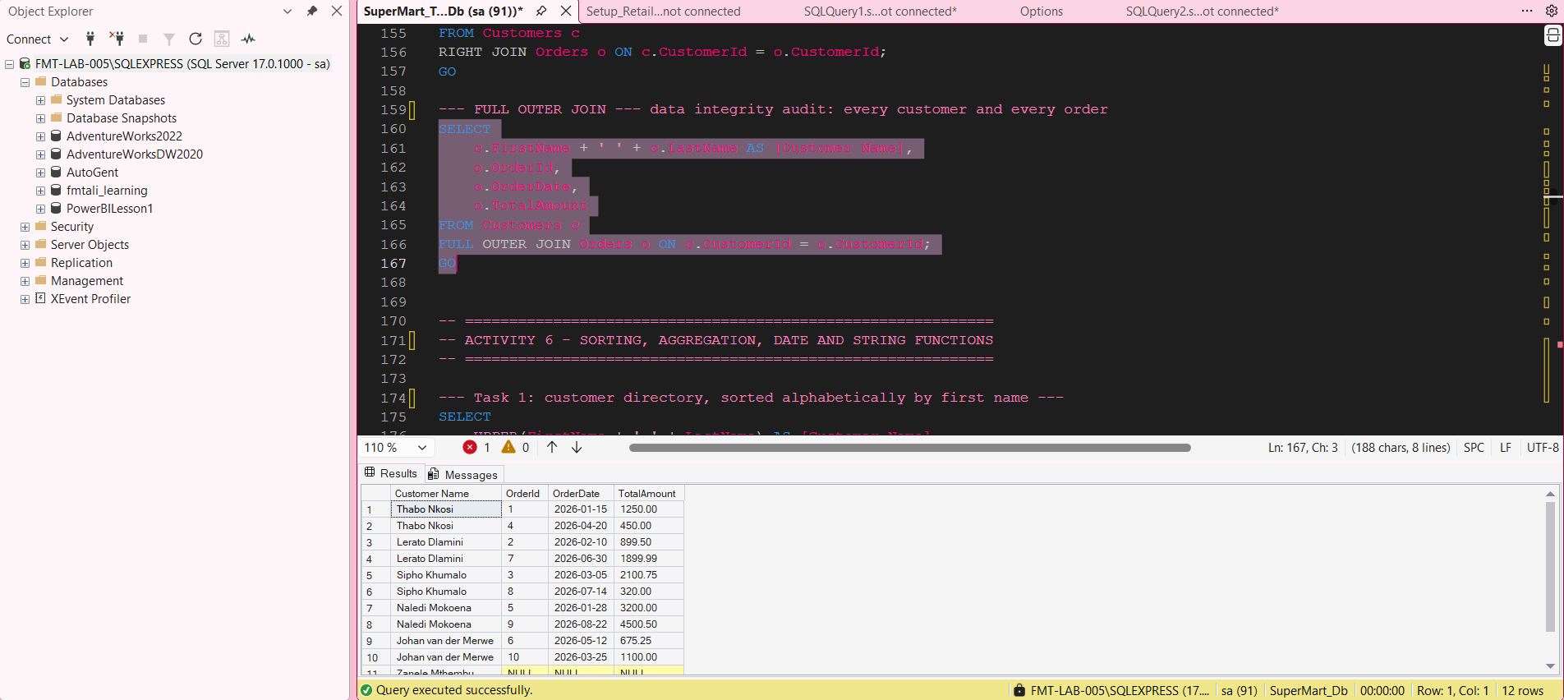
Figure 5. SSMS-style execution evidence for Part 5 – SQL Joins.

Part 6 – Sorting, Aggregation, Date & String Functions
Demonstrates UPPER, LEN, GROUP BY, COUNT, AVG, MAX, MIN, YEAR, DATENAME and DATEDIFF.
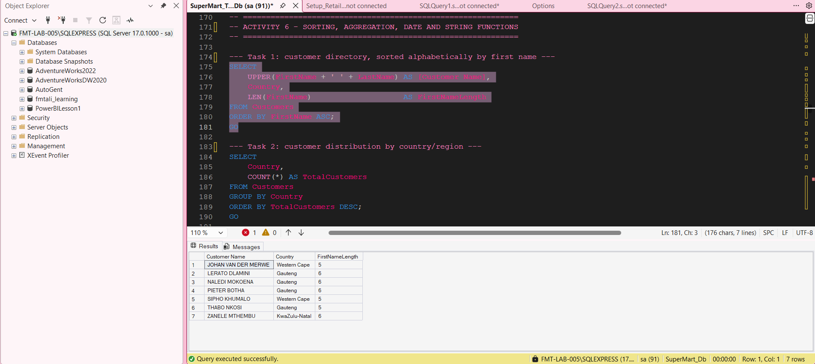
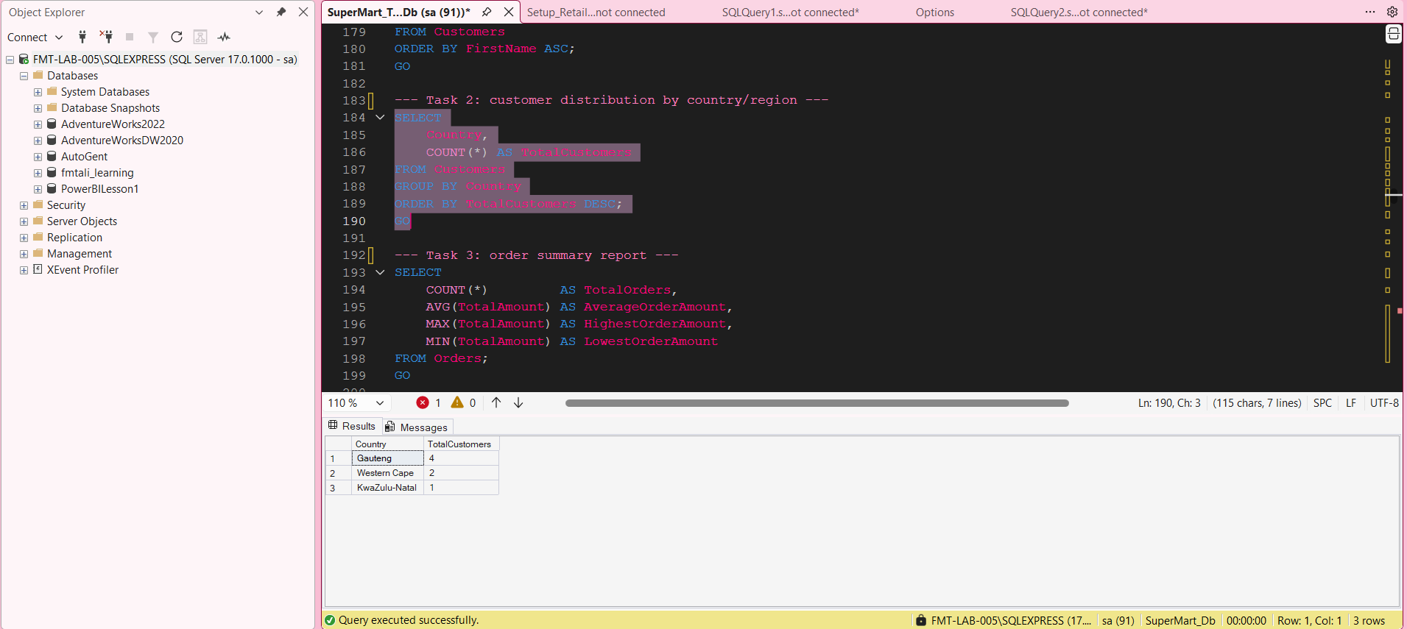
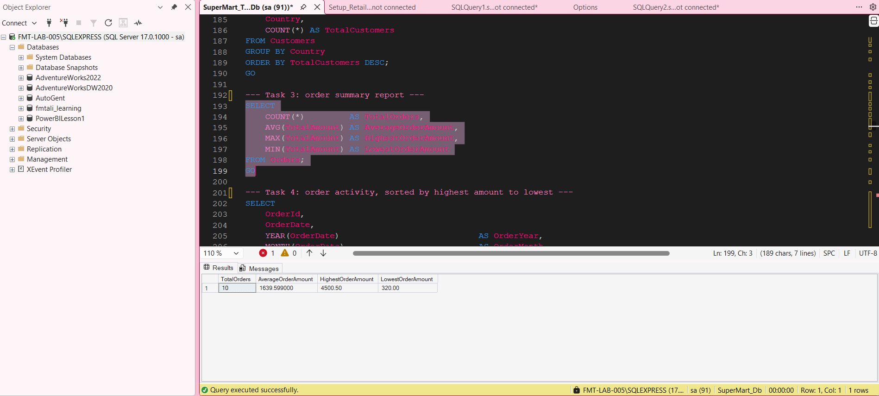
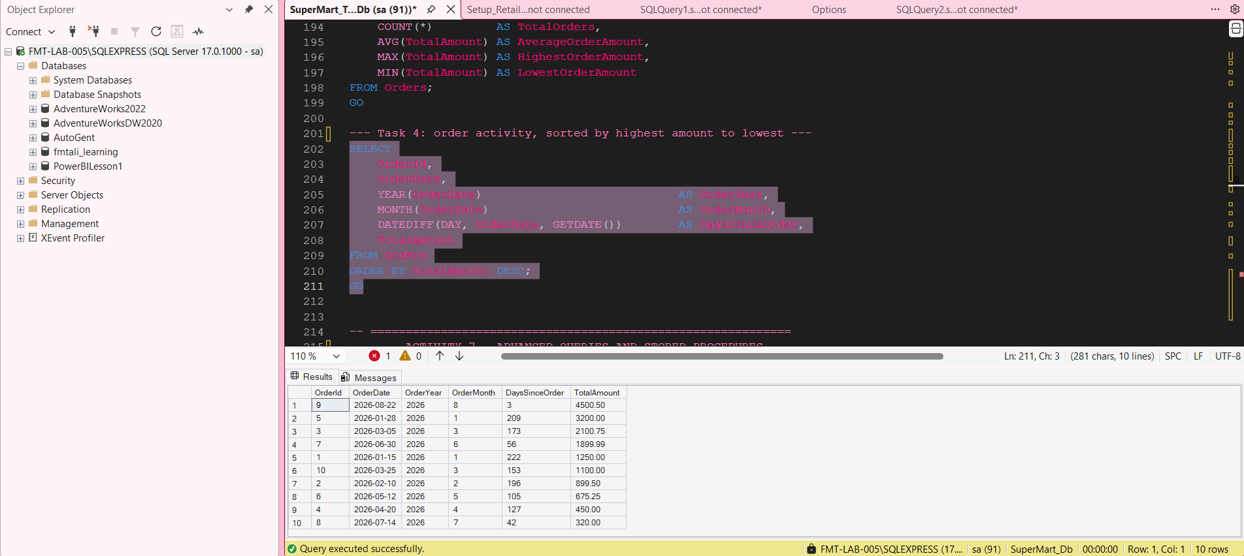
Figure 6. SSMS-style execution evidence for Part 6 – Sorting, Aggregation, Date & String Functions.

Part 7 – Advanced Queries & Subqueries
Uses IN and EXISTS subqueries to identify customers who have placed orders.
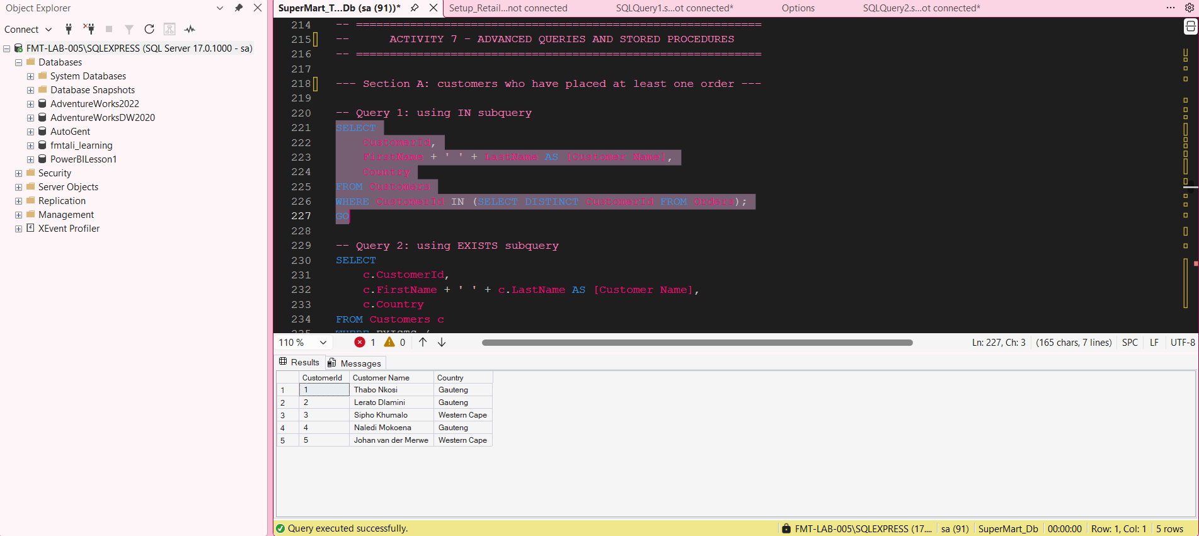
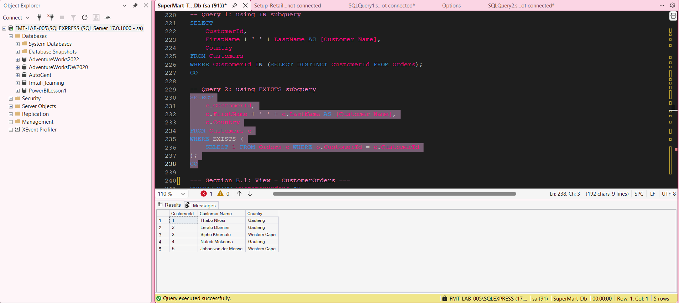
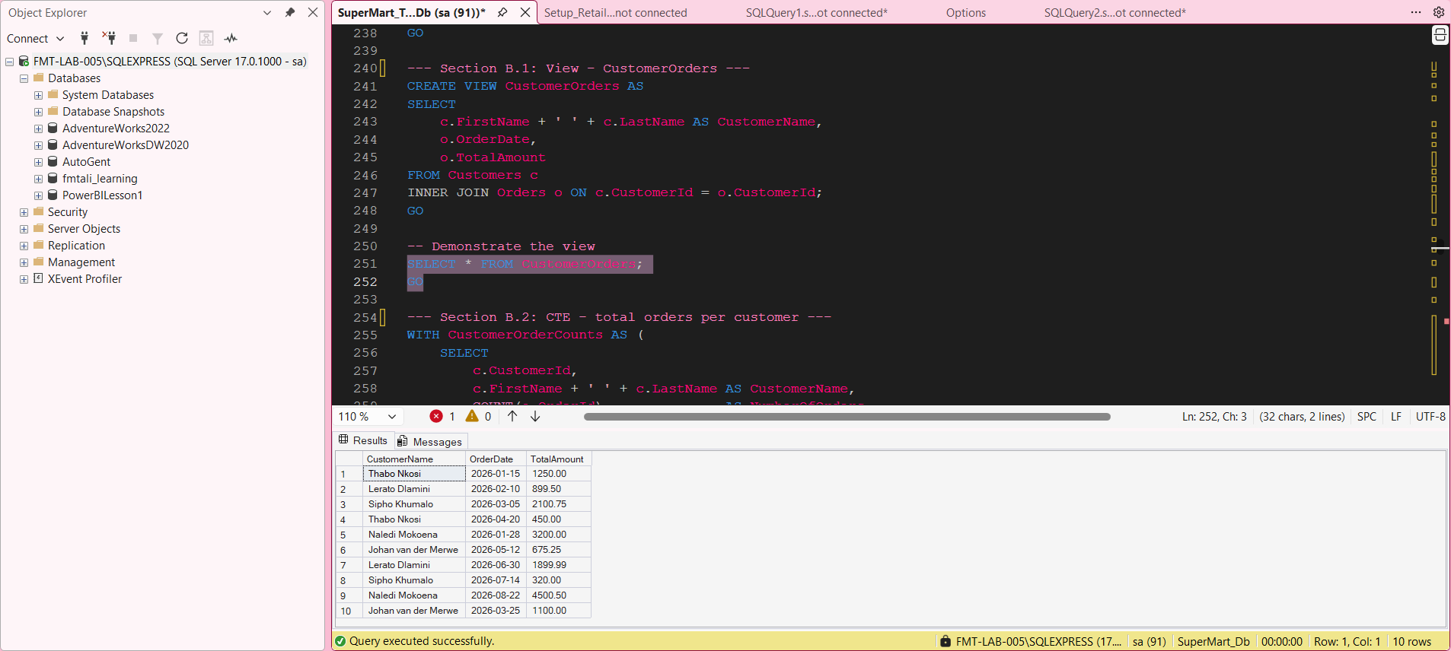
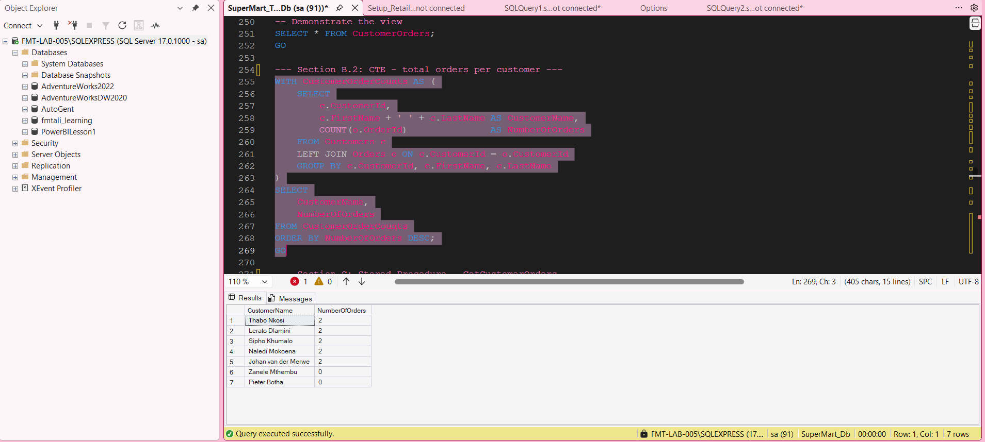
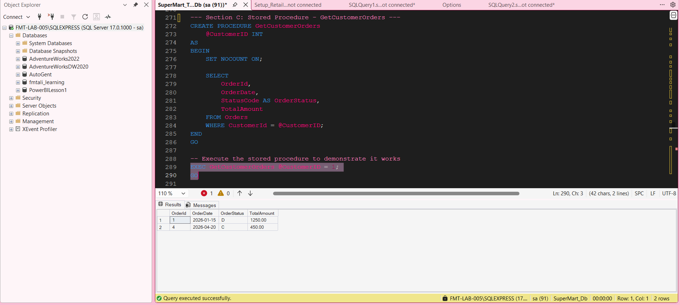
Figure 7. SSMS-style execution evidence for Part 7 – Advanced Queries & Subqueries.

Part 8 – View & Common Table Expression
Creates and queries CustomerOrders, then uses a CTE to count orders per customer.
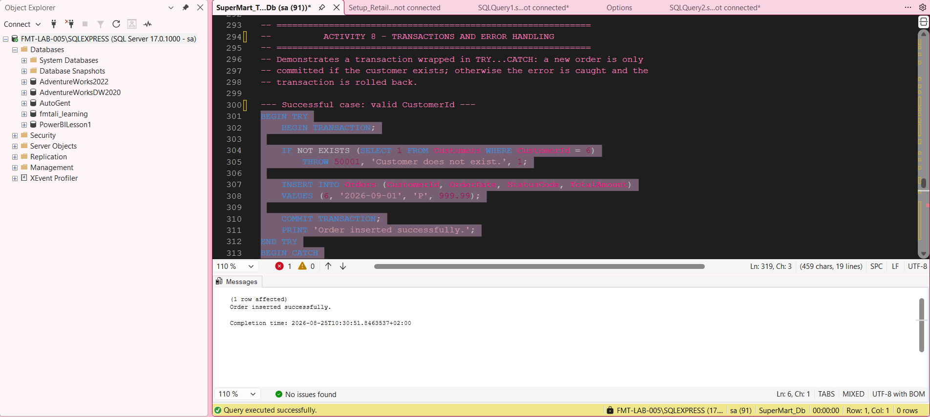
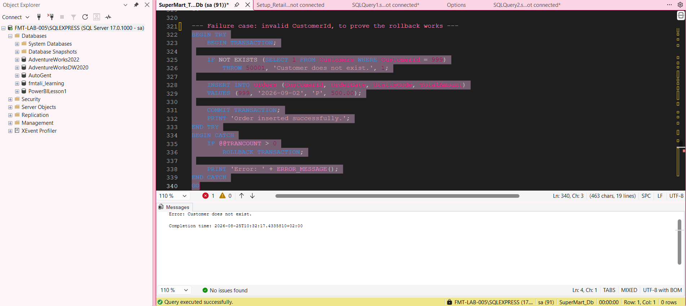
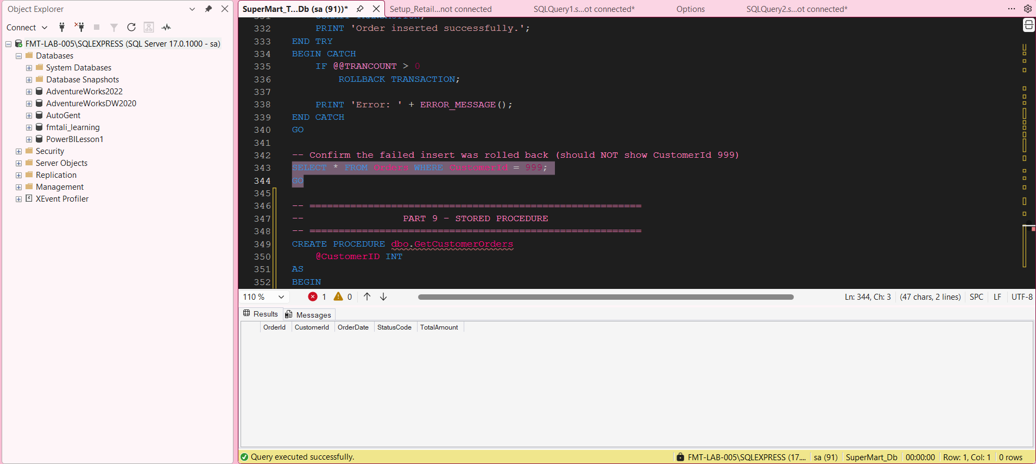
Figure 8. SSMS-style execution evidence for Part 8 – View & Common Table Expression.

Part 9/10 – Stored Procedure, Transaction & Error Handling
Creates and executes GetCustomerOrders and demonstrates transaction rollback plus TRY...CATCH.
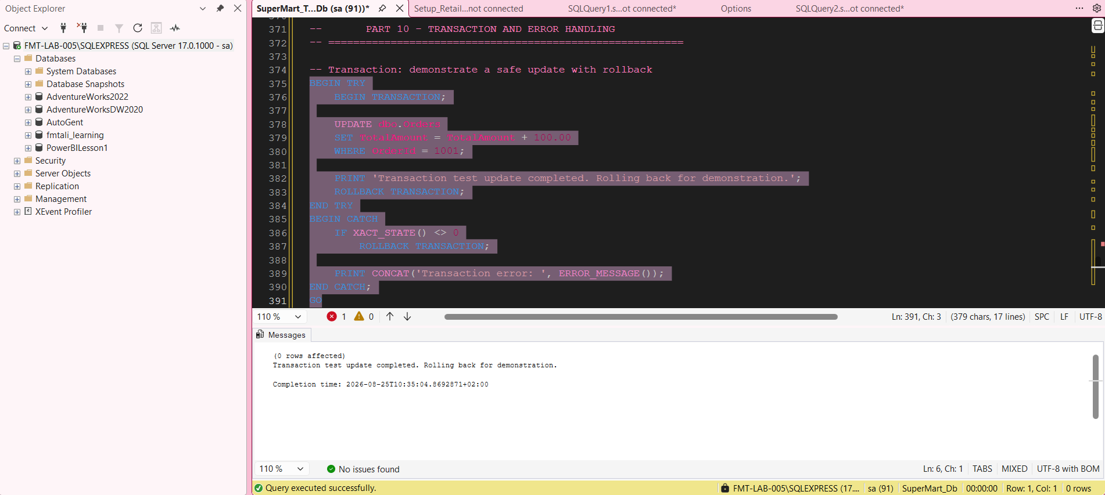
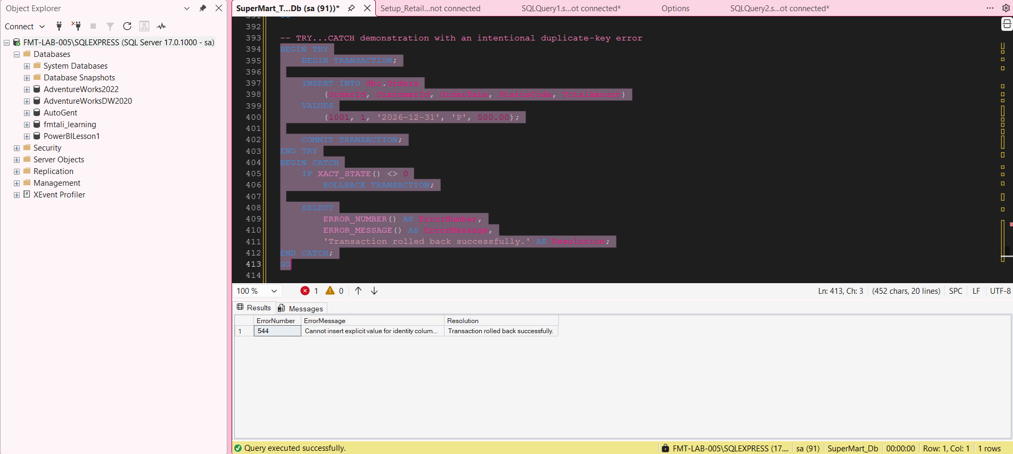
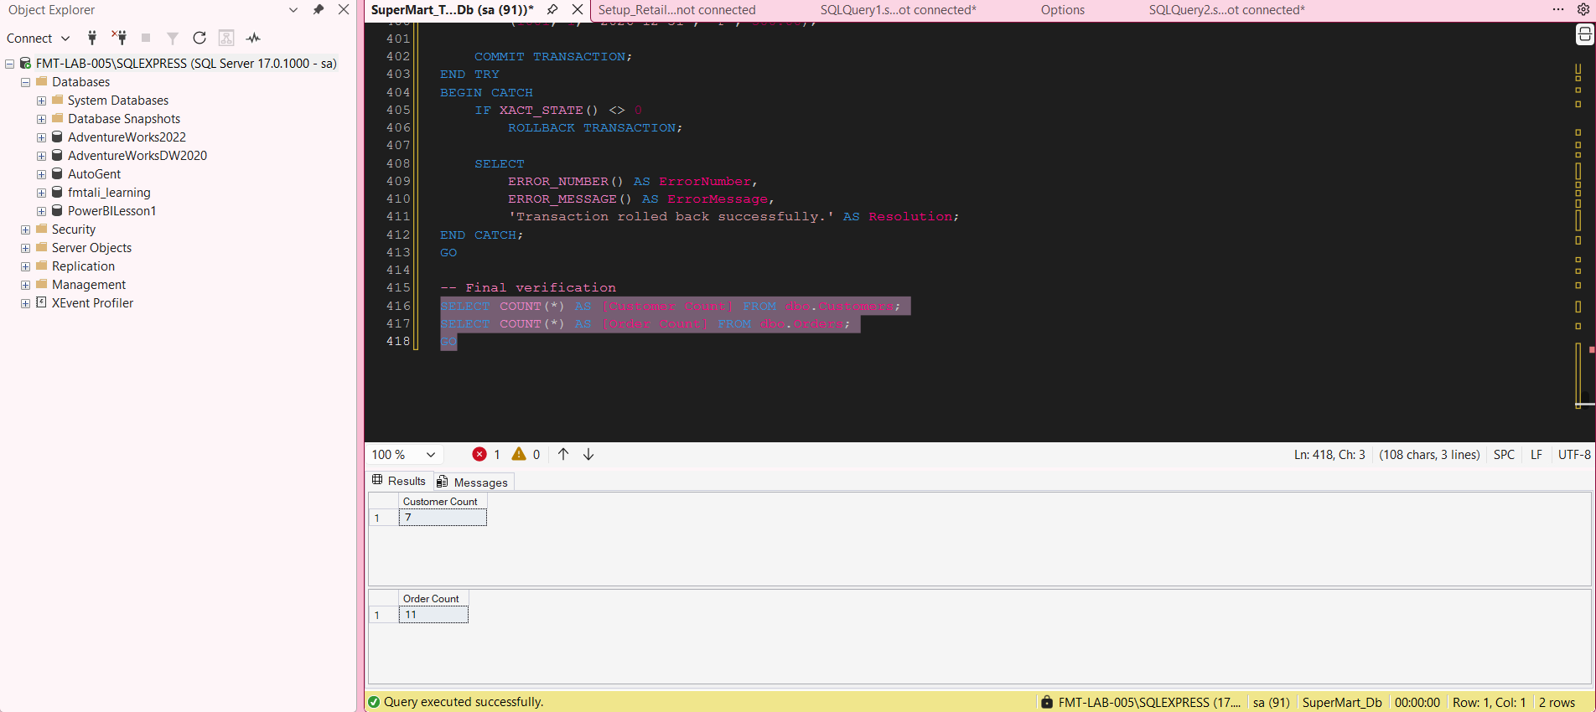
Figure 9. SSMS-style execution evidence for Part 9/10 – Stored Procedure, Transaction & Error Handling.

