Cluster Assign

Natasha Minott

2/27/2021

trucks = read_csv("trucks (1).csv")

##   
## ── Column specification ────────────────────────────────────────────────────────  
## cols(  
## Driver_ID = col_double(),  
## Distance = col_double(),  
## Speeding = col_double()  
## )

## Task 1

Between 25 and 75 miles of distance you can see a clustering of speeding. Distance between 150 and 245 seems to have speeding that is more spread out yet with higher speeds. Overall ther is some natural clustrering for speeding and one can see that the longer the distance is, the higher the speeding is.

ggplot(trucks, aes(Distance, Speeding)) + geom_point()

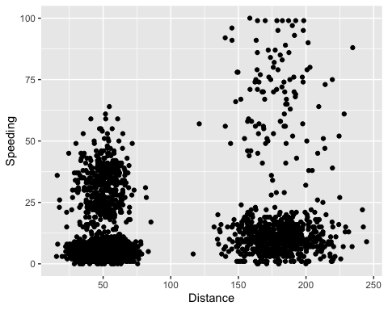

## Task 2

kmeans_recipe = recipe(~Speeding + Distance, trucks)  
  
trucks_dummy = kmeans_recipe %>%  
 step_scale(all_numeric()) %>%  
 step_center(all_numeric())   
  
trucks_dummy = prep(trucks_dummy, trucks)  
  
trucks_cleaned = bake(trucks_dummy,trucks)

## Task 3

The clusters are distributed well between 1 and 2 without outliers.

set.seed(64)  
clusts =   
 tibble(k = 2) %>%  
 mutate(  
 kclust = map(k, ~kmeans(trucks_cleaned, .x)),  
 tidied = map(kclust, tidy),  
 glanced = map(kclust, glance),  
 augmented = map(kclust, augment, trucks_cleaned)  
 )  
clusts

## # A tibble: 1 x 5  
## k kclust tidied glanced augmented   
## <dbl> <list> <list> <list> <list>   
## 1 2 <kmeans> <tibble [2 × 5]> <tibble [1 × 4]> <tibble [4,000 × 3]>

clusters =   
 clusts %>%  
 unnest(cols = c(tidied))  
  
assignments =   
 clusts %>%   
 unnest(cols = c(augmented))  
  
clusterings =   
 clusts %>%  
 unnest(cols = c(glanced))

p1 =   
 ggplot(assignments, aes(x = Distance, y = Speeding)) +  
 geom_point(aes(color = .cluster), alpha = 0.8) +   
 facet_wrap(~ k)  
p1

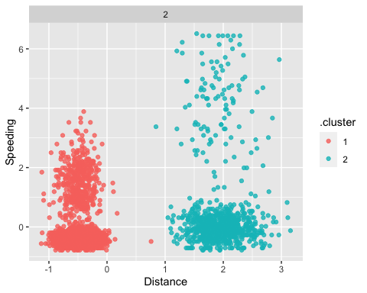

## Task 4

4 seems to be the most appropriate.

set.seed(412)  
clusts =   
 tibble(k = 1:8) %>%  
 mutate(  
 kclust = map(k, ~kmeans(trucks_cleaned, .x)),  
 tidied = map(kclust, tidy),  
 glanced = map(kclust, glance),  
 augmented = map(kclust, augment, trucks_cleaned)  
 )  
  
clusts

## # A tibble: 8 x 5  
## k kclust tidied glanced augmented   
## <int> <list> <list> <list> <list>   
## 1 1 <kmeans> <tibble [1 × 5]> <tibble [1 × 4]> <tibble [4,000 × 3]>  
## 2 2 <kmeans> <tibble [2 × 5]> <tibble [1 × 4]> <tibble [4,000 × 3]>  
## 3 3 <kmeans> <tibble [3 × 5]> <tibble [1 × 4]> <tibble [4,000 × 3]>  
## 4 4 <kmeans> <tibble [4 × 5]> <tibble [1 × 4]> <tibble [4,000 × 3]>  
## 5 5 <kmeans> <tibble [5 × 5]> <tibble [1 × 4]> <tibble [4,000 × 3]>  
## 6 6 <kmeans> <tibble [6 × 5]> <tibble [1 × 4]> <tibble [4,000 × 3]>  
## 7 7 <kmeans> <tibble [7 × 5]> <tibble [1 × 4]> <tibble [4,000 × 3]>  
## 8 8 <kmeans> <tibble [8 × 5]> <tibble [1 × 4]> <tibble [4,000 × 3]>

clusters =   
 clusts %>%  
 unnest(cols = c(tidied))  
  
assignments =   
 clusts %>%   
 unnest(cols = c(augmented))  
  
clusterings =   
 clusts %>%  
 unnest(cols = c(glanced))

p2 =   
 ggplot(assignments, aes(x = Distance, y = Speeding)) +  
 geom_point(aes(color = .cluster), alpha = 0.6) +   
 facet_wrap(~ k)  
p2

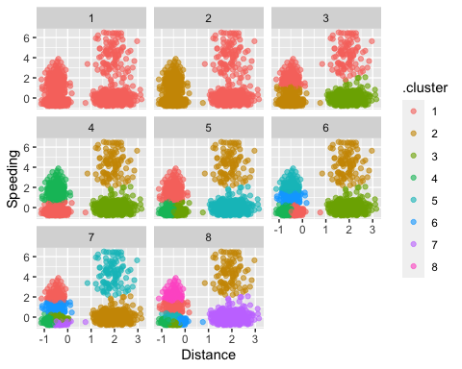

## Tasks 5

4 seems to be the most appropriate.

ggplot(clusterings, aes(k, tot.withinss)) +  
 geom_line() +  
 geom_point()

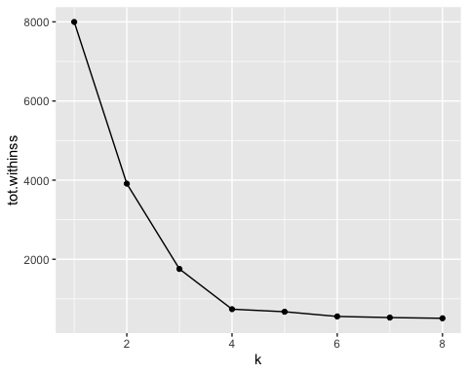

## Task 6

This is the best cluster because it is defined into groups.

set.seed(64)  
clusts =   
 tibble(k = 4) %>%  
 mutate(  
 kclust = map(k, ~kmeans(trucks_cleaned, .x)),  
 tidied = map(kclust, tidy),  
 glanced = map(kclust, glance),  
 augmented = map(kclust, augment, trucks_cleaned)  
 )  
  
clusts

## # A tibble: 1 x 5  
## k kclust tidied glanced augmented   
## <dbl> <list> <list> <list> <list>   
## 1 4 <kmeans> <tibble [4 × 5]> <tibble [1 × 4]> <tibble [4,000 × 3]>

cliuters=  
 clusts %>%  
 unnest(cols = c(tidied))  
  
assignments =   
 clusts %>%   
 unnest(cols = c(augmented))  
  
clusterings =   
 clusts %>%  
 unnest(cols = c(glanced))

p3 =   
 ggplot(assignments, aes(x = Distance, y = Speeding)) +  
 geom_point(aes(color = .cluster), alpha = 0.8) +   
 facet_wrap(~ k)  
p3

