

TOPIC: ADVANCED WEB
NAME: NATASHA WANJIRU
ADM NO: BSCCS/2024/53895
COURSE: BACHELOR OF SCIENCE IN INFORMATION TECHNOLOGY
DEPARTMENT: COMPUTING AND INFORMATICS
UNIT CODE: BIT3208
UNIT NAME: ADVANCED WEB DEVELOPMENT
DEPARTMENT: COMPUTING AND INFORMATICS
ACADEMIC YEAR:3.2
LECTURER: MR NYORO
SUBMISSION DATE: 05/06/2026

GITHUB REPOSITORY: https://github.com/natashanats170-sudo/Advanced-Web-Design

Contents
1.0 WEEK 1- 3 3
WEEK 2: Wireframes, GUI Design and Project Planning. 4
WEEK 3 Java script and php basics 4
WEEK 4 - SIMPLE PHP CONSCEPTS 5
4.1 DATABASE CREATION 6

Figure 1 Control panel 3
Figure 2 operation on local host 3
Figure 3 canva layout for gui design 4
Figure 4 Javascript validation 4
Figure 5 forms and php 5
Figure 6 login form 5
Figure 7 login page 6
Figure 8 my sql databse creation 6
Figure 9 connection string 7
Figure 10 database tables 7
Figure 11 A fully working database with data 8

1.0 WEEK 1- 3
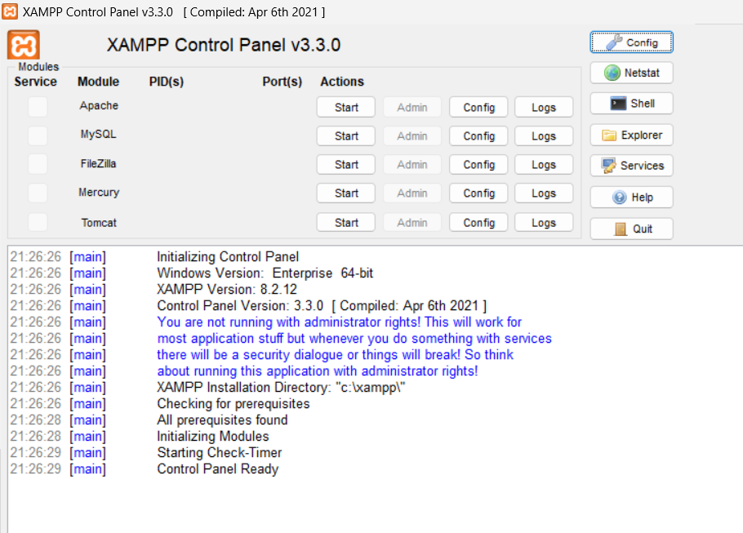
Figure 1 Control panel
The image shows a successfully installed xampp running in the control panel

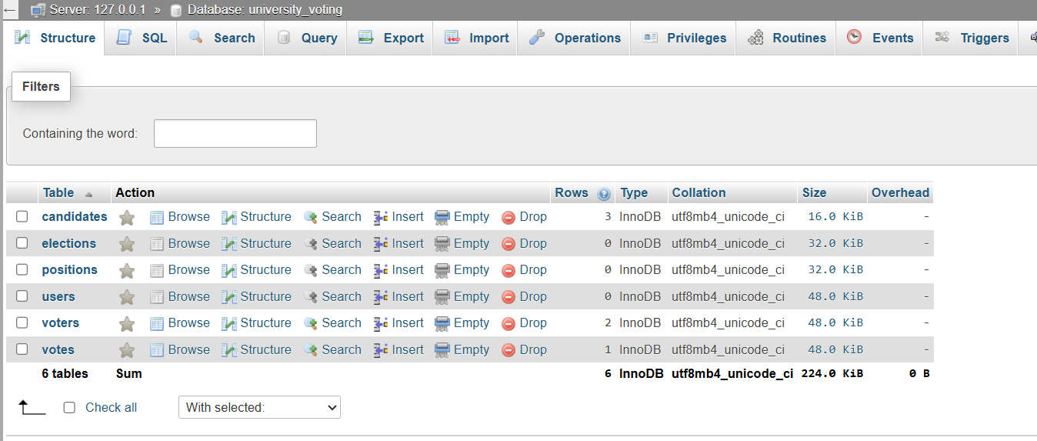
Figure 2 operation on local host

WEEK 2: Wireframes, GUI Design and Project Planning.

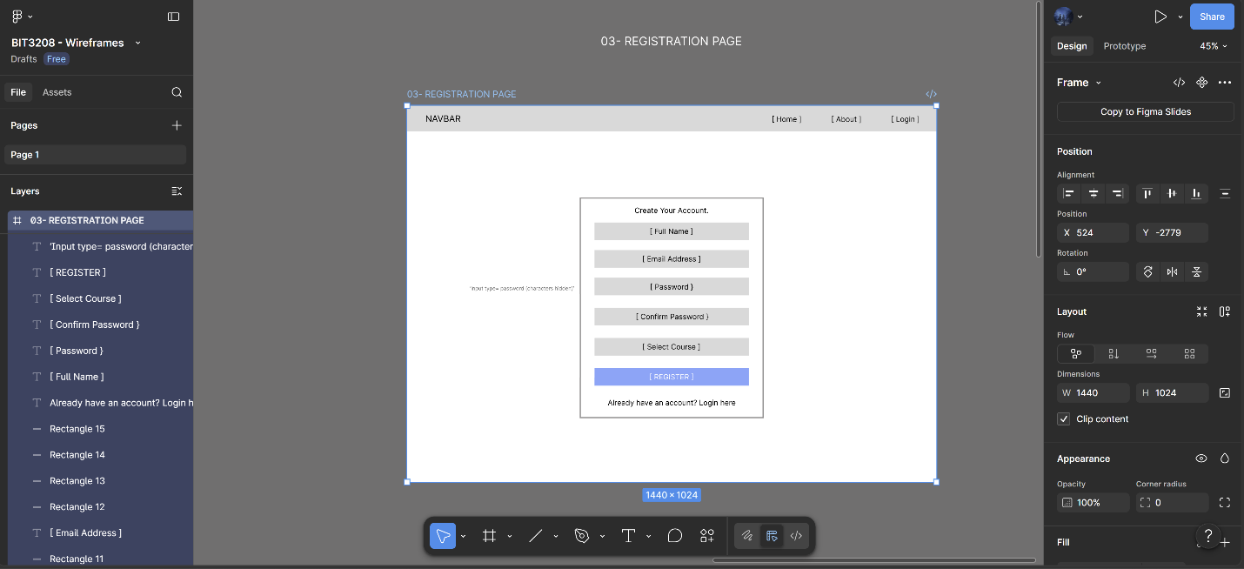
Figure 3 canva layout for gui design

3.0 Java script and php basics

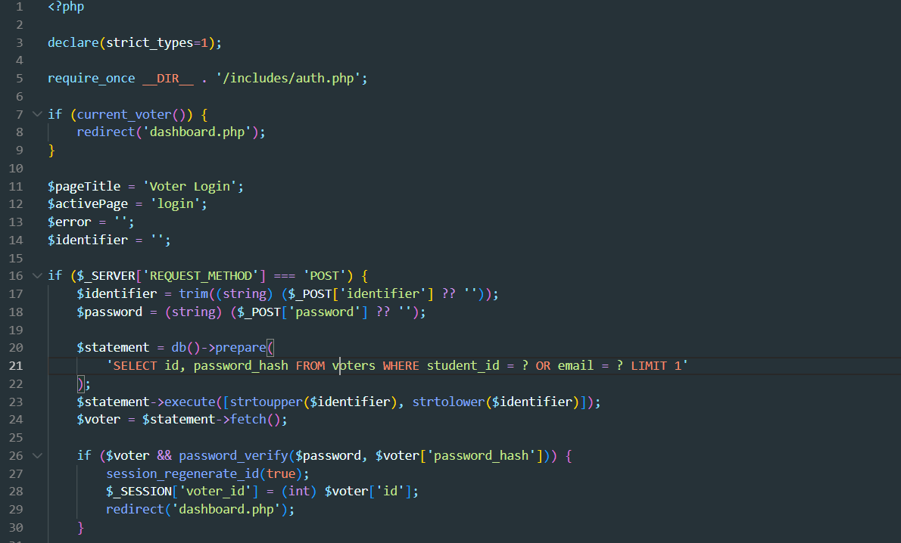
Figure 4 Javascript validation

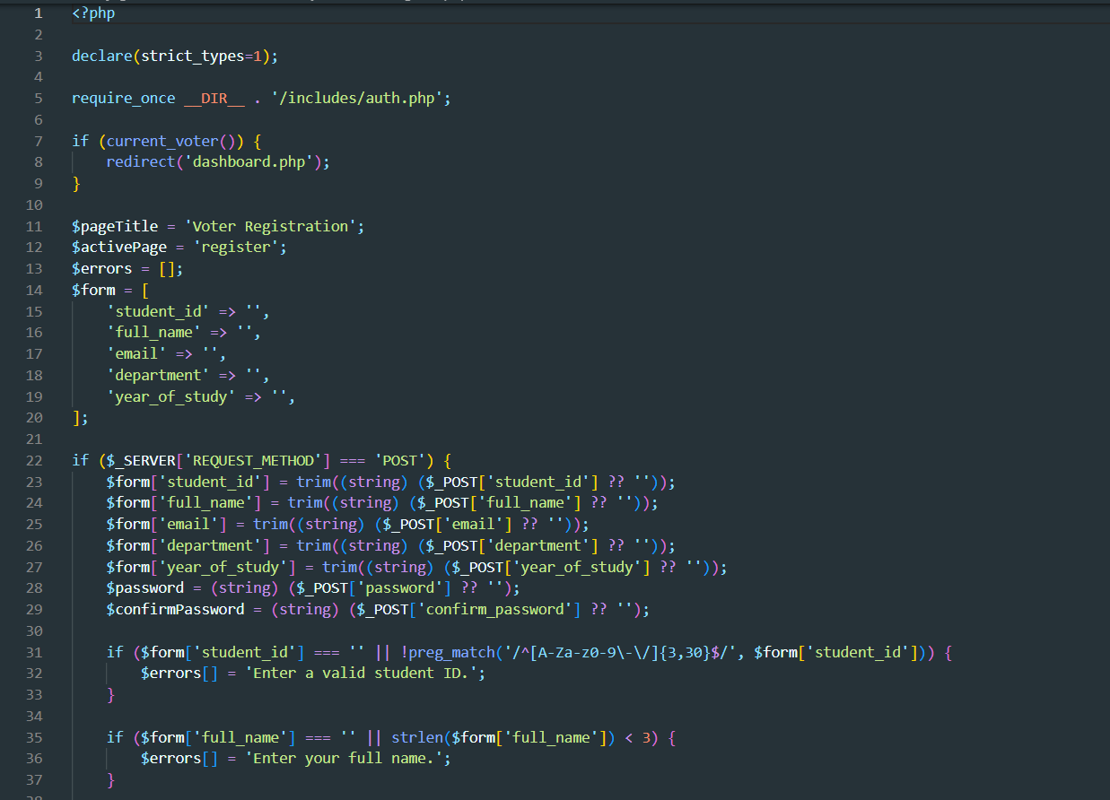
Figure 5 forms and php

4.0 - SIMPLE PHP CONSCEPTS
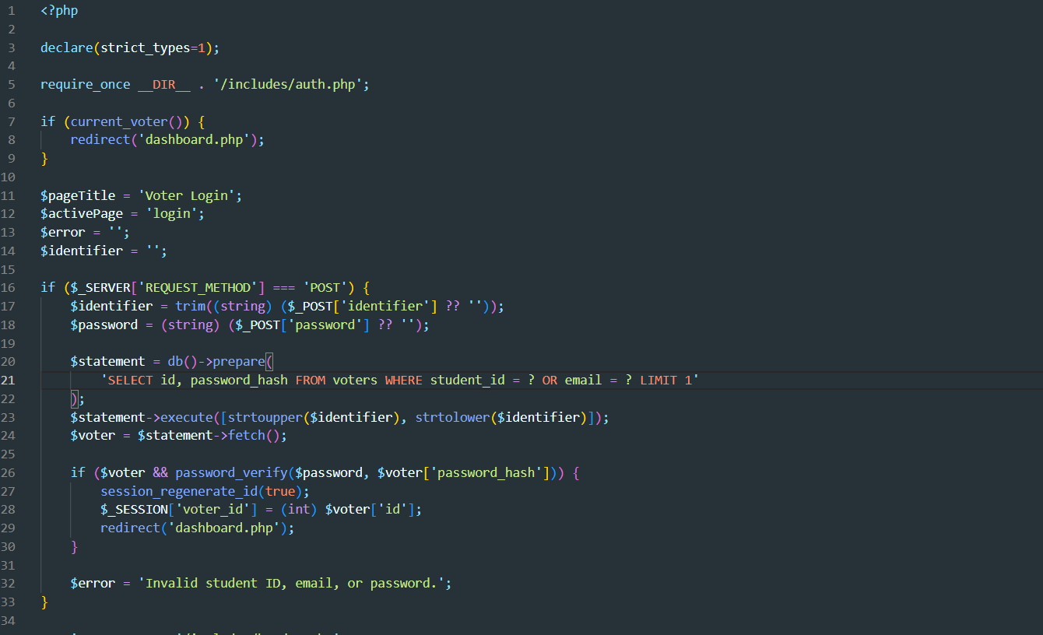
Figure 6 login form
The login form contains a depiction of the entire website and what the user expects once details are verified.
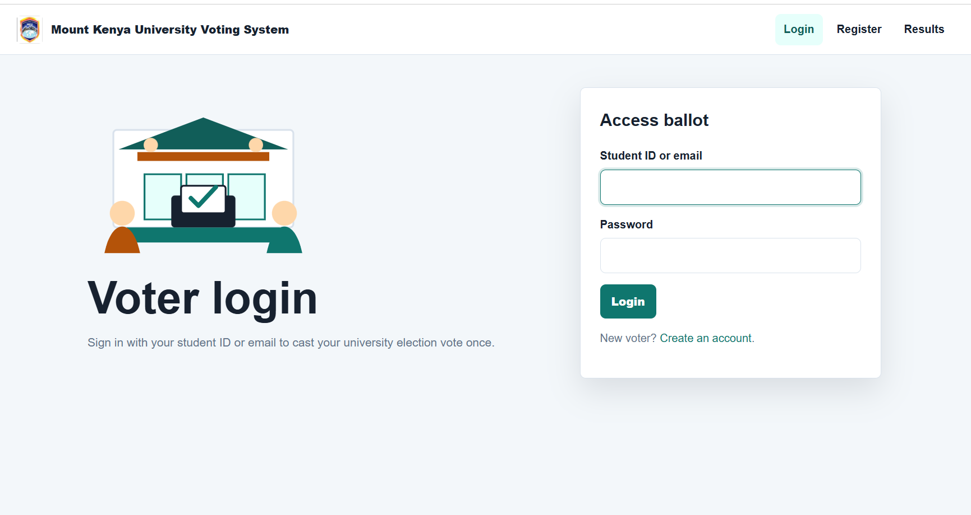
Figure 7 login page
LOG IN PAGE

4.1 DATABASE CREATION

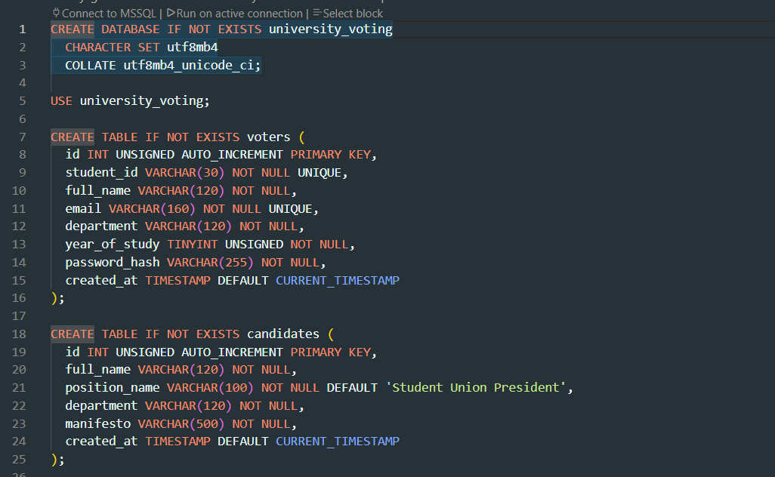
Figure 8 my sql databse creation

mySQL database creation followed with the connection string below

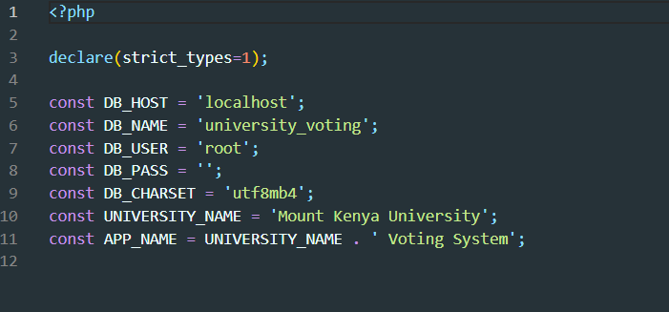
Figure 9 connection string

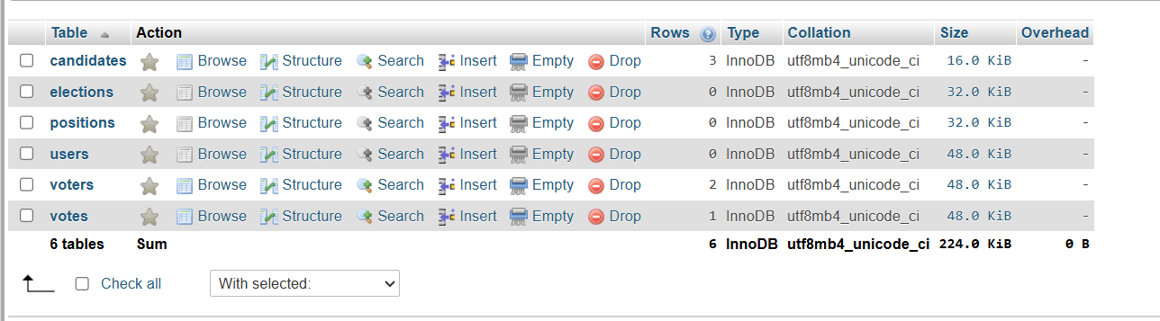
Figure 10 database tables

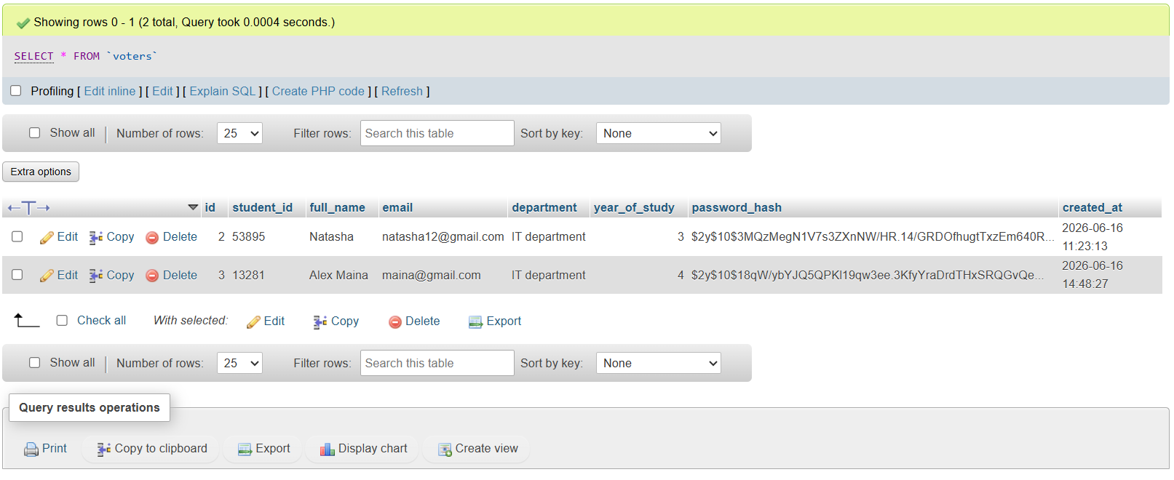
Figure 11 A fully working database with data

