**Deadwood Design**

**Introduction**  
Deadwood TM is a multiplayer board game about wandering actors working in Deadwood Studios. The game is best for two to six players, but it can handle up to eight players. Depending on the number of players, the game will proceed across three or four days (rounds). Players can take on acting roles, move across any one of the ten sets, or upgrade their actor’s rank through earning money and fame. For a four player game, the game is over by the end of the fourth day, and the player’s scores are tallied to find out who is the winner.

**Actors**

Player: The players of the game

System: Admin

**Use Case Diagram**



**Use Cases**

|  |
| --- |
| **Use Case Title:** Set Up Game **Actors:** Player, System **Trigger:** Player want to play the game **Pre-Condition:** The game has not been set up yet **Post-Condition:** The game is ready to play  **Basic Flow:**   1. Arrange the game board so that all the doorways line up 2. Each player chooses a colored dice as a pawn 3. Place each player’s dice at the Trailers with one dot facing upwards, representing their initial rank 4. Place the day cards in a stack near the board, with Day 1 on top 5. Shuffle all 60 scene cards 6. Deal one scene card into each set with the scene card facing down 7. Place a Shot Marker onto each of the 22 shot marks on the board, clapper side up 8. Randomly choose which player starts first and proceed clockwise |

|  |
| --- |
| **Use Case Title:** Move **Actor:** Player, System **Trigger:** It is the player’s turn **Pre-Condition:** Player is not working on a role **Post-Condition:** Player’s turn ends  **Basic Flow:**   1. Player chooses to move to a different stage 2. System checks if the move is legal (player is moving to an adjacent stage through a connecting doorway) 3. Player chooses to take a role   **Alternative Flow - Step 1:**  1a) Player chooses not to move  1b) End turn  **Alternative Flow - Step 1:**  1a) Player moves to a non-adjacent stage  1b) System stops the move and forces player to choose a different stage  **Alternative Flow - Step 2:**  2a) Player chooses not to take a role  2b) Leave the dice in a blank area of the stage  2c) End turn |

|  |
| --- |
| **Use Case Title:** Take a role **Actor:** Player, System **Trigger:**Player chooses to move and take a role **Pre-Condition:**Player is not working on a role and there are roles available **Post-Condition:** Player turn ends  **Basic Flow:**   1. Player places their colored dice on a role on the board 2. System checks and agrees that the player’s rank is greater or equal to the rank for the role 3. Player has taken a role and the turn ends   **Alternative Flow - Step 1:**  1a) Player places their colored dice on a role on the card  1b) End turn  **Alternative Flow - Step 2:**  1a) System says that the player rank is lower than the choosen role  1b) Fail to take a role |

|  |
| --- |
| **Use Case Title:** Work **Actor:** Player **Trigger:**Player chooses to work **Pre-Condition:**Player has a role **Post-Condition:** Player has decided to act or rehearse  **Basic Flow:**   1. Player chooses to act   **Alternative Flow - Step 1:**  1a) Player chooses to rehearse |

|  |
| --- |
| **Use Case Title:** Act **Actor:** Player **Trigger:** Player selects Act **Pre-Condition:** Player has taken a role for a scene **Post-Condition:** Player turn ends and the scene has been advanced  **Basic Flow:**   1. Player is on the card and makes a Successful Roll (player rolls a number greater than or equal to budget) 2. Remove one shot marker 3. System awards player 2 stars in fame 4. End player turn   **Alternative Flow - Step 1:**  1a) Player is on the card and makes an Unsuccessful Roll  1b) System does not award anything  1c) No shot markers are removed  1d) End player turn  **Alternative Flow - Step 1:**  1a) Player is off the card and makes a Successful Roll  1b) System awards player $1 and 1 star in fame  1c) Remove one shot marker  1c) End player turn  **Alternative Flow - Step 1:**  1a) Player is off the card and makes an Unsuccessful Roll  1b) System awards player $1  1c) No shot markers are removed  1d) End player turn  **Alternative Flow - Step 4:**  4a) If last clapper was removed and player has role on card, System will give number of dice equal to budget for player to roll  4b) Give player fame according to dice  4c) End turn |

|  |
| --- |
| **Use Case Title:** Rehearsal **Actor:** Player **Trigger:**Player choose to rehearse **Pre-Condition:**Player is working on a role **Post-Condition:** Player gets one more roll added to their next roles for that scene.  **Basic Flow:**   1. Place rehearsal marker on die (Limit 6) 2. Add one more roll to the player’s next rolls 3. End turn   **Alternative Flow - Step 1:**  1a) Player tries to rehearse a 7th time  1b) System respond with a “Player Must Act”  1c) Player acts |

|  |
| --- |
| **Use Case Title:** Upgrade **Actor:** Player, System **Trigger:**Player choose to upgrade **Pre-Condition:**Player is in Casting Office and has enough money and/or fame **Post-Condition:** Player levels up  **Basic Flow:**   1. Player chooses money to upgrade 2. System checks if the player has enough money 3. Player pays a specific amount of money to upgrade to a desired rank 4. Change player dice to the rank the player is paying money to upgrade to   **Alternative Flow - Step 1:**  1a) Player chooses fame to upgrade  1b) System checks if the player has enough fame  1c) Player pays a specific amount of fame to upgrade to a desired rank  1c) Change player dice to the rank the player is paying fame to upgrade to  **Alternative Flow - Step 1b:**  1a) Player does not have enough fame  1b) Restart Upgrade  **Alternative Flow - Step 2:**  2a) Player does not have enough money  2b) Restart Upgrade |

|  |
| --- |
| **Use Case Title:** End of day **Actor:** Player, System **Trigger:**Only one scene is left on the board  **Pre-Condition:** The recent day is not the 3rd day **Post-Condition:** New day starts  **Basic Flow:**   1. Advance to the next day card 2. All players return to the Trailers 3. Discard the final scene card from the previous day 4. Reset all of the Shot Markers 5. Deal ten new scene cards onto the board, face down 6. Play continues with the next player |

|  |
| --- |
| **Use Case Title:** Wrap up **Actor:** Player, System **Trigger:** When a scene’s final shot is finished **Pre-Condition:** Last shot mark of the scene is removed **Post-Condition:** Scene card is removed  **Basic Flow:**   1. There is a player on the scene card 2. The player who wrapped up the scene (on or off of the scene card) becomes the active player 3. Active player rolls a number of dice equal to the budget of the movie 4. Dice are distributed among the roles on the card, with the highest die going to the best (rightmost) role, the next die going to the role on the left, and so on 5. If there are more dice than roles, distribute dice on top of the previous row of dice to form columns of dice 6. Players standing on the dies on the scene card for each column receives money equal to the total value of the dies 7. System checks and says that there are no players located off of the card 8. Remove scene card from the board   **Alternative Flow - Step 1:**  1a) There is no player on the scene card  1b) Scene card is discarded  1c) End player turn  **Alternative Flow - Step 6:**  6a) There is no player on the one of the dies on scene card  6b) No money is collected by that spot  **Alternative Flow - Step 7:**  7a) System checks and says that there are players located off of the card  7b) Players are awarded money based on the rank of the role they took |

|  |
| --- |
| **Use Case Title:** Scoring **Actor:** System **Trigger:** At the end of the final day **Pre-Condition:** When the one scene is left and it is the last day **Post-Condition:** Game is end, and winner is determined  **Basic Flow:**   1. Player scores one point for every dollar 2. Player scores one point for every fame 3. Player scores five points multiplied by the rank 4. Add all points together to get score 5. Player with the highest score wins 6. Game ends   **Alternative Flow - Step 5:**  5a) There is a tie in scores  5b) The advantage goes to the player who went later on the first round of play |

**CRC cards**

|  |  |
| --- | --- |
| Admin | |
| Start Game  Get winner  Get Date  Initial Scene | Player  Room |
|
|
|
|

|  |  |
| --- | --- |
| Player | |
| Choose player’s color  Get Rank  Get Dollar  Get Fames  Get Room  Get Role  Set Rank  Set Room  Set Role  Rehearsal  Score  Can Move or not  Change Dollar  Change Fame | Room  Role |
|
|
|
|
|
|
|
|
|
|

|  |  |
| --- | --- |
| Room | |
| Neighbor  Room Name  Get Neighbor  Set Neighbor | Player  Stage  Casting Office  Trailers |
|
|
|
|

|  |  |
| --- | --- |
| Stage | |
| Room Type  Number of shot  Total Shots  Players on stage  Scene  Get Scene  Remove Shot | Role  Scene  Room |
|
|
|
|
|
|

|  |  |
| --- | --- |
| Casting Office | |
| Get Dollar List  Get Credit List  Upgrade Rank | Room |
|
|
|
|

|  |  |
| --- | --- |
| Trailers | |
| Number of Players  Room Type  Neighbor  Get Neighbor | Room |
|
|
|
|

|  |  |
| --- | --- |
| Role | |
| Role Name  Level of the role  Line of the role  Get name  Get line  Get level | Stage  Player  Starring  Extra |
|
|
|
|
|

|  |  |
| --- | --- |
| Starring | |
| Role on card | Role |

|  |  |
| --- | --- |
| Extra | |
| Role on board | Role |

|  |  |
| --- | --- |
| Scene | |
| Role on card  Budget | Stage  Role |
|
|
|
|

**Sequence Diagrams**

**Set Up Game**

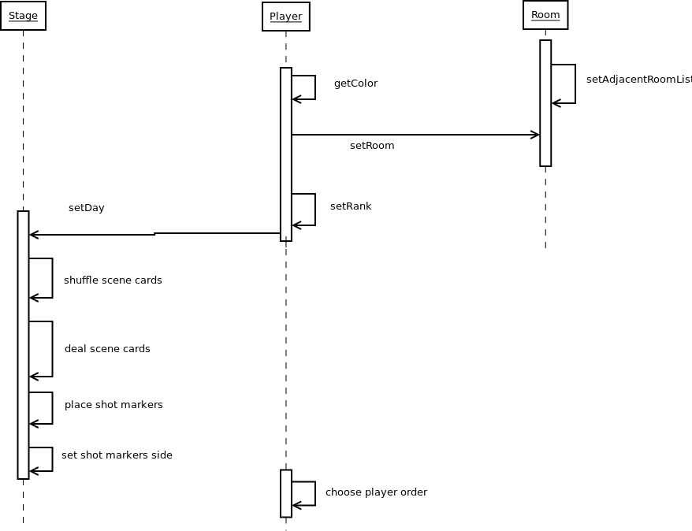

**Move**

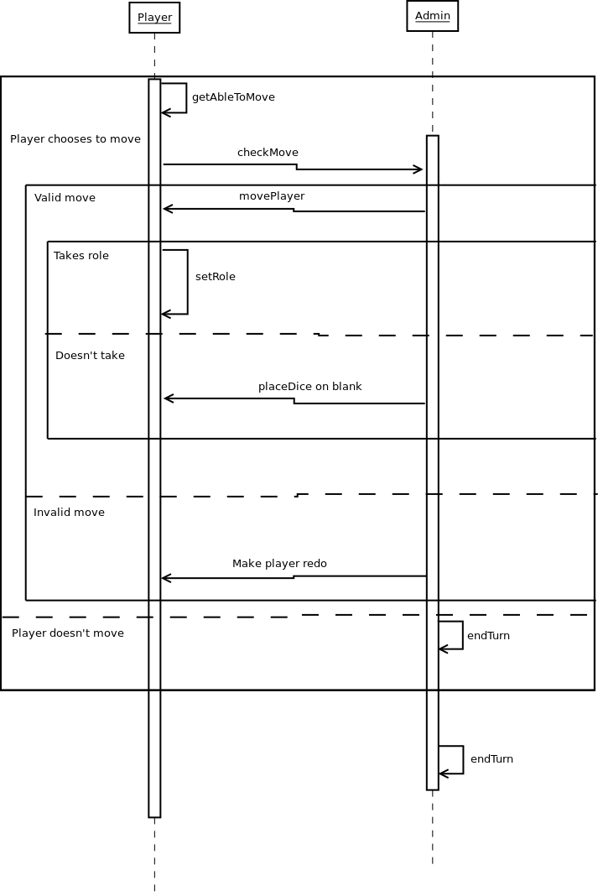

**Take Role**

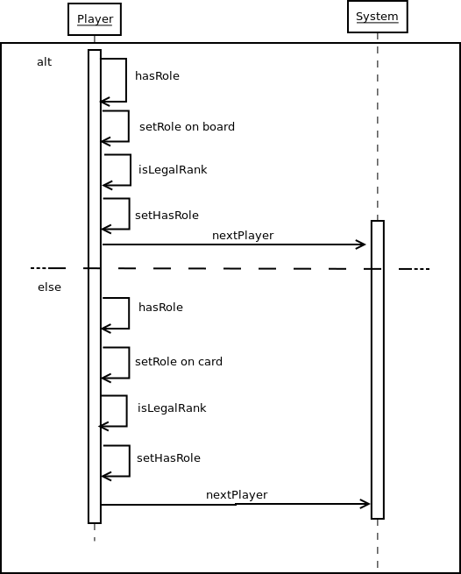

**Work**

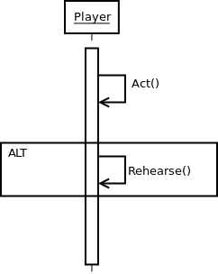

**Rehearse**

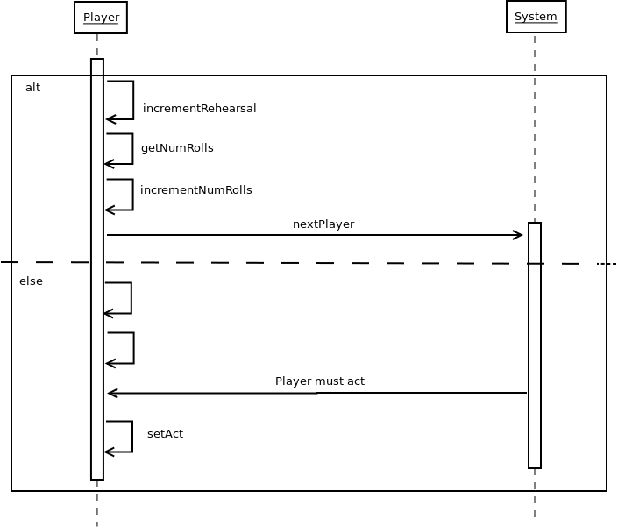

**Act**

**Upgrade**

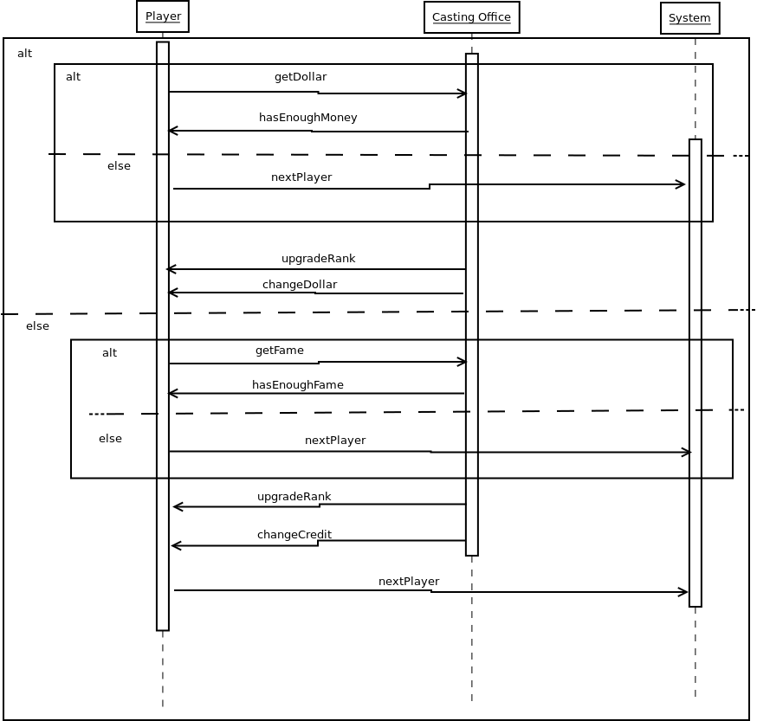

**End of Day**

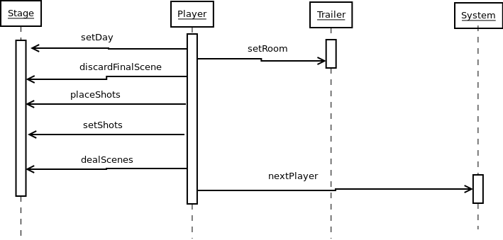

**Wrap Up**

**Scoring**

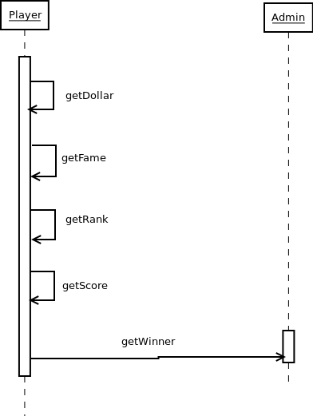

**UML Class Diagram**

