**CUSTOMER LIFETIME VALUE**

**1. Purchase Likelihood Distribution by Condition1: Fee vs. No Fee (Violin Plot)**

* **Observation:**
  + **Fee Group:**
    - The distribution is wider, indicating more variability in purchase likelihood scores.
    - Median purchase likelihood is moderately high, but there is a noticeable presence of lower values in the distribution.
  + **No Fee Group:**
    - The distribution is more concentrated, with a narrower range of scores.
    - The median is slightly higher than the Fee group, showing customers are more likely to purchase when no fee is involved.
* **Key Insights:**
  + Removing fees appears to increase purchase likelihood and reduces variability in customer behavior.
  + The presence of fees likely introduces hesitation or a barrier to purchase.

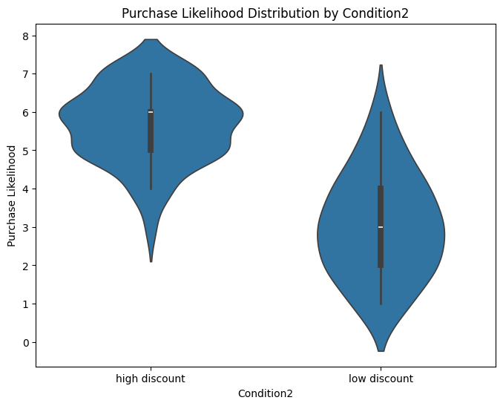

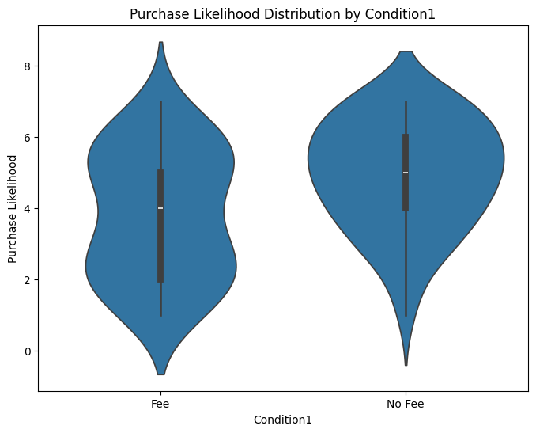

**Purchase Likelihood Distribution by Condition2: High Discount vs. Low Discount**

* **Observation:**
  + **High Discount:**
    - The distribution peaks at a higher likelihood score, reinforcing its positive effect on purchasing decisions.
    - The curve is symmetrical, with most scores concentrated around the higher end.
  + **Low Discount:**
    - The distribution is wider and flatter, with purchase likelihood spread out over a broader range.
    - The curve’s peak is lower, indicating fewer customers show a high likelihood of purchase under low discounts.
* **Key Insights:**
  + High discounts create a more focused and positive purchasing behavior.
  + The low-discount group shows dispersed behavior, with a considerable portion of customers demonstrating a lower inclination to buy.

### **Actionable Recommendations**

1. **Fee Reduction:**
   * Eliminating fees can significantly increase purchase likelihood and create more consistent customer behavior. Explore alternative revenue streams to compensate for the fee removal.
2. **Strategic Discounts:**
   * Focus on high-discount campaigns to maximize purchase likelihood and reduce variability in customer behavior.
   * Use low discounts only for less price-sensitive segments or to test new customer acquisition strategies.
3. **Behavioral Segmentation:**
   * Leverage the insights from these analyses to segment customers by price sensitivity and offer tailored incentives accordingly.

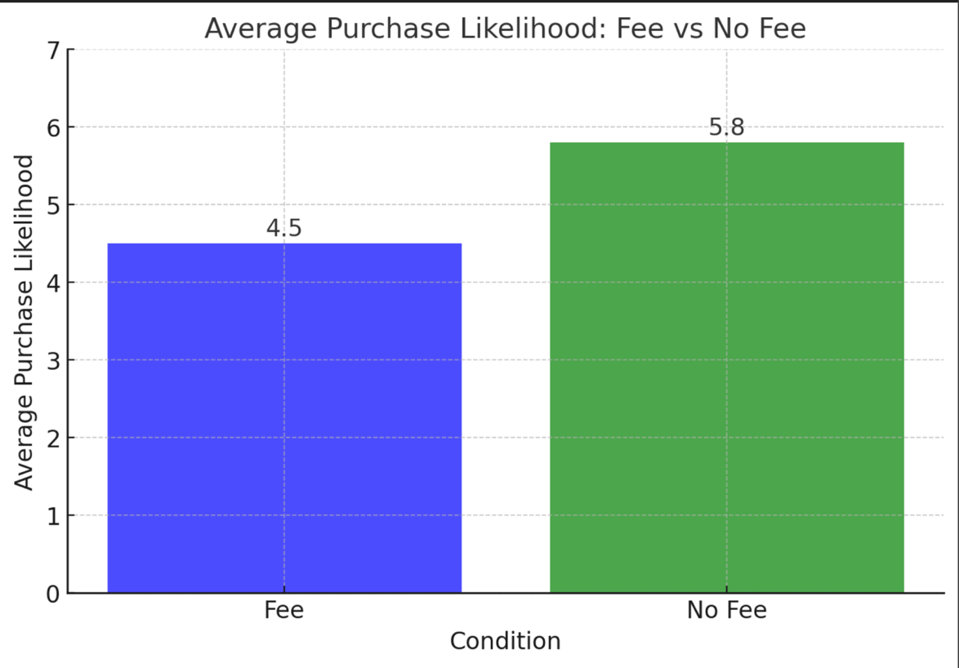

### **Insights from the Graphs**

#### **1. Fee vs. No Fee (Average Purchase Likelihood Bar Chart)**

* **Insight 1: No Fee Drives Higher Purchase Likelihood**
  + The "No Fee" condition achieves a significantly higher average purchase likelihood (5.8) compared to the "Fee" condition (4.5).
  + Fees appear to create a psychological or monetary barrier that discourages purchases. Removing fees can encourage a more positive customer response and improve conversions.
* **Insight 2: Consistency in Behavior Without Fees**
  + The "No Fee" condition likely reflects a more consistent and predictable customer response. This suggests fewer fluctuations in purchasing behavior when fees are not applied.