**YOUTUBE CODE WITH SENTIMENT ANALYSIS**

**Insights from Sentiment Distribution Chart**

**1. Positive Sentiment Dominates**

* The highest count belongs to the **Positive Sentiment** category, indicating that the majority of responses, feedback, or interactions analyzed are favorable. This reflects a strong overall satisfaction or approval from the audience.

**2. Significant Neutral Sentiment**

* The **Neutral Sentiment** category has the second-highest count, suggesting that a considerable portion of the feedback is indifferent or lacks strong emotions. This could indicate a need to better engage this segment to convert neutral perceptions into positive ones.

**3. Low Negative Sentiment**

* The **Negative Sentiment** count is the lowest, highlighting that relatively few individuals have expressed dissatisfaction. While this is a positive sign, addressing these concerns is crucial to further reduce negativity and prevent it from growing.

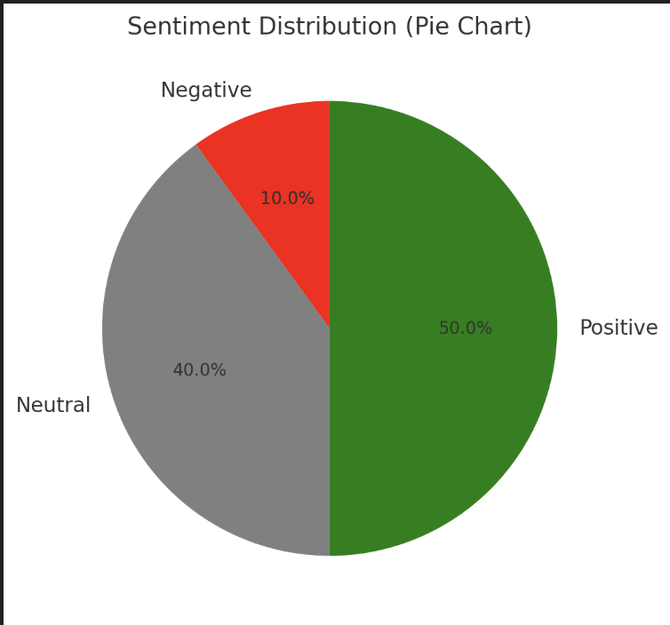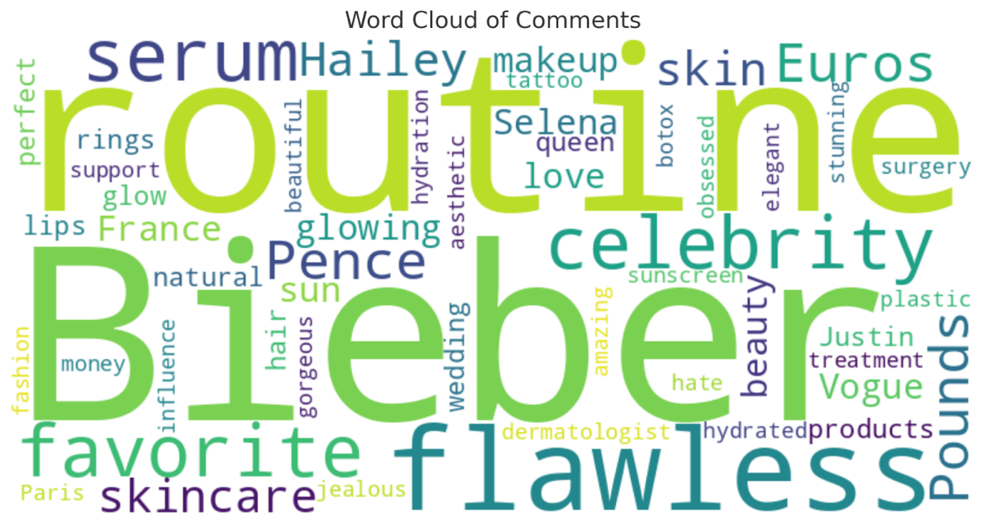

**Recommendations:**

1. **Amplify Positive Sentiment:**
   * Highlight positive feedback through testimonials, case studies, or campaigns that emphasize customer satisfaction.
   * Engage positively inclined stakeholders to act as brand ambassadors.
2. **Address Neutral Sentiment:**
   * Analyze the neutral segment to identify recurring themes or unmet expectations.
   * Use personalized engagement strategies (e.g., surveys, offers, or tailored communication) to turn neutral responses into positive ones.
3. **Reduce Negative Sentiment:**
   * Focus on identifying the root causes of negative feedback and implement corrective measures.
   * Communicate actions taken to address concerns to show responsiveness and build trust.