Power BI Assignment 1 – Retail Sales Analytics (Easy)
Oct 13, 2026 · @Dr. Subhabaha Pal

Overview
You will build a five-page Power BI report (20 visuals) for a national retail chain from a ready-made star-schema dataset of about 24,000 sales transactions.
Item | Details
Institution | IILM Jaipur
Programme | MBA
Assignment | Power BI Assignment 1 of 2
Difficulty | Easy
Tool | Power BI Desktop (latest version)
Dataset file | ShopSphere_Retail_StarSchema.xlsx
Work mode | Individual
Marks | 50
Submission date | To be announced by the faculty

Learning objectives
By the end of this assignment you should be able to:
- Import a multi-sheet Excel workbook into Power BI and check data types.
- Build a star-schema data model with one-to-many relationships.
- Write basic DAX measures (SUM, DIVIDE, DISTINCTCOUNT, CALCULATE, TOTALYTD).
- Choose the right visual for a business question and format it clearly.
- Combine visuals, slicers and KPI cards into dashboards that tell a story.
- Write short, data-backed business insights.

Business scenario
ShopSphere Retail is a fictitious Indian chain with 24 stores across four regions. It sells Electronics, Fashion, Home & Kitchen, Grocery and Beauty & Personal Care. Management has two years of sales data (January 2024 to December 2025) and wants a self-service dashboard to answer four questions:
- Is the business growing, and how strong is seasonality?
- Which categories, products and brands drive revenue and profit?
- Which stores and regions over- or under-perform?
- Who are our customers, and do promotions actually pay off?
You are the business analyst asked to build this report.

Dataset and star schema
The workbook ShopSphere_Retail_StarSchema.xlsx has one fact table (25,569 rows) and five dimension tables, plus a ReadMe sheet. Every sheet is already formatted as an Excel table with the same name. All values are in Indian Rupees (INR), and the data is synthetic.
Sheet | Type | Rows | Key column | Main columns
FactSales | Fact | 25,569 | SalesID | DateKey, ProductKey, StoreKey, CustomerKey, PromotionKey, PaymentMode, Quantity, UnitPrice, DiscountPct, SalesAmount, CostAmount, Profit
DimDate | Dimension | 731 | DateKey | Date, Year, Quarter, MonthNo, MonthName, MonthYear, MonthYearSort, DayName, DayType, FinancialYear
DimProduct | Dimension | 60 | ProductKey | ProductName, Category, SubCategory, Brand, UnitPrice, UnitCost
DimStore | Dimension | 24 | StoreKey | StoreName, StoreType, City, State, Region, OpeningDate, StoreSizeSqFt
DimCustomer | Dimension | 3,500 | CustomerKey | CustomerName, Gender, AgeGroup, Segment, City, Region, LoyaltyMember
DimPromotion | Dimension | 11 | PromotionKey | PromotionName, PromotionType, DiscountPct, StartDate, EndDate
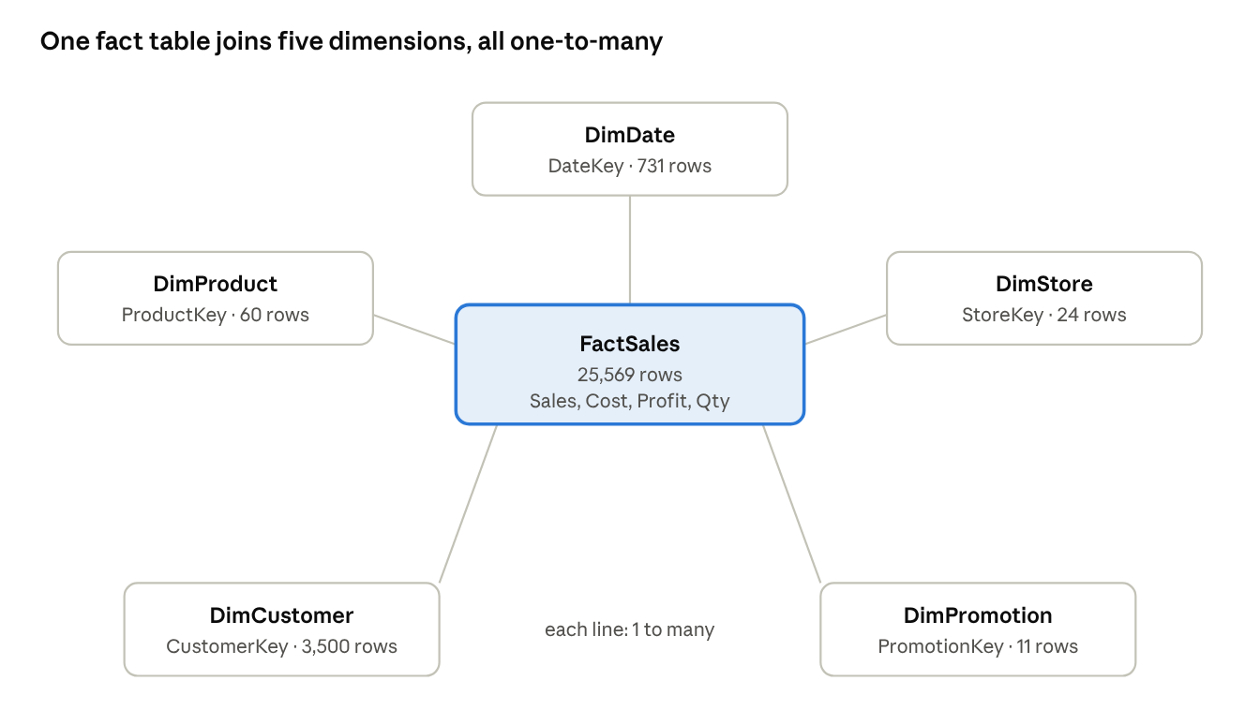
ShopSphere star schema · 1 fact, 5 dimensions
Every dimension filters FactSales through its Key column; your Power BI model view should look like this.
Column notes:
- SalesAmount is net of discount (Quantity × UnitPrice × (1 − DiscountPct)).
- Profit = SalesAmount − CostAmount. Some promotional lines have negative profit, which is intentional.
- DateKey is a whole number in yyyymmdd format (for example 20250315).
- FinancialYear follows the Indian April–March year (for example FY24-25).
- Two stores (Surat and Patna) opened on 1 July 2024, so they have no sales before that date.

Part A – Data preparation and modelling (10 marks)
Complete these steps before you build any visual.
- Load data. Home → Get Data → Excel Workbook → select all six tables (not the ReadMe sheet) → Transform Data.
- Check data types in Power Query. Date, OpeningDate, StartDate and EndDate = Date. DiscountPct = Percentage. SalesAmount, CostAmount, Profit, UnitPrice, UnitCost = Fixed decimal (currency). All Key columns = Whole number.
- Build relationships in Model view. Each dimension relates one-to-many (1:*) to FactSales, single cross-filter direction:
  - DimDate[DateKey] → FactSales[DateKey]
  - DimProduct[ProductKey] → FactSales[ProductKey]
  - DimStore[StoreKey] → FactSales[StoreKey]
  - DimCustomer[CustomerKey] → FactSales[CustomerKey]
  - DimPromotion[PromotionKey] → FactSales[PromotionKey]
- Mark DimDate as the date table (Table tools → Mark as date table → Date).
- Sort columns: MonthName by MonthNo, and MonthYear by MonthYearSort.
- Create a hierarchy in DimDate: Year → Quarter → MonthName → Date. Create a second hierarchy in DimProduct: Category → SubCategory → ProductName.
- Hide key columns in report view (all Key columns in FactSales) so report users see only meaningful fields.
- Take a screenshot of the finished model for your submission.

Part B – DAX measures (10 marks)
Create a table called _Measures (Enter data → blank table) and store every measure there. Format currency measures with the ₹ symbol and no decimals.
# | Measure | Suggested DAX
1 | Total Sales | SUM ( FactSales[SalesAmount] )
2 | Total Cost | SUM ( FactSales[CostAmount] )
3 | Total Profit | SUM ( FactSales[Profit] )
4 | Profit Margin % | DIVIDE ( [Total Profit], [Total Sales] )
5 | Total Quantity | SUM ( FactSales[Quantity] )
6 | No. of Transactions | COUNTROWS ( FactSales )
7 | Unique Customers | DISTINCTCOUNT ( FactSales[CustomerKey] )
8 | Avg Transaction Value | DIVIDE ( [Total Sales], [No. of Transactions] )
9 | Sales YTD | TOTALYTD ( [Total Sales], DimDate[Date] )
10 | Sales LY | CALCULATE ( [Total Sales], SAMEPERIODLASTYEAR ( DimDate[Date] ) )
11 | YoY Growth % | DIVIDE ( [Total Sales] - [Sales LY], [Sales LY] )
12 | Promo Sales | CALCULATE ( [Total Sales], DimPromotion[PromotionType] <> "None" )
13 | Promo Sales % | DIVIDE ( [Promo Sales], [Total Sales] )
14 | Sales per Sq Ft | DIVIDE ( [Total Sales], SUM ( DimStore[StoreSizeSqFt] ) )
Also add one calculated column, DimProduct[Price Band] = "Budget" (below ₹1,000), "Mid" (₹1,000–10,000) or "Premium" (above ₹10,000), using IF or SWITCH.

Part C – Visualizations and dashboards (20 marks)
Build five report pages (dashboards). Each page has exactly four visuals plus the slicers listed, so the report has 20 visuals in total. Give every visual a clear title that states the question it answers, and use one consistent colour theme.

Dashboard 1 – Executive Overview
Slicers: Year, Region.
# | Visual type | Fields | Business question
V1 | Multi-row card (KPI strip) | Total Sales, Total Profit, Profit Margin %, No. of Transactions, Unique Customers | What are our headline numbers?
V2 | Line chart | X: DimDate[MonthYear]; Y: Total Sales | How do sales move month by month over two years?
V3 | Clustered column chart | X: MonthName; Y: Total Sales; Legend: Year | Is 2025 ahead of 2024 in every month?
V4 | Donut chart | Legend: Region; Values: Total Sales | Which region contributes the most revenue?

Dashboard 2 – Product and Category Performance
Slicers: Year, Category.
# | Visual type | Fields | Business question
V5 | Clustered bar chart | Y: Category; X: Total Sales and Total Profit | Which categories earn revenue vs. profit?
V6 | Treemap | Category → SubCategory; Values: Total Sales | How is revenue split inside each category?
V7 | Bar chart with Top N filter | Y: ProductName; X: Total Sales; Filter: Top 10 by Total Sales | Which 10 products sell the most?
V8 | Scatter chart | Details: ProductName; X: Total Sales; Y: Profit Margin %; Size: Total Quantity; Legend: Category | Which products are high-volume but low-margin?

Dashboard 3 – Store and Regional Performance
Slicers: Year, StoreType.
# | Visual type | Fields | Business question
V9 | Map (bubble) | Location: DimStore[City]; Bubble size: Total Sales | Where are our strongest cities?
V10 | Bar chart, sorted descending, with data bars or colour by value | Y: StoreName; X: Total Sales | Which stores are the top and bottom performers?
V11 | Matrix with conditional formatting | Rows: Region → State → StoreName; Values: Total Sales, Total Profit, Profit Margin %, YoY Growth % | How does each store compare on growth and margin?
V12 | Clustered column chart | X: StoreType; Y: Sales per Sq Ft | Which store format uses its space best?

Dashboard 4 – Customer Insights
Slicers: Year, Region, LoyaltyMember.
# | Visual type | Fields | Business question
V13 | Clustered column chart | X: AgeGroup; Y: Total Sales; Legend: Gender | Which age group and gender buy the most?
V14 | Pie chart | Legend: Segment; Values: Total Sales | How much revenue comes from Premium, Regular and New customers?
V15 | Bar chart | Y: Segment; X: Avg Transaction Value | Do Premium customers spend more per bill?
V16 | 100% stacked column chart | X: Year; Y: Total Sales; Legend: PaymentMode | Is the payment mix shifting (UPI vs. cash)?

Dashboard 5 – Promotions and Time Analysis
Slicers: Year, Category.
# | Visual type | Fields | Business question
V17 | Line and clustered column chart (combo) | X: PromotionName; Columns: Total Sales; Line: Profit Margin % | Which promotions bring sales but hurt margin?
V18 | Line chart | X: MonthName; Y: Sales YTD; Legend: Year | How does cumulative sales in 2025 track against 2024?
V19 | Column chart | X: DayName (sorted by DayOfWeekNo); Y: Total Sales | Which days of the week are busiest?
V20 | KPI visual | Value: Total Sales; Trend axis: MonthYear; Target: Sales LY | Are we beating last year's sales?

Formatting checklist
- Add a page title and the company name on each page.
- Use the same slicer position (top or left) on every page.
- Show data labels where values are compared, and remove clutter (gridlines, extra decimals).
- Use conditional formatting in V10 and V11 (red for low, green for high).
- Add page navigation buttons from Dashboard 1 to the other four pages.

Part D – Business insights (10 marks)
Answer each question in two to four sentences in a short Word or PDF report. Quote the numbers from your dashboard and name the visual (V1–V20) that supports each answer.
- By what percentage did total sales grow from 2024 to 2025? Which month is the peak month and why might that be?
- Which category contributes the most revenue, and which earns the highest profit margin? What does this mean for shelf-space decisions?
- Which category grew the fastest between 2024 and 2025, and which category declined?
- About how many of the 60 products make up 80% of sales? (Hint: sort V7 or build a Pareto view.)
- Name the three weakest stores. Is the problem the store format, the region, or the individual store?
- Which age group spends the most? How much of revenue comes from Premium customers, compared with their share of the customer base?
- How has the share of UPI and cash payments changed between 2024 and 2025?
- Which promotion produced the lowest profit margin? Would you recommend running it again? Justify your answer.
- Do weekends contribute more than their share of days (2 of 7)?
- Write three recommendations for ShopSphere's management, each backed by one visual.

Submission guidelines
Submit one zip file named RollNo_Name_PBI_A1.zip on the LMS containing:
- The Power BI file (.pbix) with all five dashboards.
- A PDF export of the report (File → Export → Export to PDF).
- The insights report (Word or PDF, at most 4 pages) with the data model screenshot from Part A.
This is an individual assignment. Identical .pbix files or copied insights will receive zero marks.

Evaluation rubric (50 marks)
Component | Marks | What earns full marks
Part A – Data preparation and model | 10 | Correct data types, five 1:* relationships, date table marked, sorting and hierarchies done
Part B – DAX measures | 10 | All 14 measures and the calculated column return correct values and are formatted
Part C – 20 visuals in 5 dashboards | 20 | Right visual for each question, clear titles, working slicers, consistent theme (1 mark per visual)
Part D – Business insights | 10 | Accurate numbers, clear reasoning, practical recommendations
Total | 50

