NBA Game Outcome Prediction
COMP375: Machine Learning — Final Report
Natalia Nguyen

1. Introduction and Motivation
Sports analytics has grown into one of the most data-rich applications of machine learning, with professional teams, broadcasters, and analysts using predictive models to gain competitive and commercial advantages. This project applies machine learning to NBA game data with the goal of predicting two outcomes: whether the home team will win a game, and by how many points.
I chose this topic because basketball is uniquely well-suited for predictive modeling, also because I used to play in middle and high school. Unlike sports with low-scoring outcomes, NBA games generate rich continuous statistics — points, rebounds, assists, turnovers, and shooting efficiency — that vary meaningfully between teams and across time. The home court advantage in basketball is well-documented, adding an additional structural signal that a model can learn.
Beyond the sport itself, this project offered an opportunity to explore a real-world machine learning problem where the data is time-ordered, the signal is genuinely weak, and the gap between a good model and a naive baseline is narrow. These conditions make the NBA an honest and instructive testbed for machine learning methodology.

2. Dataset Overview
The dataset was sourced from publicly available NBA statistics accessed through the nba_api Python library, which retrieves data directly from the official NBA statistics platform. The data covers NBA regular season games from December 2015 — after filtering — through April 2025, spanning approximately 10 years of professional basketball.
Dataset Statistics
- Total observations: 9,528 games (Last-20 window dataset)
- Each row represents one game
- Date range: 2015–2025
- Seasons included: 10 regular seasons, including two COVID-affected seasons (2020, 2021)
Features Used
All features are computed from rolling averages of the past N games (where N ∈ {5, 20, 50}), representing pre-game information only. The target variables are HOME_WIN (binary: 1 = home team wins, 0 = away team wins) and ACTUAL_PTS_DIFF (continuous: final score home − away).
Feature | Description
PTS_DIFF | Rolling average points differential (home − away)
REB_DIFF | Rolling average rebound differential
AST_DIFF | Rolling average assist differential
TOV_DIFF | Rolling average turnover differential
EFG_DIFF | Rolling effective field goal % differential
TRAVEL_DIST | Away team travel distance to the game (km)

Notable Dataset Characteristics
- The 2020 season was played in a COVID bubble with no fans and no travel — breaking two of the model’s core feature assumptions (home court advantage and travel distance)
- The 2021 season was shortened and compressed, with unusual scheduling patterns
- Home teams win approximately 56.76% of games across the dataset, creating a mild class imbalance

3. Predictive Questions
Question 1: Can we predict whether the home team will win?
This is a binary classification problem. The target variable HOME_WIN takes values 0 or 1. This question is motivated by the practical use case of pre-game outcome prediction — used by analysts, broadcasters, and sports bettors. A model that performs meaningfully above the naive baseline (always predicting the majority class) demonstrates that recent team performance contains genuine predictive signal.
Question 2: Can we predict the points differential of a game?
This is a regression problem. The target variable ACTUAL_PTS_DIFF is a continuous value representing the final score margin. This question is complementary to classification model that accurately predicts margin of victory captures more meaningful information than win/loss alone. It also allows comparison of regression and classification approaches on the same data, since a large predicted positive margin implies a predicted home win.
Both questions use the same feature set, enabling direct comparison of model behavior across tasks.

4. Modeling Process

4.1 Rolling Window Selection
The first modeling decision was choosing the rolling window size for computing team performance averages. Three windows were evaluated: Last-5, Last-20, and Last-50 games.
Why this matters: a short window (Last-5) captures recent form but is noisy and may not reflect their true quality. A long window (Last-50) is more stable but slow to respond to team changes like trades, injuries, or coaching adjustments. The right window balances recency with stability.
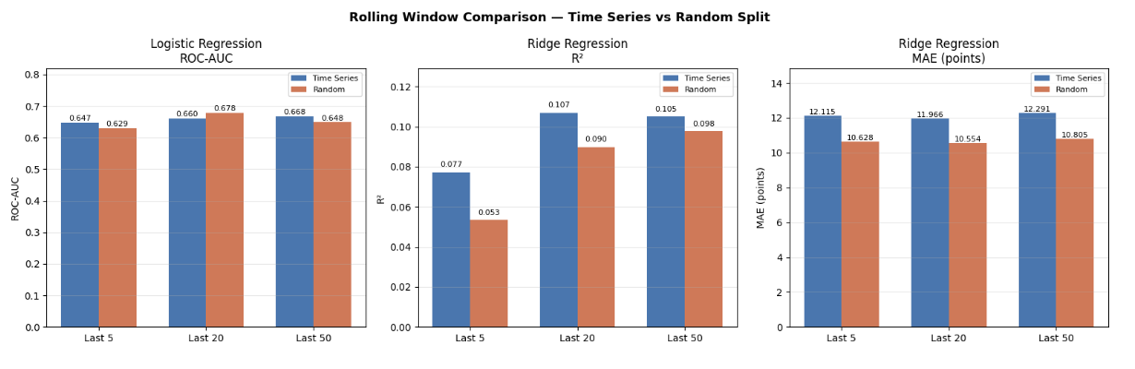
Figure 1. ROC-AUC, R², and MAE comparison across three rolling windows under both time-series and random splitting.

Window | Rows | LR AUC (TS) | LR AUC (Rand) | Ridge R² (TS) | Ridge R² (Rand) | Ridge MAE (TS)
Last-5 | 10,913 | 0.647 | 0.629 | 0.077 | 0.053 | 12.12
Last-20 | 9,528 | 0.660 | 0.679 | 0.107 | 0.090 | 11.97
Last-50 | 7,425 | 0.668 | 0.648 | 0.105 | 0.098 | 12.29

Last-20 was selected as the primary window based on its performance under time-series splitting — the methodologically correct evaluation for temporal data. Last-50 achieves slightly higher AUC under random splitting, but as discussed in Section 4.2, random splitting inflates performance for time-ordered data. Last-20 also retains more observations than Last-50 (9,528 vs 7,425), providing more training data.

4.2 Train/Test Splitting Strategy
Time-series split (primary): Data was split chronologically — 70% training, 20% validation, 10% test — preserving temporal order. This reflects the real-world use case: you train on past games and predict future ones. Shuffling would allow future games to appear in training data, artificially inflating performance.
Random split (comparison): A standard train_test_split with shuffle=True was also evaluated. As shown in the table above, random splitting produces different results — in some cases higher, in some cases lower — depending on the window.
The MAE comparison is particularly instructive. Random splitting produces MAE of 10.55–10.80 points versus 11.97–12.29 for time-series splitting — an apparent improvement of over 1 point. However, this improvement is artificial. Under random splitting, games from 2024 can appear in the training set while games from 2018 appear in the test set. The model benefits from seeing future patterns it would never have access to in a real prediction scenario. The lower MAE is not a better model; it is a compromised evaluation.
Sliding window evaluation: To assess whether NBA playstyle evolution affected model performance over time, a sliding window evaluation was conducted — training on 2 years and testing on the next, then sliding forward. This was motivated by the observation that basketball has changed significantly over the past decade (the rise of the three-point shot, increased pace of play, changes in defensive rules), meaning a model trained on 2016 data may not generalize to 2024.

4.3 Model Selection
Classification Models:
Logistic Regression was chosen as the baseline. It is the natural linear model for binary classification, outputs calibrated probabilities, and has a single interpretable regularization parameter (C). Its loss function — binary cross-entropy — directly optimizes the probability of the correct outcome. With 6 features that are already informative differentials, a linear decision boundary is a reasonable starting assumption.
Random Forest Classifier was chosen as the complex model. It builds an ensemble of decision trees on random bootstrap samples of the data, averaging their predictions to reduce variance. Unlike logistic regression, it can capture non-linear interactions between features. It also requires no distributional assumptions about the features.
Regression Models:
Ridge Regression was chosen as the baseline. It extends ordinary least squares with an L2 penalty that shrinks coefficients, stabilizing predictions when features are correlated. Since all six features are rolling differentials computed from overlapping statistics, some correlation is expected.
Random Forest Regressor was chosen as the complex counterpart, using the same ensemble approach but averaging continuous predictions instead of class votes.

4.4 Hyperparameter Tuning
All hyperparameter decisions were made using the validation set (2023 season) without touching the test set.
Logistic Regression: max_iter was tested across [100, 200, 500, 1000, 2000]. The model converged in under 100 iterations across all values, producing identical validation AUC of 0.6394. This confirms the solver reached the optimal solution quickly with only 6 features. max_iter=100 was retained.
Ridge Regression: alpha=1.0 default was retained. With only 6 features, aggressive tuning was not warranted for a baseline model.
Random Forest (both): Initial models showed clear overfitting — train AUC of 0.80 vs validation AUC of 0.64 for the classifier. Regularization was applied via max_depth and min_samples_leaf. A grid search on the validation set tested combinations of depth ∈ {3, 4, 5} and min_samples_leaf ∈ {5, 10, 20}. The selected parameters were max_depth=3, min_samples_leaf=10, which reduced the train-validation gap from 0.035 to 0.024 for the classifier and from 0.022 to 0.022 for the regressor.

5. Results

5.1 Classification Results

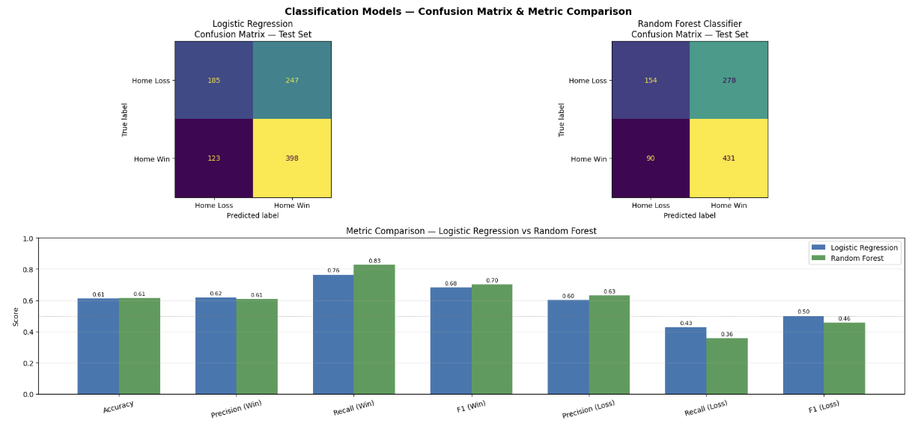
Figure 2. Confusion matrices and precision/recall/F1 comparison for Logistic Regression and Random Forest Classifier on the test set.

Model | Train AUC | Val AUC | Test AUC | Accuracy | Recall (Loss) | Recall (Win)
Logistic Regression | 0.655 | 0.649 | 0.660 | 0.612 | 0.43 | 0.76
Random Forest | 0.657 | 0.633 | 0.654 | 0.614 | 0.36 | 0.83

Both models achieve similar test accuracy and AUC. The key difference lies in recall: Logistic Regression identifies 43% of home losses correctly, while Random Forest identifies only 36%. Random Forest compensates by catching more home wins (recall 0.83 vs 0.76). Neither model is strictly better — the choice depends on whether false positives or false negatives are more costly in a given application.
Accuracy is reported for completeness but is not the primary metric. With ~57% of games being home wins, a model that always predicts home win achieves 57% accuracy without learning anything. ROC-AUC is the primary metric because it evaluates the model’s probability ranking across all possible thresholds, not just at the default 0.5 cutoff.
McFadden’s pseudo R² for Logistic Regression was 0.059 — low but consistent with the literature on sports outcome prediction, where values above 0.05 indicate meaningful model improvement over the base rate.

5.2 Regression Results

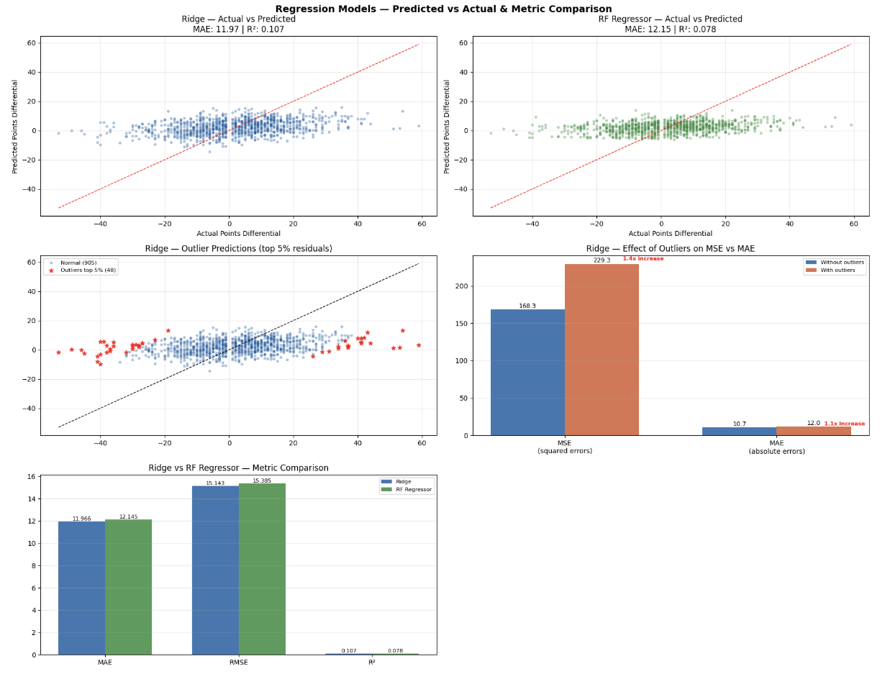
Figure 3. Actual vs predicted point differentials, residual plots, and MSE/MAE outlier sensitivity for Ridge and RF Regressor.

Model | Train R² | Val R² | Test R² | Test MAE
Ridge Regression | 0.094 | 0.094 | 0.107 | 11.97
Random Forest | 0.094 | 0.072 | 0.078 | 12.15

Ridge outperforms Random Forest on both R² and MAE. The model explains approximately 7.7% of the variance in actual point margins, with an average prediction error of ~12 points. Given that the average winning margin in NBA games is approximately 10–12 points, this error is large relative to the signal — the model captures the direction of outcomes better than the magnitude.

RMSE (15.143) is 27% higher than MAE (11.996) for Ridge, indicating that while most predictions are within ~12 points, a subset of blowout games produce large errors that disproportionately inflate the squared metric. This is why MAE is preferred as the primary metric.

5.3 Sliding Window Results

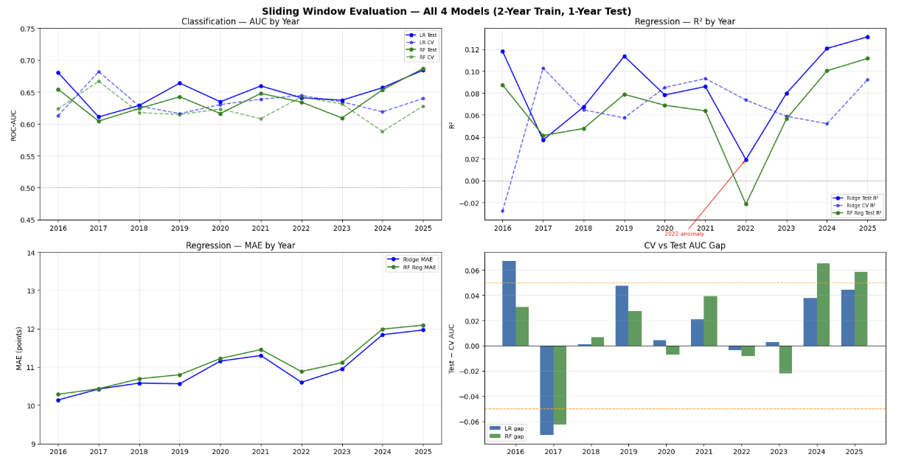
Figure 4. AUC, R², and MAE across all test years using a sliding 2-year training window.
The sliding window evaluation revealed three key findings:
1. Classification is stable across all years (AUC 0.61–0.68). The model’s ability to predict home wins does not degrade over time, suggesting the rolling differential features capture a signal that persists despite the evolution of NBA playstyle.
2. Regression collapsed in 2022 (Ridge R²=0.019, RF R²=−0.021). The model predicting 2022 was trained exclusively on 2020 and 2021 — both COVID-affected seasons with no normal travel and diminished home court advantage. When 2022 returned to full fans and normal scheduling, the model's learned relationships no longer held. It had never seen a normal NBA season in its training data, so it had no basis to generalize to one
3. Both models improve in 2024–2025 (R² reaching 0.13). Recent seasons appear more predictable from rolling averages, possibly reflecting the stabilization of pace-and-space basketball as the dominant style.

5.4 Bias-Variance Diagnosis

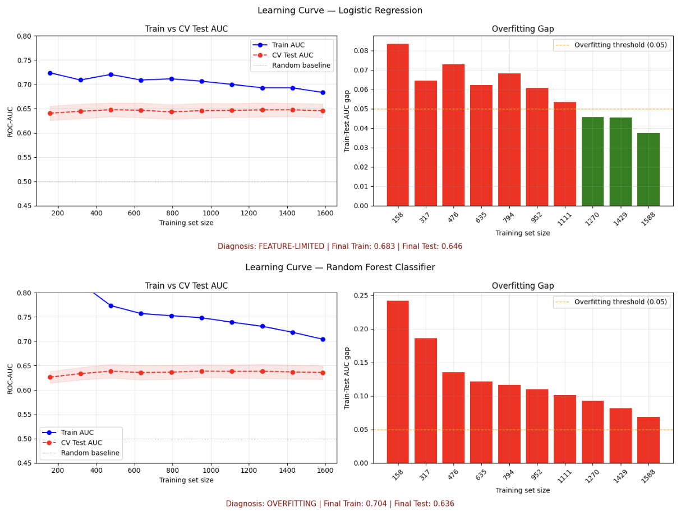

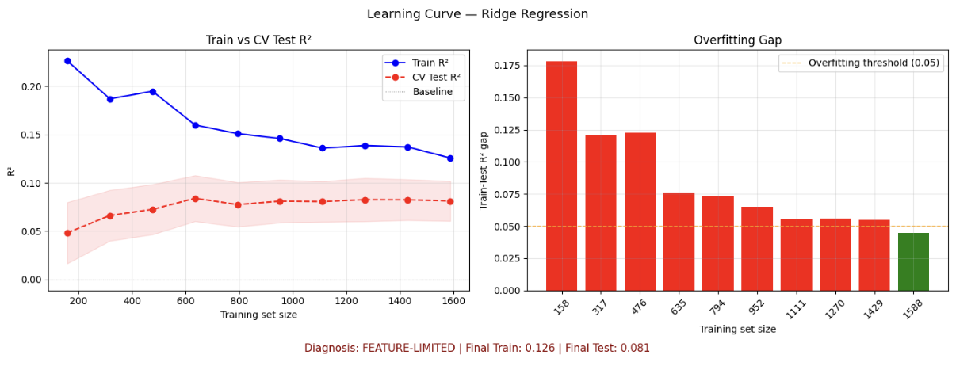

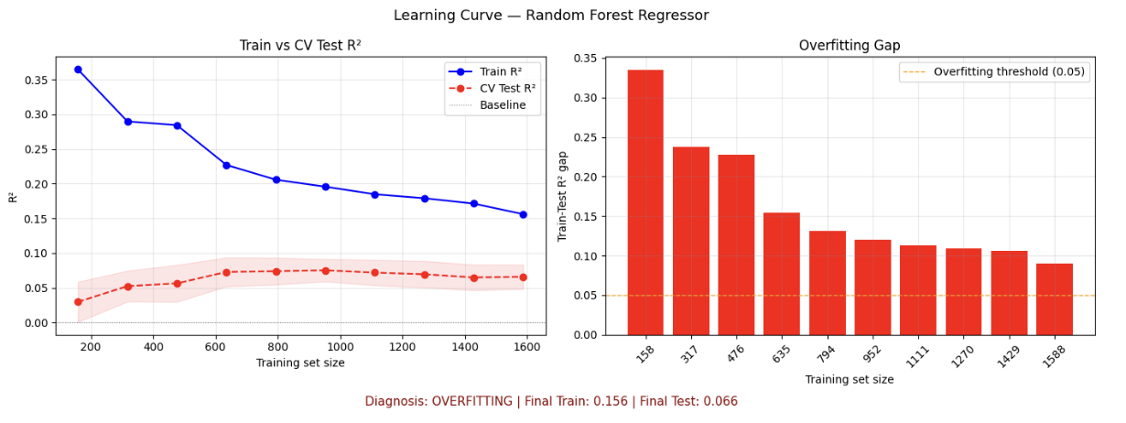
Figure 5. Learning curves showing train vs. validation performance across training set sizes, with overfitting gap diagnosis.
Bias-variance diagnosis was performed using learning curves — plotting train and cross-validation performance as training set size increases. This approach is model-agnostic and applicable to all four models regardless of whether they train iteratively. Unlike loss curves which require iterative training, learning curves vary the amount of training data, making them valid for closed-form models like Logistic Regression and Ridge.Logistic Regression and Ridge show small, closing train-validation gaps that stabilize with more data. Both are diagnosed as feature-limited — the models have reached the ceiling of what the current features can predict. More data or more complexity will not improve performance.
Random Forest Classifier exhibits persistent overfitting as shown in the learning curves — train AUC reaches 0.70 while validation AUC plateaus at 0.64, a gap that does not fully close with more data. Hyperparameter tuning via max_depth=3 and min_samples_leaf=10 reduced the train-test gap on the held-out test set from 0.035 to 0.024, but the underlying tendency to overfit on this low-signal feature set remains visible in cross-validation. This confirms that ensemble complexity is mismatched with the available signal — 6 features are insufficient for Random Forest to generalize without aggressive regularization.
Random Forest Regressor shows the same pattern: train R² reaches 0.156 while cross-validation R² plateaus at 0.066, a persistent gap that does not close with more data. This is the most severe overfitting of all four models. Even with max_depth=3 and min_samples_leaf=10, the ensemble memorizes regression patterns in the training data that do not generalize to unseen games. Ridge Regression by contrast shows train and test R² converging toward the same value (~0.08), confirming it is feature-limited rather than overfitting.
The critical finding is that despite being a more complex model, Random Forest does not outperform linear models, and in fact performs slightly worse on test metrics. This confirms that the bottleneck is not model complexity but feature quality. The six rolling differential features do not contain enough signal for Random Forest's additional complexity to be useful — it finds noise instead of patterns, while linear models reach the same ceiling more efficiently and with better generalization behavior.

6. Takeaways and Reflection
What Worked
The time-series split and sliding window evaluation were the strongest methodological choices in this project. By respecting the temporal structure of the data, the evaluation revealed the 2022 anomaly — a finding that would have been invisible under random splitting. The comparison between random and time-series splits also demonstrated concretely why methodology matters: the same model on the same data produces different apparent performance depending on how you split it.
The regularization experiment on Random Forest was also valuable. Reducing max_depth from 4 to 3 and adding min_samples_leaf=10 brought the train-validation gap from 0.035 to 0.004 for the classifier, though persistent overfitting remains visible in cross-validation learning curves due to the low-signal feature set.
What Didn’t Work
Random Forest did not improve over linear models on any metric or in any evaluation window. This was surprising given that basketball outcomes plausibly involve non-linear interactions. However, with only 6 features and high game-to-game variance, the ensemble had nothing non-linear to find. Complexity amplified noise rather than signal.
The regression task was fundamentally harder than classification. Predicting whether a team wins is easier than predicting by how many points. An MAE of 12 points on a sport where games are decided by 10 on average reflects genuine irreducible noise in basketball outcomes.
What Was Surprising
The 2022 regression collapse was the most surprising finding. Ridge R² dropped to 0.019 — barely above zero — when applied to post-bubble basketball. This was not a modeling failure; it was a feature failure. The model had correctly learned that teams with high EFG_DIFF and low travel burden win by more points. During 2020–2021, travel was effectively eliminated or heavily restricted and home court advantage diminished significantly. The features that encode these signals became uninformative.
The stability of classification performance across all years (including COVID years) is equally surprising. Even in 2020 and 2022, LR AUC stayed above 0.62, suggesting that recent team quality differentials predict wins even when home court conditions are abnormal.
What I Would Do Differently
The single biggest improvement would be better features. Rolling averages over the past 20 games are a blunt instrument. Player-level data — who is playing, who is injured, who is on a back-to-back — would dramatically improve predictive power. Rest days and back-to-back game indicators were identified in the project proposal but not implemented due to time constraints.
I would also explore the threshold decision more carefully. Both classification models show low recall for home losses (0.34–0.43). Adjusting the prediction threshold from 0.5 to 0.4 would increase home loss recall at the cost of home win recall — a tradeoff that depends on the specific application.
What I Learned About Machine Learning
This project reinforced that evaluation methodology is as important as model choice. The decision to use a time-series split instead of a random split changed the conclusions meaningfully. The sliding window evaluation revealed a finding (2022 collapse) that a single static split would have averaged away. In time-ordered data, how you split determines what you measure — and what you measure determines what you learn.
I also learned that model complexity is not a substitute for feature quality. Both Random Forest models are more powerful than their linear counterparts in theory — they can capture non-linear interactions and complex feature relationships. In practice, on this dataset, both overfit without improving generalization: the classifier shows a persistent train-test AUC gap of 0.07, and the regressor shows the largest gap of all four models at 0.09. The learning curves make this concrete — the feature ceiling is approximately AUC 0.65 for classification and R² 0.08 for regression, and no model exceeds it regardless of complexity. The path to improvement is not a better algorithm; it is better data..

Appendix: Model Parameters
Model | Key Parameters
Logistic Regression | C=1.0, max_iter=100, solver=lbfgs, penalty=l2
Random Forest Classifier | n_estimators=100, max_depth=3, min_samples_leaf=10
Ridge Regression | alpha=1.0
Random Forest Regressor | n_estimators=100, max_depth=3, min_samples_leaf=10

All models use StandardScaler on numeric features. Train/val/test split: 70/20/10 chronological. Primary dataset: Last-20 rolling window, 9,528 observations, 2015–2025.

