**Vanier College**

**Computer Science Department**

**420-331-VA**

**Application Development-1 (Sec-02)**

**Winter 2024**

**Lab/Assignment Number and Title:** Assignment‐01: Object Oriented Programming in C#

**Submitted by**

**Student Name: Nat_______________ _____Bitton___________  
 First name Last name**

**Student ID: ____6205857_______**

**Problem‐01: Target‐Heart‐Rate Calculator**

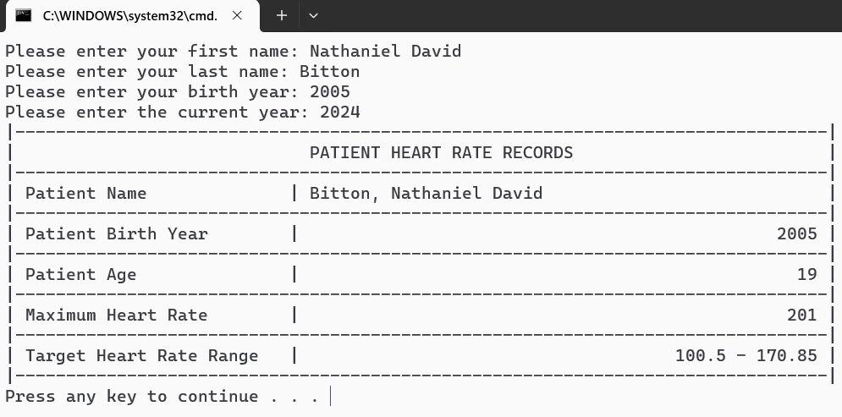

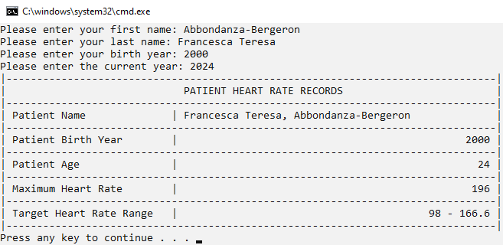

**Problem‐02: Computerization of Health Records**

