**Vanier College**

**Computer Science Department**

**420-331-VA**

**Application Development-1 (Sec-02)**

**Winter 2024**

**Lab/Assignment Number and Title: : Introduction to LINQ and the List collection**

**Submitted by**

**Student Name: Nat_______________ _____Bitton___________  
 First name Last name**

**Student ID: ____6205857_______**

**Question 1**

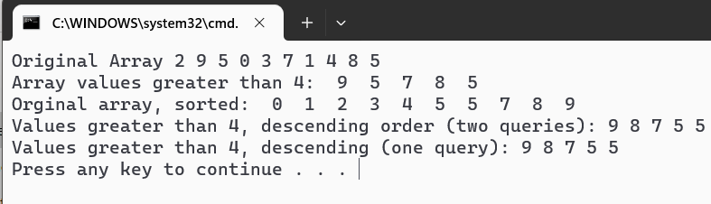

**Question 2**

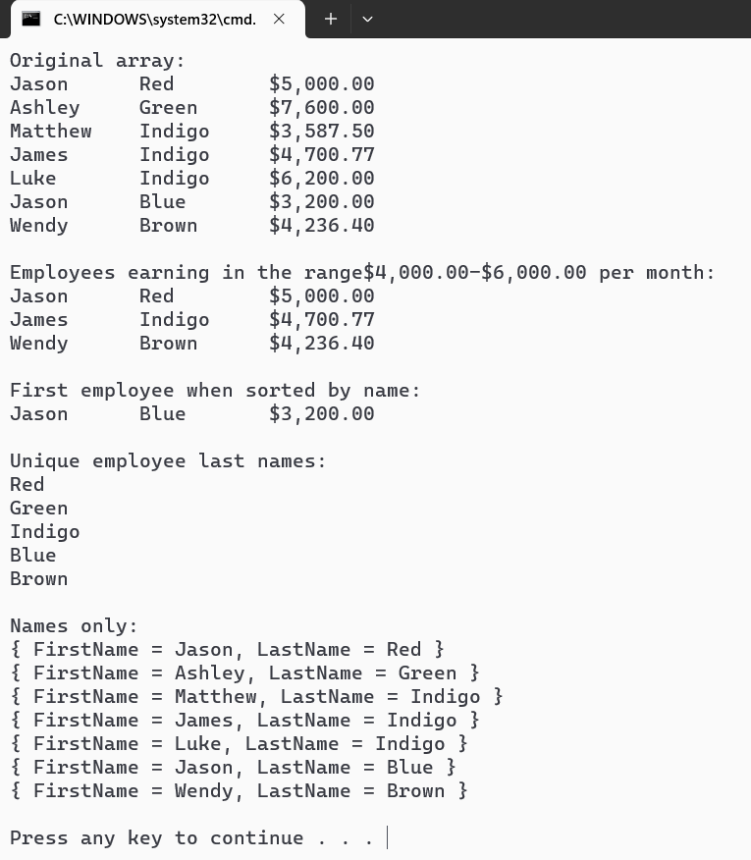

**Question 3**

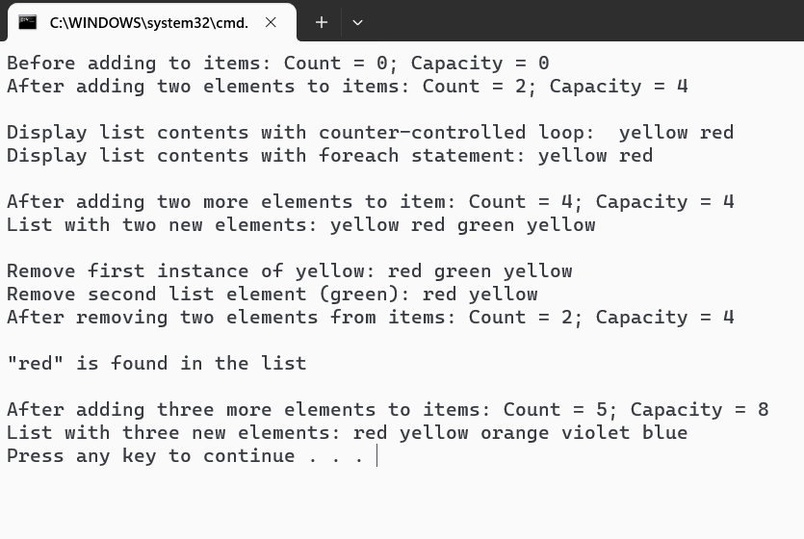

**Question 4:**

