**Vanier College**

**Computer Science Department**

**420-331-VA**

**Application Development-1 (Sec-02)**

**Winter 2024**

**Lab/Assignment Number and Title:** Assignment‐02: Object Oriented Programming ‐ Inheritance

**Submitted by**

**Student Name: Nat_______________ _____Bitton___________  
 First name Last name**

**Student ID: ____6205857_______**

**Part 1: Account**

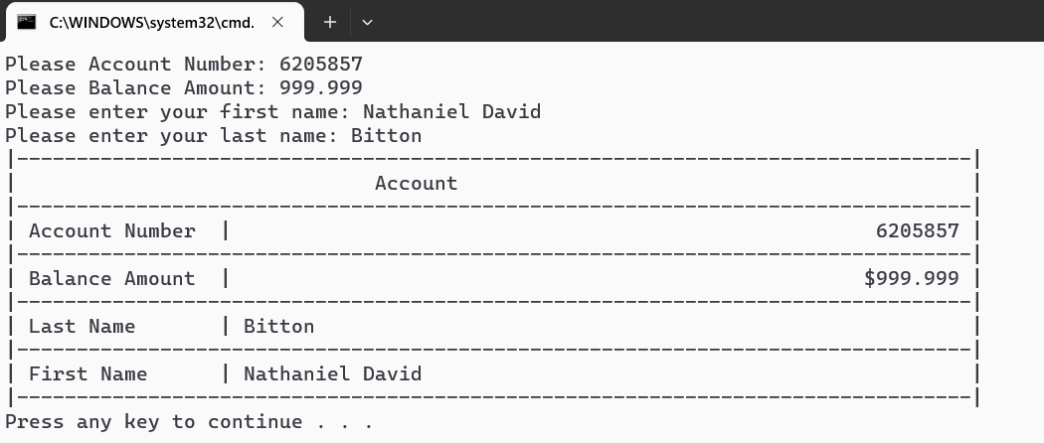

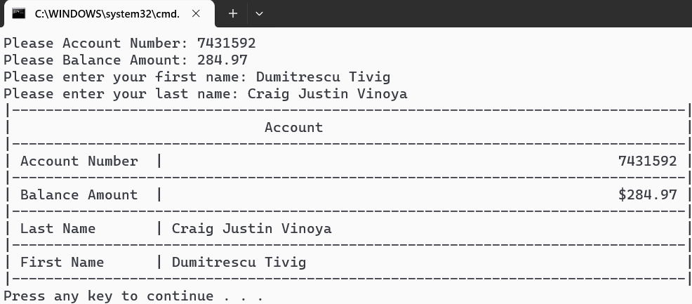

**Part 2: Saving account**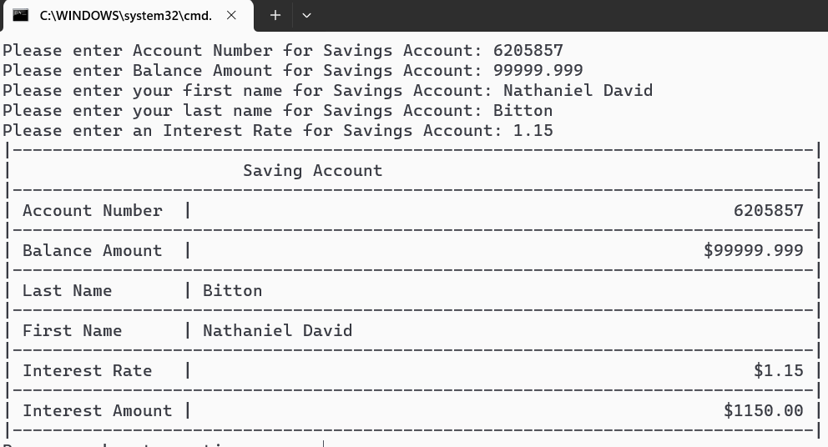

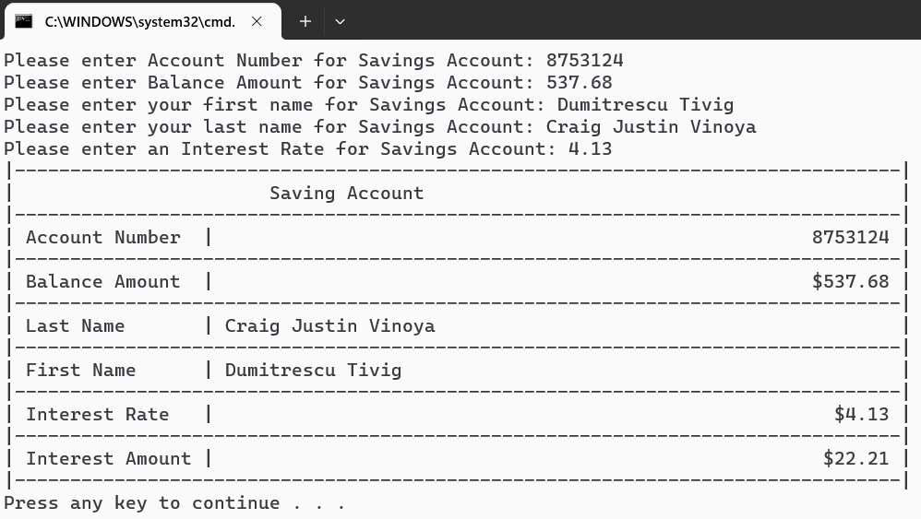

**Part 3: Checking account**

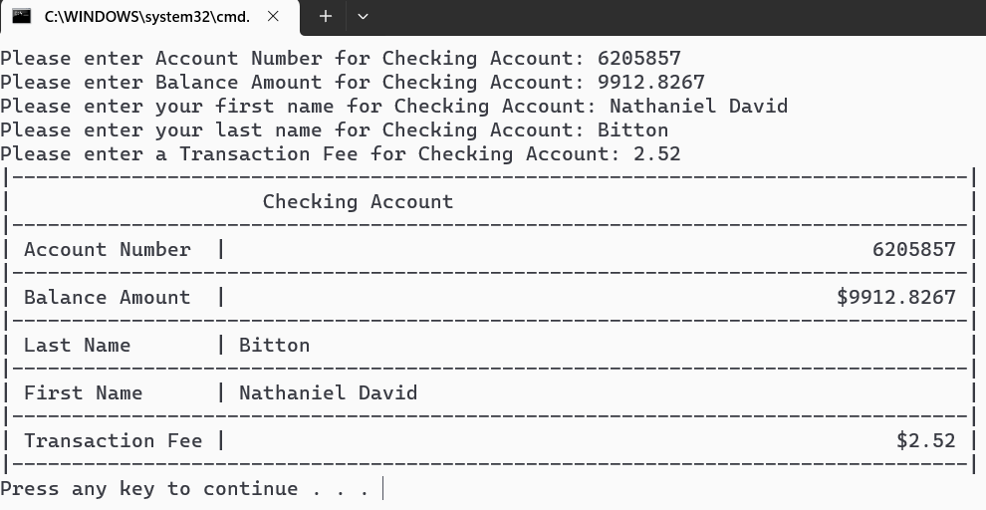

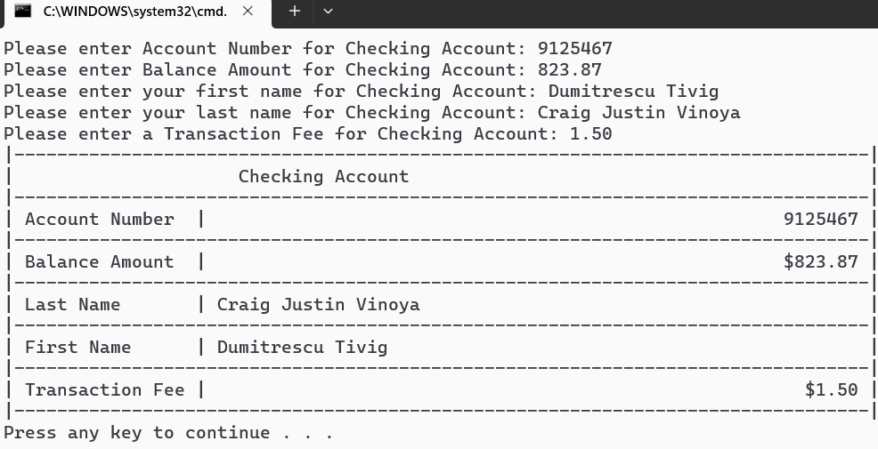

**Part 4: Driver class**

**Driver output next page**

**Short name (my name)**

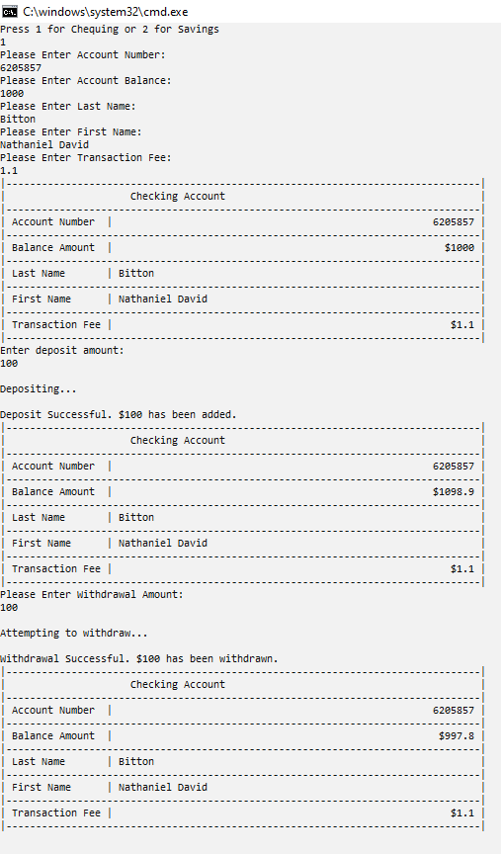

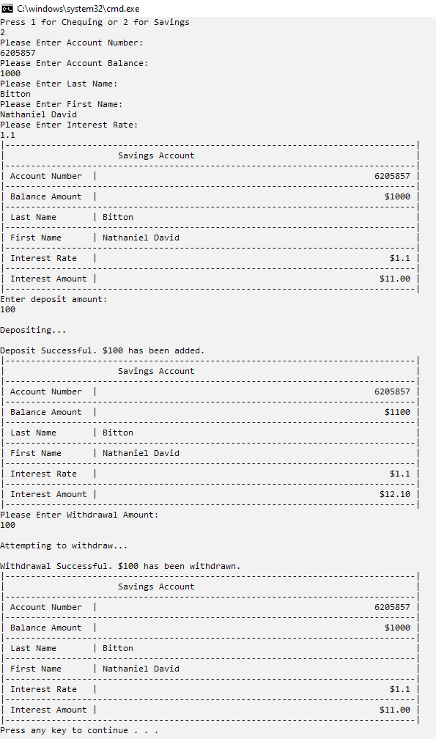

**Long names**

