1. Download libraries either separately from the web or as installation package supplied with InVEST.

2. Save in a folder that does not contain spaces in the folder pathway (for example, C:\InVEST). Do not save under C:\Python.
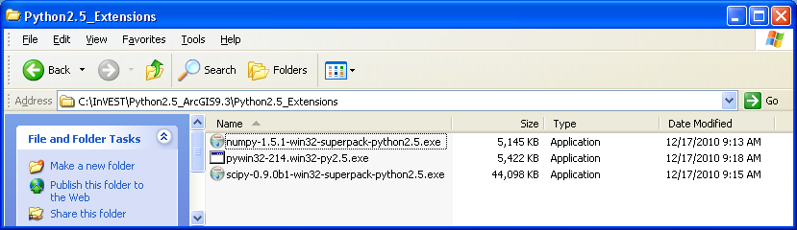

3. We will begin the installation of the python libraries using the matplotlib library as an example.
- XP users - double left click on .exe file
- Vista and Win 7 users, right-click .exe file and select Run as Administrator
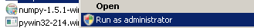

4. Click Next to initialize the installation and detect the location of your Python installation folder.
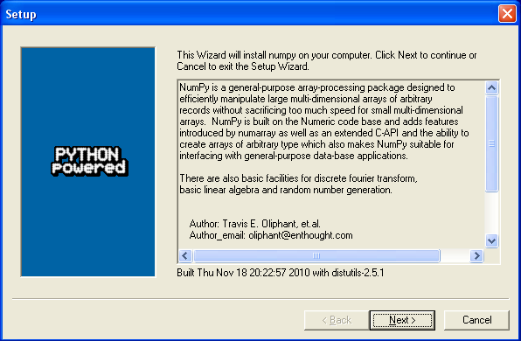

5. The installer will automatically detect and show the location of your Python installation folder. Click Next to continue the installation.
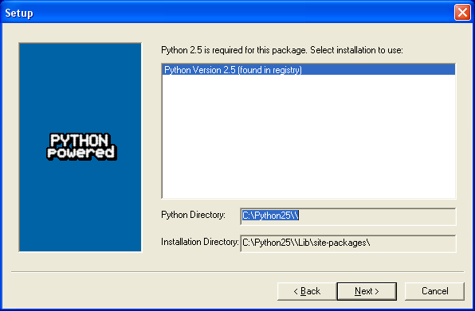

6. Click Next to begin the installation.
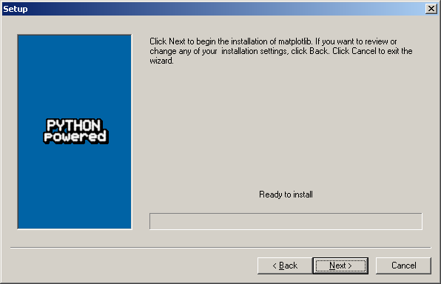

7. After a minute or so, all necessary files will be installed. Click Finish to complete the installation.
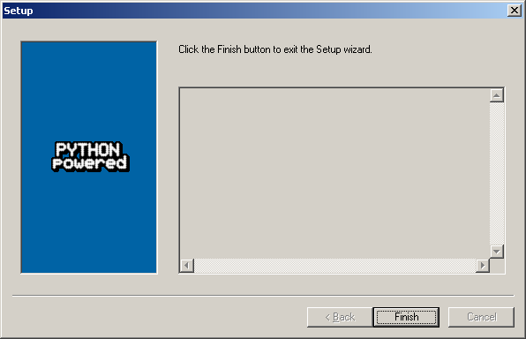

Follow the preceding steps (3 through 7) to install the remaining libraries for SciPy and PythonWin.
1. Open Layers Properties. Right-click on Layers; select Properties
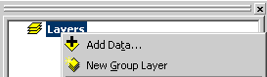

2. Data Frame Properties. Expand Predefined coordinate systems Expand Projected Coordinate Systems

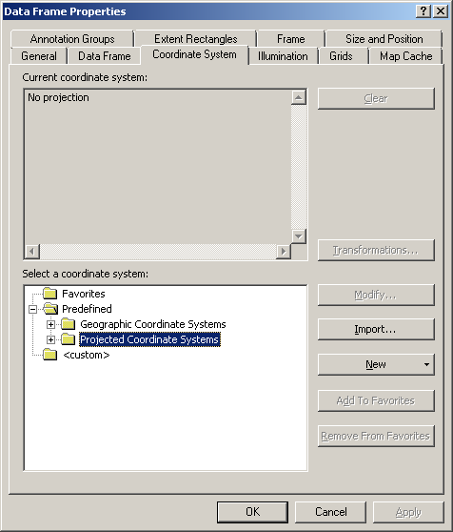
3. Click on or expand UTM

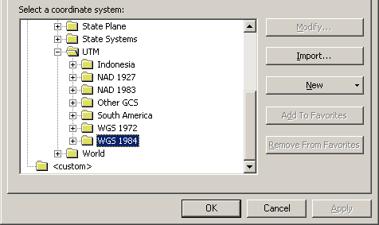

4. Click on or expand WGS 1984

5. Select WGS 1984 UTM Zone 10N

6. Click to set the coordinate system

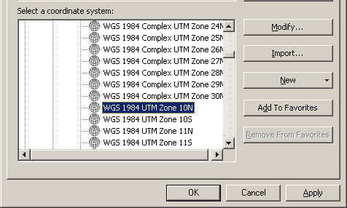

You can follow this process to set the map view projection based on your geographic area of interest.

1. Open the Project Tool from Data Management Tools > Projections and Transformations > Feature
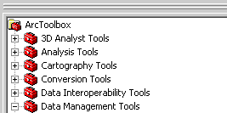
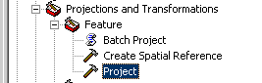

2. The Project Tool window will open.
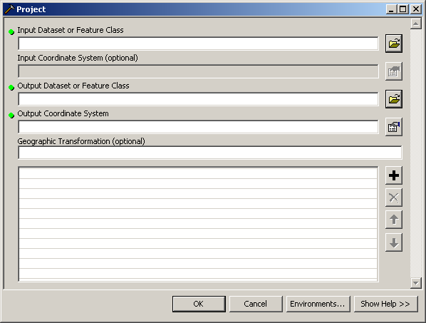

a. Specify Input Dataset. Click the Open Folder icon and navigate to your input data folder. As an example we use the shapefile Base_Data\Marine\Vancouver_Island\VI_PointsofInterest.shp

b. Specify Output Dataset. Click and navigate to your input data folder and specify an output name.
3. Specify the Coordinate System. Click the Coordinate System button . The Spatial Reference Properties window will open.
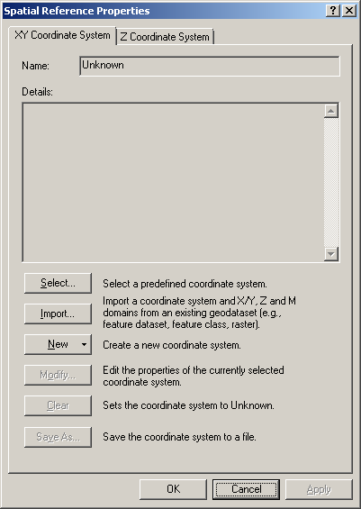

4. Click to select a Predefined Coordinate System.
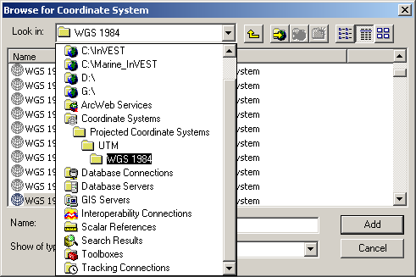
5. Navigate through the folders Coordinate Systems > Projected Coordinate Systems > UTM > WGS 1984.

In this example, we are selecting WGS 1984 UTM Zone 10N. The exact coordinate will depend on your geographic location.

6. The coordinate system/projection reference information is now set.
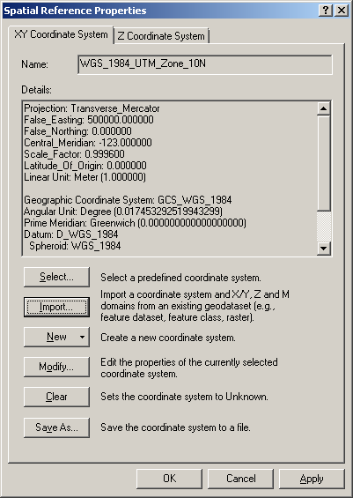

Click to commit the changes and to return to the Project window.
7. The Project tool is completed and ready to be run.
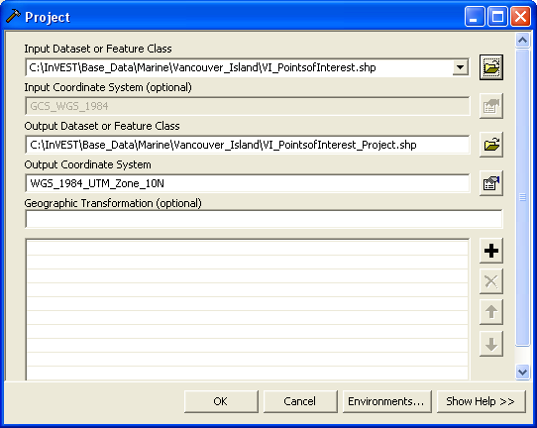

Click to run the tool.

8. The tool has successfully projected the input data. Check the output shapefile under the input data folder.
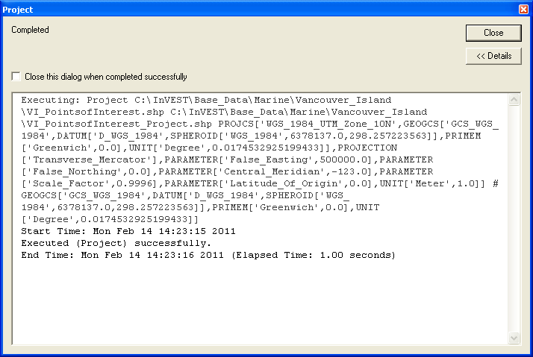
1. Adding a dataset with a datum (that is, geographic coordinate system) different than the map view produces a Geographic Coordinate System warning. In this example, we added a AquaWEM_points shapefile that uses the NAD 1983 datum while the map view is in WGS 1984.
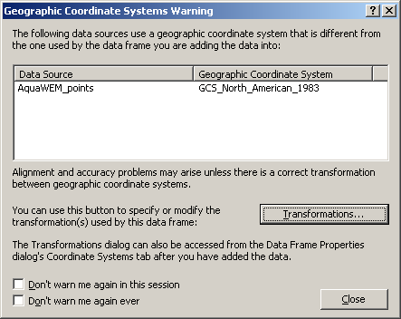
Users can check the Adobe file geographic_transformations.pdf under the ArcGIS installation ArcGIS\Documentation folder to determine the appropriate datum transformation by geographic location.

2. We can use NAD_1983_To_WGS_1984_1 to convert from NAD 1983 to WGS 1984, which is valid for Canada, Central America, Mexico, and United States (Alaska, CONUS)

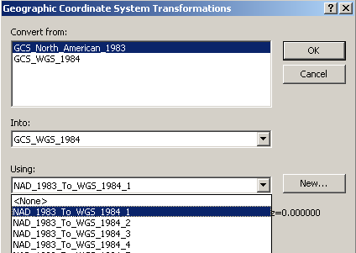
3. The appropriate transformation is specified and we can continue.
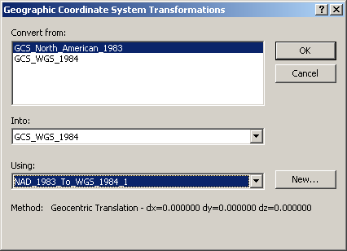

4. Click to calculation the transformation.

5. To save a copy of the AquaWEM_points shapefile with the WGS 1984 datum, right-click the AquaWEM_points name in the table of contents.
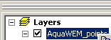

Select Data (near the bottom of the drop-down menu) and select Export Data.
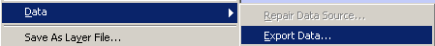

6. The Export Data window opens and you need to specify the source of the coordinate system and the output file name.

a. You need to specify the same coordinate system as the data frame (map view) in order to preserve the datum transformation specified in step 2.
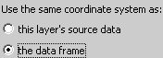

b. Click and navigate to the C:\InVEST\AestheticQuality\Input folder (same folder as AquaWEM_points). Here we use AquaWEM_points_WGS1984.shp

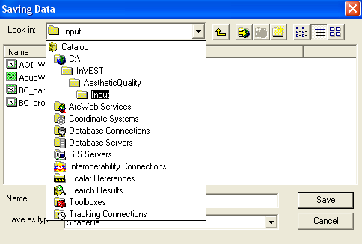

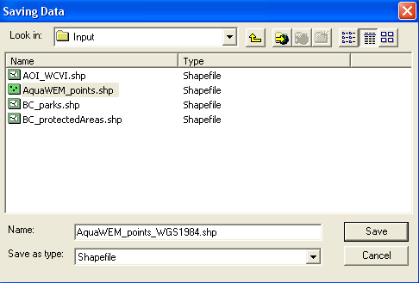
7. The Export Data window is completely filled to export the data to calculate and preserve the datum transformation.
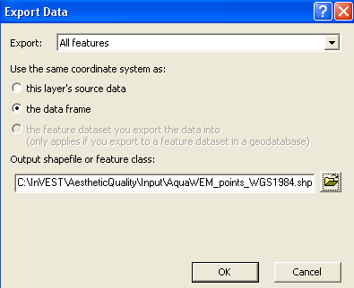

8. Click to export the data.

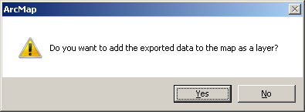

9. Click to add the new data to the map view.

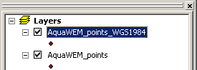

1. Add Drawing toolbar
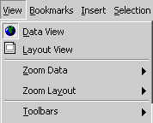

2. Change Drawing tool to Polygon. In the lower left corner, click black down arrow next to white square

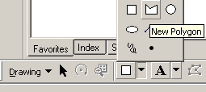

3. With the cross-shaped cursor + start creating the AOI by left-clicking along shoreline.
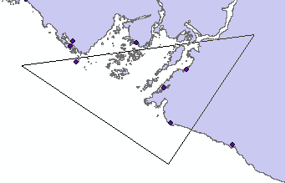

4. As you left-click, the corners of the AOI polygon will be created, defining the AOI shape. Continue left-clicking until you are satisfied with your AOI. Double left click to finish the AOI polygon.
5. With the polygon selected left-click the Drawing button to open the Draw menu.

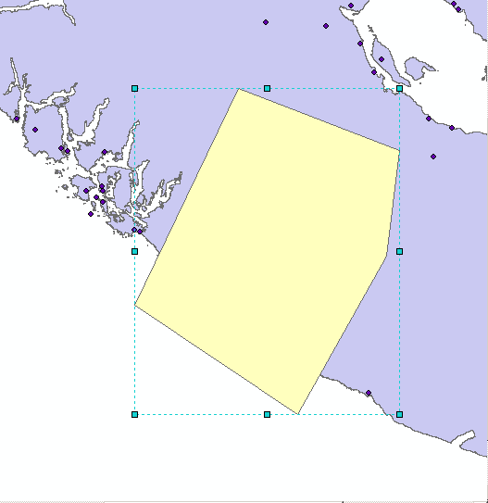

6. Select the Convert Graphics To Features tool
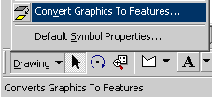

7. Specify options for convert graphics to featues
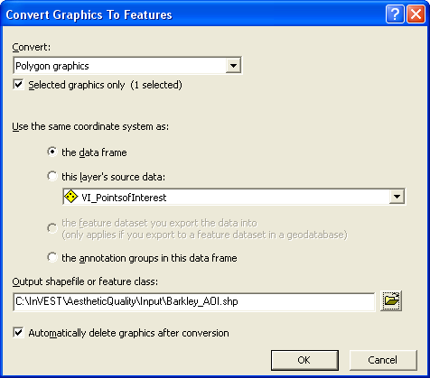

a. Specify the same coordinate system as data frame
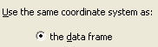

b. Give your AOI a meaningful name
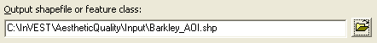

c. Check the Auto delete graphics checkbox

d. Click to create
8. Add exported graphic to map
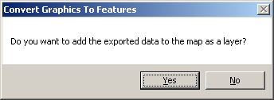

9. Completed AOI
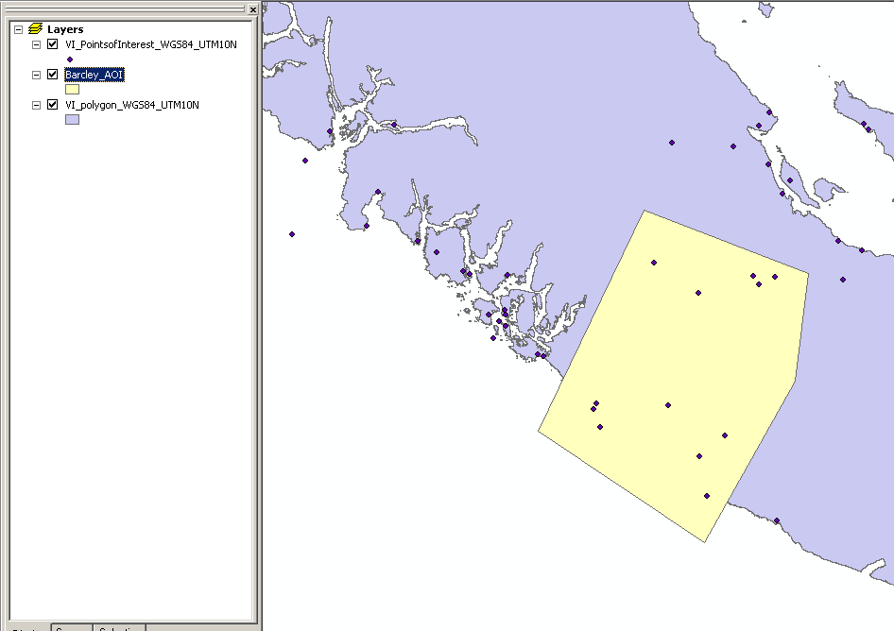
1. Create a polygon shapefile following Creating an AOI instructions.

2. Adding a new field, RANK. Open attribute table of sea level rise shapefile
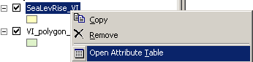

2. At the bottom of the attribute table click Options and Add field
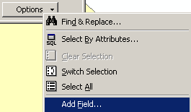

3. In the Add field window, create a new field named RANK (Type: Short Integer) that contains the risk of sea level rise.

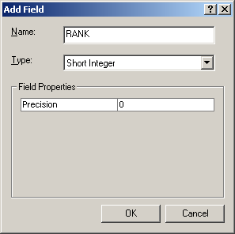
4. Start an editing session. Add the Editor toolbar
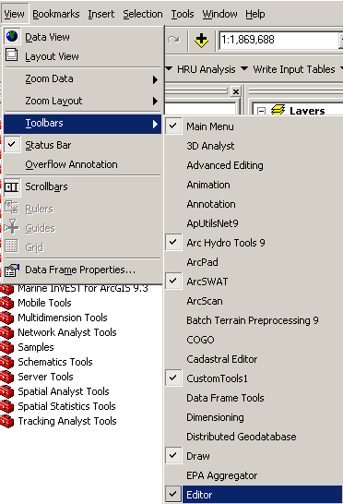

5. Click the button and then Start Editing

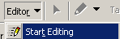
6. Select the folder to edit from; this is the location of the sea level rise shapefile you just created.

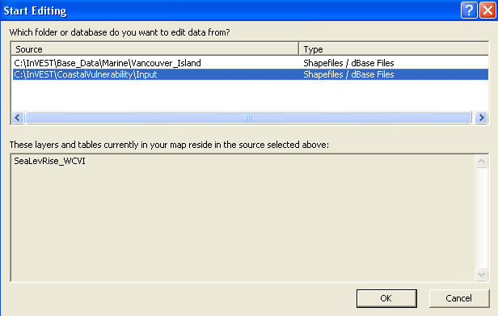

Editing toolbar:

7. Turn on the Snapping environment. Snapping allows you to create exact locations and continuously connected data, and to avoid an errors when cutting polygons. Click on the Editor menu and select Snapping.
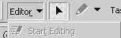
:
:
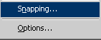
8. Set the polygon parts you want to snap to. Check Vertex and End. This ensures continuous connecting lines when cutting a polygon at the corner of a previous cut.
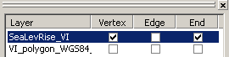

9. Setting the snapping tolerance value and set the snapping tolerance to ‘map units’. The snapping tolerance is the distance within which the cursor is snapped to another location. You will need to experiment with the tolerance value based on the geographic extent you are working at.

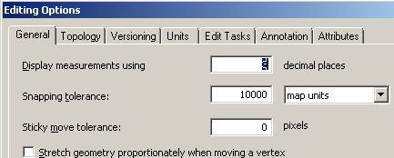

10. Click to set the snapping tolerance options.

11. Cutting the polygon. Change the Editing task to Cut Polygon Features

12. Select the Edit tool from the Editor toolbar and select the polygon
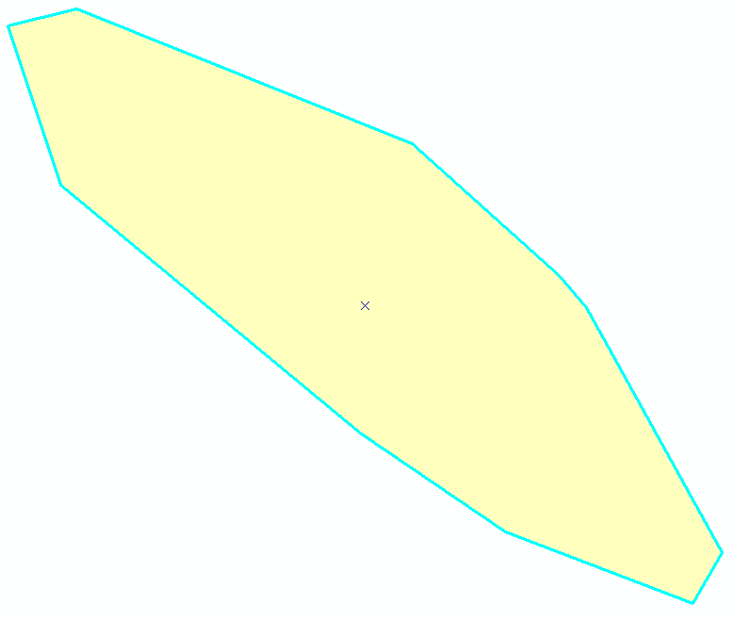
13. Click on the Sketch Tool 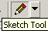. The cursor will turn to a cross with a blue dot and use this to

14. Draw a cut line by left-clicking to start the line and to add vertices to define the line.
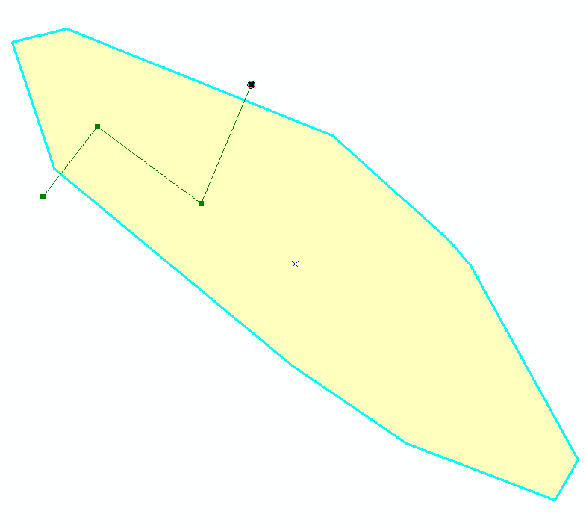
15. Double-left click to finish the line.
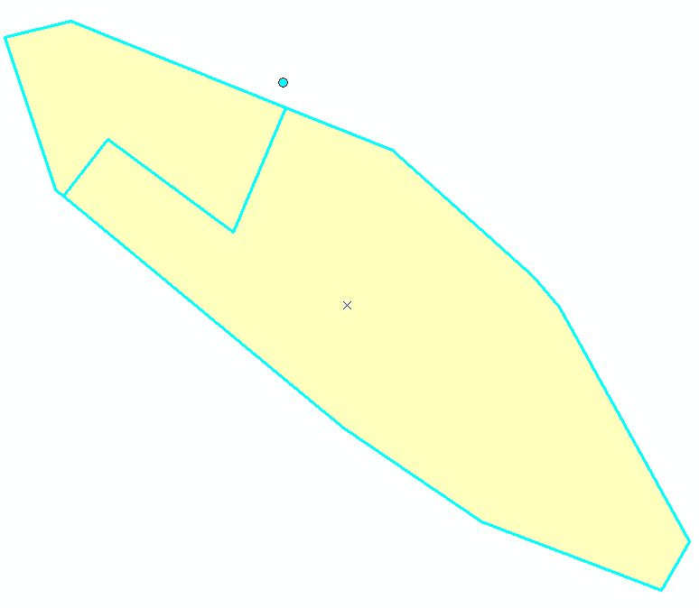
16. Continue cutting the polygons until you have completed the sea level rise shapefile.

17. Save your edits by clicking the Editor menu and selecting Save Edits.
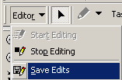

18. Populate the RANK field. Click the Edit tool and select on of the polygons. Click the Attributes button to open the Attributes editor window.
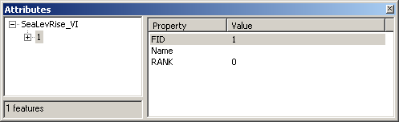
19. Click on the 0 value next the RANK field name to change the value.
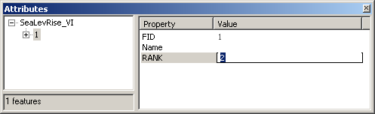
Use the Edit tool to click another polygon.

Continue this step until all polygons’ RANK values are assigned.

20. Save your edits.

21. Stop the Editing session by clicking the Editor menu and then Stop Editing
Completed sea level rise data
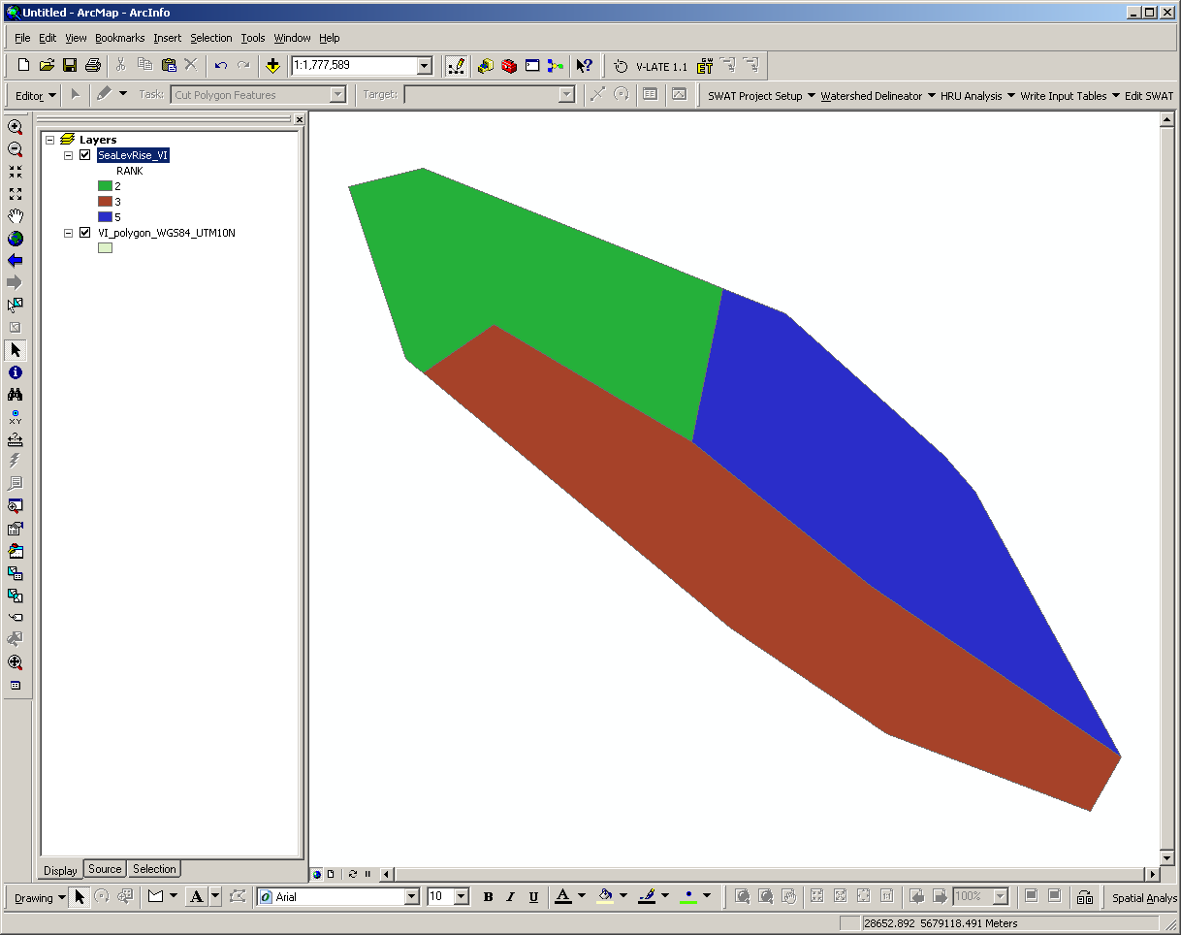
1. Add the global_pop raster to ArcMap data frame (from C:\InVEST\Base_Data\Marine\Population folder).
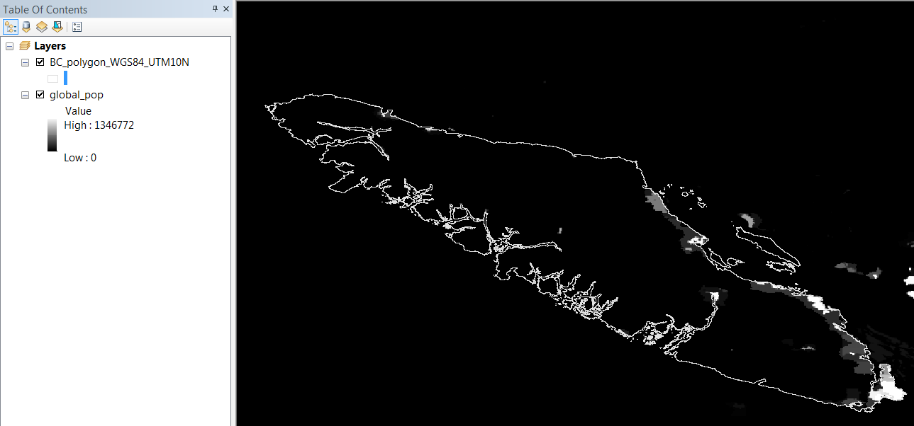

2. Open global_pop properties. Right-click the global_pop name (or double left-click).
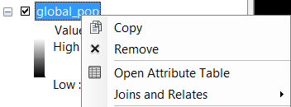

3. Click on the Symbology tab on the Layer Properties window.
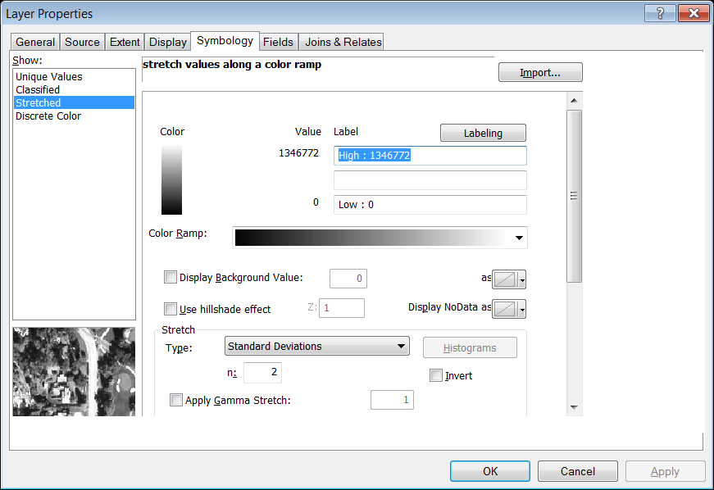
4. Assign symbology layer. Click , then click and path to the appropriate .lyr file.
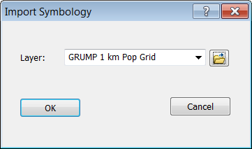

5. Click to load the symbology layer.
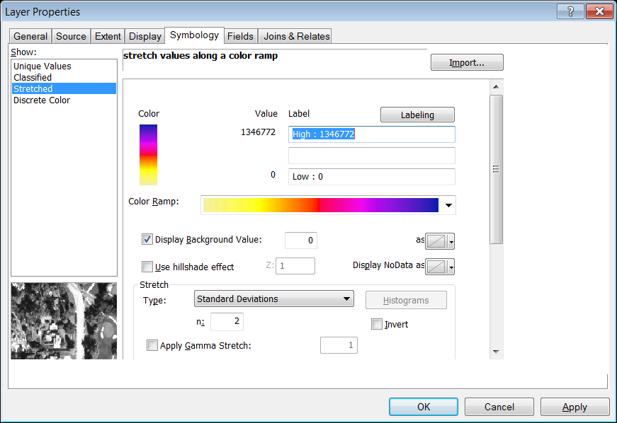

6. Click to assign the symbology to the global_pop raster.
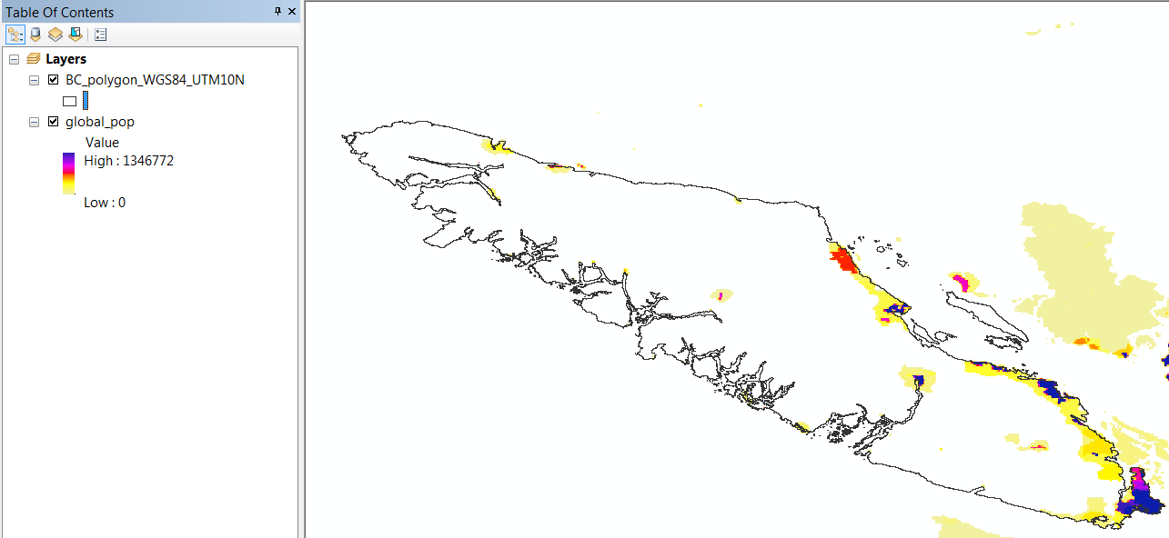
You can use this approach to load pre-defined symbology to any dataset.
1. Add the global_pop raster to ArcMap data frame (from C:\InVEST\Base_Data\Marine\Population folder).

2. Open global_pop properties. Right-click the global_pop name (or double left-click).

3. Click on the Source tab on the Layer Properties window.
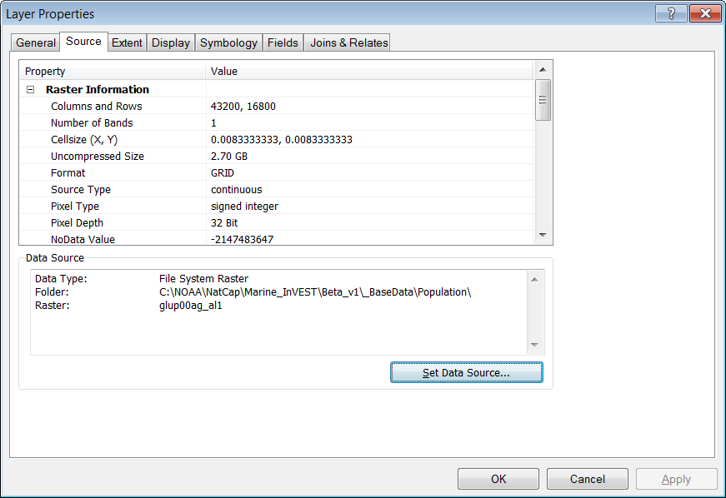
4. The Spatial Reference information can be found near the bottom of the Property scroll window.
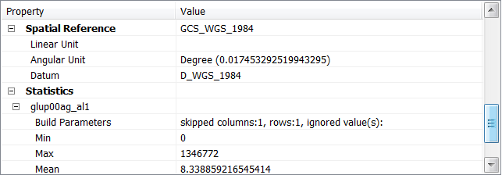

Note that GCS_WGS_1984 is the spatial reference information for the global_pop raster. This means the raster is in the WGS 1984 Geographic Coordinate System (or datum).

This information is very useful when projecting data or performing a datum transformation.

5. Click to close the Layer Properties window and carry on with your InVEST modeling.

1. Adding data to the current map view. Add VI_polygon_WGS84_UTM10N.shp from the \InVEST\Base_Data\Marine\Vancouver_Island folder

Add UTM_Zone.shp from \InVEST\Base_Data\Marine\Grids\

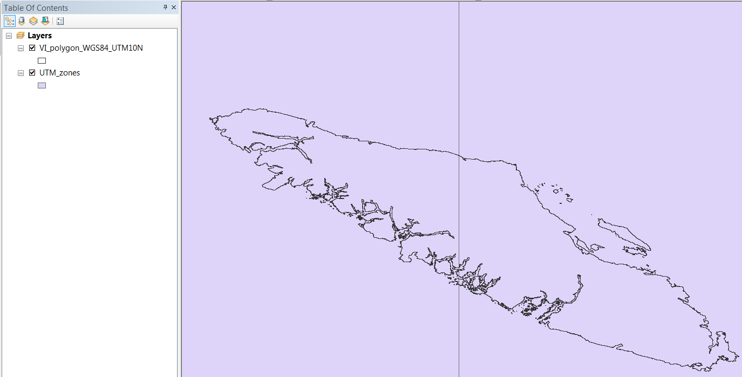

2. Change the symbology. Left-click on the symbol box under UTM_zones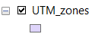 to open the Symbol Selector.

3. Click on to open the color pallete. Change the fill color to No Color and the Outline Color to dark green with an outline width of 2.
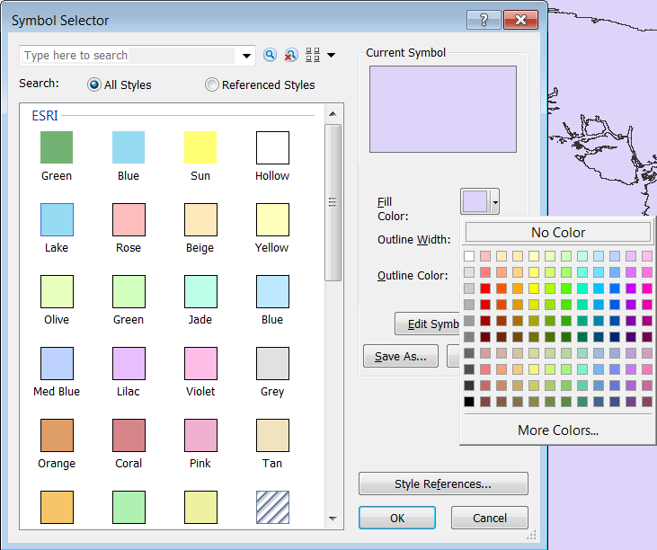
4. Double left click the UTM_Zone.shp name to open the Layer Properties and click on the Labels tab.
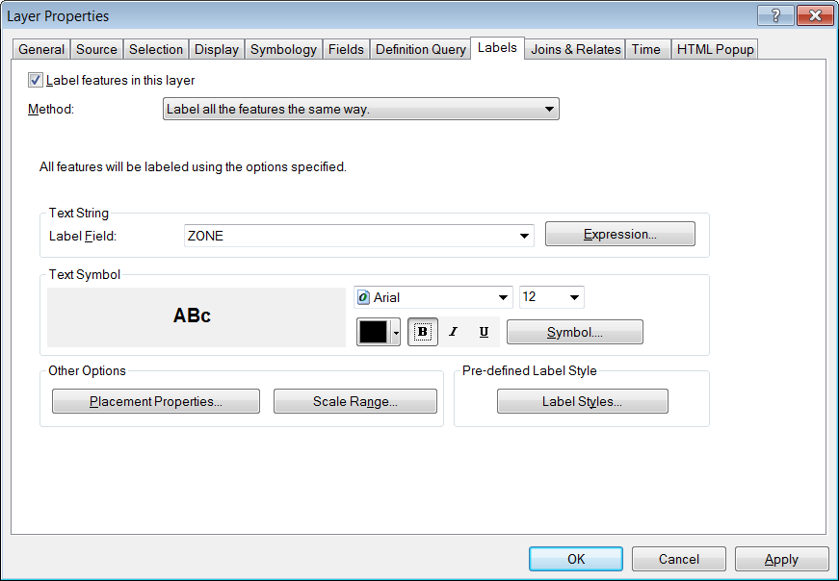

Check the checkbox.
Ensure the Label Field is set to ZONE
Change the font size to 12 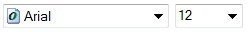and Bold the labels.
Click to label the zones.

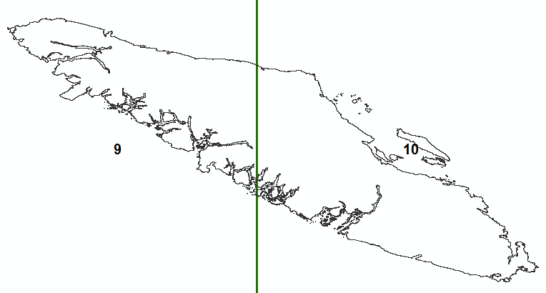
You can now determine the appropriate UTM zone for the InVEST models and to project your data, if needed.
1. Add Drawing toolbar

2. Change Drawing tool to Marker (Point). In the lower left corner, click black down arrow next to white square

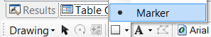

3. With the cross-shaped cursor + start creating the AOI by left-clicking along shoreline.
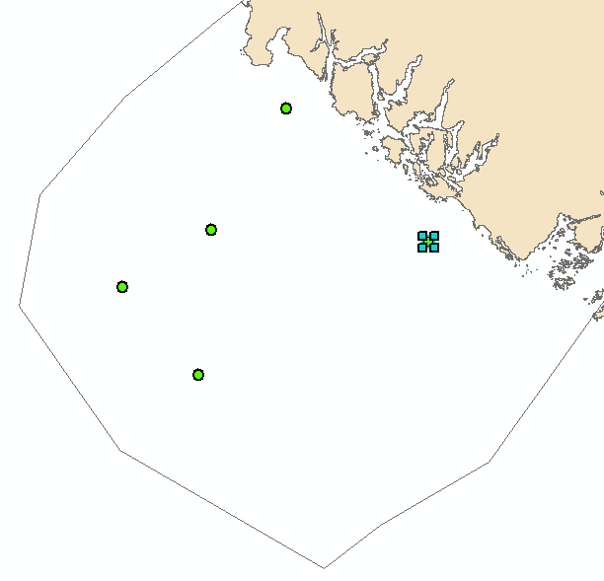

4. Left-clicking the mouse will create points. Each time you want to add a point you will need to click back on the Point marker tool .
5. With all the points selected left-click the Drawing button to open the Draw menu.

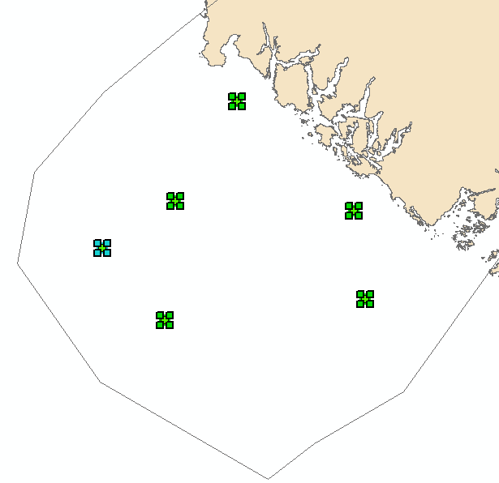
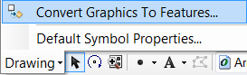
6. Select the Convert Graphics To Features tool

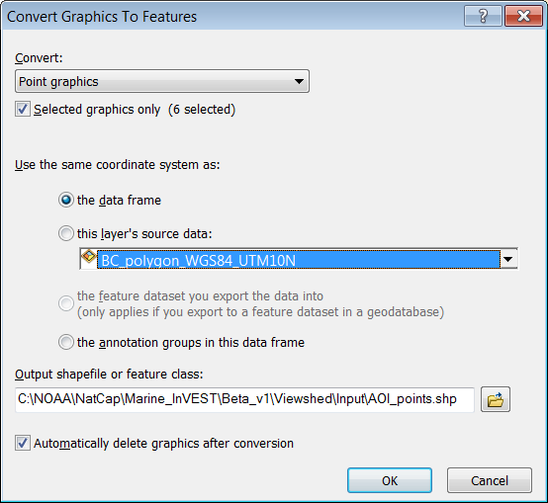
7. Specify the options to convert graphics to features
a. Specify the same coordinate system as data frame
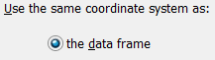

b. Give your AOI a meaningful name
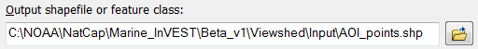

c. Check the Auto delete graphics checkbox
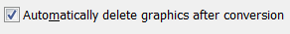

d. Click to create

8. Click 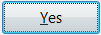 to add exported graphic to map
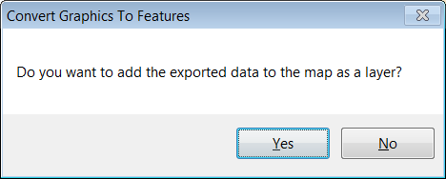

9. Completed points.
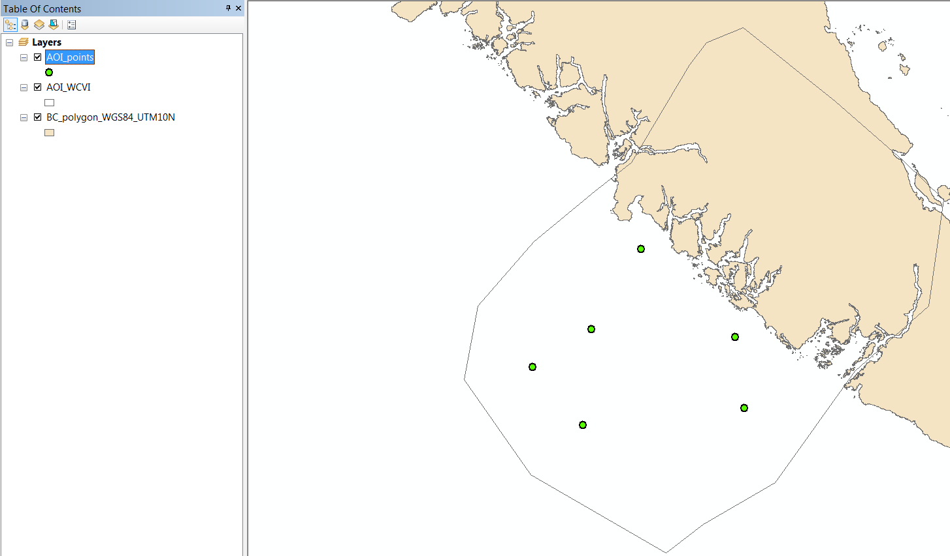
10. Modifying the attribute table: Calculating a field and Adding a new field.

Open the attribute table of the new point shapefile,
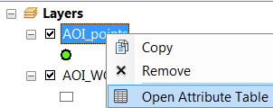

The shapefile already has Name field where you can enter a specific name for each point.

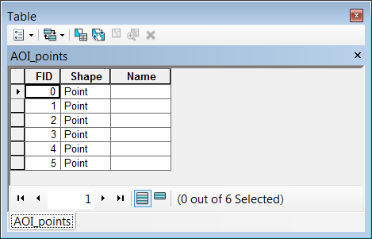

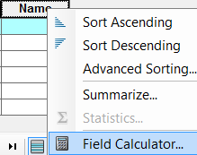
11. To add a name, left-click a row and then right-click the Name field heading to open the Field Calculator.

12. Enter a name in the expression text box under Name =. Since we are creating text data, make sure the point name is enclosed in double quotes. For example “View Point 1”.
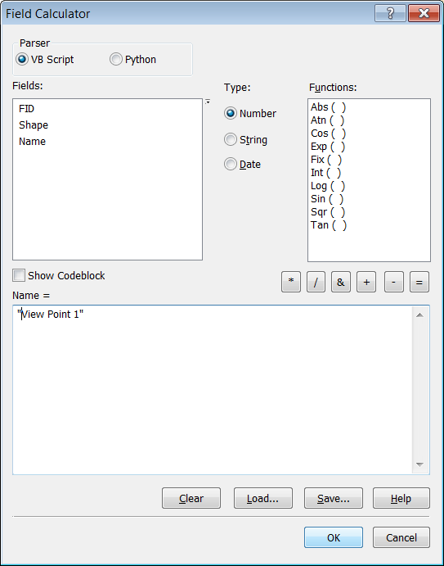

13. Click to make the calculation.
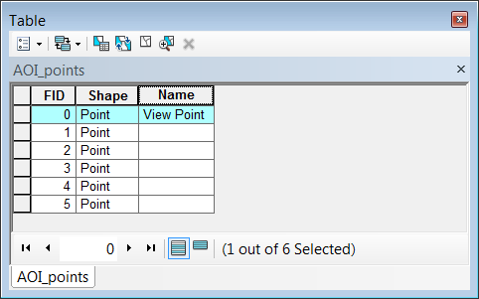

Left click another row to calculate another name.
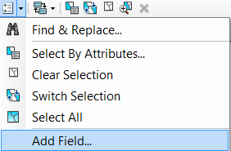
14. To add a new field, click the Table Options button and click Add Field.

15. Enter a name for the new field.
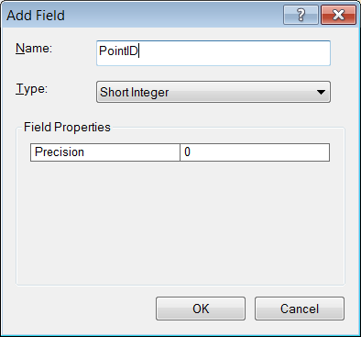

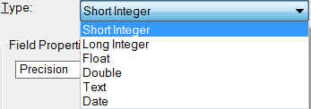
16. You can select the data type, inter (short or long), decimal (float or double), text or data by clicking on the poull down arrow to the right of Type

17. Click to create the field. Repeat as needed. 