

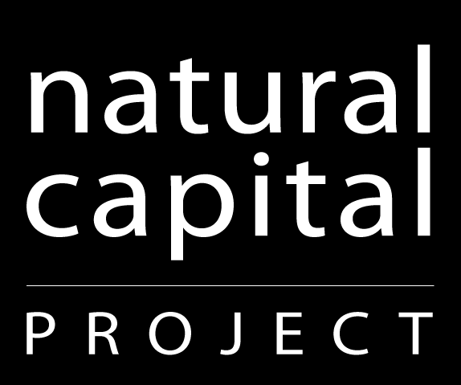
Aligning Water Fund Investment Prioritization
in Latin America
Sept 27-29
Hotel Santo Domingo, Santo Domingo, Dominican Republic

Meeting Objectives:
1. Present case examples of water fund investment prioritization
2. Initiate process for aligning water fund design approaches, including agreement on core steps for water fund investment prioritization
3. Alignment of water fund investment prioritization and monitoring protocols

Tuesday, Sept 27

Optional field trip to Dominican Republic water fund area

Wednesday, Sept 28

8:30 Introductions and initiation of meeting Silvia Benitez/Heather Tallis

Water Fund Investment Prioritization Experience & Opportunity
This session will introduce the state of play for water fund development in Latin America, the opportunity to align practices across emerging and existing funds, and the examples we have to build on.

8:45 Water fund investment prioritization in the
context of water fund development Silvia Benitez

9:00 Developing Latin American priorities for
nature based solutions to water security Jerry Touval

9:30 The case of the Brazilian Water Producer Program Anita Diederichsen

10:00 The case of FONAPA in Ecuador Carlos Cabrera

10:30 The case of Agua por la Vida y Sostenibilidad Alejandro Calvache

11:00 Break

11:15 Core components of water fund investment prioritization Heather Tallis

11:30 Brainstorm on major questions that need to be answered in water fund selection and design
Short group brainstorming on major questions followed by plenary discussion of missing core components that need to be added.

Setting Objectives
The next several sessions will go through each of the core steps for investment prioritization in detail, highlighting options for each step. The focus will be on discussing the options and identifying standards of practice for each step.
12:15 What makes a good objective? Heather Tallis
12:30 Break out groups (count off)
- How do we determine what’s achievable and measurable for biodiversity objectives? What approaches are missing? Silvia
- How do we determine what’s achievable and measurable for ecosystem service objectives? What approaches are missing? Heather
- How do we determine what’s achievable and measurable for social objectives? What approaches are missing? Supin + Alejandro
1:00 Report back and discuss
What recommendations can we make now? What needs further exploration and discussion? Silvia Benitez/Heather Tallis

1:30 Lunch

Choosing Activities
2:30 Brainstorm and discussion on strategies and activities (plenary)
Brainstorm on what activities and strategies a fund could invest in. Discuss options for selecting among activities and decide what kind of guidance should be developed (e.g. recommendations for activities or selection approaches in different contexts).
Silvia Benitez/Heather Tallis

Diagnostic Screening
Options for identifying investment priority areas
3:30 Strengths and weaknesses of modeling (static and
scenario-based) and ranking approaches for identifying
priority areas Heather Tallis
Discuss situations where each approach is most useful and identify recommendations for standard use of each.

4:30 Building consensus for a ranking approach
to identifying ecological priority areas Heather Tallis

4:45 Break

5:00 Break out groups to discuss key issues in ranking analysis (pick your group)
1). Should there be standard factors for each ecological objective? Juan Sebastian
2). Do rankings need to differ for restoration and protection? Heather
3). Do rankings need to differ across scales? Fernando
4). Aligning factors and monitoring protocols Silvia

5:45 Report back from groups and discussion
Identify consistencies and recommendations for standards, needs for further research and discussion and next steps.

6:30 Adjourn

7:30 Group dinner

Thursday, Sept 29

8:30 Review of decisions and next steps from Day 1 Fernando Veiga/Heather Tallis

Options for identifying social and political priority areas

9:00 Stakeholder preferences and purely social objectives Benitez/Calvache

9:30 On-line stakeholder engagement tool for identifying
social and political priority areas Rich Sharp
Discussion of options and decision on whether some approaches are preferred, how to inform and learn from monitoring, and next steps for guidance/tools.

10:30 Break

10:45 Combining ecological, social and political priorities Heather Tallis
Discussion of options and decision on whether some approaches are preferred, next steps for guidance/tools.

Allocating the Budget
11:15 Options for allocation of budget among activities
and watersheds (historic pattern, ROI, area-based,
beneficiary-based, equal) Heather Tallis
Discussion of options and decision on whether some approaches are preferred, next steps for guidance/tools.

Selecting Water Funds or Investment Portfolios
12:00 Options for selecting where to invest first
(ROI-objective, ROI-beneficiary, Negotiation) Heather Tallis
Discussion of options and decision on whether some approaches are preferred, next steps for guidance/tools.

1:00 Lunch

Estimating Project Returns
2:00 Options for estimating how much conservation, ecosystem
service and social return to expect from a portfolio
(literature review, modeling, other options?) Heather Tallis

2:30 Breakout groups
- How much certainty do different audiences need in estimated returns?
- What are the options for estimating social and economic returns? What new social and economic methods or tools are most promising for further development?
- Which approaches are best under what conditions? Are additional tools or methods needed?
3:00 Report back

3:15 BREAK

Next Steps and Follow Up
3:30 Breakout groups:
Discuss what kinds of outputs we want to be able to produce from prioritization. (Fernando, Silvia, Heather, Nelida)

4:00 Report back

4:30 Review needs for capacity building for process to proceed
Discuss workplan for follow up after workshop

LOGISTICS FOR AIRPORT TAXIS AND EXIT TAX

5:30 Adjourn

7:30 Group dinner

