# InVEST Frequently Asked Questions

**Table of Contents**

# General Questions

1. Where has InVEST been used?
2. What ecosystem services are currently modeled in InVEST?
3. Will any new models be added to InVEST in the future?
4. How are ecosystem services and mapping important for different areas of interest (e.g. urban planning, agricultural production, equity)?
5. What approach does InVEST use to model ecosystem services?
6. Can InVEST tell me what ecosystem services are worth? How are services valued?
7. How easy is it to use InVEST? Do I need technical skills to use InVEST?
8. How much does InVEST cost to download and use?
9. Can I use InVEST outside the U.S.?

**Marine GIS Questions**

1. How to install the InVEST Python extensions
2. How to set the coordinate system/projection for the Map view
3. How to project a shapefile
4. How to convert geographic coordinate systems/datums
5. How to create an area of interest (AOI) polygon
6. How to create sea level rise data
7. How to quickly symbolize a dataset with a layer (.lyr) file
8. How to check the spatial information of a GIS dataset
9. How to determine the UTM zone of your area of interest
10. How to create a point shapefile

# Hardware, software and source code

1. What software is required to run InVEST models?
2. What tools and models can InVEST work with?
3. How do I edit the source code for InVEST?
4. What is the latest version of InVEST?
5. How can I find out which version of InVEST I am using?

# Data

1. Does InVEST come with any data?
2. What are the input data I’ll need to run InVEST?
3. How do I get help finding/creating my input data?

**Using InVEST**

1. Are there any recommendations or estimates for the number of people, cost, and hours it will take to use InVEST?
2. What kind of subject matter expertise would a tool user need to effectively apply the tool?
3. How does stakeholder engagement work with InVEST?
4. What have been the challenges found in tool uptake?
5. How do I make scenarios?
6. Is there an optimal scale and data resolution for applying InVEST?
7. What time steps can I model with InVEST (annual, monthly, daily, seasonal)?

# Training, discussion forum and support

1. Do you offer training on InVEST such as tutorials or videos?
2. If I create a new model, can it be included in InVEST?
3. Can I get help using InVEST? Is there a forum for asking technical questions?
4. How can I suggest new features for InVEST?
5. How do I share data with other InVEST users in my area and learn about their projects?
6. What does it mean to *model tradeoffs*?
7. Does the Natural Capital Project want to see my InVEST results?

**Keeping up with new developments, staying connected, and learning more**

1. How can I subscribe to updates about InVEST and the Natural Capital Project?
2. Where can I learn more about InVEST and the Natural Capital Project?

**Collaborating with the Natural Capital Project**

1. Will the Natural Capital Project help me find funding to use InVEST for my project or give me a grant?
2. Can the Natural Capital Project help me publish my work with InVEST?
3. Can the Natural Capital Project send someone to present InVEST to my group and participate in my meeting?

# General Questions

## Where has InVEST been used?

InVEST has been used to inform spatial planning and zoning, payments for ecosystem services, permitting and mitigation, multi-stakeholder planning, and climate adaptation around the world. To learn more about where InVEST has been used see our [TEEB case studies](http://www.naturalcapitalproject.org/pubs/NatCap_InVEST_Tool_Description_All_TEEBcases_2010.pdf), [peer-reviewed publications](http://www.naturalcapitalproject.org/publications.html), and [InVEST in Practice series](http://www.naturalcapitalproject.org/policy_tools.html) – a guide for applying InVEST to policy and planning decisions.

## What ecosystem services are currently modeled in InVEST?

**\* = models offering valuation**

* **\*Carbon Storage and Sequestration**
  + The amount and value of carbon stored and sequestered naturally in five carbon pools: above ground biomass, belowground biomass, soil, harvested wood products, and dead organic matter.
* **\*Crop Pollination**
  + The abundance of pollinators in an area of interest and the number of pollinators likely visiting crops on a landscape.
* **\*Timber Production**
  + The amount and value of timber harvest.
* **\*Water Purification: Nutrient Retention** 
  + The amount and value of nutrient retention by vegetation for water purification (includes phosphorus and nitrogen).
* **\*Erosion Control**
  + The amount and value of sediment retention by vegetation for erosion control.
* **\*Reservoir Hydropower Production**
  + The amount of water yielded from each unit of the landscape and its annual value to hydropower production.
* **Biodiversity**
  + The location and rating of habitat quality and rarity.
  + Habitat Risk in Marine and Coastal Habitats: The regions on a landscape or seascape where human impacts on habitat are highest.
* **Fisheries and Recreation**
  + The location and amount of ocean fishing and recreational uses.
* **\*Marine Aquaculture Harvest**
  + The amount and value of Atlantic salmon aquaculture based on farming practices, the water temperature, and economic factors.
* **Coastal Vulnerability**
  + The location of populations near the coastal region of interest and the relative exposure of those regions to erosion and inundation caused by large storms.
* **\*Wave Energy Conversion**
  + The potential value of energy capture from ocean waves.
* **Aesthetic Quality**
  + The visibility of offshore objects from the surrounding landscape or seascape providing information on the aesthetic effects of offshore development.

## Will any new models be added to InVEST in the future?

We continue to develop new ecosystem service models. Some upcoming models include:

* Fisheries Production
* Recreational Fishing
* Coastal Protection from Erosion and Inundation
* Coastal/Marine Water Quality
* Blue Carbon Storage and Sequestration
* Shellfish Aquaculture
* Open Access Harvest (NTFPs) with valuation
* Agriculture Production
* Terrestrial Storm Peak Mitigation

We are always improving our models, so look out for updates on our [website](http://naturalcapitalproject.org/)!

## How are ecosystem services and mapping important for different areas of interest (e.g. urban planning, agricultural production, equity)?

Ecosystem services and mapping are important for anyone who is affected by or affects land-use decisions and anyone who wants to analyze the ecosystem service tradeoffs they face. Mapping ecosystem services can show tradeoffs for different scenarios and can be very useful for decision-makers facing a variety of issues including government agencies in both developed and developing countries, businesses (particularly those with significant control over or impact on land or water), conservation NGOs, non-conservation NGOs (who affect land use or management), multi-lateral development banks, and private land owners, who often manage lands and waters for multiple uses and must evaluate trade-offs among these uses.

For more information on how InVEST has been applied to answer diverse questions see our [TEEB case studies](http://www.naturalcapitalproject.org/pubs/NatCap_InVEST_Tool_Description_All_TEEBcases_2010.pdf), [peer-reviewed publications](http://www.naturalcapitalproject.org/publications.html), and [InVEST in Practice series](http://www.naturalcapitalproject.org/policy_tools.html).

## What approach does InVEST use to model ecosystem services?

InVEST models ecosystem services using simple production functions of land cover and associated attributes. InVEST outputs can deliver good first estimates of trends in ecosystem services that can be useful for decision-making. These models can be complemented by more sophisticated and data-intensive analyses as needed.

These production functions are described in further detail in the recent book, [Natural Capital Theory and Practice of Mapping Ecosystem Services](http://ukcatalogue.oup.com/product/9780199588992.do). In addition, the [InVEST User’s Guide](http://stanford.edu/~woodsp/natcap/invest/docs/21/index.html) outlines the assumptions and approaches in the models.

## Can InVEST tell me what ecosystem services are worth? How are services valued?

Most InVEST models quantify ecosystem service distribution in biophysical terms (e.g., tons of carbon, acre feet of water) and estimate values, using a range of economic valuation techniques, including avoided damage or treatment costs, market valuation, and production economics techniques. Many of the major assumptions (e.g. discount rate) are input by the user.

## How easy is it to use InVEST? Do I need technical skills to use InVEST?

InVEST requires basic to intermediate skills in ArcGIS because InVEST models run as script tools in the ArcGIS ArcToolbox environment. In addition, knowledge of hydrological processes will be useful for interpreting hydrology model outputs. InVEST comes with a set of sample data and a [User’s Guide](http://stanford.edu/~woodsp/natcap/invest/docs/21/index.html) that can help you get to know the models and interpret output results.

## How much does InVEST cost to download and use?

InVEST is free to download at: <http://invest.ecoinformatics.org/>. However, InVEST runs as a script in ArcGIS software (<http://www.esri.com>) which is not free.

## Can I use InVEST outside the U.S.?

InVEST can be used anywhere as long as data are available for input into the models.

# Marine GIS Questions

## How to install the InVEST Python extensions

1. Download libraries either separately from the web or as installation package supplied with InVEST.

2. Save in a folder that does not contain spaces in the folder pathway (for example, C:\ InVEST2_1). Do not save under C:\Python.

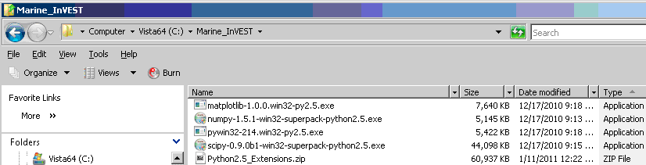

3. Close all applications including ArcMap and ArcCatalog before installing the python extension; there are conflicts among the programs.

4. We will begin the installation of the python libraries using the **matplotlib** library as an example.

* XP users - double left click on .exe file
* Vista and Win 7 users, right-click .exe file and select Run as Administrator

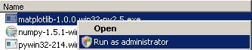

5. Click Next to initialize the installation and detect the location of your Python installation folder.

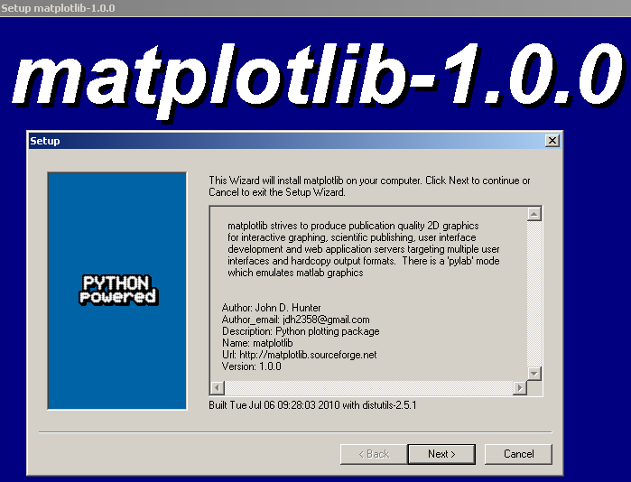

6. The installer will automatically detect and show the location of your Python installation folder. Click Next to continue the installation.

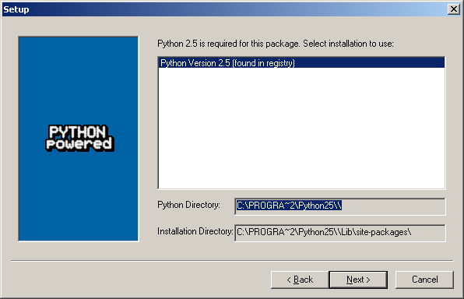

7. Click Next to begin the installation.

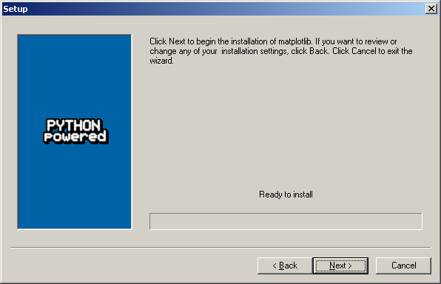

8. After a minute or so, all necessary files will be installed. Click Finish to complete the installation.

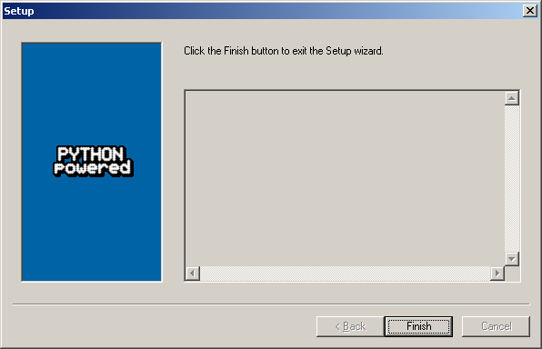

Follow the preceding steps (3 through 7) to install the remaining libraries for **numpy, scipy, and pywin32**.

## How to set the coordinate system/projection for the Map view

1. Open Layers Properties. Right-click on Layers; select Properties

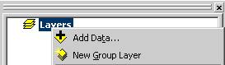



2. Data Frame Properties. Expand Predefined coordinate systems  Expand Projected Coordinate Systems 

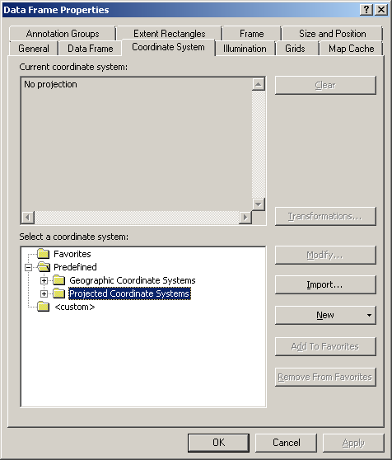

3. Click on or expand UTM 

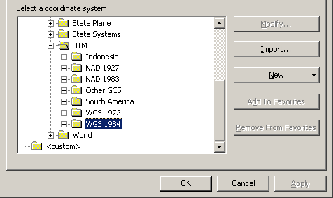

4. Click on or expand WGS 1984 

5. Select WGS 1984 UTM Zone 10N

6. Click  to set the coordinate system

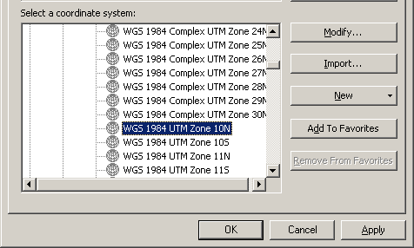

You can follow this process to set the map view projection based on your geographic area of interest.

## How to project a shapefile

1. Open the Project Tool from Data Management Tools > Projections and Transformations > Feature

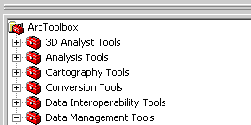

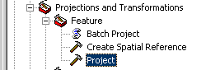

2. The Project Tool window will open.

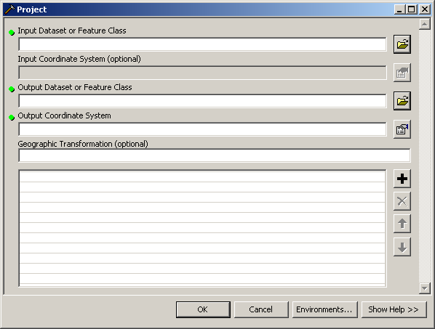

a. Specify Input Dataset. Click the Open Folder icon  and navigate to your input data folder. As an example we use the shapefile *_BaseData\Vancouver_Island\VI_PointsofInterest.shp*

b. Specify Output Dataset. Click  and navigate to your input data folder and specify an output name.

3. Specify the Coordinate System. Click the Coordinate System button . The Spatial Reference Properties window will open.

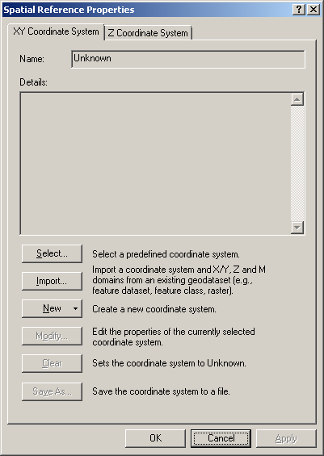

4. Click  to select a Predefined Coordinate System.

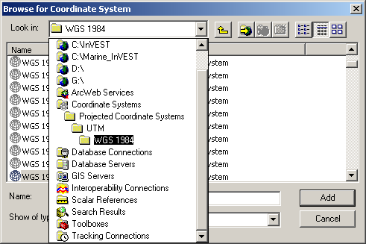

5. Navigate through the folders Coordinate Systems > Projected Coordinate Systems > UTM > WGS 1984.

In this example, we are selecting WGS 1984 UTM Zone 10N. The exact coordinate will depend on your geographic location.

6. The coordinate system/projection reference information is now set.

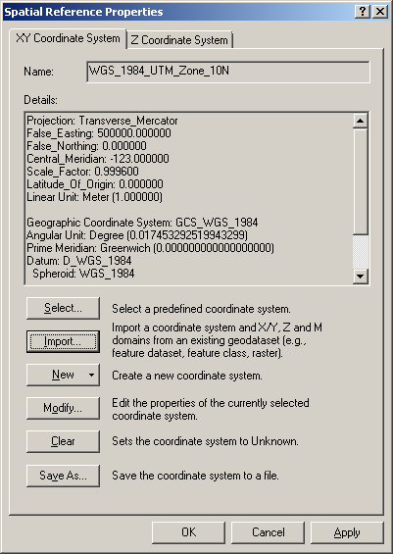

Click  to commit the changes and to return to the Project window.

7. The Project tool is completed and ready to be run.

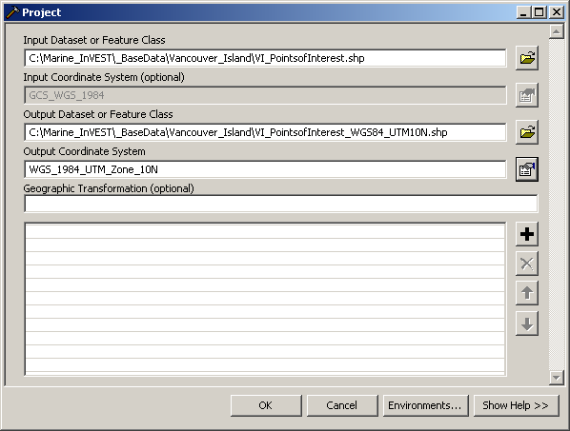

Click  to run the tool.

8. The tool has successfully projected the input data. Check the output shapefile under the input data folder.

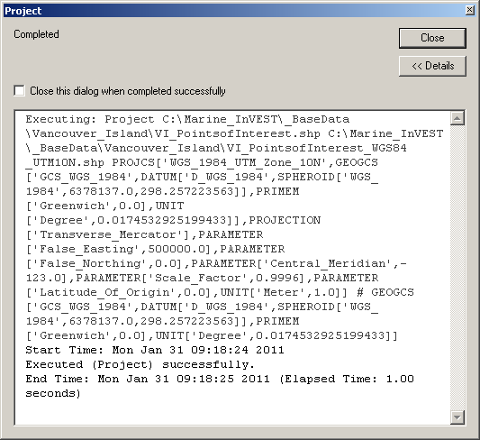

## How to convert geographic coordinate systems/datums

1. Adding a dataset with a datum (that is, geographic coordinate system) different than the map view produces a Geographic Coordinate System warning. In this example, we added a AquaWEM_points shapefile that uses the NAD 1983 datum while the map view is in WGS 1984.

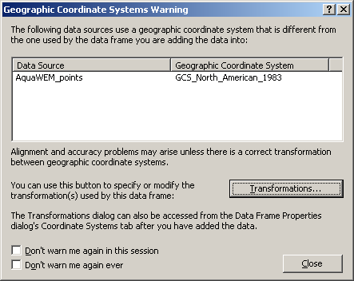

Users can check the Adobe file geographic_transformations.pdf under the ArcGIS installation ArcGIS\Documentation folder to determine the appropriate datum transformation by geographic location.

2. We can use NAD_1983_To_WGS_1984_1 to convert from NAD 1983 to WGS 1984, which is valid for Canada, Central America, Mexico, and United States (Alaska, CONUS)

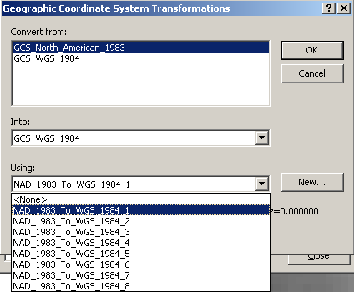

3. The appropriate transformation is specified and we can continue.

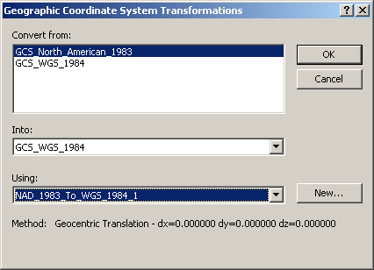

4. Click  to calculation the transformation.

5. To save a copy of the AquaWEM_points shapefile with the WGS 1984 datum, right-click the AquaWEM_points name in the table of contents.



Select Data (near the bottom of the drop-down menu) and select Export Data.



6. The Export Data window opens and you need to specify the source of the coordinate system and the output file name.

a. You need to specify the same coordinate system as the data frame (map view) in order to preserve the datum transformation specified in step 2.



b. Click  and navigate to the C:\Marine_InVEST\Viewshed\Input folder (same folder as AquaWEM_points). Here we use AquaWEM_points_WGS1984.shp

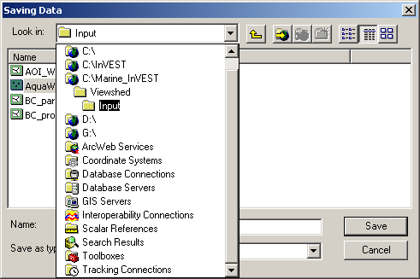

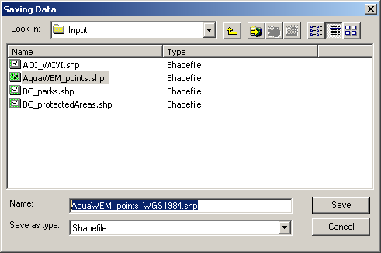

7. The Export Data window is completely filled to export the data to calculate and preserve the datum transformation.

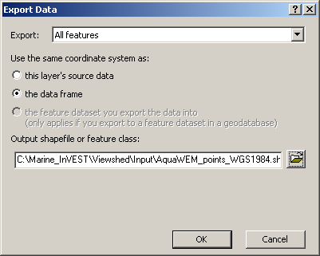

8. Click  to export the data.

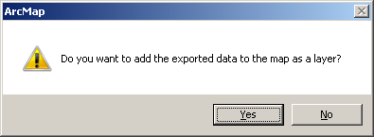

9. Click  to add the new data to the map view.

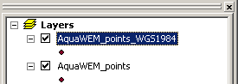

## How to create an area of interest (AOI) polygon

1. Add Drawing toolbar

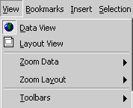

2. Change Drawing tool to Polygon. In the lower left corner, click black down arrow  next to white square 

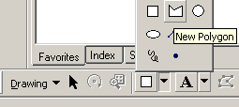

3. With the cross-shaped cursor + start creating the AOI by left-clicking along shoreline.

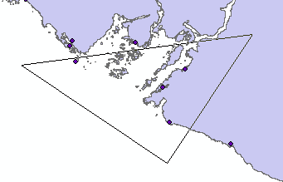

4. As you left-click, the corners of the AOI polygon will be created, defining the AOI shape. Continue left-clicking until you are satisfied with your AOI. Double left click to finish the AOI polygon.

5. With the polygon selected left-click the Drawing button  to open the Draw menu.

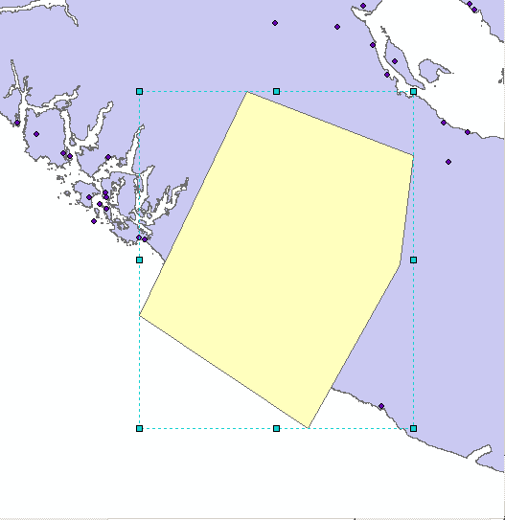

6. Select the Convert Graphics To Features tool

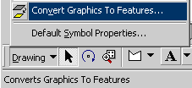

7. Specify options for convert graphics to featues

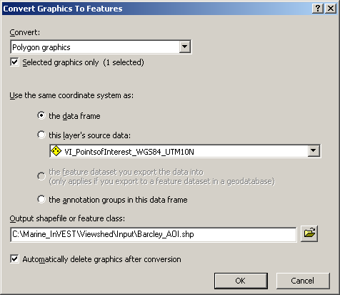

a. Specify the same coordinate system as data frame



b. Give your AOI a meaningful name



c. Check the Auto delete graphics checkbox



d. Click  to create

8. Add exported graphic to map

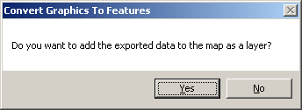

9. Completed AOI

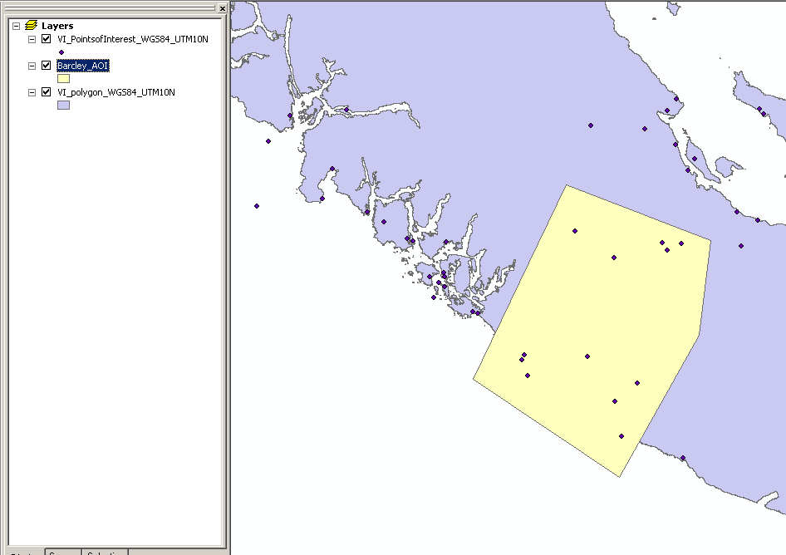

## How to create sea level rise data

1. Create a polygon shapefile following Creating an AOI instructions.

2. Adding a new field, RANK. Open attribute table of sea level rise shapefile

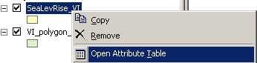

2. At the bottom of the attribute table click Options  and Add field 

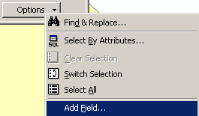

3. In the Add field window, create a new field named RANK (Type: Short Integer) that contains the risk of sea level rise.

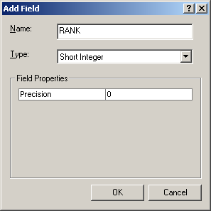

4. Start an editing session. Add the Editor toolbar

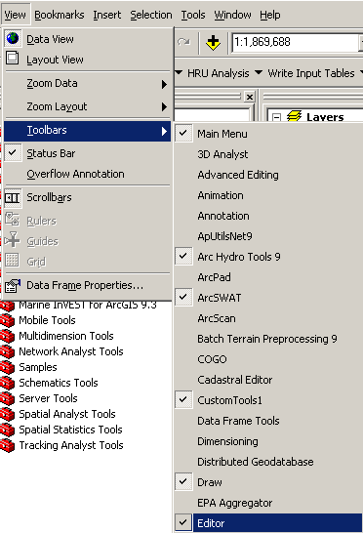

5. Click the  button and then Start Editing



6. Select the folder to edit from; this is the location of the sea level rise shapefile you just created.

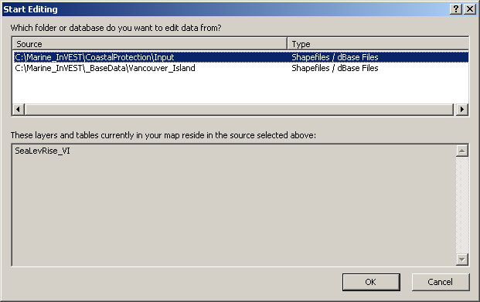

*Editing toolbar:*



7. Turn on the Snapping environment. Snapping allows you to create exact locations and continuously connected data, and to avoid an errors when cutting polygons. Click on the Editor menu and select Snapping.



**:**

**:**



8. Set the polygon parts you want to snap to. Check Vertex and End. This ensures continuous connecting lines when cutting a polygon at the corner of a previous cut.

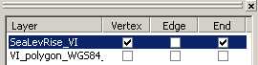

9. Setting the snapping tolerance value and set the snapping tolerance to ‘*map units*’. The snapping tolerance is the distance within which the cursor is snapped to another location. You will need to experiment with the tolerance value based on the geographic extent you are working at.

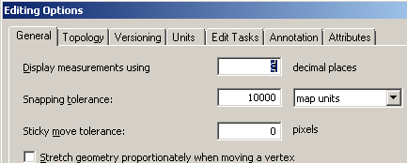

10. Click  to set the snapping tolerance options.

11. Cutting the polygon. Change the Editing task to Cut Polygon Features 

12. Select the Edit tool  from the Editor toolbar and select the polygon

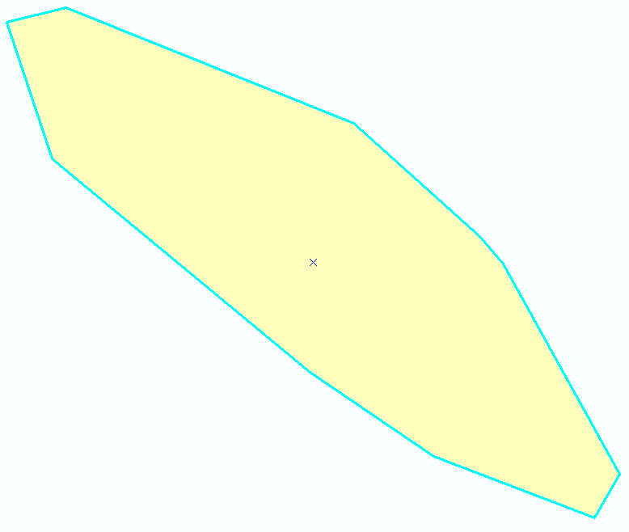

13. Click on the Sketch Tool . The cursor will turn to a cross with a blue dot  and use this to

14. Draw a cut line by left-clicking to start the line and to add vertices to define the line.

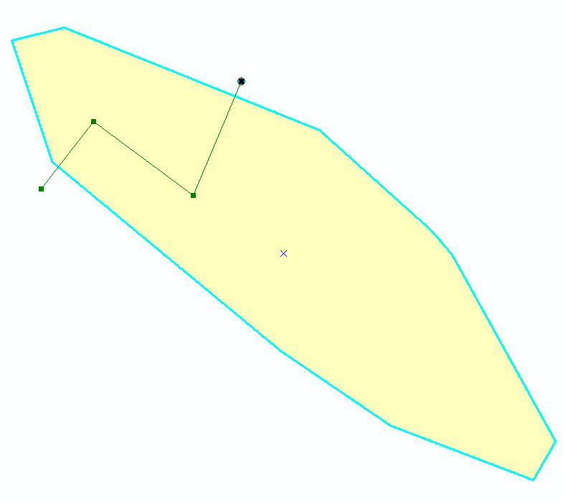

15. Double-left click to finish the line.

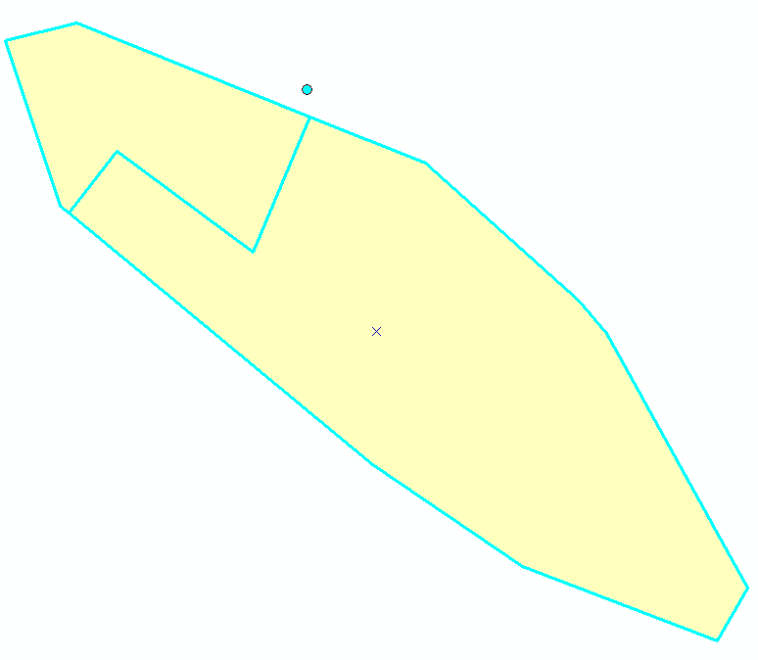

16. Continue cutting the polygons until you have completed the sea level rise shapefile.

17. Save your edits by clicking the Editor menu and selecting Save Edits.

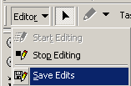

18. Populate the RANK field. Click the Edit tool  and select on of the polygons. Click the Attributes button  to open the Attributes editor window.

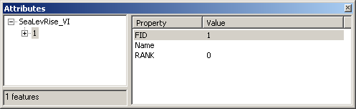

19. Click on the 0 value next the RANK field name to change the value.

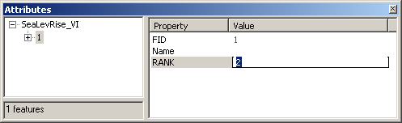

Use the Edit tool to click another polygon.

Continue this step until all polygons’ RANK values are assigned.

20. Save your edits.

21. Stop the Editing session by clicking the Editor menu and then Stop Editing

Completed sea level rise data

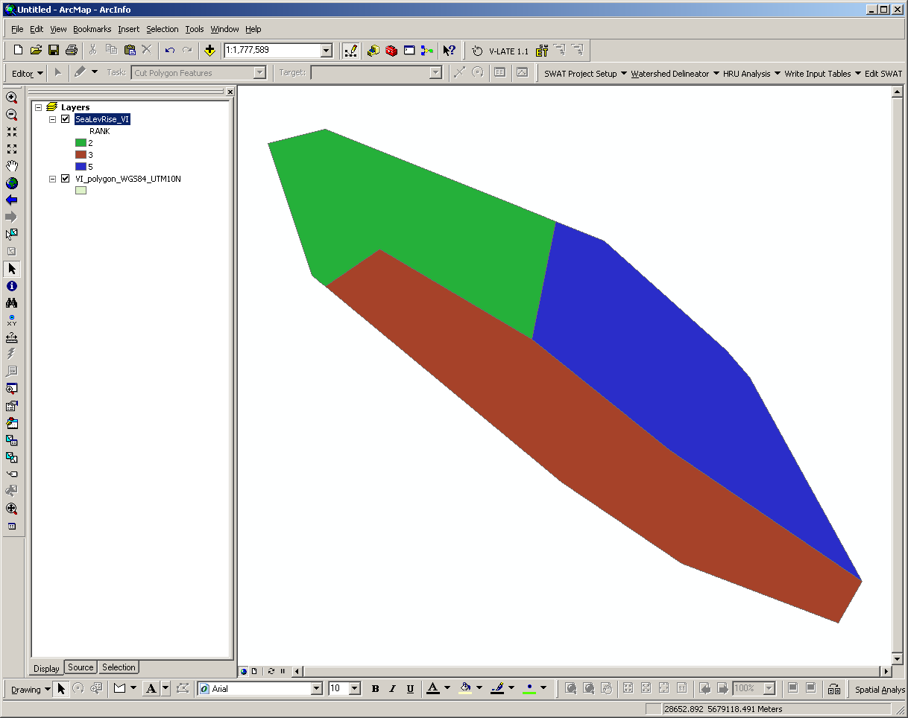

## How to quickly symbolize a dataset with a layer (.lyr) file

1. Add the *global_pop* Raster to ArcMap data frame (from *C:\Marine_Invest\_BaseData\Population* folder).

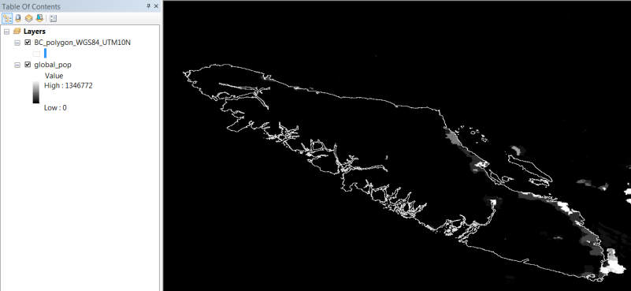

2. Open *global_pop* properties. Right-click the *global_pop* name (or double left-click).

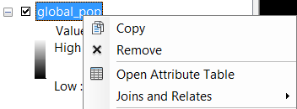



3. Click on the Symbology tab on the Layer Properties window.

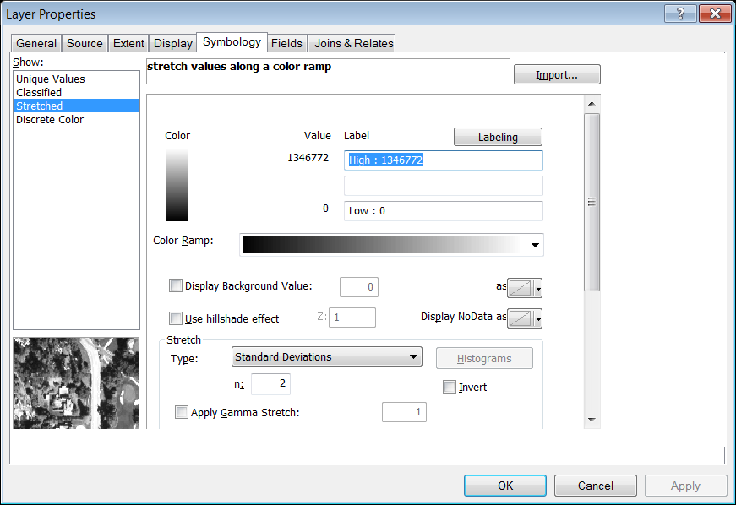

4. Assign symbology layer. Click , then click  and path to *GRUMP 1 km Pop Grid.lyr* (from *C:\Marine_Invest\_BaseData\Population* folder).

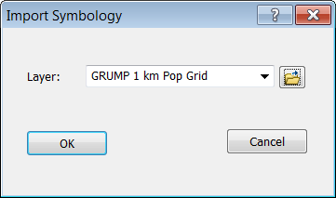

5. Click  to load the symbology layer.

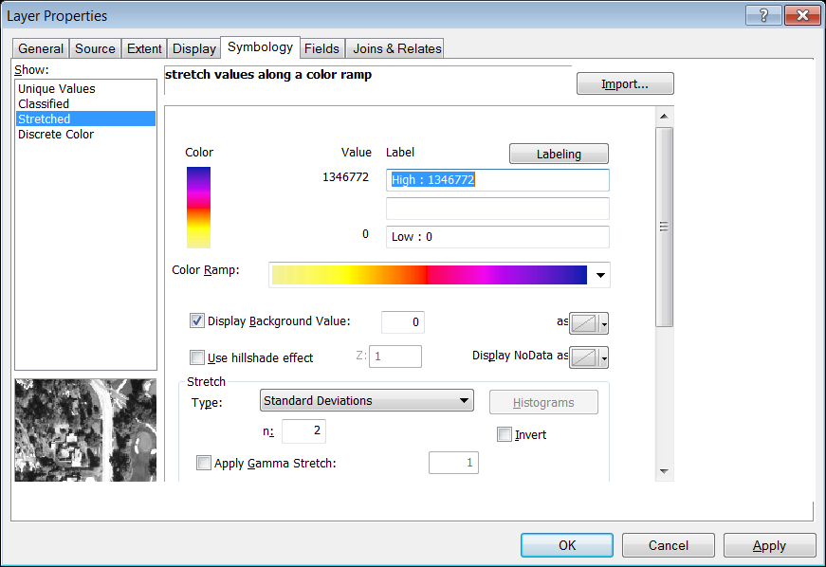

6. Click  to assign the symbology to the *global_pop* Raster.

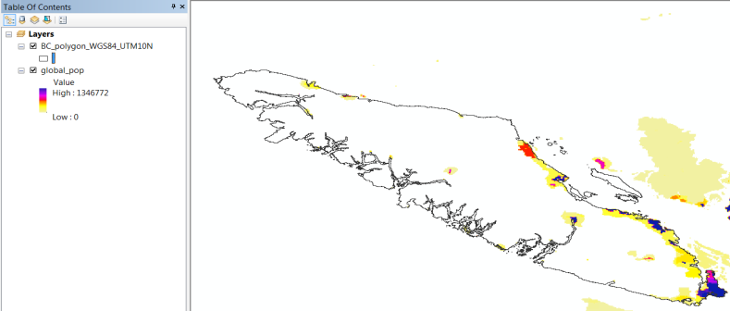

You can use this approach to load pre-defined symbology to any dataset.

## How to check the spatial information of a GIS dataset

1. Add the *global_pop* Raster to ArcMap data frame (from *C:\Marine_Invest\_BaseData\Population* folder).

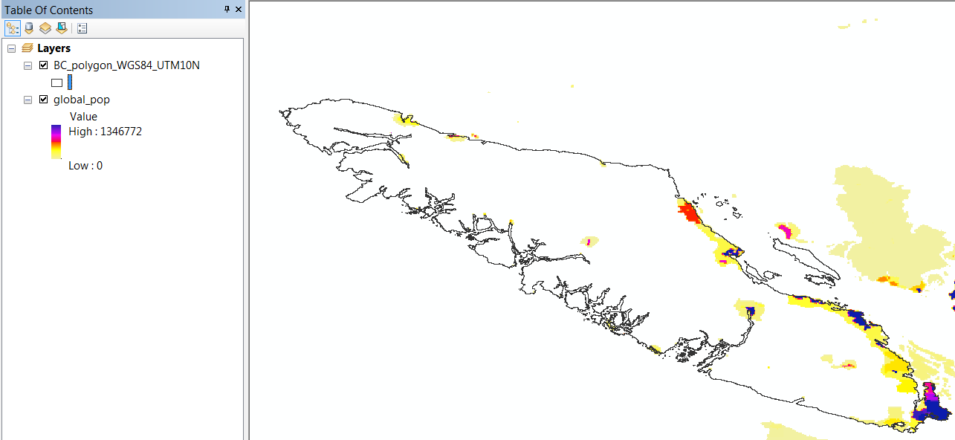

2. Open *global_pop* properties. Right-click the *global_pop* name (or double left-click).





3. Click on the Source tab on the Layer Properties window.

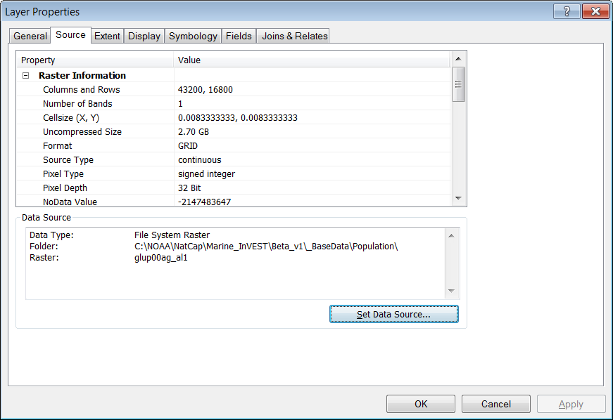

4. The Spatial Reference information can be found near the bottom of the Property scroll window.

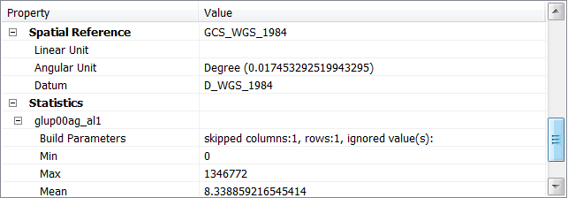

Note that GCS_WGS_1984 is the spatial reference information for the *global_pop* Raster. This means the Raster is in the WGS 1984 Geographic Coordinate System (or datum).

This information is very useful when projecting data or performing a datum transformation.

5. Click  to close the Layer Properties window and carry on with your InVEST modeling.

## How to determine the UTM zone of your area of interest

1. Adding data to the current map view. Add *VI_polygon_WGS84_UTM10N.shp* from MarineInVEST\_BaseData\Vancouver_Island

Add *UTM_Zone.shp* from MarineInVEST\_BaseData\Grids\

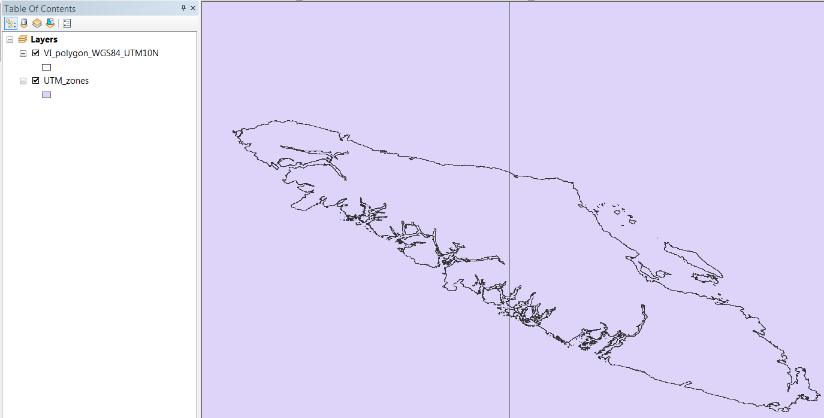

2. Change the symbology. Left-click on the symbol box under UTM_zones to open the Symbol Selector.

3. Click on  to open the color pallete. Change the fill color to No Color and the Outline Color to dark green with an outline width of 2.

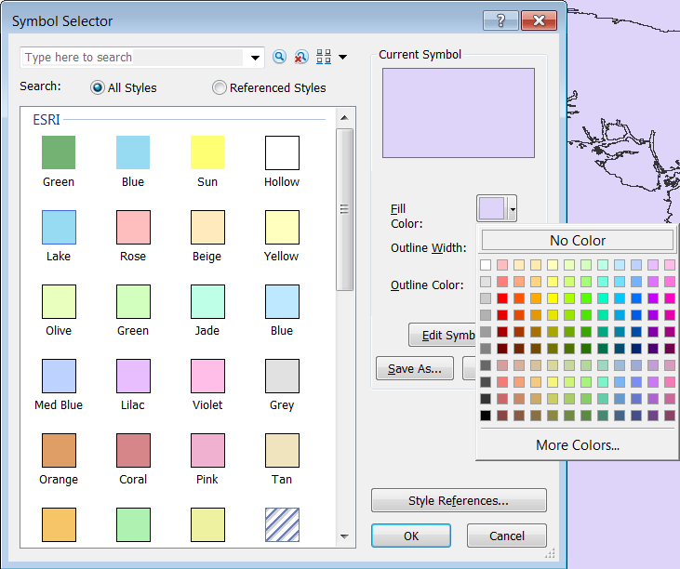

4. Double left click the *UTM_Zone.shp* name to open the Layer Properties and click on the Labels tab.

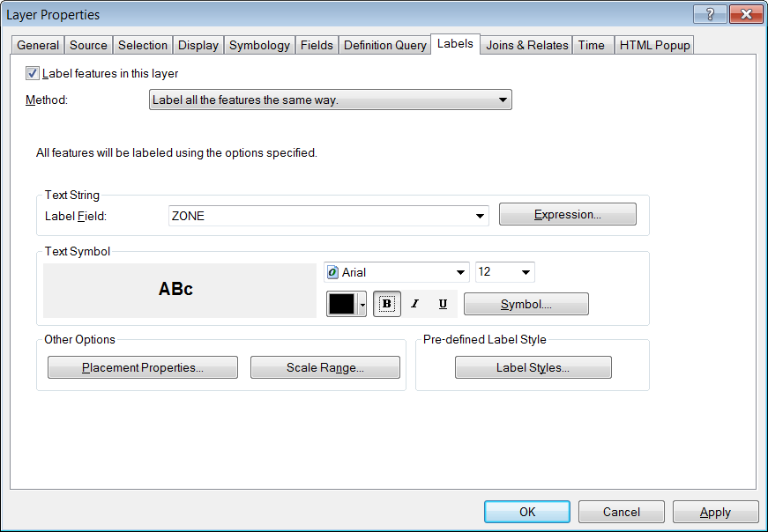

Check the checkbox.

Ensure the Label Field is set to ZONE 

Change the font size to 12 and Bold  the labels.

Click to label the zones.

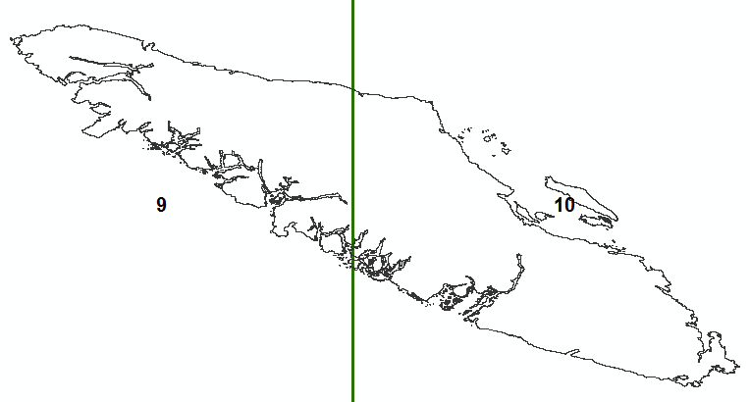

You can now determine the appropriate UTM zone for the InVEST models and to project your data, if needed.

## How to create a point shapefile

1. Add Drawing toolbar



2. Change Drawing tool to Marker (Point). In the lower left corner, click black down arrow  next to white square 



3. With the cross-shaped cursor + start creating the AOI by left-clicking along shoreline.

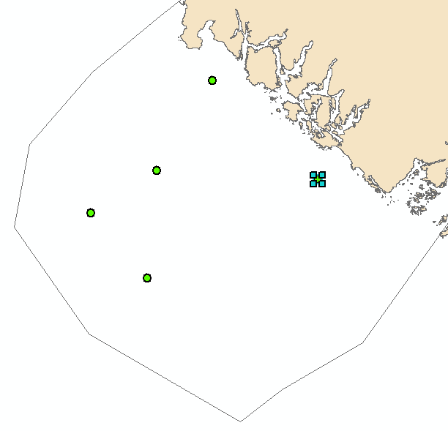

4. Left-clicking the mouse will create points. Each time you want to add a point you will need to click back on the Point marker tool .

5. With all the points selected left-click the Drawing button  to open the Draw menu.

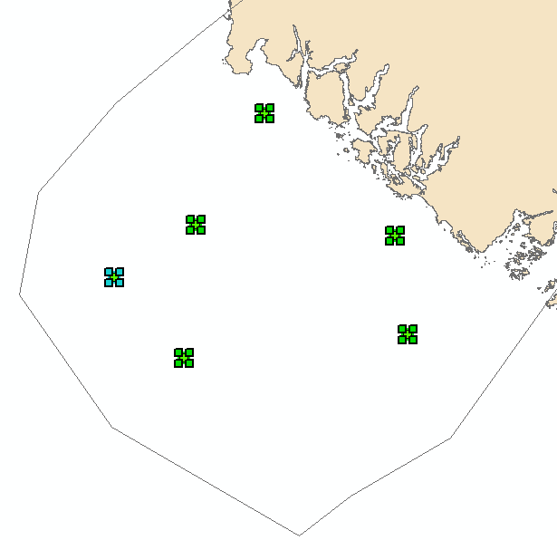

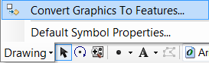

6. Select the Convert Graphics To Features tool

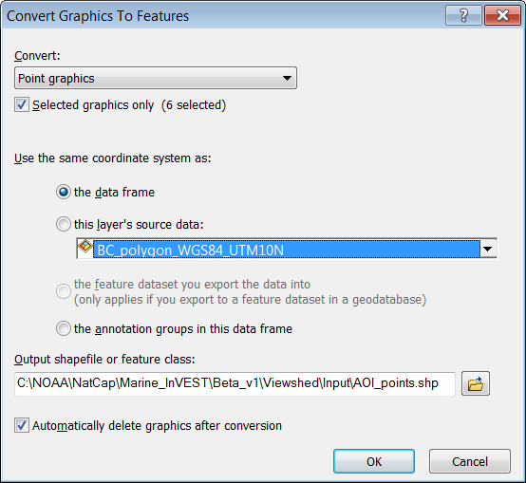7. Specify the options to convert graphics to features

a. Specify the same coordinate system as data frame



b. Give your point shapefile a meaningful name



c. Check the Auto delete graphics checkbox



d. Click  to create

8. Click  to add exported graphic to map

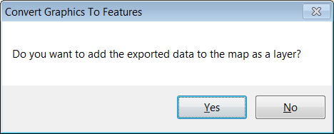

9. Completed points.

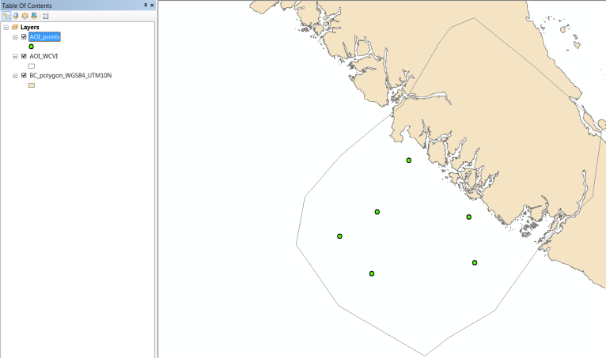

10. Modifying the attribute table: Calculating a field and Adding a new field.

Open the attribute table of the new point shapefile,

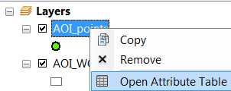

The shapefile already has Name field where you can enter a specific name for each point.

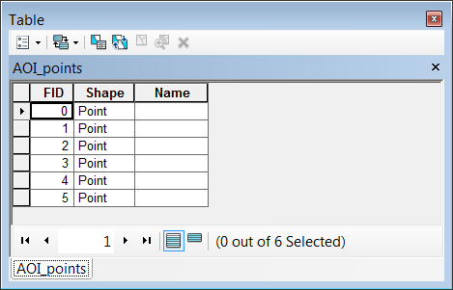

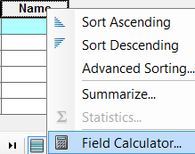11. To add a name, left-click a row  and then right-click the Name field heading to open the Field Calculator.

12. Enter a name in the expression text box under Name =. Since we are creating text data, make sure the point name is enclosed in double quotes. For example “*View Point 1*”.

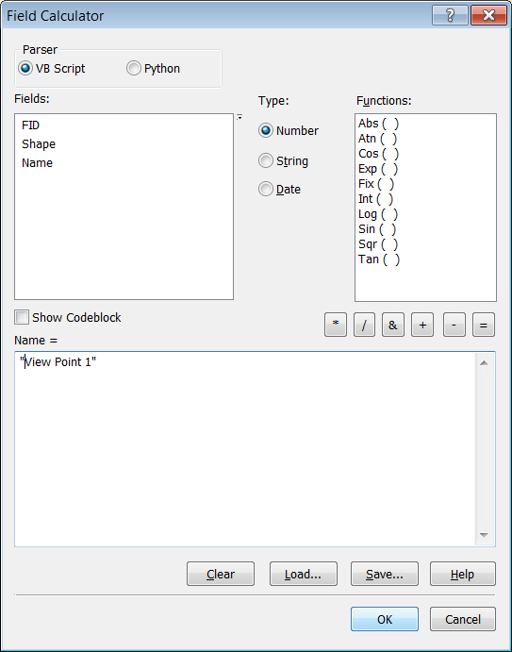

13. Click  to make the calculation.

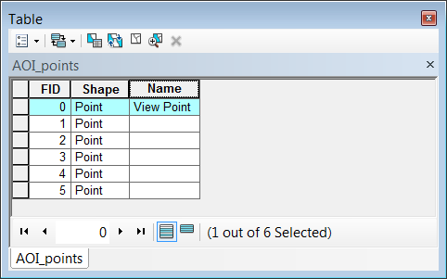

Left click another row to calculate another name.

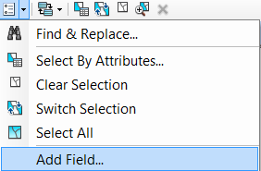14. To add a new field, click the Table Options button  and click Add Field.

15. Enter a name for the new field.

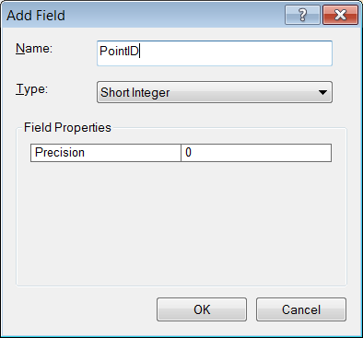

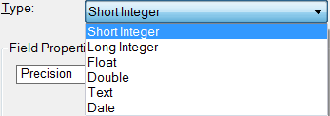16. You can select the data type, inter (short or long), decimal (float or double), text or data by clicking on the poull down arrow to the right of Type

17. Click  to create the field. Repeat as needed. 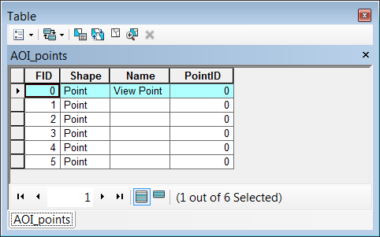

# Hardware, software and source code

## What software is required to run InVEST models?

InVEST tools run as script tools in the ArcGIS Arc Toolbox environment. To run InVEST, you must have:

* ArcGIS 9.3 (service pack 1 or 2) or ArcGIS 10 (service pack 1) with Spatial Analyst extension installed and activated.
* Python 2.5 or higher, which is typically installed automatically as part of ARCGIS. The pollination model and all marine models require additional Python libraries.

## What tools and models can InVEST work with?

InVEST works in the ArcGIS platform so any tools or models that can work on this platform can be combined with InVEST. The code is open source; it can be edited to bring different models together. InVEST has standard mapping outputs that can be combined with other tools or models that use these similar, standard outputs.

## How do I edit the source code for InVEST?

InVEST is an open source product and as such the source code of each model can be inspected and modified by users. The python scripts are in the folder \InVEST\python\. There is one script per model, and each ends with a *.py suffix and can be edited as needed using IDLE (which comes with the ArcGIS Python install), Pythonwin or any text editing software. InVEST is subject to standard open source license and attribution requirements, which are described and must be agreed to in the installation process. We hope that users will submit improvements, error fixes, and suggestions to the Natural Capital Project so that improvements can be made to future versions.

## What is the latest version of InVEST?

The latest version of the software is [InVEST 2.1 Beta](http://invest.ecoinformatics.org/), which was released on May 13, 2011.

## How can I find out which version of InVEST I am using?

Upon installation, the folder name will state the version of InVEST, e.g., InVEST 2.1. In addition, the toolbox name will have the version number included in the title and the [InVEST User’s Guide](http://stanford.edu/~woodsp/natcap/invest/docs/21/index.html) documentation downloaded with the software will also contain the version number.

# Data

## Does InVEST come with any data?

A set of sample data for the Willamette valley in Oregon, United States is supplied with the InVEST models to help users gain familiarity with the models and how they work. To use InVEST for your context, however, you will need to compile the data described in the [InVEST User’s Guide](http://stanford.edu/~woodsp/natcap/invest/docs/21/InVEST_Documentation_v2.1.pdf) chapters for the models you wish to run and format them as indicated. The guide also includes suggested data sources.

## What are the input data I’ll need to run InVEST?

Each ecosystem service model requires different input data, which can be found for each model under “Data Needs” in the [InVEST User’s Guide](http://stanford.edu/~woodsp/natcap/invest/docs/21/index.html).

## How do I get help finding/creating my input data?

Suggested data sources are available in the [InVEST User’s guide](http://stanford.edu/~woodsp/natcap/invest/docs/21/index.html). When creating input data, we suggest that you consult with local experts (i.e. local universities) and look for peer-reviewed publications for your area or areas similar in habitat types and bioregions. Due to the large number of users and our small number of staff, we are limited in helping with individual data needs.

# Using InVEST

## Are there any recommendations or estimates for the number of people, cost, and hours it will take to use InVEST?

Cost for an InVEST project will depend on scope, available data, and many other variables. Many of the data used by InVEST are freely available online, but some applications will require field study or other data acquisition. For a typical NatCap application of InVEST of several models, we recommend a team of 1-3 people for 2 months to a year. Such a team may be composed of a GIS analyst, a hydrologist to review hydrological inputs and outputs, and a project coordinator who can synthesize the InVEST analysis and connect it to policy and management questions.

## What kind of subject matter expertise would a tool user need to effectively apply the tool?

InVEST users require basic to intermediate knowledge of GIS. In some cases, effective application will require hydrological expertise for hydrological ecosystem service models. Familiarity with the local policy or management context as well as some knowledge of economic valuation can be helpful for interpreting InVEST results to inform the relevant policy or decision process.

## How does stakeholder engagement work with InVEST?

Stakeholder engagement is an important part of using InVEST in a decision-making process. For example, InVEST uses input values that draw on stakeholder consultation for preferences and information relating to ecosystem services (e.g. discount rate, carbon price). In addition, through discussion, stakeholders develop spatial “scenarios” to show future land use and marine and coastal uses. Following stakeholder consultations and scenario development, InVEST can estimate how the current location, amount, and value of relevant services are likely to change in the future.

## What have been the challenges found in tool uptake?

InVEST has been used in the U.S., Canada, China, Colombia, Ecuador, Indonesia, Belize, Uganda/DRC, and Tanzania and new NatCap sites are under development. NatCap is collecting and analyzing feedback from its current sites about the usefulness of InVEST in a variety of decision contexts and the level of expertise, time and funding required to conduct an InVEST analysis. Challenges so far include:

* Existing tradeoffs, special interests and politics of policy-making mean that most sustainable ecosystem service options are not easy to implement.
* Existing policy and institutional frameworks do not support multiple ecosystem service management.
* InVEST may be most useful in a heuristic or awareness-raising fashion in contexts where more sophisticated models and data are available.
* Additional analyses and models may be needed (beyond InVEST) for some applications.
* It can be difficult to obtain necessary input data.
* Some people prefer their ‘own’ tools, and it is necessary to build sense of ownership of the InVEST analysis and the legitimacy of InVEST results.
* There is a lack of understanding of environmental economics concepts and terminology.

## How do I make scenarios?

The Natural Capital Project is putting together a primer on scenario development for ecosystem service analysis, which will be released in early 2012. Scenarios typically include maps of potential future land use and land cover and/or marine habitats and ocean uses. Land use and land cover scenarios (LULC) can be created by using current LULC maps as a baseline and modifying them to reflect potential future changes. Stakeholder engagement can provide valuable inputs and review for scenario development so that InVEST can estimate how the current distribution and value of relevant services are likely to change in the future.

## Is there an optimal scale and data resolution for applying InVEST?

InVEST is flexible and can be used at any scale, from individual land parcels to entire landscapes, although there is some variation in the ideal scale across ecosystem service modules. The optimal data resolution will depend on the extent of your study area, the ecosystem services being modeled, and what the outputs will be used for.

## What time steps can I model with InVEST (annual, monthly, daily, seasonal)?

The time steps that can be modeled with InVEST vary by ecosystem service. For example, hydrological services are modeled annually due to high variability on smaller time scales. Please refer to the [InVEST User’s Guide](http://stanford.edu/~woodsp/natcap/invest/docs/21/index.html) to find out more information on the time steps modeled.

# Training, discussion forum and support

## Do you offer training on InVEST such as tutorials or videos?

Several InVEST training workshops may be offered annually, subject to funding and demand. Information on these trainings will be announced on the [Natural Capital Project website](http://www.naturalcapitalproject.org). Currently there are no tutorial videos available, but they will be posted on the website when developed.

## If I create a new model, can it be included in InVEST?

The Natural Capital Project encourages users that have modified versions of the code or that have created a new model to submit their code and supporting documentation to our modelers and developers, who will consider it for future versions of the open source product. You can contribute through our [online user support community](http://invest.ecoinformatics.org).

## Can I get help using InVEST? Is there a forum for asking technical questions?

Registered users have access to limited online support. Users can submit questions, formal error reports, bug fixes, or modified versions of InVEST source code through the [discussion forum](http://invest.ecoinformatics.org/discuss). We are actively working on making this system more robust.

## How can I suggest new features for InVEST?

Registered users can submit suggestions for improvement or modified versions of code for InVEST models, which will be considered for future versions of the open source product. Submit your suggestions and code through the [discussion forum](http://invest.ecoinformatics.org/discuss). If you have completed a project using InVEST, please share your experience with us through our [user survey](http://invest.ecoinformatics.org/user-survey) and we will use the feedback to improve InVEST

## How do I share data with other InVEST users in my area and learn about their projects?

A [discussion forum](http://invest.ecoinformatics.org/discuss) is available for registered InVEST users that can be helpful for finding other users in your area. Start a new conversation in the *General Support Issues* topic. If you have collected good data that you would like to share with others, please post links to it on the User Forum, please be sure to provide source references and/or metadata. For smaller datasets (i.e. table of values or document containing data sources), please post the information in the shared older on the user support site.

## What does it mean to *model tradeoffs*?

Tradeoffs can arise from management choices or actions that alter the quality or quantity of multiple ecosystem services. For instance, forest management that maximizes timber yield could diminish carbon storage and sequestration, sediment retention, and biodiversity. Assessing tradeoffs through modeling involves estimating the ecosystem services for an existing landscape and comparing those estimates to the results of alternative future management choices. This enables decision-makers to identify the risks and opportunities of a management action in terms of ecosystem services gained or lost.

## Does the Natural Capital Project want to see my InVEST results?

Yes! We want to hear how you are using InVEST. Please share your project with us through our [user survey](http://invest.ecoinformatics.org/user-survey).

# Keeping up with new developments, staying connected, and learning more

## How can I subscribe to updates about InVEST and the Natural Capital Project?

You can subscribe to updates by registering on the InVEST website at <http://invest.ecoinformatics.org/> and checking *subscribe to InVEST newsletters*. If you have already registered and would like to receive emails or are not sure if you are subscribed to NatCap updates, log in to the website and view your subscription status under *Personal Preferences*.

## Where can I learn more about InVEST and the Natural Capital Project?

A book describing the science of the InVEST approach, [Natural Capital Theory and Practice of Mapping Ecosystem Services](http://ukcatalogue.oup.com/product/9780199588992.do), has been published by Oxford University Press. Our website also provides information about our tools, projects, publications, and staff, including a [InVEST User’s Guide](http://stanford.edu/~woodsp/natcap/invest/docs/21/index.html), which provides step-by-step instructions for using InVEST, including suggested data sources.

# Collaborating with the Natural Capital Project

## Will the Natural Capital Project help me find funding to use InVEST for my project or give me a grant?

Unfortunately, we do not provide fundraising support to use InVEST.

## Can the Natural Capital Project help me publish my work with InVEST?

We typically do not help publish work that uses InVEST; however, we do encourage you to share how you are using InVEST us through our [user survey](http://invest.ecoinformatics.org/user-survey).

## Can the Natural Capital Project send someone to present InVEST to my group and participate in my meeting?

The Natural Capital Project staff welcomes opportunities to participate in your meetings; however, due to time constraints, we accommodate such requests on an individual basis. Please contact us directly at [invest@naturalcapitalproject.org](mailto:invest@naturalcapitalproject.org) to see if a Natural Capital Project staff member is able to participate in your meeting.