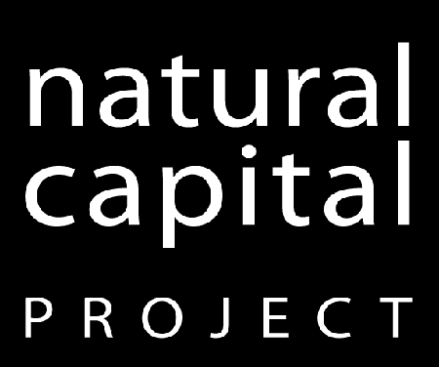

**Natural Capital Symposium**

**2015 Draft Agenda (January 7 version)**

The **Training Track** will be a 3-day course in NatCap's approach and our primary software tool, InVEST, for those who have limited or no prior experience with our approach and tools. There will also be more advanced technical training sessions offered each day for experienced users, focusing on hands-on work with specific models, the latest updates and advancements with the software, and other topics.

The **Engagement** **and** **Pathways to Impact Track**, experts from around the world will share experiences in using InVEST and related tools and approaches to drive change in policy and practice. We will compare theories of change with actual experience of change in contrasting sites, sectors and decision contexts. In sessions on Integrating Natural Capital and Resilience, we will discuss recent advances, emerging trends, and key challenges. NatCap strives to advance the science behind ecosystem services, and to apply new ways to bring our approach to governments, corporations, and other organizations across the globe. Sharing lessons and opportunities among members of the broader practitioner community is a great way to do that.

The **NatCap Learning Exchange** will offer a variety of opportunities to work in small focus groups with NatCappers as well as practitioners from other organizations, including model-specific small-group workshops, poster sessions, focused discussion groups, panel discussions, and more. We know that we have a lot to learn from others working in this space, and we hope to foster a lively exchange of knowledge, information, and understanding. This will be a great opportunity to seek out new collaborations with NatCap and many other organizations and individuals who will also be in attendance.

We will be frequently updating this agenda with more detailed information in the coming weeks. Please see the following pages for the tentative schedule of events. In the meantime, please contact [Henry Borrebach](mailto:borrebach@stanford.edu) with any questions.

**Monday, March 23**



**Tuesday, March 24**



**Wednesday, March 25**

