Design Document

InVEST Urban Health Model

Link to PEP Urban Mental Health Model

v0.1.0: 2023-05-18 – first draft
v0.2.0: 2024-06-02 – group edits
v0.3.0: 2025-05-10 – update with simplification after 2025 Olympics

Last update: 2025-05-27

* Draft & revised by Yingjie Li, building on earlier work by Bratman, Lawler, Wheeler, Roy Remme et al.

Earlier work for reference:
- InVEST Mental Health Model Drive
- https://github.com/natcap/invest-mental-health
- Urban Nature Access — InVEST documentation
- Piloting Nature-based Solutions for Urban Cooling | GPSC (Guangzhou case)
- Link to InVEST urban nature access and physical activity and health model.docx [Yougeng]

Table of contents
Table of contents 1
1. Introduction 2
2. Model description 3
2.1 Overview 3
2.2 Health impact assessment 4
2.3 Nature exposure (NE) estimation 6
2.3.1 NE estimation [option 1] - tree cover scenarios 6
2.3.2 NE estimation [option 2] - Translating LULC to NDVI with attribute mapping 9
2.3.3 NE estimation [option 3] - Translating LULC to NDVI with observed NDVI rasters 10
2.4 Health cost estimation 11
2.5 Summary of inputs 12
2.6 Summary of outputs 13
3. Use cases 14
3.1 Public health assessment 14
3.2 Green infrastructure planning and management 14
References 14

Introduction

The model aims to estimate the impacts of nature exposure on mental health. It acknowledges the fact that nature exposure comprises only a small proportion of the total predictors of health, which include many other social, economic, and environmental determinants (Bratman et al. 2019).

We constructed a comprehensive conceptual framework for mental health modeling by synthesizing existing knowledge and several working group discussions (Figure 1). Natural features in cities can be characterized by the size, type, and qualities. Nature exposure is estimated through methods that take availability, accessibility (or proximity) [cite UNA model], and intensity of nature contact into account. Given that people have different levels of awareness and perceptions of natural environments, the same nature exposure may generate different mental health effects. The concept of “nature dose” can further characterize the types and intensity of experience that exposure instantiates. The mental health effects of nature dose can vary according to the moderating influences of individual differences and sociocultural context, which may affect the impact experienced by people (e.g., population income groups A to D).
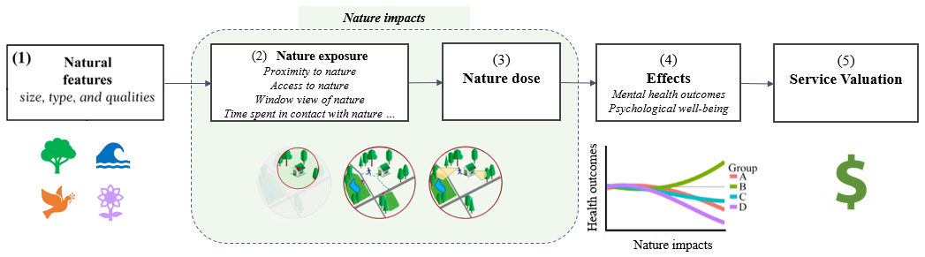
Figure 1. A conceptual model for the nature-health relationship (adapted from Bratman et al. 2019).

Ideally, the mental health model could fully incorporate various aspects in this broad conceptual framework. However, due to the limited understanding of the various pathways through which urban nature impacts on human health outcomes, the proposed model is a simplified version of the ideal framework, and was constructed based on the best availability of current science and knowledge. The proposed model presented in the following sections mainly uses residential greenness–one of the most commonly evaluated nature exposures–to characterize the effects of urban nature on mental health outcomes. Although simplified, the model is conceptualized with a range of flexibilities & complexities in order to be applicable to different modeling needs. This model is open for discussion/development and a comparable conceptual framework is being developed for physical health. Ideally, both mental and physical health outcomes can be modeled in the same InVEST model, only requiring on InVEST health model.

Model description

Overview
The mental health model calculates the preventable mental disorder (or mortality) cases at the pixel level, based on alternative urban greening scenarios. Based on data availability and model feasibility, this model only focuses on residential nature exposure, and considers including two types of land use scenarios to characterize the effect of nature exposure on mental health outcomes.

Residential nature exposure is defined as the average greenery around a residence that benefits human mental health. Commonly this is measured by the average NDVI or the percentage of greenspace within a certain distance. In this proposed model, we chose to use average NDVI as the main proxy. This is because when estimating the health impacts using an existing relative risk, it is important to use an exposure assessment methodology for the impact assessment that is as similar as possible to the one used to estimate the exposure-response function itself (Giannico et al. 2024). Most of the studies included in the meta-analyses (Rojas-Rueda et al. 2019; Liu et al. 2023) used NDVI as a proxy for nature exposure, typically based on annual average NDVI values. To maintain consistency with these effect sizes, it is recommended that users input annual NDVI data into the model. However, if users have access to health effect sizes derived from seasonal NDVI, they may instead use season-specific NDVI inputs. Users should keep in mind that mental health outcomes often reflect longer-term exposures and may not respond to short-term or highly variable changes in greenness. We recommend using this approach for year-to-year comparisons, even when employing season-specific NDVI inputs.

Land use scenarios are key to understanding how alternative land use change and associated greenery change might impact mental health benefits. To ensure best use of existing science knowledge and better communication with policy makers, we included three options for land use scenario (Figure 2).
- The first is to use tree cover. Several ambitious cities in the world in terms of greening, including Barcelona, Bristol, Canberra, Seattle, and Vancouver, have set a target of achieving 30% canopy cover in every neighbourhood. Tree canopy cover is a promising and appealing argument for stakeholders, especially urban policy makers, to set an intuitive goal. A recent study has used tree canopy cover for a counterfactual scenario and linked the target to NDVI changes for health impact assessment (Giannico et al. 2024). The proposed model follows the same framework to estimate preventable mental disorder cases.
- The second option for land use scenarios is based on land use and land cover maps, which are commonly used on other InVEST models as well as in real world urban planning practices. Users need to provide the baseline LULC and a LULC under a future or counterfactual scenario in order to get an estimate of the nature exposure difference, which will be measured by NDVI values, based on statistical mapping between land cover types and NDVI values (e.g., forest cover usually has a higher NDVI value than bare land cover and built-up land). Users therefore need to provide a LULC attribute table, specify the average or median NDVI values, for each LULC type.
- The third option is similar to Option 2, with the key difference being that users are asked to provide NDVI rasters for both the baseline and scenario conditions. These two rasters are then used to calculate the average NDVI for each LULC type under each scenario, allowing for a more nuanced and context-specific mapping between land use/land cover and NDVI values.

In the following section, we will elaborate on the model structure and necessary data inputs as well as the model outputs for interpretation.

Option 3
Option 2
Option 1
NDVI_delta
NDVI baseline
Tree cover (TC)
TC target
NDVI scenario
NDVI ~ TC curve
Health effect size table
Baseline incidence rate
Preventable cases
Health cost rate
Preventable cost
Population raster
LULC baseline
LULC scenario
LULC attribute table
NDVI baseline
NDVI scenario
LULC baseline
LULC attribute table
LULC scenario
Legend

Input data

Intermediate data

Output data
NDVI
baseline
NDVI
scenario
NDVI baseline
(mask water)
NDVI scenario
(mask water)
Figure 2. Flowchart illustrating the main computational steps of the Urban Mental Health model, from input data processing to estimation of preventable (or additional) cases and the corresponding changes in health costs. Note: NDVI is used as a proxy of nature exposure.

Health impact assessment
The model conducts a quantitative health impact assessment at the pixel level to estimate the number of preventable mental health cases resulting from changes in nature exposure. Specifically, it compares exposure under a baseline scenario with that of a counterfactual or target greening scenario.

When estimating preventable cases (PC), the model first calculates baseline cases (BC) for each spatial unit (e.g., region, district, or census tract), using either observed case counts or prevalence (or incidence) rates. If only baseline prevalence (or incidence) rates are available, users must provide spatialized population raster data to derive baseline case estimates (Equation 1).

For each pixel, the model computes the change in nature exposure (ΔNE) by subtracting baseline exposure (NE_baseline) from the counterfactual or scenario value (NE_scenario). The model then applies a dose–response function, expressed as a relative risk (RR) per unit change in exposure (e.g., ${RR}_{0.1NE}$), to quantify the health impact.

Using this, the preventable fraction (PF) and associated number of preventable cases (PC) are calculated. Confidence intervals around RR can be incorporated to capture uncertainty. Equations (1) through (4) in the design document detail the full mathematical formulation of this process.

$PC = PF × BC = PF × (BIR × POP)$ (1)
$PF = 1-RR$ (2)
$RR=exp(ln({RR}_{0.1NE})×10×ΔNE)$ (3)
$ΔNE ={NE}_{scenario}-{NE}_{baseline}$ (4)

where
- PC: preventable cases
- PF: preventable fraction
- BC: baseline cases. By default, baseline cases are calculated using the baseline prevalence (or incidence) rate and population data provided by the user.
- BIR: baseline prevalence (or incidence) rate. Input data provided by users, typically sourced from national or local health agencies such as the CDC. These rates are often derived from survey-based statistics and are available at various spatial levels (e.g., region, district, or census tract). If the data is provided in tabular format rather than as shapefiles, users must join it to the corresponding spatial units before using it as model input.
- POP: population. A raster dataset provided by the user, representing the number of inhabitants per pixel across the study area. Pixels with no population should be assigned a value of 0.
- RR: relative risk or risk ratio.
- NE: nature exposure. Here, the model uses NDVI as a proxy. NE_baseline is provided by the user as input, representing baseline nature exposure levels. NE_scenario is typically calculated within the model based on a user-defined tree cover target or land use/land cover (LULC) scenario, allowing for assessment of changes in exposure under alternative greening strategies (see section 2.3 for details).
- ${RR}_{0.1NE}$: RR per 0.1 NE increase. By default, the model uses the relative risk associated with a 0.1 increase in NDVI-based nature exposure. This value must be provided by users in the effect size table, based on empirical studies or meta-analyses relevant to the selected health outcome. In the sample data, we derived effect sizes for depression and anxiety from a meta-analysis by (Liu et al. 2023).

If the risk ratio is not available, while other effect size matrices, such as the odds ratio (OR) is available, a commonly used method to approximate the RR from an OR is based on a formula proposed by Zhang and Yu (Zhang and Yu 1998). This formula requires you to know or estimate the baseline risk (the prevalence or incidence of the outcome in the reference or non-exposed group).
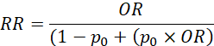 (5)
Where $p_{0}$ is the baseline risk. In this modeling case, this should be the probability of mental disorder for a population without nature exposure or with very limited nature exposure.

Nature exposure (NE) estimation
To estimate changes in health risk or benefits resulting from landscape modifications—such as those driven by land use planning or land cover change—nature exposure must be assessed under both baseline and scenario conditions (see Equation 3).

The baseline nature exposure is the actual level of greenness as measured by the average NDVI within a defined buffer distance from each residence. In the case study, we calculated the NDVI at a resolution of 30 m using images from the Landsat image collections via Google Earth Engine. Users can also use Sentinel-2 or MODIS (or Moderate Resolution Imaging Spectroradiometer) imagery to derive NDVI rasters. Given the potential mental health benefits of blue spaces, it would be ideal to include them in exposure assessments to more fully capture the diverse contributions of natural environments to human well-being. However, water bodies typically exhibit negative NDVI values, and there is currently insufficient empirical scientific evidence to derive a reliable effect size for blue space exposure using NDVI as a proxy. Consequently, the current version of the model provides an option to exclude (mask out) pixels classified as water bodies from the greenness exposure assessment. However, if users have access to robust, peer-reviewed effect sizes linking NDVI-based blue space exposure to health outcomes, they may choose to retain water bodies in the analysis.

[Assist Tool]:

Google Earth Engine script for generating NDVI rasters from the Landsat image collection (1986–present): https://code.earthengine.google.com/70c17ec2df3486da1c0013e3967c3619?accept_repo

Google Earth Engine script for generating tree canopy cover (tcc) rasters from existing datasets
https://code.earthengine.google.com/?accept_repo=users/yingjieli/invest-mh

Nature exposure under a scenario condition can be estimated using one of three approaches, designed to leverage the best available scientific knowledge while enhancing communication with policymakers. Each option is detailed in the following subsections.

NE estimation [option 1] - tree cover scenarios
The first approach estimates scenario-based nature exposure using a user-defined tree cover target. Tree canopy cover is a promising and appealing argument for stakeholders, especially urban policy makers, to set an intuitive goal. A recent study has used tree canopy cover for a counterfactual scenario and linked the target to NDVI changes for health impact assessment (Giannico et al. 2024). The proposed model follows the same framework to estimate preventable mental disorders.

To translate a tree cover target into an NDVI-based scenario, we follow the approach of Giannico et al. (2024), which establishes a non-linear relationship between tree canopy cover (%) and population-weighted NDVI using Generalized Additive Model (GAM). The model specification is as follows in Equation (6):

${NDVI}_{i}=β_{0}+f({TreeCover}_{i})+ϵ_{i}$ (6)

where NDVI_i is the normalized difference vegetation index at location 𝑖, 𝛽_0 is the intercept, 𝑓(.) is a smooth function of tree canopy cover, and 𝜀_i is the error term assumed to be normally distributed with mean zero. 𝛽_0 and 𝜀_i are calculated from GAM (see an example Python code below). We applied a cubic regression spline for f(.), as it provides a flexible yet stable approximation of non-linear relationships. The model was fit using population as a sampling weight, so that estimates reflect population-relevant patterns in greenness exposure.

from pygam import LinearGAM, s

# Define model with cubic spline
gam = LinearGAM(s(0, n_splines=10, basis='cr')) # Cubic spline (cr)

# Prepare data
X = data[['canopy_cover']]
y = data['ndvi']
weights = data['population']

# Fit model with population weights
gam.fit(X,y, weights)

# Summary
print(gam.summary())

This translation serves as a practical tool for communicating with stakeholders across diverse knowledge backgrounds. For instance, in the Italy case study, achieving 30% tree cover corresponded to NDVI values at the 75th percentile of the population-weighted NDVI distribution. This suggests that reaching the tree cover target could elevate nature exposure levels to or above what 75% of the population currently experiences, effectively illustrating the potential magnitude of health benefits under the greening scenario (Giannico et al. 2024). This proposed model automatically performs the translation from tree cover target to NDVI-based exposure (NE_scenario) once the user provides a baseline NDVI raster, a tree cover raster, and a defined tree cover target (Figure 3). The change in nature exposure (ΔNE) is then calculated by subtracting the baseline exposure (NE_baseline) from the scenario exposure (NE_scenario), forming the basis for estimating potential health benefits.

In some cases, certain districts may already exceed the city-wide tree cover target or have higher NDVI values than the target scenario. Additionally, it is unlikely that a city-wide urban greening target would involve removing existing greenspace (but for scenarios involving more spatially explicit land use changes—including the conversion of greenspace to non-green uses—please refer to Options 2 and 3). To avoid misleading or confusing results from option 1 case, the model automatically sets negative ΔNE values to NoData, indicating that no additional greening—and thus no additional benefit—is expected in those areas. For transparency and quality assurance, the original output with negative values is also saved separately in the output folder for reference.

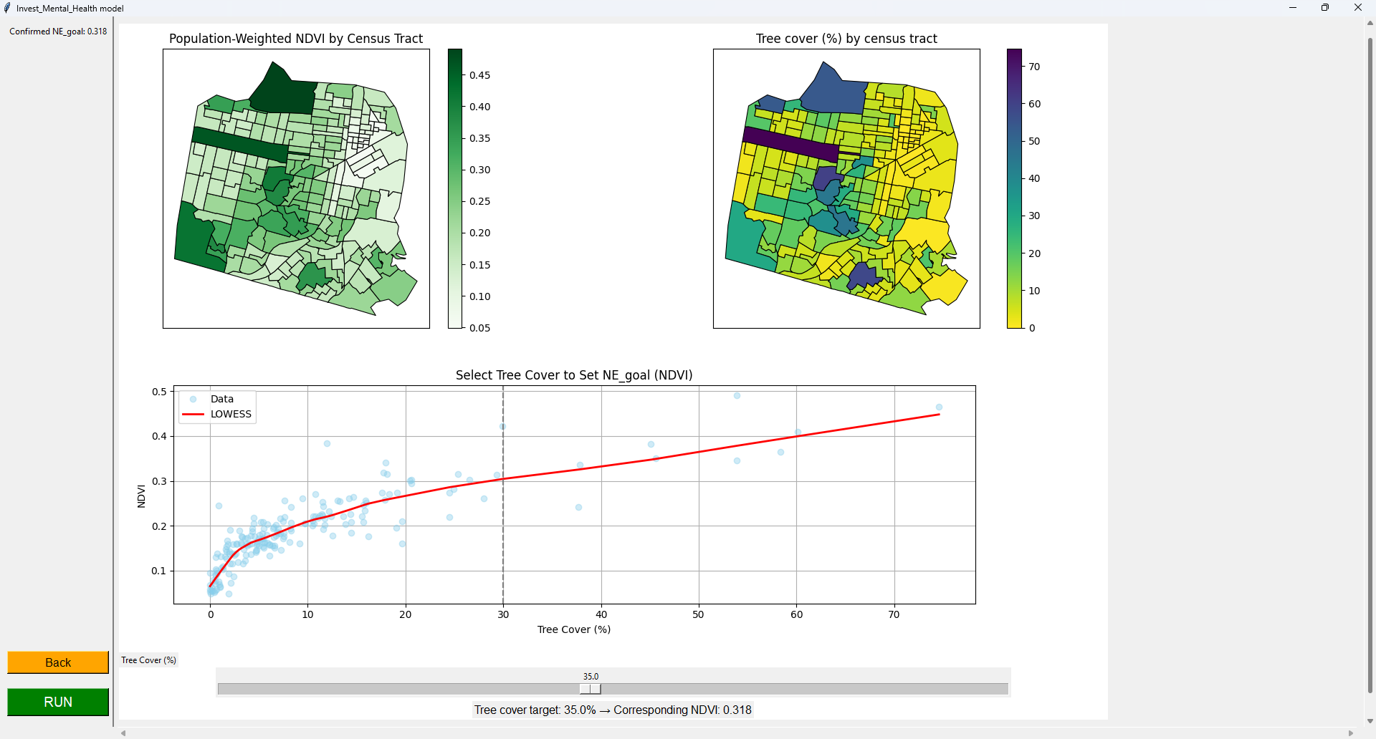
Figure 3. Illustration of how the correlation between tree canopy cover and population-weighted NDVI is used to translate a tree cover target into an NDVI-based nature exposure scenario.

Further Details on Population-Weighted Exposure (PWE)
The model uses population-weighted NDVI to estimate the average greenness exposure experienced by people in a given area. This approach recognizes that the benefits of green space are more impactful where larger numbers of people live in close proximity to vegetation. PWE has been widely used in health impact assessments, including studies on air pollution exposure and environmental equity (citations).

To calculate population-weighted NDVI, users must define a case-specific search radius (d) that reflects the typical distance people are likely to access residential green space. In our example, we use a 300-meter buffer based on recommendations from the World Health Organization (WHO) and Konijnendijk et al., representing approximately a 5-minute walk along pedestrian-accessible routes (Figure 4).

For each inhabited point (e.g., grid cell with population data), a circular buffer of radius d is generated. The mean NDVI of all pixels within the buffer is then calculated. To compute the overall population-weighted exposure (PWE), these NDVI values are averaged across the study area, weighted by the population count at each centroid. The full calculation is described in Equation (7).
${PWE}_{d} = \sum_{d}{}({NDVI}_{i}×{POP}_{i})/\sum_{d}{}({POP}_{i})$ (7)

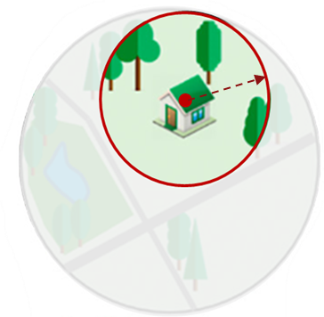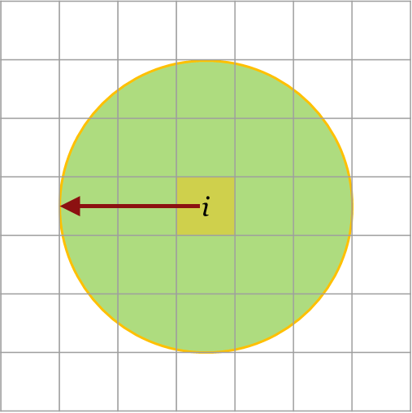
Figure 4. Residential nature exposure is estimated as the average NDVI within a defined buffer distance from each residence (illustration on the left was adapted from (Labib et al. 2021)).

NE estimation [option 2] - Translating LULC to NDVI with attribute mapping
The second approach estimates scenario-based nature exposure using land use and land cover (LULC) maps, which are widely used in other InVEST models and real-world urban planning applications. To apply this method, users must provide both a baseline LULC map and a scenario LULC map (e.g., reflecting future or counterfactual conditions). The change in nature exposure (ΔNE) is then derived by translating LULC categories into corresponding NDVI values, based on established statistical relationships between land cover types and vegetation greenness. For example, forested areas typically exhibit higher NDVI values than bare or built-up land.

To enable this translation, users are required to supply a LULC attribute table that assigns an average or median NDVI value to each LULC type (see Table 1 for an example). Using this table, the model computes NE_baseline and NE_scenario from the respective LULC maps, allowing for an estimation of ΔNE that reflects the projected landscape changes.

Unlike Option 1, which assumes a greening scenario based on a defined tree cover target, LULC-based scenarios (Options 2 and 3) may reflect more realistic urban planning outcomes—including the conversion of natural or vacant land into built-up areas. In such cases, the model allows for negative values in ΔNE, capturing potential declines in nature exposure. This enables policymakers to assess not only the potential health benefits of urban greening but also the health risks associated with land use changes that reduce access to greenspace.

Table 1. Sample Land use and land cover (LULC) attribute table.
lc_code | lc_desc | lc_exclude | lc_ndvi
11 | Open water | 1 | -0.1437
21 | Developed, open space | 0 | 0.5873
22 | Developed, low intensity | 0 | 0.3773
23 | Developed, medium intensity | 0 | 0.2305
24 | Developed high intensity | 0 | 0.1040
31 | Barren land (rock/sand/clay) | 0 | 0.1700
41 | Deciduous forest | 0 | 0.7493
42 | Evergreen forest | 0 | 0.6956
43 | Mixed forest | 0 | 0.6931
52 | Shrub/scrub | 0 | 0.6074
71 | Grassland/herbaceous | 0 | 0.5289
81 | Pasture/hay | 0 | 0.5167
82 | Cultivated crops | 0 | 0.4255
90 | Woody wetlands | 1 | 0.5779
95 | Emergent herbaceous wetlands | 1 | 0.2792
Note: The `lc_exclude` field identifies LULC classes that should be excluded (masked out, indicated by a value of 1) from the greenness exposure assessment. We recommend excluding water bodies, as they typically exhibit negative NDVI values and there is currently insufficient empirical evidence to establish a reliable effect size for blue space exposure using NDVI as a proxy. `lc_ndvi` field specifies the average or median NDVI value associated with each LULC class. Users can derive these values by overlaying a LULC raster and an NDVI raster from the same time period (e.g., the same year or growing season) to ensure temporal consistency. * Users may provide `lc_ndvi` values for excluded LULC types, but it is not required.

NE estimation [option 3] - Translating LULC to NDVI with observed NDVI rasters
The third approach is similar to Option 2, but with a key enhancement: users are required to provide NDVI rasters for both baseline and scenario conditions. This allows the model to translate land use/land cover (LULC) into NDVI values based on actual observed data, enabling a more nuanced and context-specific mapping of vegetation greenness across LULC types.

This option is particularly useful when users wish to use historical or observed data to assess the potential health benefits or risks associated with past or projected landscape changes.

Unlike Option 2, users do not need to manually assign NDVI values to each LULC type. Instead, the model automatically calculates these values by averaging the NDVI of all pixels within each LULC class for each scenario. This data-driven approach increases flexibility and accuracy in diverse geographic or temporal contexts.

As in the other options, once NDVI-based NE_baseline and NE_scenario are derived, the model computes the change in nature exposure (ΔNE) to estimate the health impact of the landscape transformation.

Health cost estimation
To quantify the economic value of improved mental health outcomes, the model estimates the avoided health costs associated with the number of preventable cases identified in the health impact assessment.

For each spatial unit or pixel, the model multiplies the estimated number of preventable cases (PC) by the corresponding cost per case (in USD PPP or local currency units), as shown in Equation (7). This cost can be any available cost estimates that the users can get or they are most interested in. For societal cost, it represents the average economic burden of a single case of a given mental health outcome (e.g., depression or anxiety), including direct healthcare costs, productivity losses, and other social costs. If users cannot access societal cost, they can specify any format of estimate for this calculation.

$Avoided Cost = PC × Health Cost Rate$ (7)
- PC: preventable cases
- Note: A negative value for “Avoided Cost” indicates an “Additional Cost.”

Users are required to provide a health cost rate table (see Table 2), which includes illness-specific and, where available, country- or region-specific estimates of cost per case. To address data gaps, we compiled a reference list of mental health cost estimates from a global meta-analysis (Christensen et al. 2020), which reports societal costs of mental disorders across more than 30 countries.

Where more detailed or local data are available, users are encouraged to customize the table with those values for increased accuracy. In the absence of granular data, national or regional averages may serve as reasonable substitutes. Given the model’s focus on urban studies and the limited availability of health cost data at the sub-urban level, the current version supports uniform cost inputs at the city level. However, users may supply varying cost data across different cities to enable comparisons across diverse geographic and economic contexts. This step allows users to assess not only the health implications of urban greening scenarios, but also their potential economic co-benefits, supporting cost–benefit analyses for policy and planning decisions.

Table 2. Example health cost table (in shapefile). This table provides sample inputs for the societal cost per case of specific mental health conditions by region. The model uses these values to estimate the total avoided healthcare costs based on the number of preventable cases.
region | health_indicator | cost_indicator | cost_value | cost_unit | cost_ref_year
USA | depression | Societal cost per patient | 11,000 | USD PPP | 2018
CHN | depression | Societal cost per patient | 2,180 | USD PPP | 2018

Summary of inputs
Name |  | Type | Description
Area of interest |  | Shapefile | Area of interest (e.g., a city)
Land use scenario (option 1) | Tree cover | Raster | Tree canopy cover under current or baseline conditions.
 | Tree cover target (%) | Number | User-defined target for tree canopy cover within the city or study area. This value represents a desired scenario and will be used to compare against the baseline tree cover to estimate potential health benefits.
 | NDVI_baseline | Raster | Normalized Difference Vegetation Index – determines the greenness of vegetation in a given cell.
Land use scenario (option 2) | LULC_baseline | Raster | Land use and land cover under current or baseline conditions.
 | LULC_scenario | Raster | Land use and land cover under a future or counterfactual scenario.
 | LULC attribute table | CSV | A table containing LULC codes, corresponding LULC class names, excluded LULC (0 for keeping, and 1 for excluding), and NDVI value.
Land use scenario (option 3) | LULC_baseline | Raster | Land use and land cover under current or baseline conditions.
 | LULC_scenario | Raster | Land use and land cover under a future or counterfactual scenario.
 | LULC attribute table | CSV | A table containing LULC codes, corresponding LULC class names, excluded LULC (0 for keeping, and 1 for excluding).
 | NDVI_baseline | Raster | This NDVI layer is used to calculate the average NDVI value for each LULC class in the baseline dataset.
 | NDVI_scenario | Raster | This NDVI layer is used to calculate the average NDVI value for each LULC class in the scenario dataset.
Nature exposure type |  | Drop-down box | ☑ Residential nature (Availability)  ☐ Neighborhood (Accessibility) – This option is currently not included in the model but is identified as a potential feature for future development.  ☐ Visitation – This option is currently not included in the model but is identified as a potential feature for future development.
Search Radius (meters) |  | Number | The distance used to define the surrounding area of a person's residence that best represents daily exposure to nearby nature.
Effect size table |  | CSV | A table containing health indicator-specific effect sizes, such as risk ratios or odds ratios, representing the relationship between nature exposure and mental health outcomes.
Baseline prevalence (or incidence) rate |  | Shapefile | A spatial dataset providing the baseline prevalence (or incidence) rates of specific mental health outcomes (e.g., depression or anxiety) across administrative units within the study area. This data allows the model to estimate preventable cases by comparing current rates with those projected under improved nature exposure scenarios.
Health cost rate (optional) |  | CSV | A CSV table providing the societal cost per case (e.g., in USD PPP) for specific mental health outcomes. This data enables the model to estimate the economic value of preventable cases under different urban nature scenarios. Costs can be specified at national, regional, or local levels depending on data availability.
Population |  | Raster | Gridded population data representing the number of people per pixel, ideally at the pixel level. Where available, additional demographic attributes (e.g., age, income) can enhance model accuracy and equity assessments. For population count rasters, users are recommended to use the WorldPop data, which has global coverage at 100 meter resolution https://hub.worldpop.org/project/categories?id=3

Summary of outputs
Name | Type | Description
preventable_cases.tif | Raster | Preventable cases at pixel level.
preventable_cost.tif | Raster | Preventable cost at pixel level. The sample data use societal cost per case, expressed in USD PPP (2018). Users may customize the currency unit and reference year in the health cost rate table to better align with local policy priorities and economic conditions.
preventable_case_cost_sum.shp | Shapefile | Aggregated total preventable cases, and total preventable costs by sub-region (e.g., census tract or zip code) within the area of interest (The area of interest input will be used here).
preventable_cases_cost_sum.csv | CSV | Aggregated total preventable cases and total preventable costs by sub-region (e.g., census tract or zip code) within the area of interest, with an additional row showing the total cases for the entire area (e.g., a city).
preventable_cases.png | PNG image | Default visual outputs for users.
preventable_cases_sum.png | PNG image | Default visual outputs for users.
preventable_cost.png | PNG image | Default visual outputs for users.
preventable_cost_sum.png | PNG image | Default visual outputs for users.

Use cases

Public health assessment
Cities aiming to assess the overall well-being of their residents increasingly recognize the importance of environmental factors, including the availability and access to nature. This model can support public health agencies by identifying areas where increased urban green space is associated with better mental health outcomes, as well as neighborhoods where degraded greenness may correspond to a higher mental health burden. These spatial insights can inform targeted interventions, resource allocation, and integrated strategies that connect urban planning with public health goals.

Green infrastructure planning and management
As part of a long-term strategy to enhance urban resilience and livability, cities often develop multi-year plans to expand or optimize green infrastructure. The Urban Mental Health model enables planners to simulate scenario-based improvements—such as achieving a specific tree cover target or implementing new green corridors—and rerun the model to evaluate how these changes might impact population-level mental health and avoided healthcare costs. This supports data-driven, equity-informed decisions for landscape investments.

References
Bratman GN, Anderson CB, Berman MG, et al (2019) Nature and mental health: An ecosystem service perspective. Science Advances 5:eaax0903. https://doi.org/10.1126/sciadv.aax0903
Christensen MK, Lim CCW, Saha S, et al (2020) The cost of mental disorders: a systematic review. Epidemiology and Psychiatric Sciences 29:e161. https://doi.org/10.1017/S204579602000075X
Giannico OV, Sardone R, Bisceglia L, et al (2024) The mortality impacts of greening Italy. Nat Commun 15:10452. https://doi.org/10.1038/s41467-024-54388-7
Labib SM, Huck JJ, Lindley S (2021) Modelling and mapping eye-level greenness visibility exposure using multi-source data at high spatial resolutions. Science of The Total Environment 755:143050. https://doi.org/10.1016/j.scitotenv.2020.143050
Liu Z, Chen X, Cui H, et al (2023) Green space exposure on depression and anxiety outcomes: A meta-analysis. Environmental Research 231:116303. https://doi.org/10.1016/j.envres.2023.116303
Rojas-Rueda D, Nieuwenhuijsen MJ, Gascon M, et al (2019) Green spaces and mortality: a systematic review and meta-analysis of cohort studies. The Lancet Planetary Health 3:e469–e477. https://doi.org/10.1016/S2542-5196(19)30215-3
Zhang J, Yu KF (1998) What’s the Relative Risk?A Method of Correcting the Odds Ratio in Cohort Studies of Common Outcomes. JAMA 280:1690–1691. https://doi.org/10.1001/jama.280.19.1690
Gascon, M., Triguero-Mas, M., Martinez, D., Dadvand, P., Forns, J., Plasencia, A., Nieuwenhuijsen, M.J., 2015. Mental health benefits of long-term exposure to residential green and blue spaces: a systematic review. International Journal of Environmental Research and Public Health 12, 4354-4379.
Wheeler, B. W., Lovell, R., Higgins, S. L., White, M. P., Alcock, I., Osborne, N. J., ... & Depledge, M. H. (2015). Beyond greenspace: an ecological study of population general health and indicators of natural environment type and quality. International journal of health geographics, 14(1), 17.

White, M. P., Pahl, S., Wheeler, B. W., Depledge, M. H., & Fleming, L. E. (2017). Natural environments and subjective wellbeing: Different types of exposure are associated with different aspects of wellbeing. Health & place, 45, 77-84.

