Platform Enhancement Proposal (PEP)

Contacts
The Software Team
Primary contact: Dave Fisher - davefisher@stanford.edu

Abstract
This is a proposal to deprecate two InVEST models: Finfish Aquaculture & Fisheries. These two are proposed because they meet at least three of the four criteria for deprecation given by the PSC: 1) data indicates they are not being used 2) the state of their code makes them an unusually high burden to maintain, and 3) they lack scientific support within NatCap.

In this proposal’s Software Team Burden and User Demand sections, we illustrate that these two models have a particularly poor “maintenance-to-usefulness” ratio. That is, they are equal or more burdensome to maintain than the average InVEST model, and they are used by the community much less.

“Deprecate” has a specific meaning: to end maintenance, support, and distribution of a piece of software at a specific date in the future. Deprecated InVEST models are still available to download as part of older releases of InVEST, but they are not supported/maintained.

The deprecation date is not too important, but we propose it coincide with the next non-bugfix release of InVEST (version 3.10).

Motivation
Software team resources are finite. As NatCap and the PSC approve new software projects & features, the overall maintenance burden grows. It is worth assessing if we are maintaining software that is not useful, and if we are, we should consider deprecating that software to free up resources for higher impact projects.

Criteria for evaluating models or tools to be deprecated (as given by the PSC):
  - ES science credibility: has the science changed/advanced such that this no longer represents our current understanding
  - User demand: actionability of information for application/uptake, current usage stats - how “popular” of a model is it?
  - Science support available - does anyone on staff have the knowledge/expertise to maintain and answer questions
  - Software team burden: user support required, how broken is it, what % time is required to maintain it

Software Team Burden
There are a number of maintenance tasks that must be applied to all InVEST models individually. Here we list some typical examples from the recent past and some expected in the near future. Tasks like this will always be part of the maintenance workload, so it’s important to weigh these costs against the benefits of publishing the software (see User Demand section).

- Migrating all code (source code and test code) from python2 to python3. Complete. This typically involved dozens of fixes per model wherever the python API changed.
- Compatibility changes after major changes to libraries we depend on. Ongoing. Similar to the python migration, these tasks are smaller in scale but happen more frequently. All InVEST models use python libraries like gdal, pygeoprocessing, pandas, and others. Whenever they have non-backward-compatible changes, we are forced to update how we use these libraries across InVEST.
- New cross-model InVEST features. Ongoing. Sometimes we need to add structure to every model in order to support features like:
  - input data validation
  - auto-generated User’s Guide content
  - new user-interface (the Workbench)
- Foreign language translations. Upcoming. There are maintenance costs in the form of code changes within every InVEST model to allow the translated text substitutions. But in this case there are also clear monetary costs of the translation itself for every additional model & User’s Guide chapter to be translated.

The Finfish & Fisheries models stand out as more burdensome to maintain than most InVEST models because their software design has never really been modernized in the same way we have done for other models. They have been brought along for the compatibility changes, but their implementations are needlessly complex relative to the actual computations they need to do. Basically, these models are overdue for a refactor if we were to keep them around.

For these models, nearly all changes to the source code in recent years has been forced maintenance -- the type described above that must be applied to all models -- rather than model-specific bugfixes or enhancements that are common for well-used models.

Data from our invest github repository:
- Finfish - 100% of changes were forced maintenance in past 6 years (github history)
- Fisheries - 1 non-forced maintenance bugfix in 3 years (github history)

User demand:
Data from invest usage stats. Each time someone runs an invest model from the user-interface, we log the model, version, date & time, in a database. Here are some plots of use over time:

Finfish: 0 runs since January, 2021:
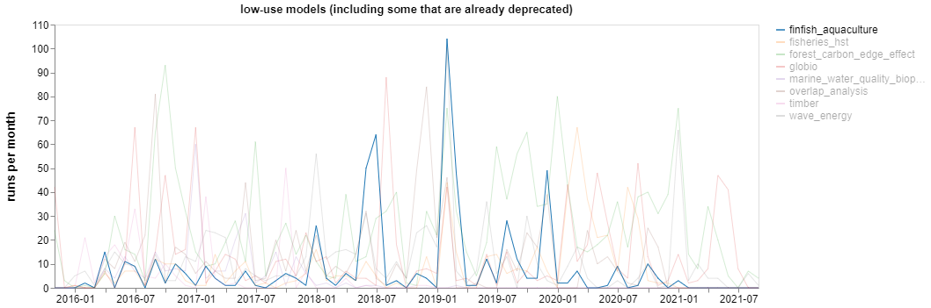

Fisheries: 0 runs since December, 2020, except 2 runs in June, 2021:

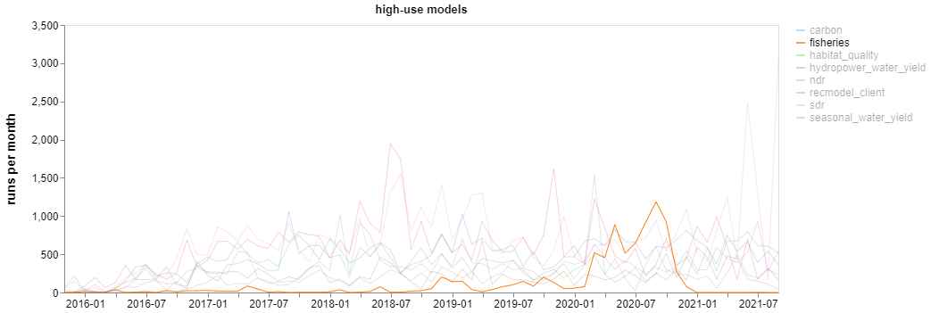
The y-axis is different from the previous plot because Fisheries monthly runs peaked at levels similar to the most popular models before dropping to 0!

Interactive versions of these plots for all InVEST models are here: https://nbviewer.jupyter.org/github/davemfish/invest-usage-stats/blob/main/invest_usage_stats.ipynb

Data from our forum, where we tag all threads with the model that is being discussed. These counts go back ~2.5 years, since we switched to the current forum platform. Counts of all models are here: https://community.naturalcapitalproject.org/tags/

- Finfish Aquaculture - 0 threads
- Fisheries - 2 threads

Forum data does not give a complete picture of demand, it’s more a measure of demand for support, which might be a function of overall model popularity, ease of use, etc.

Science Support available:
According to our spreadsheet: https://docs.google.com/spreadsheets/d/143HM51bD92NL6K6gs5Wialej6QCqFXDTpXoKRcQ-9D0/edit#gid=0

We do not have a science lead for these models. The spreadsheet references Katie (now an alum), but also includes the caveat: “We don't have the right person on staff to be the "Science Lead", so have someone who is assigned to fill in the gap. [They] can be thought of as on the hook (with help from the peer-reviewer), but if heavy stuff comes up, this is a gap.”

ES Science credibility:
No issues about scientific credibility were raised in this proposal because the authors are not experts in these domains and have not attempted to assess the science in these models.

It would be valuable to get scientific feedback on these models. We may find them to be totally valid, and that could be considered a reason to continue maintaining them despite low usage numbers.

Support
Unlike basically any other PEP, this one has no long-term support costs! Up-front costs include about a day of engineer time at or near the future “deprecation date” to modify repositories, documentation, and website.

Specification
Not Applicable

Open Issues

References

Since the usage logging endpoint is on a google-hosted URL, it is highly likely that the majority of InVEST users in China are not recorded by this system or represented in the usage stats.

