Thai Banknotes Recognition System

Using Image Processing

Natchanon Sayasonti

Student ID: 5988116

Natchanon.say@student.mahidol.ac.th

Faculty of Information and Communication Technology

Mahidol University

Wannaporn Vichaisri

Student ID: 5988266

Wannaporn.vih@student.mahidol.ac.th

Faculty of Information and Communication Technology

Mahidol University

***Abstract*—Thai Banknotes Recognition System is the system which could be used to recognize each Thai Banknotes using image processing. The system can recognize 20, 50, 100, 500, and 1000 Baht of both Rama 9 and Rama 10. There are two main methods which are Neuron Network and Euclidean Distance.**

***Keywords—Image Processing, Thai Banknotes Recognition***

# Introduction

Prior to the adoption of banknotes and flat coins, Thailand used the shell, Baked Clay Coins, and Pot Duang as the money. The first Thai banknote is used since 1912. King Rama 5 had the policy to establish the banknotes. It leads to a growing economic system. People at that time can exchange the product and banknote as obviously. Thai banknotes are made from cotton fiber, not plastic. The reason why we aim to classify Thai banknote is helping an unknown person such as a foreigner. This tool can help them to classify in a few times.

This project focused on Thai Banknotes which used in King Rama 9, and 10. There are 5 focused types of banknotes which are 20, 50, 100, 500, and 1000. These banknotes have many styles. Therefore, this project will not use all style. The objective is to classify Thai banknotes which one is 20, 50, 100, 500, and 1000 correctly by using a digital image processing method.

# literature review

## *Banknotes detected using Image Processing Techniques*

H. Masoumi and N. Panah presented banknotes detection using MATLAB in 2017. The scope is Iranian banknotes. In this paper, an automatic system is proposed. This system consists of two steps. First, the banknote image in the input will be read by the RGB color model. Then, applying image processing techniques, they get a numerical model that is between 1 and 10. Second, the input banknote image is in black and white models. Then by applying some image processing techniques on the banknote image, the value of money will be determined. During this process, they managed to eliminate some of the photo noise of input banknotes. It should be noted that the proposed algorithm is very flexible and by working on it much more noise can be removed from the input photo [1].

## *Paper Currency Verification System Based on Characteristic Extraction Using Image Processing*

Rubeena Mirza and Vinti Nanda researched Paper Currency Verification System Based on Characteristic Extraction using LBP tool and MATLAB in 2012. The approach consists of a number of components including image processing, edge detection, image segmentation, characteristic extraction, comparing images. The image processing approach is discussed with MATLAB to detect the features of paper currency. The scope is Indian Paper Currency. Approach suggested from the beginning of image acquisition to converting it to grayscale image and up to the word segmentation has been stated. The work will surely very useful for minimizing the counterfeit currency [2].

## *A High-Performance Banknote Recognition System Based on a One-Dimensional Visible Light Line Sensor*

Veda Samhita Abburu et al. built the currency recognition system using image processing. The method works by first identifying the country of origin using certain predefined areas of interest, and then extracting the denomination value using characteristics such as size, color, or text on the note, depending on how much the notes within the same country differ. The scope is 20 banknotes in each country consist of Australian Dollars, Canadian Dollars, Chinese Renminbi, American Dollars, Danish Krone, Euro, Hong Kong Dollar, Indian Rupee, Indonesian Rupiah, Kuwaiti Dinar, Mexican Peso, Norwegian Kroner, New Zealand Dollar, Philippine Peso, Japanese Yen, Russian Rubles, Saudi Riyal, Singapore Dollar, Swiss Franc, and UAE Dirhams They have found that our system is able to accurately recognize most of the countries and denominations correctly (93.3% accuracy, where accuracy is defined as the number of notes correctly identified divided by the total number of notes tested) [3].

## *Decision tree model for classification of fake and genuine banknotes using SPSS*

Young Ho Park et al. use semidefinite programming to create a High-Performance Banknote Recognition System Based on a One-Dimensional Visible Light Line Sensor An algorithm for recognizing banknotes is required in many fields, such as banknote-counting machines and automatic teller machines (ATM). Due to the size and cost limitations of banknote-counting machines and ATMs, the banknote image is usually captured by a one-dimensional (line) sensor instead of a conventional two-dimensional (area) sensor. Therefore, they propose in this paper a novel method for pre-classifying banknotes’ direction for implementation in banknote recognition systems. The scope is United State dollar. This report showed that the error rate for the proposed pre-classification method was lower than that of other methods. In addition, the banknote-recognition error rate after pre-classifying the banknote’s direction was as low as 0.114%. However, incorrect recognition occurred when part of the banknote was damaged or when contaminants were present in the upper or lower region of the banknote [4].

## *Decision tree model for classification of fake and genuine banknotes using SPSS*

Akanksha Upadhyaya, Vinod Shokeen, and Garima Srivastava studied Decision tree model for classification of fake and genuine banknotes using SPSS. This paper proposes an effective predictive model based on a machine learning technique for authentication of banknotes, which can predict with good accuracy whether the given banknote is fake or genuine. Dutch, German, English, and US counterfeit banknotes are the scope. The model shows 91% of accuracy. This model can be used for the classification of fake and genuine currency of different countries. The work can be extended by comparing this model with other predictive models for the calculated values of different currencies notes in terms of four independent variables mentioned in the paper [5].

## *Banknotes Recognition in Real Time Using ANN*

A thesis submitted to School of Engineering, Computer and Mathematical Sciences, Auckland University of Technology by Yueqiu Ren studied Banknotes Recognition in Real Time Using ANN. The scope is New Zealand banknotes. As the recognition results of 500 test images, with 100 test images for each class, the average F-measure of every combination is beyond 0.88 when using the banknote images captured by webcam for training, while not all the combinations can achieve this when using the scanned banknote images for training [6].

## *Image Processing Based Feature Extraction of Currency Notes*

Mohammad Arif created feature extraction of Numerous Indian Currency notes of value 100 using MATLAB. The Methodology is direction (front, rotated front, back, and rotated back) and face value, neural network-based bill recognition and verification method, the learning vector quantization (LVQ) method. Approaches suggested from the beginning of scanning a document to converting it to binary image, thresholding, morphological filtering and word segmentation has been successfully stated in our current approach, the whole character itself was used as a feature. Selection of feature extraction method is the single most important factor in achieving high recognition performance [7].

## *Perfecting Counterfeit Banknote Detection*

Malladi Tejasvi et al. By International Journal of Innovative Technology and Exploring Engineering (IJITEE) researched Perfecting Counterfeit Banknote Detection using Machine Learning. The scope is 1372 greyscale bank note images each of size 400x400 pixels. The result is perfect classification (100%) was achieved using ANN, SVM and KNN. The logistic regression followed by decision tree and simple perceptron have also performed well by detecting fake notes at 99.27%, 98.91% and 98.91% respectively [8].

## *Analysis of Banknote Authentication System using Machine Learning Techniques*

M.A. Zamalloa Jaraa et al. uses portable X-ray Fluorescence spectrometer to exploratory analysis for the identification of false banknotes using portable X-ray Fluorescence spectrometer. The 200 Nuevos Soles banknotes is the scope. The results from the semi quantitative elemental analysis, using pXRF, show that the chemical composition of the ink used in the false banknotes is different to that of the original ones [9].

## *Decision tree model for classification of fake and genuine banknotes using SPSS*

Sumeet Shahani, Aysha Jagiasi, and Priya R. L. analyzed Banknote Authentication System using Machine Learning Techniques. The results of training and test data do not show much difference except for sensitivity of SVM. The training sensitivity of SVM is 98.68% and the test sensitivity is 98.69%. BPN gives 100% detection rate and SVM gives 98.90% success rate. The result shows that back-propagation neural network outperforms support vector machine and gives 100% success rate [10].

# conceptual diagram

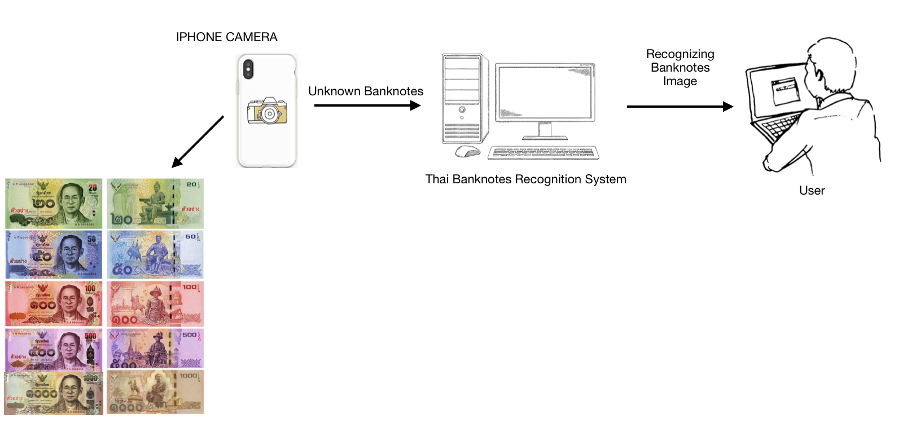

Figure 1: Conceptual Diagram

# structure chart

The Thai banknote recognition system consists of four main process modules which are image acquisition , feature extraction, image recognition, and result presentation as shown in figure 2.

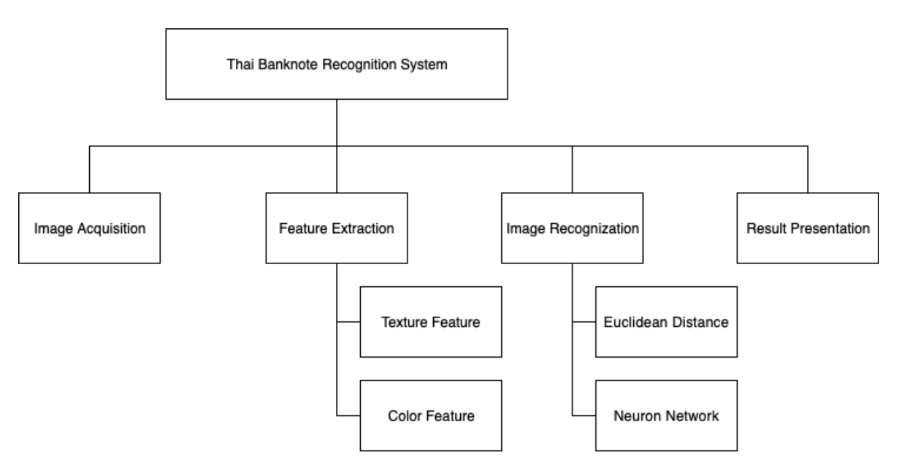

Figure 2: Structure Chart

## *Image acquisition*

The aggregate data which are images should be taken from bird-eye-views as input in this system. The banknotes must set in the same environment by using A4 paper as a background. While taking a picture, the mobile has to available a flashlight mode for controlling the light in the image. All of the banknotes, which are a dataset, have to place in a horizontal line. Both King Rama 9 and King Rama 10 including 20, 50, 100, 500, 1000 Baht which is a data were taken 10 images each.

## *Feature extraction*

Headings The 10 images of data in each type must divide 8 images for training in this process. All of image don’t have to use an image enhancement. This is because image acquisition was already set a same environment such as location and light. There are two features that were used in the Thai Banknote Recognition System. All of feature has a value in 0 to 1 which provide a high accuracy to recognize. Texture and color are 2 hypothesis features which this system focus to extract.

1. Texture feature: This system extract a texture feature by using a Gray-Level Co-occurrence Matrix (GLCM) technique including Entropy, Energy, Contrast, Homogeneity, and Correlation. This process used 0 degrees in GLCM (Pic[i,j] = Pic[0,1]).

2. Color feature: The system keep the mean color of each color into the excel file. The color consists of 4 colors which are red, green, blue, and gray.

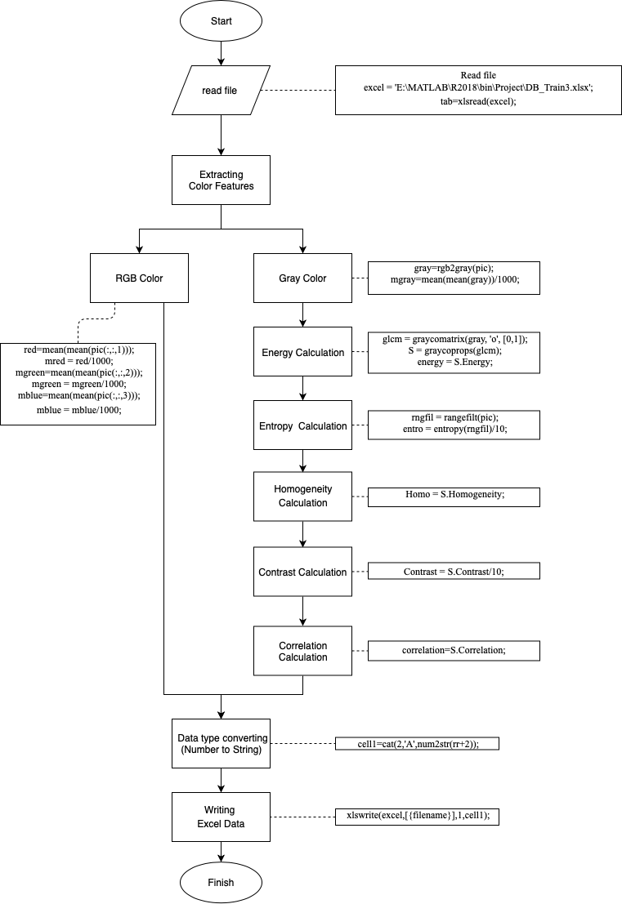

Figure 3: Feature Extraction Flowchart

## *Image Recognition*

After preparing an excel file, there will be an image recognition method. The technique which this system used to compare two images is Euclidean distance and Neuron Network.

1. Euclidean Distance

This formula can be used to calculate the distance between two data points in a plane. If the value is very few, it meant that two datasets are very similar as well. The equation is below in figure 4.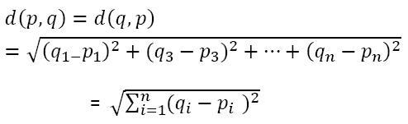

Figure 4: Euclidean Distance Equation

2. Neuron Network

Before using this technique, this system need to install a deep learning toolbox matlab. Moreover, the are some bit data which have to prepare including bit64, bit32, bit16, bit8, bit4, bit2, and bit1. Therefore, the program uses 7 neuron network models. Each model contains 2048 hidden layers. The validation and test ratio are 5 percent.

# Graphic User Interface

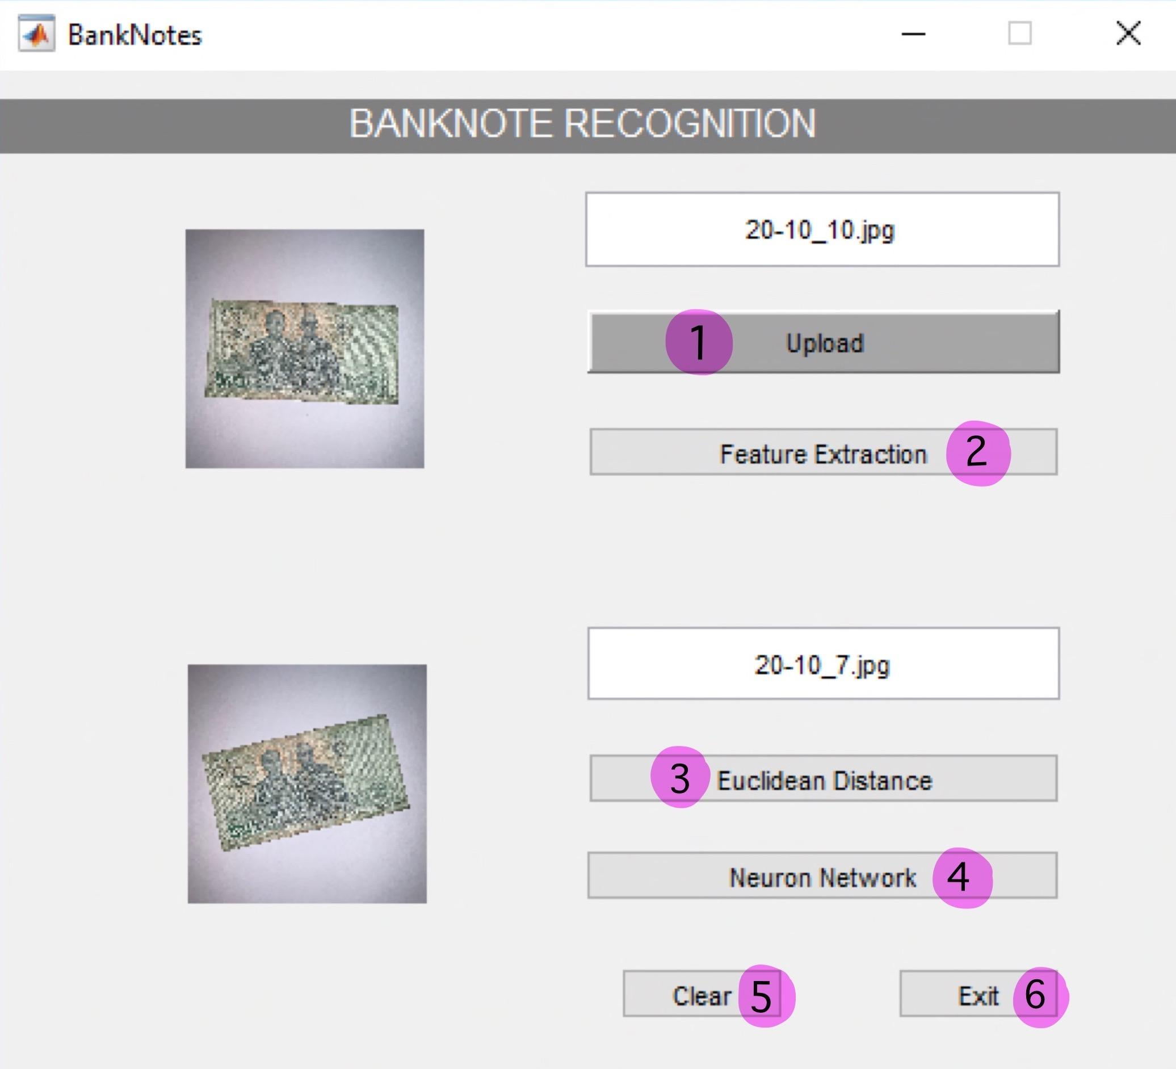

Figure 5: Graphic user interface

# Implementation

1) Upload

The code below is using for import the photo in format of bmp and jpg from users.

global image;

global pic;

global filename;

[filename pathname]=uigetfile({'*.bmp','*.jpg'},'file select');

image = strcat(pathname,filename);

pic = imread(image);

axes(handles.axes1); imshow(pic);

axes(handles.axes2); cla;

set(handles.edit1,'string',filename);

2) Feature Extraction

Each feature are extracted into the excel file which a value has a range 0 to 1

global pic;

global filename;

global excel;

excel = 'E:\MATLAB\R2018\bin\Project\DB_Train1.xlsx';

tab=xlsread(excel);

[rr,cc]=size(tab);

Calculate RGB, gray color, and features

red=mean(mean(pic(:,:,1)));

mred = red/1000;

mgreen=mean(mean(pic(:,:,2)));

mgreen = mgreen/1000;

mblue=mean(mean(pic(:,:,3)));

mblue = mblue/1000;

gray=rgb2gray(pic);

mgray=mean(mean(gray))/1000;

%%%Energy Calcultion%%%

gray=rgb2gray(pic);

glcm = graycomatrix(gray, 'o', [0,1]);

S = graycoprops(glcm);

energy = S.Energy;

%%%Entropy Calcultion%%%

rngfil = rangefilt(pic);

entro = entropy(rngfil)/10;

%%%Homogeneity Calcultion%%%

Homo = S.Homogeneity;

%%%Contrast Calcultion%%%

Contrast = S.Contrast;

%%%Correlation Calcultion%%%

Correlation=S.Correlation;

Convert datatype ( Number to String )

cell1=cat(2,'A',num2str(rr+2));

cell2=cat(2,'B',num2str(rr+2));

cell3=cat(2,'C',num2str(rr+2));

cell4=cat(2,'D',num2str(rr+2));

cell5=cat(2,'E',num2str(rr+2));

cell6=cat(2,'F',num2str(rr+2));

cell7=cat(2,'G',num2str(rr+2));

cell8=cat(2,'H',num2str(rr+2));

cell9=cat(2,'I',num2str(rr+2));

cell10=cat(2,'J',num2str(rr+2));

Write Excel data

xlswrite(excel,[{filename}],1,cell1);

xlswrite(excel,[mred],1,cell2);

xlswrite(excel,[mgreen],1,cell3);

xlswrite(excel,[mblue],1,cell4);

xlswrite(excel,[mgray],1,cell5);

xlswrite(excel,[entro],1,cell6);

xlswrite(excel,[energy],1,cell7);

xlswrite(excel,[Homo],1,cell8);

xlswrite(excel,[Contrast],1,cell9);

xlswrite(excel,[correlation],1,cell10);

system('taskkill /F /IM EXCEL.EXE');

3) Euclidean Distance

It uses to check the similarity by using the equation

global pic;

global excel;

excel = 'E:\MATLAB\R2018\bin\Project\DB_Train1.xlsx';

datasetpath ='E:\MATLAB\R2018\bin\Project\Dataset01\';

tab=xlsread(excel);

[rr,cc]=size(tab);

Calculate Features

data(1)=(mean(mean(pic(:,:,1))))/1000;

data(2)=(mean(mean(pic(:,:,2))))/1000;

data(3)=(mean(mean(pic(:,:,3))))/1000;

gray=rgb2gray(pic);

data(4)=(mean(mean(gray)))/1000;

gray=rgb2gray(pic);

glcm = graycomatrix(gray, 'o', [0,1]);

S = graycoprops(glcm);

rngfil = rangefilt(pic);

data(5) = entropy(rngfil)/10;

data(6) = S.Energy;

data(7) = S.Homogeneity;

data(8) = S.Contrast;

data(9) =S.Correlation;

Matching Process

min=999;

rec=0;

for i=1 : rr

diff=0;

for j=1 : cc

diff=diff+sqrt(power(tab(i,j)-data(j),2));

end

if (diff <=0.1)

min=diff;

rec=i;

end

end

if (rec ~= 0)

%found

cellx=cat(2,'A',num2str(rec+1));

%cellx = A3

[~,ff]=xlsread(excel,1,cellx);

file=ff{1};

imgfile = strcat(datasetpath,file);

result=imread(imgfile);

axes(handles.axes2); imshow(result);

file= strcat('Found : ',file);

set (handles.edit2, 'string',file);

else

% not found

fig=zeros(250,300);

axes(handles.axes2); imshow(fig);

set (handles.edit2, 'string','NOT FOUND');

end

4) Neuron Network

Before doing Neuron Network, the model implementation is needed.

Recognition part

global excel;

global pic;

excel = 'E:\MATLAB\R2018\bin\Project\DB_Train1.xlsx';

load('E:\MATLAB\R2018\bin\Project\model-01\model-01.mat','net64');

load('E:\MATLAB\R2018\bin\Project\model-01\model-01.mat','net32');

load('E:\MATLAB\R2018\bin\Project\model-01\model-01.mat','net16');

load('E:\MATLAB\R2018\bin\Project\model-01\model-01.mat','net8');

load('E:\MATLAB\R2018\bin\Project\model-01\net4.mat','net4');

load('E:\MATLAB\R2018\bin\Project\model-01\net2.mat','net2');

load('E:\MATLAB\R2018\bin\Project\model-01\model-01.mat','net1');

red=mean(mean(pic(:,:,1)));

mred = red/1000;

mgreen=mean(mean(pic(:,:,2)));

mgreen = mgreen/1000;

mblue=mean(mean(pic(:,:,3)));

mblue = mblue/1000;

gray=rgb2gray(pic);

mgray=mean(mean(gray))/1000;

%energy

gray=rgb2gray(pic);

glcm = graycomatrix(gray, 'o', [0,1]);

S = graycoprops(glcm);

energy = S.Energy;

%entropy

rngfil = rangefilt(pic);

entro = entropy(rngfil)/10;

%homo

Homo = S.Homogeneity;

%contrast

Contrast = S.Contrast;

%Correlation

correlation=S.Correlation;

test = [mred; mgreen; mblue; mgray; entro; energy; Homo; Contrast; correlation;];

bit64 = net64(test); bit64 = round(bit64);

bit32 = net32(test); bit32 = round(bit32);

bit16 = net16(test); bit16 = round(bit16);

bit8 = net8(test); bit8 = round(bit8);

bit4 = net4(test); bit4 = round(bit4);

bit2 = net2(test); bit2 = round(bit2);

bit1 = net1(test); bit1 = round(bit1);

Image_Index = (bit64*64)+ (bit32*32)+(bit16*16)+(bit8*8)+(bit4*4)+(bit2*2)+(bit1*1);

rec=ceil(Image_Index+1);

if rec==0

rec=1;

end

cellx=cat(2,'A',num2str(rec));

[~,ff]=xlsread(excel,1,cellx);

file=ff{1};

filepath= 'E:\MATLAB\R2018\bin\Project\Dataset01\';

file_path = strcat(filepath,file);

axes(handles.axes2); imshow(file_path);

set (handles.edit2, 'string',file);

5) Clear the pages

axes(handles.axes1); cla;

axes(handles.axes2); cla;

set (handles.edit1, 'string',' ');

set (handles.edit2, 'string',' ');

6) Exit the System:

Close

# Experiment result

Thai Banknote Recognition System can recognize banknotes by 2 techniques which are Neuron Network and Euclidean distance Recognition. The experiment uses 2 pictures of each type for testing. For Neuron Network technique, it can recognize all pictures including both match and mismatch but most result is match. Another technique which is Euclidean distance recognition cannot find 2 from all testing.

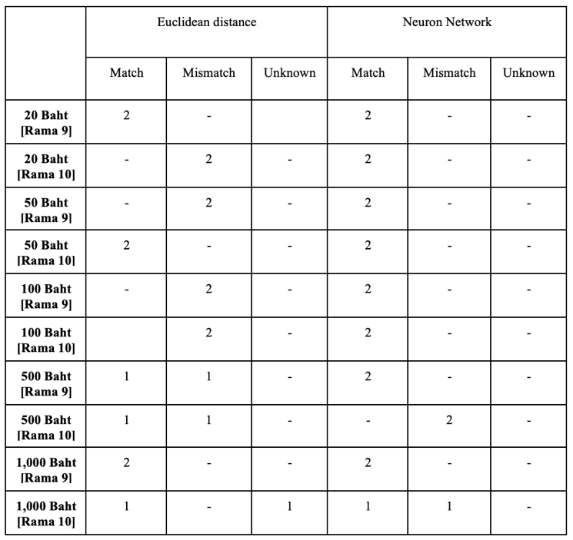

Table 1: Result table from the experiment

# conclusion

Thai Banknote Recognition System use image processing to classify Thai Banknote by 2 techniques which are Euclidean distance and Neuron Network. There were 10 types and 10 images of each banknote type. 10 images were divided into 8 images for training and 2 images for testing. Based on the experiment result, the program is able to recognize 85% correctly from Neuron Network technique and 45% correctly from Euclidean distance technique. From the statistic result, Neuron Network technique performed better than Euclidean distance technique.

##### References

1. N.Panah and H.Masoumi, “Banknotes detected using Image Processing Techniques (2017)”, URL:https://www.ijcsmc.com/ docs/ papers/May2017/V6I5201710.pdf
2. Rubeena Mirza and Vinti Nanda, “Paper Currency Verification System Based on Characteristic Extraction Using Image Processing (2012)”, URL: https://www.semanticscholar.org/paper/Currency-Verification-System-Based-on-Extraction-Mirza-Nanda / 0e8f89e2da e48ed45a6ba07b5b9523bebd64c015
3. Vedasamhitha Abburu, Saumya Gupta, S. R. Rimitha, Manjunath Mulimani, and Shashidhar G. Koolagudi, “Currency recognition system using image processing (2017)”, URL:https://www.resear chgate.net/publication/323056402_Currency_recognition_system_using_image_processing
4. Young-Ho Park, Seung Yong Kwon, Tuyen Danh Pham, Kang Ryoung Park, Dae Sik Jeong, and Sungsoo Yoon, ”A High-Performance Banknote Recognition System Based on a One-Dimensional Visible Light Line Sensor (2015)”, URL:https:// www.researchgate.net/publication/278792894_A_High_Performance_Banknote_Recognition_System_Based_on_a_One-Dimensional_Visible_Light_Line_Sensor
5. Akanksha Upadhyaya, Vinod Shokeen, and Garima Srivastava, “Decision tree model for classification of fake and genuine banknotes using SPSS (2018)”, URL: https://www.researchgate.net/publication /330736939_Decision_tree_model_for_classification_of_fake_and_genuine_banknotes_using_SPSS
6. Yueqiu Ren, “Banknotes Recognition in Real Time Using ANN”, URL:https://pdfs.semanticscholar.org/14a9/d6b7b99ea411c1fe85ab2869cb27209d9635.pdf
7. MOHAMMAD ARIF, “IMAGE PROCESSING BASED FEATURE EXTRACTION OF CURRENCY NOTES”, URL:https://www.irjet. net/archives/V3/i4/IRJET-V3I4517.pdf
8. Malladi Tejasvi, A.Nayeemulla Khan, A.Shahina, “Perfecting Counterfeit Banknote Detection - A Classification Strategy”, URL: https://www.ijitee.org/wpcontent/uploads/papers/v8i6/F3597048619.ppd
9. M.A. Zamalloa Jaraa, C. Luízar Obregónb, C. Araujo Del Castilloa, “Exploratory analysis for the identification of false banknotes using portable X-ray Fluorescence spectrometer”, URL: https://www.s ciencedirect.com/science/article/pii/S0969804317300167
10. Sumeet Shahani, Aysha Jagiasi, Priya R. L., “Analysis of Banknote Authentication System using Machine Learning Techniques”, URL:https://www.ijcaonline.org/archives/volume179/number20/shahani-2018-ijca-916343.pdf