Program Structure
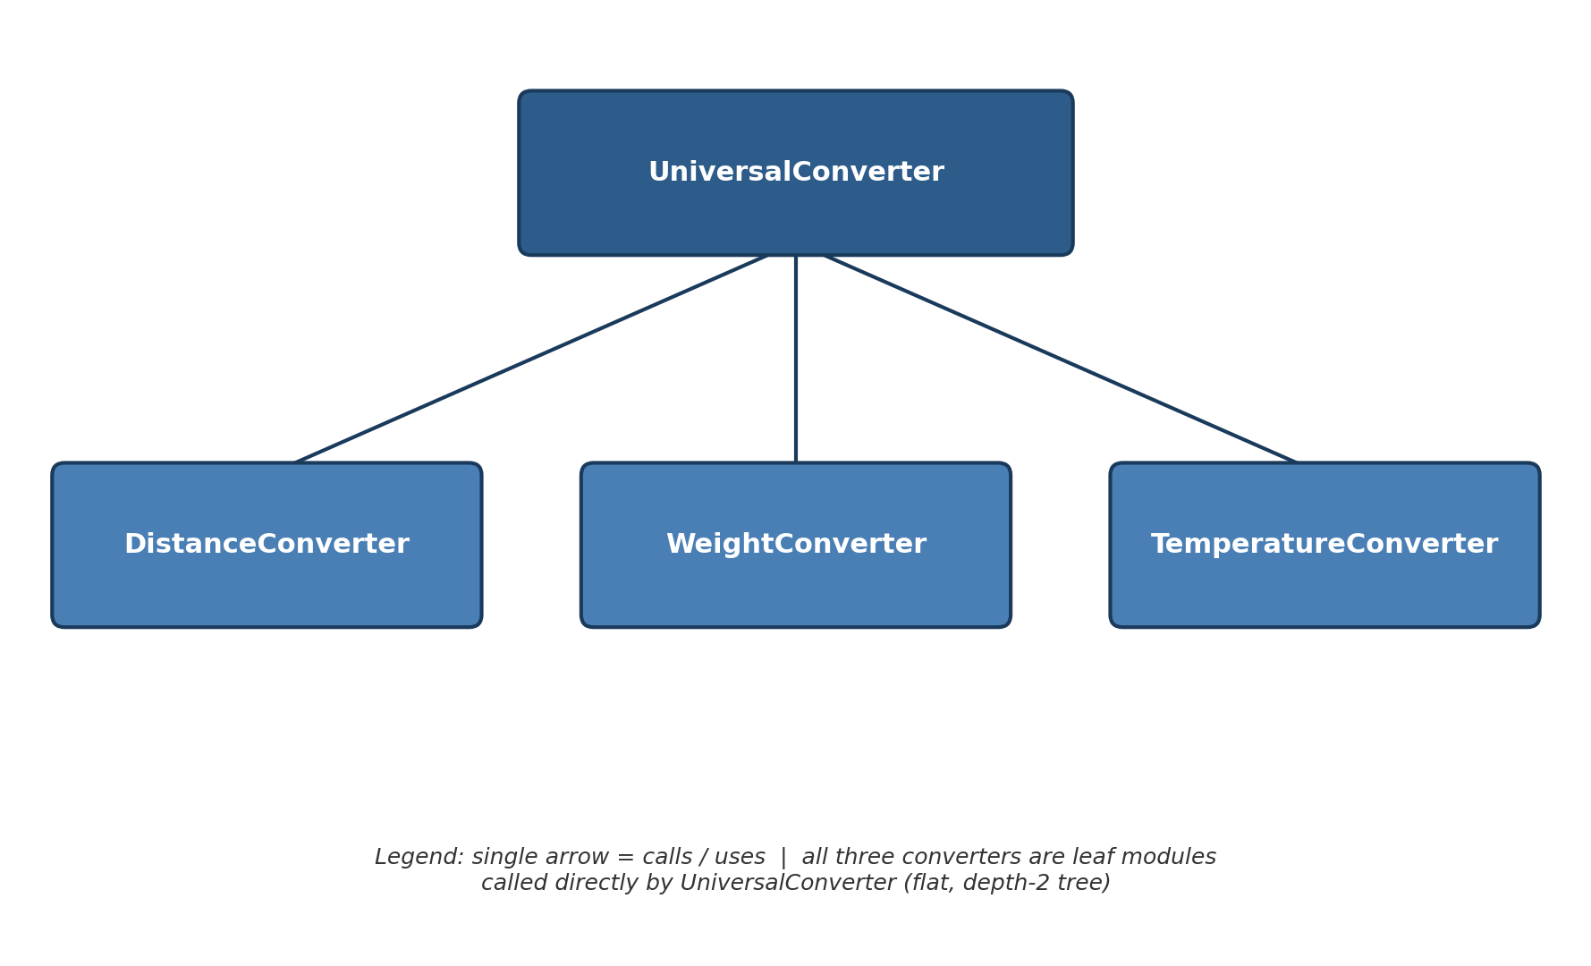
UniversalConverter (module หลัก/ราก) เรียกใช้ module ลูก 3 ตัวโดยตรง คือ DistanceConverter, WeightConverter และ TemperatureConverter ไม่มี module ไหนเรียกใช้ module อื่นต่อ พี่น้องไม่คุยกันเอง และตอนนี้ยังไม่มีใครเรียกใช้ UniversalConverter เลย เพราะยังไม่มี GUI หรือโปรแกรมหลักที่ครอบมันอีกที

Top-down Integration
Unit under test | List of Stubs/Drivers | result | Stub’s return value | Expected results | Actual results | Pass/Fail/No run
UniversalConverter | StubDistanceConverter, StubWeightConverter, StubTemperatureConverter | convert(10, "Distance", "kilometer", "meter") | 999.0 (StubDistanceConverter) | 999.0 | 999.0 | Pass
UniversalConverter | StubDistanceConverter, StubWeightConverter, StubTemperatureConverter | convert(5, "Weight", "kilogram", "gram") | 888.0 (StubWeightConverter) | 888.0 | 888.0 | Pass
UniversalConverter | StubDistanceConverter, StubWeightConverter, StubTemperatureConverter | convert(0, "Temperature", "C", "F") | 777.0 (StubTemperatureConverter) | 777.0 | 777.0 | Pass
UniversalConverter  + DistanceConverter (real) | StubWeightConverter, StubTemperatureConverter | convert(10, "Distance", "kilometer", "meter") | N/A (real module used) | 10000.0 | 10000.0 | Pass
UniversalConverter  + DistanceConverter, WeightConverter (real) | StubTemperatureConverter | convert(5, "Weight", "kilogram", "gram") | N/A (real module used) | 5000.0 | 0.005 | Fail (defect: kg↔g multiplier reversed)
UniversalConverter  + DistanceConverter, WeightConverter (real) | StubTemperatureConverter | convert(1000, "Weight", "gram", "kilogram") | N/A (real module used) | 1.0 | 1000000.0 | Fail (defect: g↔kg multiplier reversed)
UniversalConverter (full integration – all real) | None | convert(100, "Temperature", "C", "F") | N/A | 212.0 | 132.0 | Fail (defect: int division 9/5)
UniversalConverter (full integration – all real) | None | convert(212, "Temperature", "F", "C") | N/A | 100.0 | 0.0 | Fail (defect: int division 5/9)
UniversalConverter (full integration – all real) | None | convert(0, "Temperature", "C", "K") | N/A | 273.15 | 273.15 | Pass
UniversalConverter (full integration – all real) | None | convert(100, "Temperature", "K", "F") | N/A | -279.67 | -141.15 | Fail (defect: int division 9/5)

Bottom-up Integration
Unit under test | List of Stubs/Drivers | result | Stub’s return value | Expected results | Actual results | Pass/Fail/No run
DistanceConverter | DriverDistance | run(1, "kilometer", "meter") | N/A (driver used) | 1000.0 | 1000.0 | Pass
DistanceConverter | DriverDistance | run(10, "mile", "kilometer") | N/A (driver used) | 16.09 | 16.09 | Pass
WeightConverter | DriverWeight | run(5, "kilogram", "gram") | N/A (driver used) | 5000.0 | 0.005 | Fail (defect: kg↔g multiplier reversed)
WeightConverter | DriverWeight | run(16, "ounce", "lbs") | N/A (driver used) | 1.0 | 16.0 | Fail (defect: code checks "once" not "ounce")
TemperatureConverter | DriverTemperature | run(0, "C", "F") | N/A (driver used) | 32.0 | 32.0 | Pass (coincidence: 0 × 1 = 0 × 1.8)
TemperatureConverter | DriverTemperature | run(100, "C", "F") | N/A (driver used) | 212.0 | 132.0 | Fail (defect: int division 9/5)
TemperatureConverter | DriverTemperature | run(32, "F", "C") | N/A (driver used) | 0.0 | 0.0 | Pass (coincidence)
TemperatureConverter | DriverTemperature | run(212, "F", "C") | N/A (driver used) | 100.0 | 0.0 | Fail (defect: int division 5/9)
UniversalConverter (full integration, all real) | DriverMain | run(10, "Distance", "kilometer", "meter") | N/A (driver used) | 10000.0 | 10000.0 | Pass
UniversalConverter (full integration, all real) | DriverMain | run(5, "Weight", "kilogram", "gram") | N/A (driver used) | 5000.0 | 0.005 | Fail (defect confirmed after integration)

