Smart Body Composition System
User Manual
Version | 1.0
Last Updated | May 2026
Author | Nathanael Anak Chulif @ Douglas Chulip
Institution | Universiti Malaysia Sarawak (UNIMAS)

Table of Contents
Contents
Table of Contents 2
1. About the System 5
What It Does 5
Who It Is For 5
Key Features at a Glance 5
2. System Requirements 6
For Users (Accessing the Deployed System) 6
For Local Installation (Developer / Administrator) 6
3. Installation Guide 6
Step 1 — Install XAMPP 7
Step 2 — Install Composer 7
Step 3 — Install Node.js 8
Step 4 — Clone the Repository 8
Step 5 — Install PHP Dependencies 8
Step 6 — Configure Environment Variables 8
Step 7 — Generate Application Key 10
Step 8 — Create Database & Run Migrations 10
Step 9 — Build Frontend Assets 11
Step 10 — Composer Setup 11
Step 11: Start Server 11
4. First-Time Setup 12
Creating an Account 12
Setting Up Your Profile 12
Choosing Your Unit System 13
5. User Interface Overview 14
Top bar Navigation 14
Dashboard Layout 15
6. Entering Body Composition Data 15
Step-by-Step 16
Understanding Each Metric 16
Tips for Accurate Measurements 17
Managing Records 17
7. Viewing Trends 18
How to Use 18
Reading the Charts 19
What to Look For 19
8. Setting & Tracking Goals 19
Creating a Goal 19
Monitoring Progress 21
Editing or Deleting Goals 21
9. Health Recommendations 21
How Recommendations Work 21
Generating Recommendations 21
Understanding Recommendation Cards 22
Marking Recommendations 22
10. AI Tips 23
Accessing AI Tips 23
11. Notifications 24
Types of Notifications 24
Notification Preferences 25
12. Admin Panel 25
Accessing the Admin Panel 25
Admin Features 26
Dashboard 26
Manage Users 26
View Records 27
Recommendation Templates 28
System Settings 29
13. Troubleshooting 30
"Database connection refused" error 30
"Vite manifest not found" or blank white page 30
"Specified key was too long" error 31
Port 8000 already in use 31
Application shows "500 Server Error" 31
Cannot log in after registration 32
npm install fails with errors 32
Composer install takes too long or fails 32
Apache won't start in XAMPP 32
"class not found" or "permission denied" errors 32

1. About the System
The Smart Body Composition System is a web-based health tracking platform designed to help you monitor, analyse, and gradually improve your body composition over time. It was developed as a Final Year Project at Universiti Malaysia Sarawak (UNIMAS), with one central idea in mind: your smart scale already collects valuable data — this system helps you do something meaningful with it.

What It Does
At its core, the system is a personal health tracker built around body composition rather than weight alone. Here is what it offers:
- Log body composition measurements from your smart scale — weight, body fat %, muscle mass, visceral fat, bone mass, and more.
- Visualize trends over time with interactive charts covering 7, 14, 30, or 90-day periods, so you can see the bigger picture rather than obsessing over day-to-day fluctuations.
- Receive AI-driven health recommendations personalized to your measurement history, age, and gender — not just generic fitness advice.
- Set and track fitness goals for weight, body fat, muscle mass, and visceral fat, each with a target value and a deadline.
- Stay on track with weekly reports and measurement reminders delivered through the in-app notification system.

Who It Is For
This system was built with a broad audience in mind. If you own a body composition smart scale — whether it's a Tanita, Omron, InBody, Xiaomi, or any similar device — and you want to do more than just glance at the numbers, this is for you. It is equally useful for:
- Fitness enthusiasts wanting to go beyond weight and track body fat %, muscle gain, and metabolic health over time.
- Anyone who has ever wondered what their body composition readings actually mean and how they are changing.

Key Features at a Glance
Feature | Description
10 Body Metrics | Weight, body fat %, body fat kg, muscle mass, bone mass, body water %, visceral fat, calories (kcal), body age, physical rating
Trend Charts | Interactive line graphs for any metric over 7/14/30/90 days
AI Recommendations | Personalised health insights generated from your data
Goal Tracking | Set targets with deadlines and monitor progress
Notifications | Weekly reports, measurement reminders, goal-achievement alerts
Admin Panel | Manage users, system settings, and recommendation templates
Unit Conversion | Toggle between metric (kg/cm) and imperial (lb/in)

⚠ Important: This system does not connect directly to your smart scale. You will need to manually enter the readings shown on your scale's display into the system. This is by design — it keeps the system compatible with any brand of smart scale, regardless of whether it supports Bluetooth or app integration.

2. System Requirements
Most users will access the system through a web browser and need nothing more than a stable internet connection. If you are setting up the system locally — perhaps as a developer or system administrator — there are a few more prerequisites to take care of first.

For Users (Accessing the Deployed System)
- A modern web browser — Google Chrome, Mozilla Firefox, Microsoft Edge, or Opera (latest versions recommended).
- An internet connection.
That is genuinely all you need. The system runs entirely in the browser with no downloads or plugins required.

For Local Installation (Developer / Administrator)
If you are running the system on your own machine, make sure the following software is installed before you begin:
Software | Minimum Version | Purpose
XAMPP | 8.2+ | Local Apache + MySQL + PHP server
PHP | 8.2 or higher | Server-side runtime
Composer | 2.x | PHP dependency manager
Node.js | 20.x or higher | Frontend build tools (includes npm)
MySQL / MariaDB | 5.7 or higher | Database (included with XAMPP)
Git | Any version | For cloning the repository

Note: XAMPP is the recommended choice for Windows users because it bundles Apache, MySQL, and PHP into a single installer — no configuration headaches. Download it from apachefriends.org.

3. Installation Guide
What follows is a step-by-step walkthrough for getting the system running on your local machine. If you are accessing a hosted version of the system — for example, deployed on Render.com — you can skip ahead to Section 4: First-Time Setup. For everyone else, follow the steps below in order.

Step 1 — Install XAMPP
- Download XAMPP from https://www.apachefriends.org.
- Run the installer and accept the default settings — the defaults work perfectly for this project.
- Once the installation completes, open the XAMPP Control Panel.
- Click Start next to both Apache and MySQL.
- Both services should show a green background with "Running" status. If either fails to start, see the Troubleshooting section.
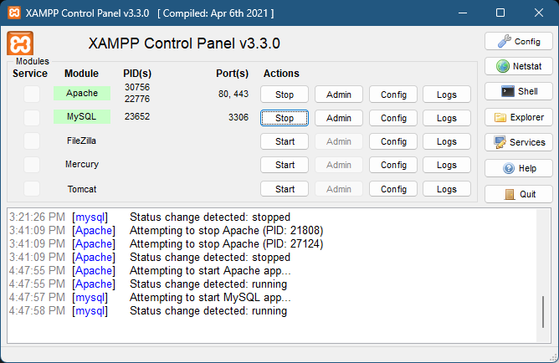

Step 2 — Install Composer
- Download the Composer installer from https://getcomposer.org.
- Run the installer. When prompted, point it to the PHP executable inside your XAMPP folder — for most Windows users, this will be at C:\xampp\php\php.exe.
- Once the installation finishes, verify that it worked by opening PowerShell or Command Prompt and running:

composer --version

Step 3 — Install Node.js
- Download the LTS version of Node.js from https://nodejs.org. The LTS release is the most stable.
- Run the installer with the default settings.
- Verify both Node.js and npm installed correctly:

node --version
npm --version

Step 4 — Clone the Repository
With the prerequisites in place, it is time to download the project itself. Open PowerShell or Command Prompt and run:

git clone https://github.com/natd23111/Smart-Body-Composition-System.git
cd Smart-Body-Composition-System

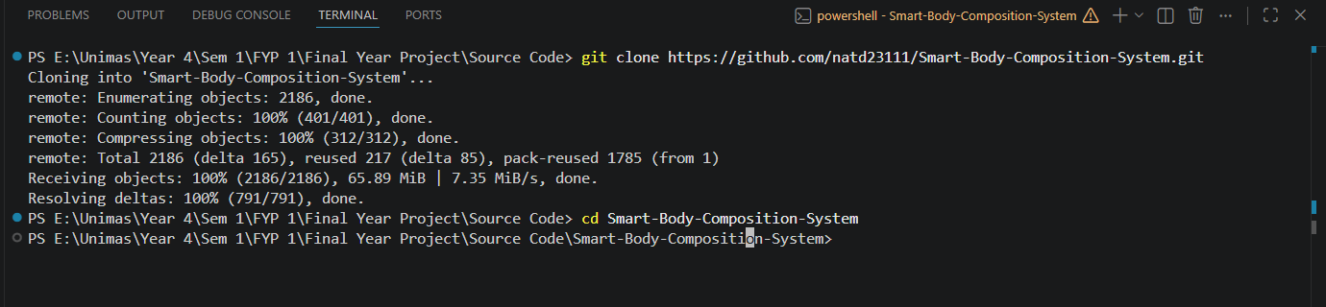

Step 5 — Install PHP Dependencies
Inside the project folder, run Composer to download all required PHP packages:

composer install

Depending on your internet speed, this may take anywhere from two to five minutes. You will see packages downloading one by one — that is completely normal.

Step 6 — Configure Environment Variables
The application reads its configuration — database credentials, app keys, mail settings — from a file called .env. Create yours by copying the provided example:

copy .env.example .env

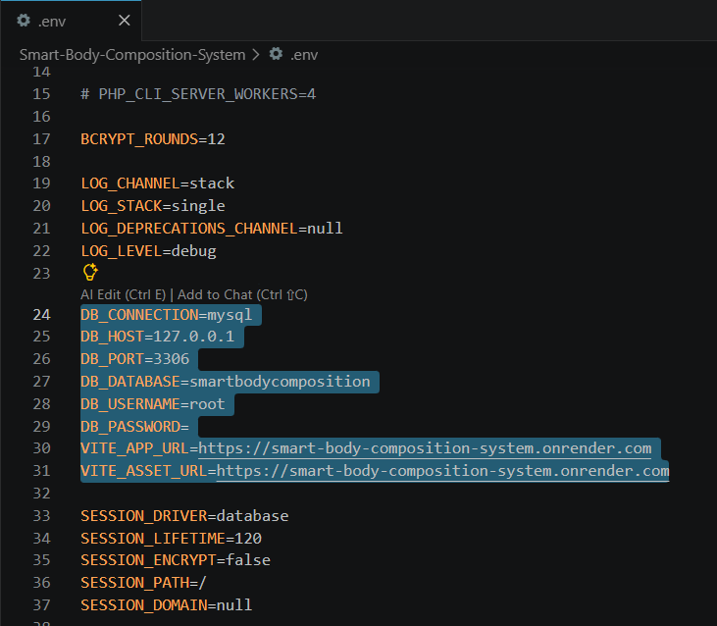

Open the new .env file in any text editor (Notepad, VS Code, and Notepad++ all work fine) and update the database section:

DB_CONNECTION=mysql
DB_HOST=127.0.0.1
DB_PORT=3306
DB_DATABASE=smartbodycomposition
DB_USERNAME=root
DB_PASSWORD= # Leave empty for XAMPP default

Step 7 — Generate Application Key
Laravel requires a unique application key for encrypting session data and cookies. Generate one with:

php artisan key:generate

You should see the confirmation message: Application key set successfully.

Step 8 — Create Database & Run Migrations
- Open your browser and navigate to http://localhost/phpmyadmin.
- Click New on the left sidebar.
- Enter smartbodycomposition as the database name, then click Create.
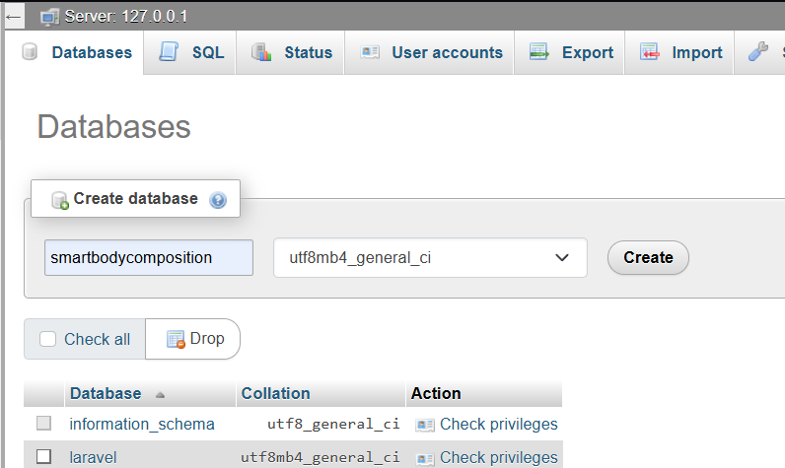

- Back in the terminal, run the migrations to create all the necessary tables and populate them with demo data:

php artisan migrate --seed

Step 9 — Build Frontend Assets
The frontend is built using Vite and needs to be compiled before the application can serve its pages correctly:

npm install
npm run build

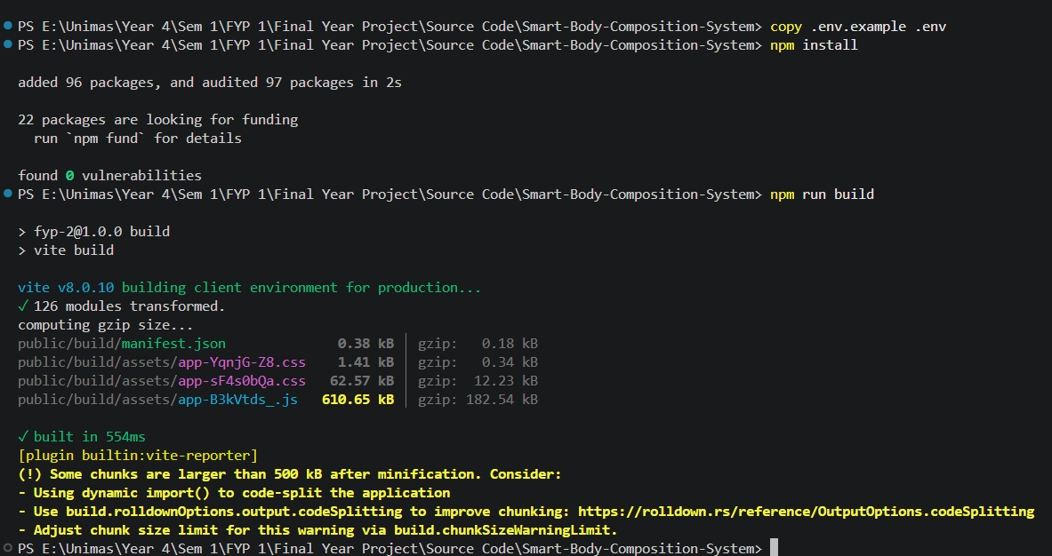

Step 10 — Composer Setup

composer setup

This single command automates dependency installation, environment setup, key generation, database migrations, seeding, and the frontend build. You still need to edit your .env file with the correct database credentials before running it.

Step 11: Start Server
Everything is in place. Start the development server with:

php artisan serve

Then open your browser and visit http://127.0.0.1:8000. If you see the login page, the installation was successful — proceed to Section 4 to create your account.

4. First-Time Setup
Once you can reach the login page — whether through a local installation or a hosted deployment — the next step is to create your account and provide the profile information that allows the system to personalize its recommendations for you.

Creating an Account
- On the login page, click the Sign up link.
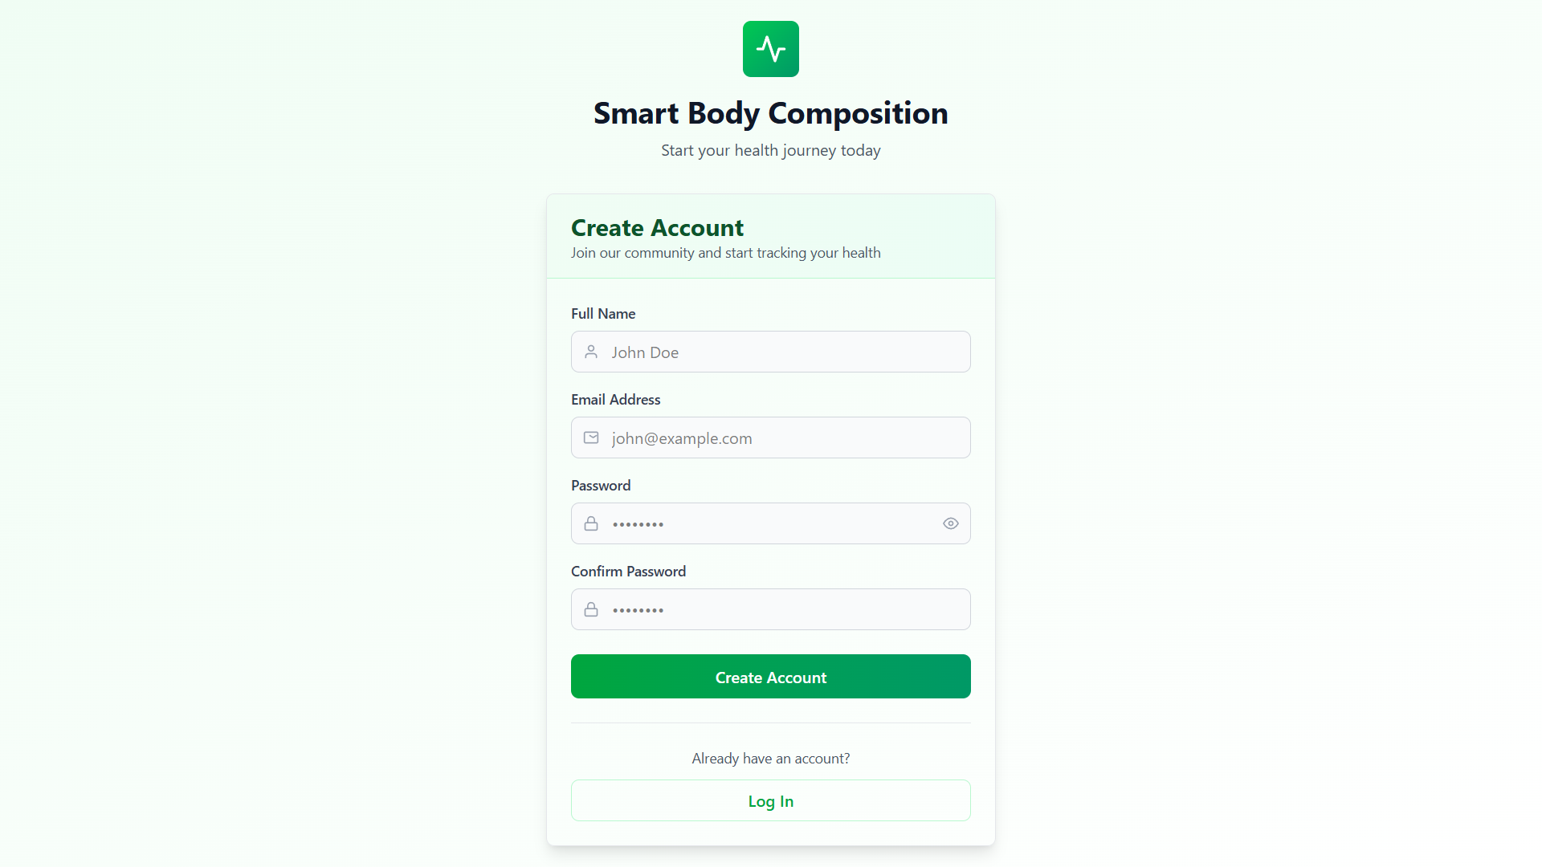

- Fill in the registration form with your details:
  - Name — your full name.
  - Email — a valid email address you have access to.
  - Password — at least 8 characters.
  - Confirm Password — re-enter the same password to confirm.
- Click Create Account. You will be redirected automatically to the profile setup page.

Setting Up Your Profile
This is an important step that is easy to rush through — please take a moment to fill it in accurately. The system uses your age, gender, and height to calibrate its health recommendations; the reference ranges for body fat %, muscle mass, and other metrics differ significantly between a 22-year-old man and a 45-year-old woman, for instance.
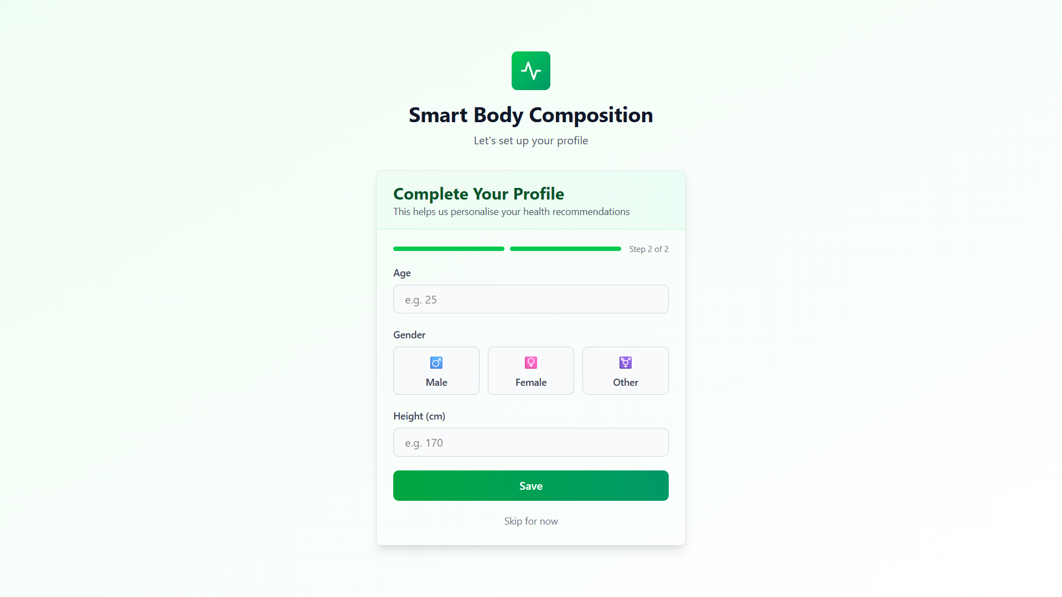

Field | Description | Example
Age | Your current age in years | 25
Gender | Select Male or Female | Male
Height | Your height in centimetres (or inches, if using imperial units) | 170

Note: The system uses your age, gender, and height to personalise health recommendations. Reference ranges for body fat %, muscle mass, and other metrics vary by these factors. Providing accurate data ensures your recommendations are relevant.

- Click Save to continue.

Choosing Your Unit System
Head over to Settings to choose the unit system you prefer:
- Metric — weight in kilograms (kg), height in centimetres (cm).
- Imperial — weight in pounds (lb), height in inches (in).

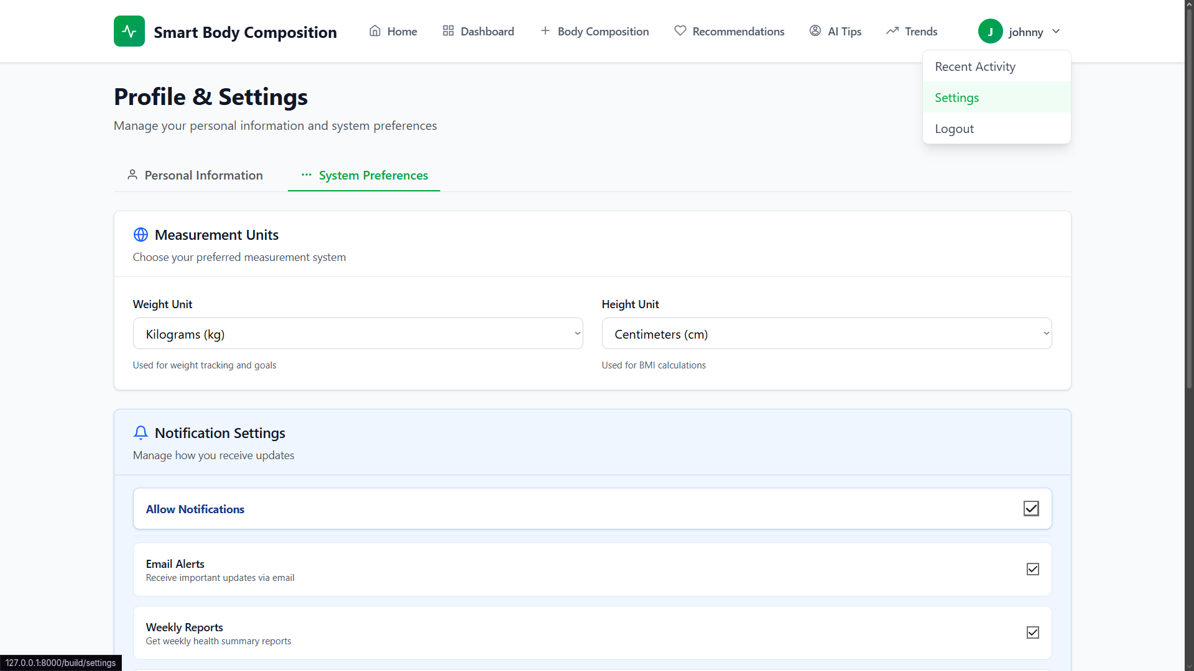

Whichever you choose, all measurements you enter going forward will follow that unit system consistently throughout the application.

5. User Interface Overview
Before diving into specific features, it helps to get a feel for how the interface is organized. The layout is intentionally simple: on the top navigation.

Top bar Navigation
Everything in the system is reachable from the top bar. Here is a quick reference for what each item does:
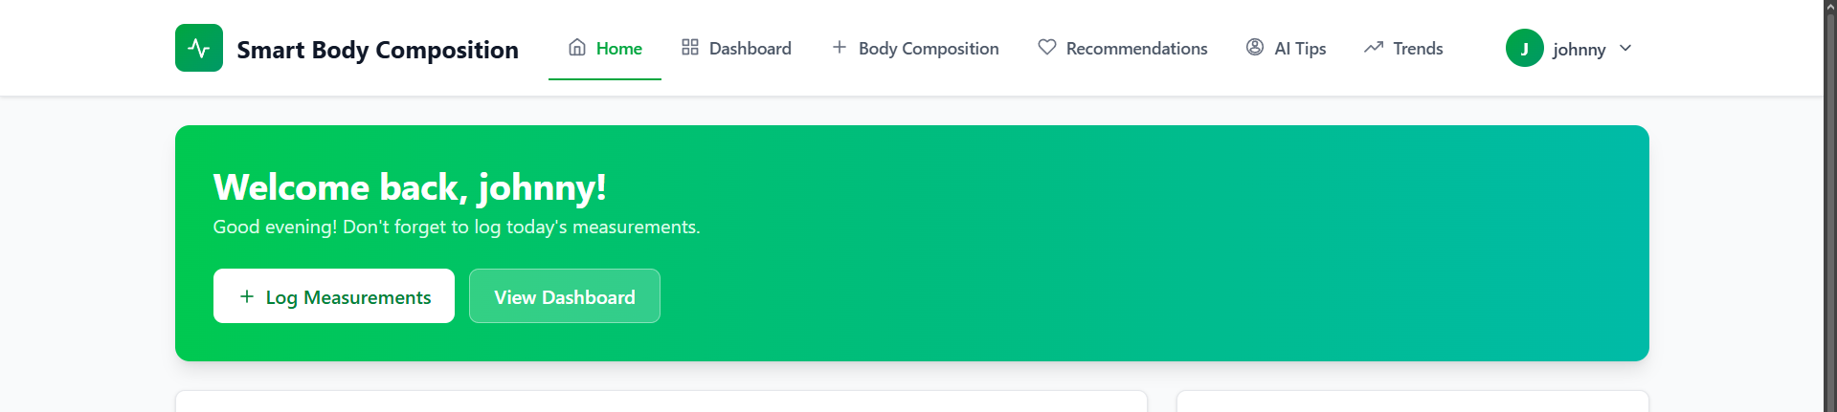

Menu Item | Purpose
Home | Overview of your recent activity, quick actions, and goals.
Dashboard | Overview of your health metrics, latest measurements, and recent trends
Body Composition | Add, view, edit, and delete body composition records
Recommendations | View AI-generated health insights
AI Tips | Quick health tips based on your profile
Trends | Visualize measurement changes over time

Dashboard Layout
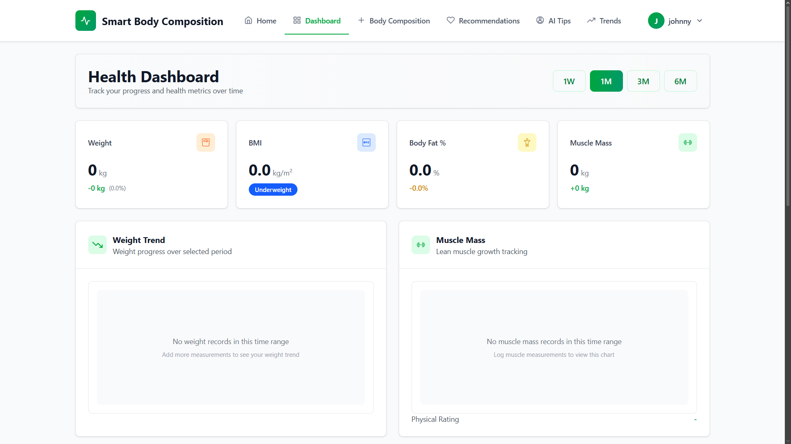

The Dashboard is your home base — the first page you see after logging in. It is designed to give you a complete snapshot at a glance without needing to navigate anywhere:
- Summary cards — your latest values for key metrics (weight, body fat, muscle mass, and more).
- Latest measurement — your most recent full body composition record in one place.
- Active goals — a quick view of the goals you are currently working toward and your current progress against each.
- Recent trends — compact mini-charts showing how your key metrics have moved recently.

6. Entering Body Composition Data
Recording your measurements is the most fundamental action in the system — everything else, from the trend charts to the AI recommendations, depends on the data you enter here. The process is straightforward: after stepping off your smart scale, open this page and key in exactly what the scale shows.

Step-by-Step
- Click Body Composition in the sidebar.
- Click the Add New Record button at the top of the page.
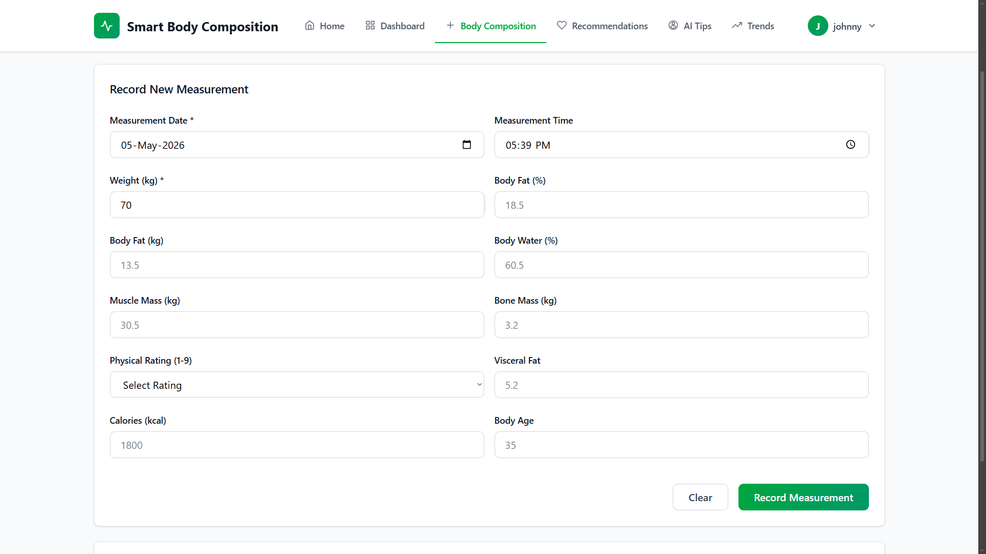

- Fill in each field with the reading shown on your scale (refer to the table below if you are unsure what any metric means).
- Click Save Record.

Understanding Each Metric
# | Metric | Description | Typical Healthy Range
1 | Weight (kg) | Your total body weight | Varies by height/build
2 | Body Fat (%) | Percentage of your body that is fat tissue | Men: 10–20%, Women: 18–28%
3 | Body Fat (kg) | Absolute weight of fat tissue | Calculated from weight × body fat %
4 | Muscle Mass (kg) | Weight of skeletal muscle | Men: ~35–45 kg, Women: ~25–35 kg
5 | Bone Mass (kg) | Weight of bone mineral content | 2.5–4.0 kg typical
6 | Body Water (%) | Hydration level — percentage of body that is water | 45–65%
7 | Visceral Fat | Fat around internal organs (scale 1–59) | 1–12 is healthy
8 | Calories (kcal) | Your Basal Metabolic Rate (BMR) — calories burned at rest | 1200–2500 typical
9 | Body Age | Metabolic age estimate based on your composition | Should be close to actual age
10 | Physical Rating | Overall fitness classification (scale 1–9) | 5–9 is active/athletic

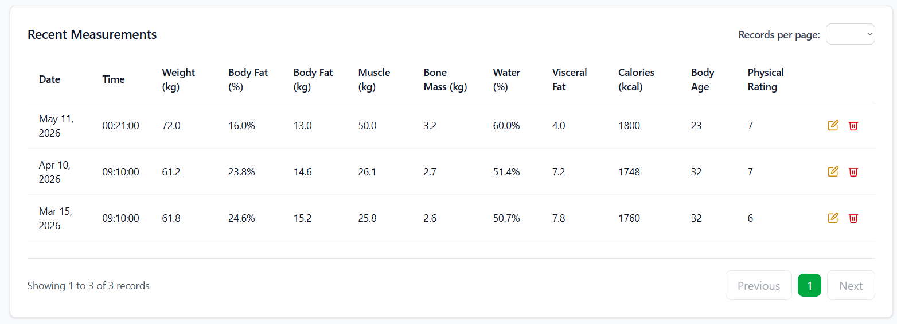

Tips for Accurate Measurements
The quality of your trend data depends heavily on how consistently you take measurements. A few habits make a significant difference:
- Measure at the same time every day — ideally first thing in the morning, after using the bathroom and before eating or drinking anything.
- Stand barefoot on the scale with both feet squarely on the metal electrodes. Socks or shoes will interfere with the bioelectrical impedance reading.
- Keep the scale on a hard, flat surface. Carpet absorbs and distorts the impedance signal.
- Enter the date and time of each measurement accurately — the system uses these timestamps for all trend calculations.
- Aim for at least one measurement per week. More frequent entries produce smoother, more meaningful trend lines.

Managing Records
All your records are listed in a table on the Body Composition page. You can edit a record by clicking the edit icon next to it — useful if you mistyped a value — or delete it entirely by clicking the delete icon. The system will ask you to confirm before permanently removing any record.

7. Viewing Trends
A single measurement tells you where you are today. A trend tells you where you are heading — which is far more useful. The Trends page visualises your body composition changes over time as interactive line charts, making it easy to spot patterns that would be invisible from isolated readings.

How to Use
- Click Trends in the sidebar.
- Use the time period selector to choose your window:
  - 7 days — a one-week snapshot, useful for spotting short-term fluctuations.
  - 14 days — two weeks of context.
  - 30 days — a full month, generally the most useful starting point for identifying real trends.
  - 90 days — three months, ideal for seeing sustained progress or long-term drift.
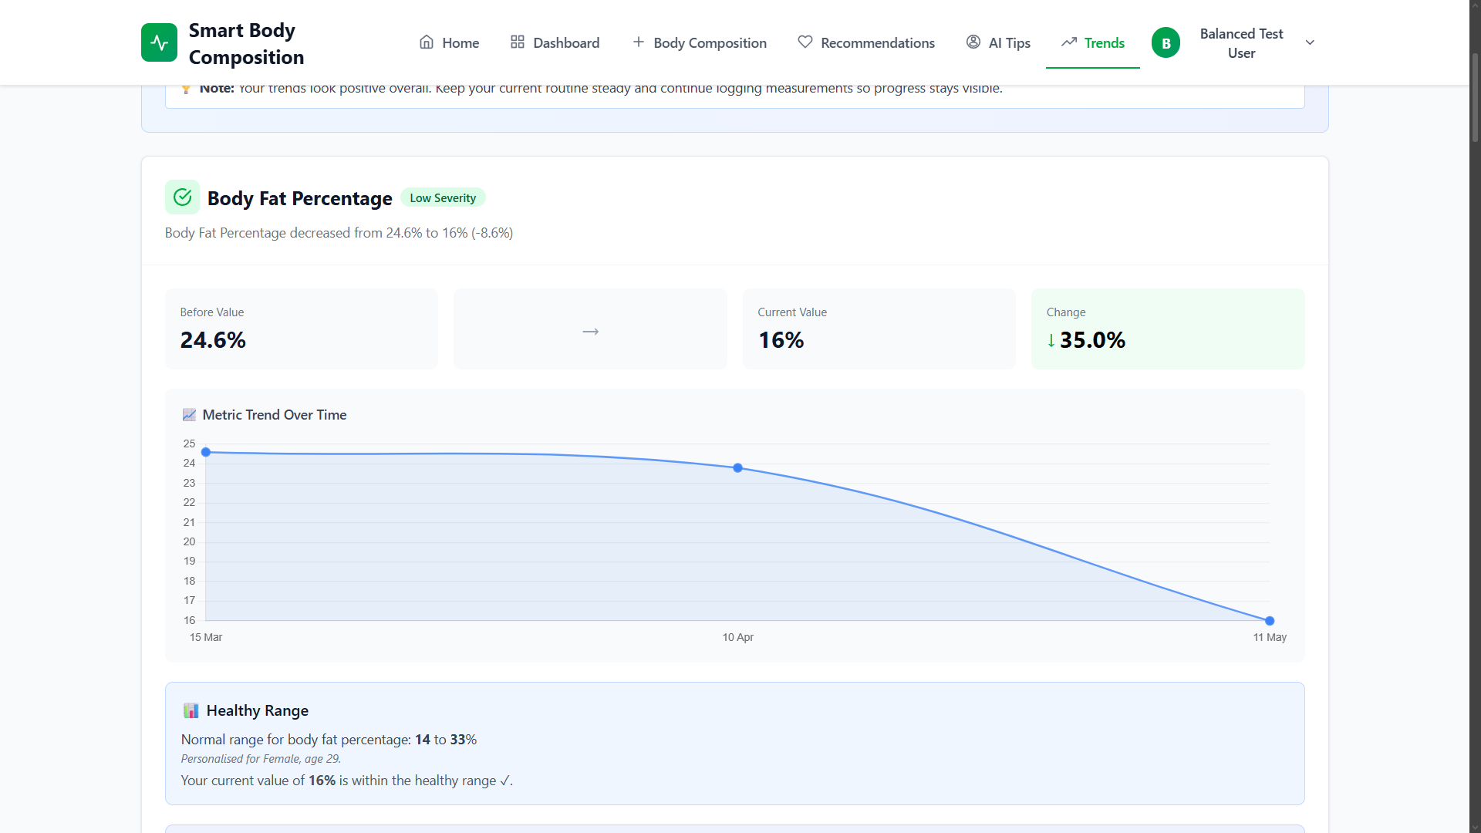

- The chart updates automatically as soon as you change the period. Hover over any data point to see the exact value and date.

Reading the Charts
- X-axis (horizontal) — the dates of your measurements.
- Y-axis (vertical) — the value of the metric being displayed (weight, fat %, etc.).
- Connected dots — each dot is one measurement entry; the line connecting them shows the direction of change.
- Gaps in the line — periods where no measurement was recorded. This is a useful visual reminder to stay consistent.

What to Look For
Rather than chasing a specific number on any given day, focus on the direction and shape of the trend:
Goal | What a good chart looks like
Losing weight | A gradual downward slope (not a sharp drop)
Gaining muscle | A gradual upward slope on the muscle mass chart
Reducing body fat | A steady decline in body fat % and body fat kg
Healthy hydration | Body water % staying consistently between 45–65%
Lowering visceral fat | A declining number, ideally below 12

Note: Healthy change is slow and steady. A drop of more than 1 kg per week typically reflects water loss rather than actual fat reduction — and it is not sustainable. Patience matters more than speed here.

8. Setting & Tracking Goals
Tracking data is motivating on its own, but having a concrete target to work toward makes a real difference. The Goals feature lets you define exactly what you want to achieve, when you want to achieve it, and then automatically tracks your progress each time you log a new measurement.

Creating a Goal
- Click My Goals in the sidebar.
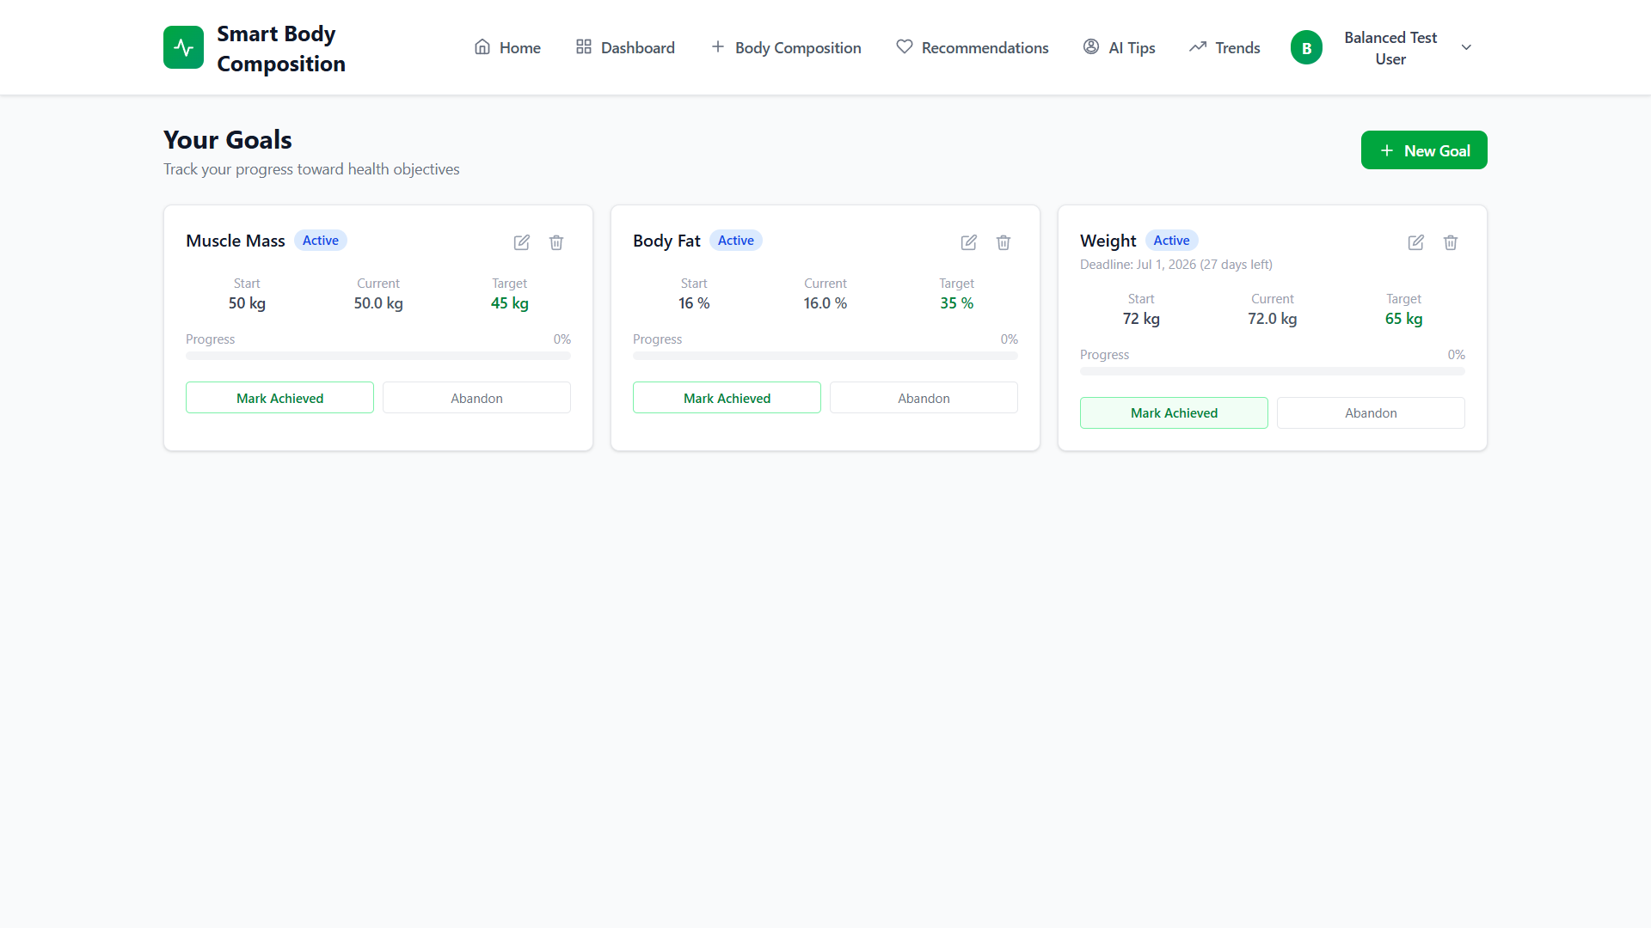

- Click the New Goal button.
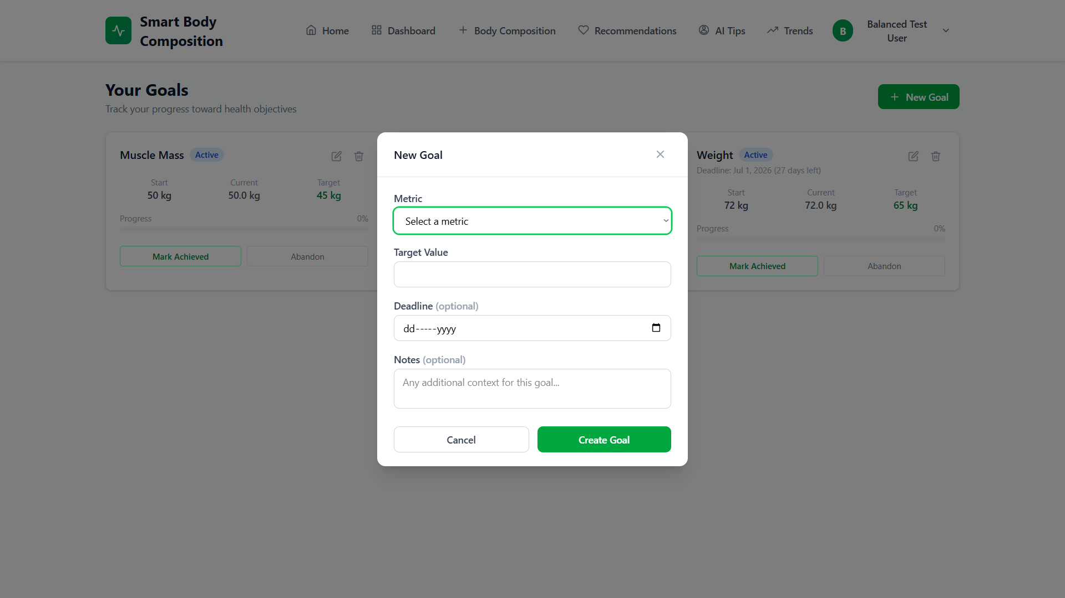

- Fill in the goal form:
Field | Description | Example
Metric | What you want to improve | Weight (kg), Body Fat (%), Muscle Mass (kg), or Visceral Fat
Target Value | Your desired measurement | 78.0 (if you want to weigh 78 kg)
Start Value | Your current measurement (auto-filled from latest record) | 88.2
Deadline | Date by which you want to achieve the target | 2026-07-31
Notes | Any additional notes about your strategy | "Caloric deficit + 3x gym per week"

- Click Create Goal.

Monitoring Progress
Once a goal is saved, the system takes over the tracking. Each goal card displays a progress bar that updates automatically whenever you log a new measurement — there is nothing else you need to do manually. Goals sit in one of three states:
- Active — you are still working toward the target.
- Achieved — congratulations: you have hit your target value.
- Abandoned — you have chosen to stop tracking this particular goal.

Editing or Deleting Goals
Life changes, and so do targets. If you need to adjust a goal's deadline, update a target value, or add new notes about your approach, click the edit icon on the goal card. To remove a goal entirely, click the delete icon — but note that this action is permanent.

9. Health Recommendations
One of the more distinctive features of this system is its ability to generate health recommendations that are tailored to your specific data, rather than serving up the same generic advice to every user. The recommendations engine looks at how your metrics have changed and compares them against reference ranges calibrated to your age and gender.

How Recommendations Work
When you trigger a recommendation generation, the system compares your earliest measurement to your most recent one within the selected period. It then evaluates each metric against appropriate reference ranges — adjusted for your age and gender — and produces an advice card for any metric that falls outside the healthy range or shows a concerning trend. If everything looks good, it says so.

Generating Recommendations
- Click Recommendations in the sidebar.
- Make sure you have at least two measurements recorded — the engine needs a before and after to detect any kind of trend.
- Click the Generate button.
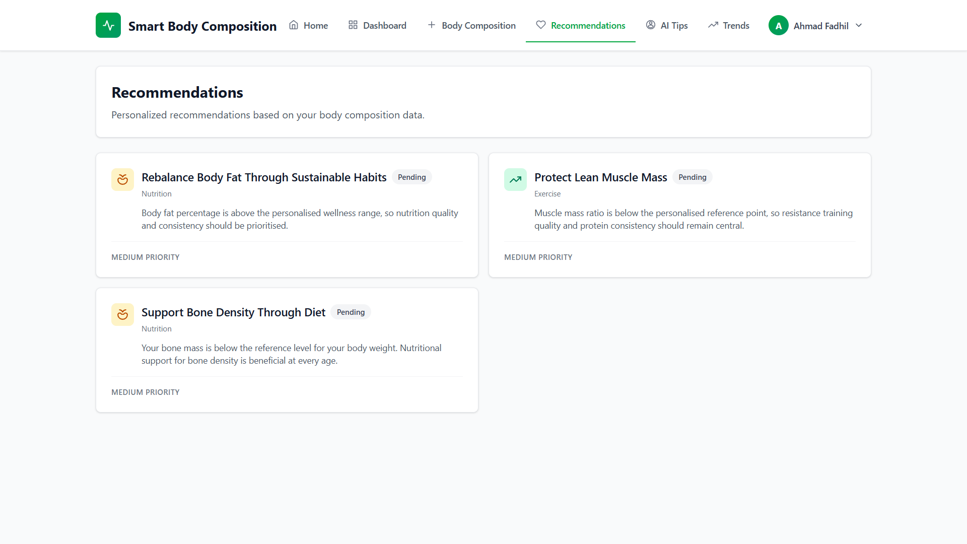

Understanding Recommendation Cards
Each card is structured to give you both context and actionable direction at a glance:
Element | Description
Title | The metric being addressed (e.g., "Body Fat Percentage")
Recommendation Text | Actionable advice tailored to your situation

Marking Recommendations
Once you have read a recommendation and decided how to act on it, you can mark it as read by clicking the checkmark or toggle on the card. A filter at the top of the page lets you switch between viewing all recommendations, only active ones, or only those you have already read.
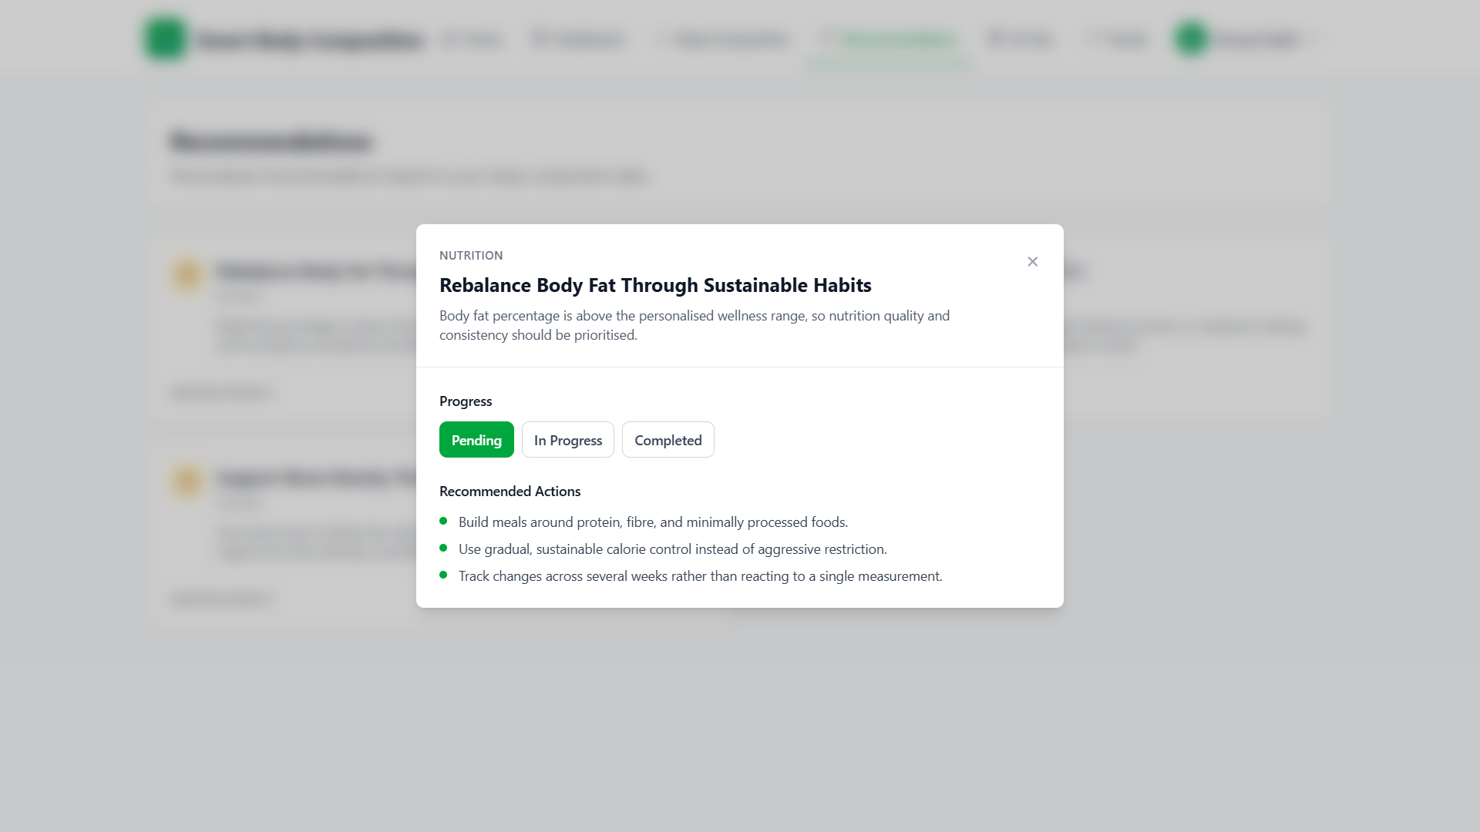

10. AI Tips
Where the Recommendations page delivers personalized insights drawn from your measurement history, the AI Tips feature offers something a little different: quick, general health guidance tailored to your profile — your age, gender, height, and overall trends. Think of it as a lighter, faster alternative when you want a nudge in the right direction without a full recommendation cycle.

Accessing AI Tips
- Click AI Tips in the sidebar.
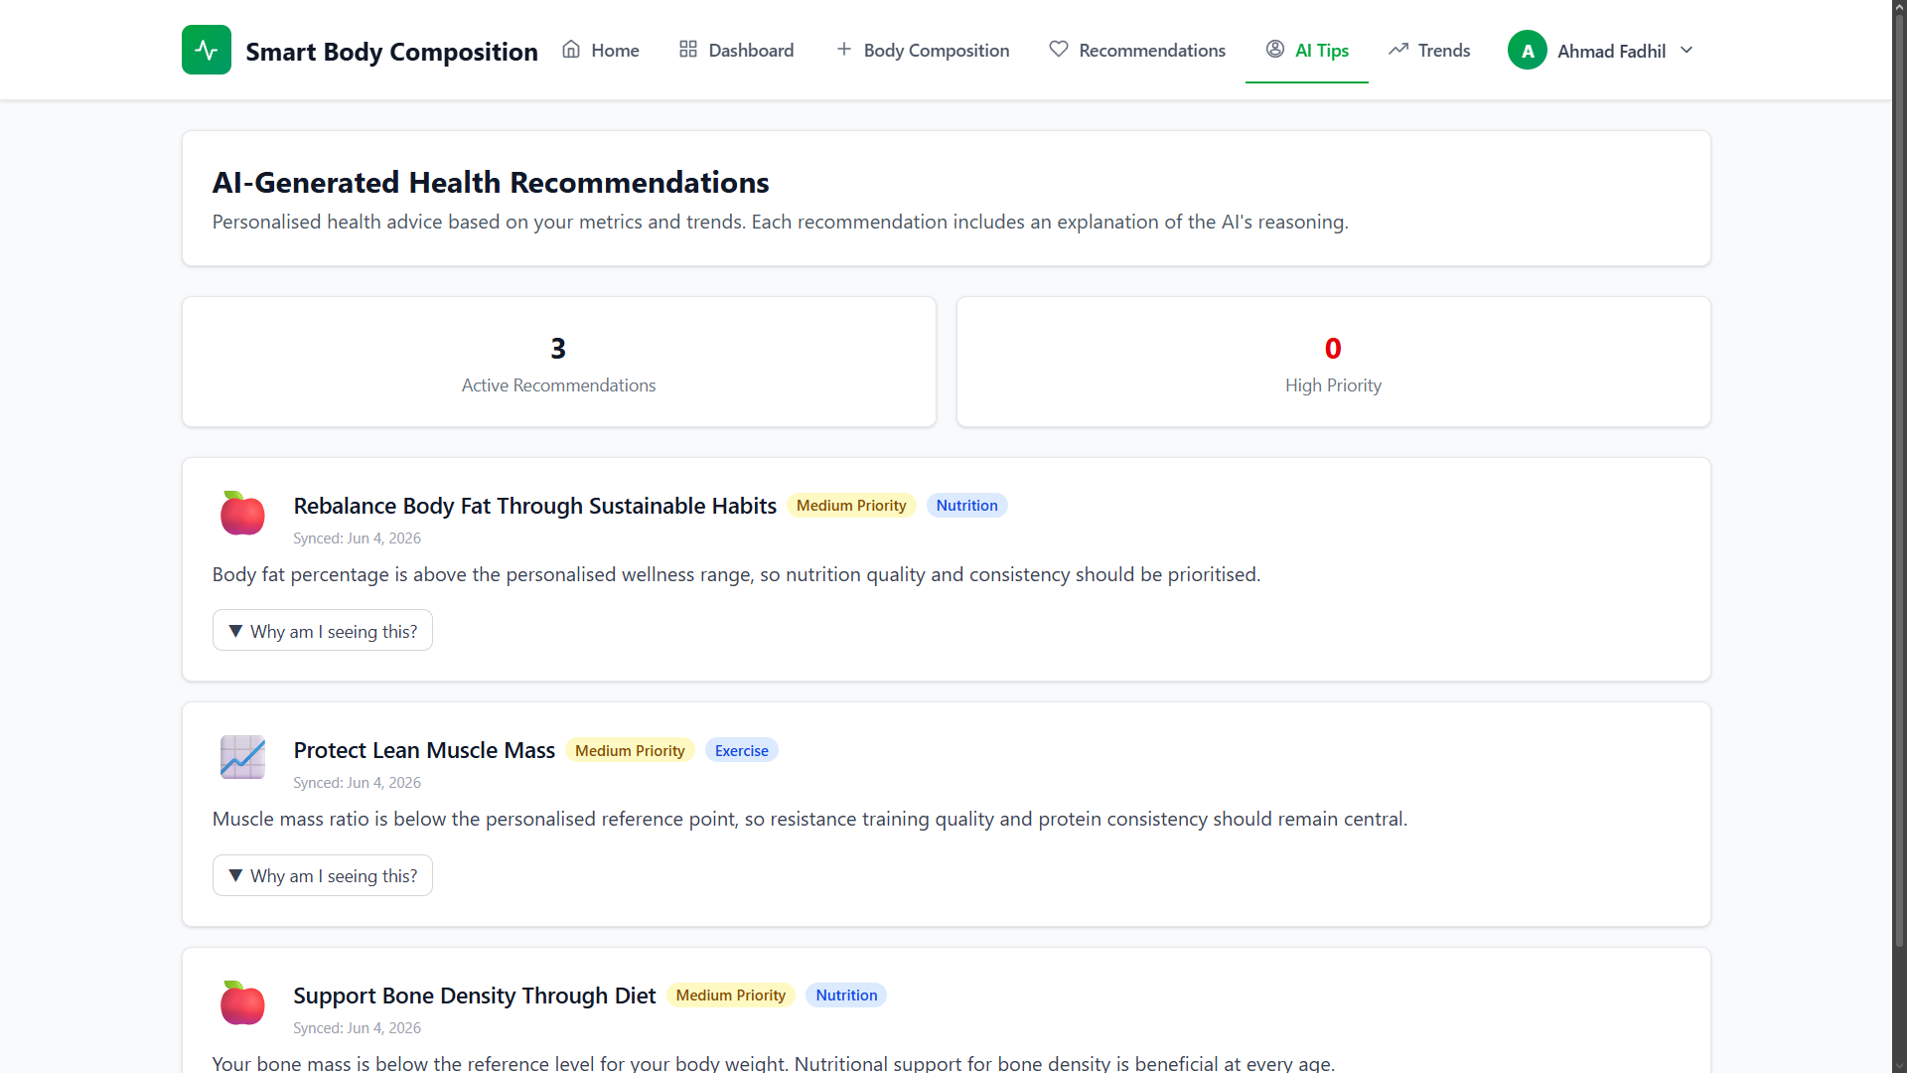

- Tips are displayed as cards with brief, actionable suggestions.
- The content covers general wellness, hydration, physical activity, and nutrition — areas that apply broadly rather than to a specific metric anomaly.

Note: AI Tips are broad suggestions based on your profile. For deeper, measurement-based insights, use the Recommendations page — it looks at your actual trend data rather than general health principles.

11. Notifications
Consistency is the hardest part of any health tracking habit. The notification system is designed to help with that — keeping you informed about your progress and gently reminding you when it is time to log another measurement.

Types of Notifications
Type | Trigger | Content
Weekly Report | Automatically generated every week | Summary of your measurements and trends over the past 7 days
Measurement Reminder | Scheduled daily at 8:00 PM | Reminder to take and log your daily measurement
Goal Achieved | When you reach a goal target | Congratulations and summary of your achievement
Recommendation Generated | After generating new recommendations | Alert that new health insights are available

Notification Preferences
If you find certain notifications unnecessary, you can dial them back in Settings under the notification preferences section:
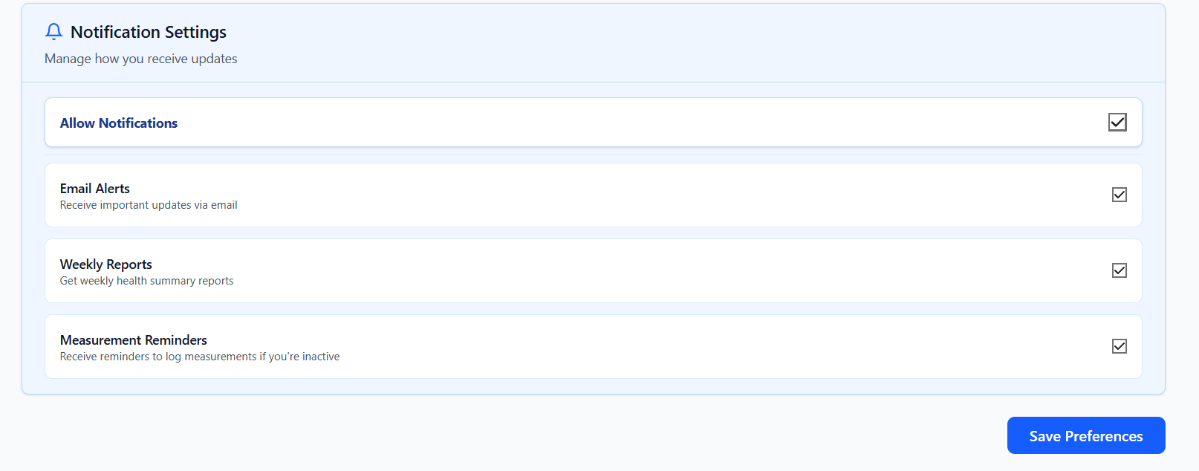

Toggle | What it controls
Notifications Enabled | Master switch for all notifications
Email Alerts | Receive notifications by email (requires email configuration by admin)
Weekly Reports | Enable/disable weekly summary reports
Measurement Reminders | Enable/disable daily measurement reminders

12. Admin Panel
The admin panel is the control room for the entire system, and access is restricted to users with the admin role. From here, an administrator can manage user accounts, review all data in the system, edit the recommendation templates that drive the advice engine, and configure system-wide settings like session timeouts and mail credentials.

Accessing the Admin Panel
Admin accounts see an additional Admin menu group in the sidebar that is invisible to regular users. If you are evaluating the system and need to explore the admin features, use the demo credentials below:
Email | Password
admin.demo@example.com | password

Admin Features

Dashboard
The admin dashboard gives a high-level health check of the entire system — not just one user's data, but everything:
- Total users — number of registered accounts.
- Total records — how many body composition entries exist across all users.
- Recent activity — the latest registrations and measurements logged by any user.
- System health — quick status indicators.

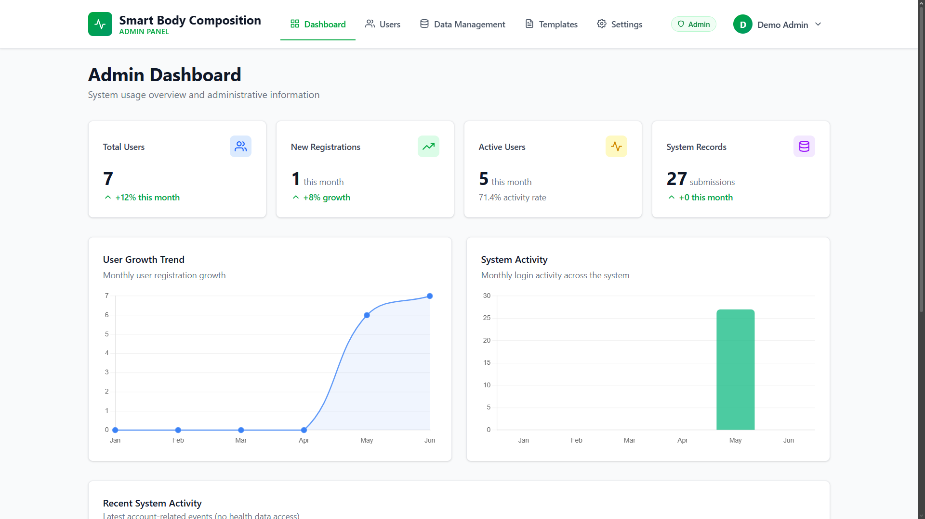

Manage Users
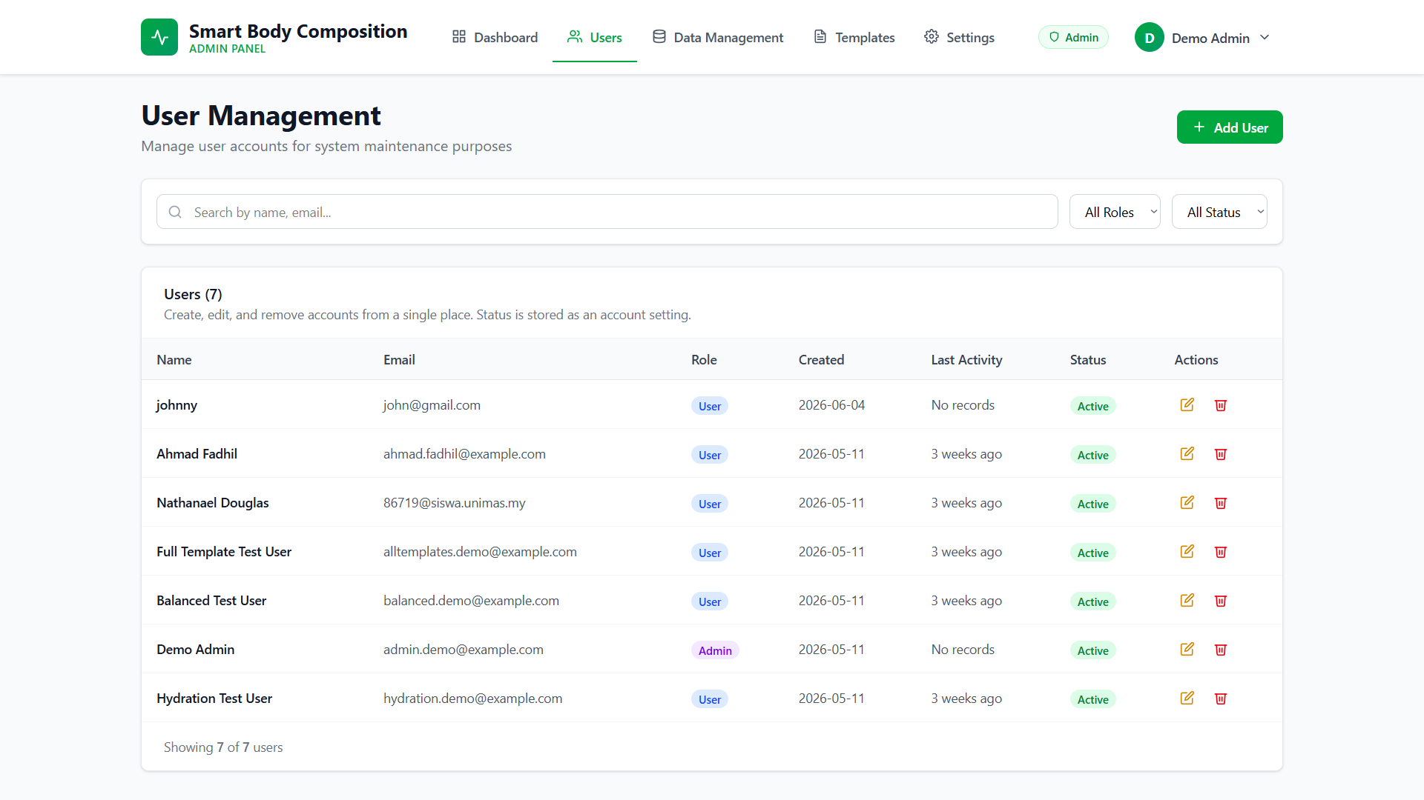

The user management page is where most day-to-day administration happens. You can search the full user list, create new accounts manually, edit any user's profile details (name, email, age, gender, height), toggle account status to enable or disable access, and view the body composition history of any individual user.

View Records
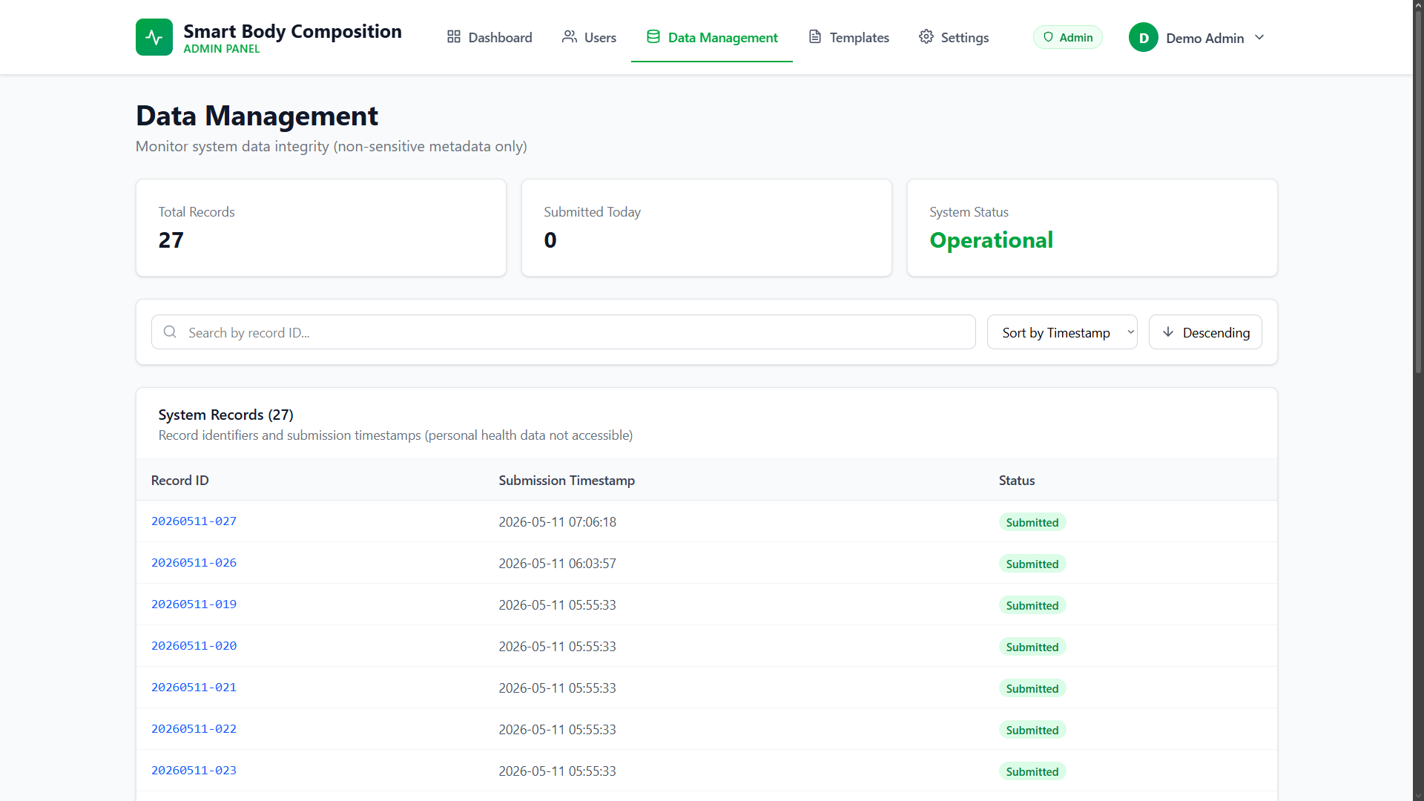

A system-wide view of all body composition records. Useful for auditing data quality or tracking system-wide usage patterns.

Recommendation Templates
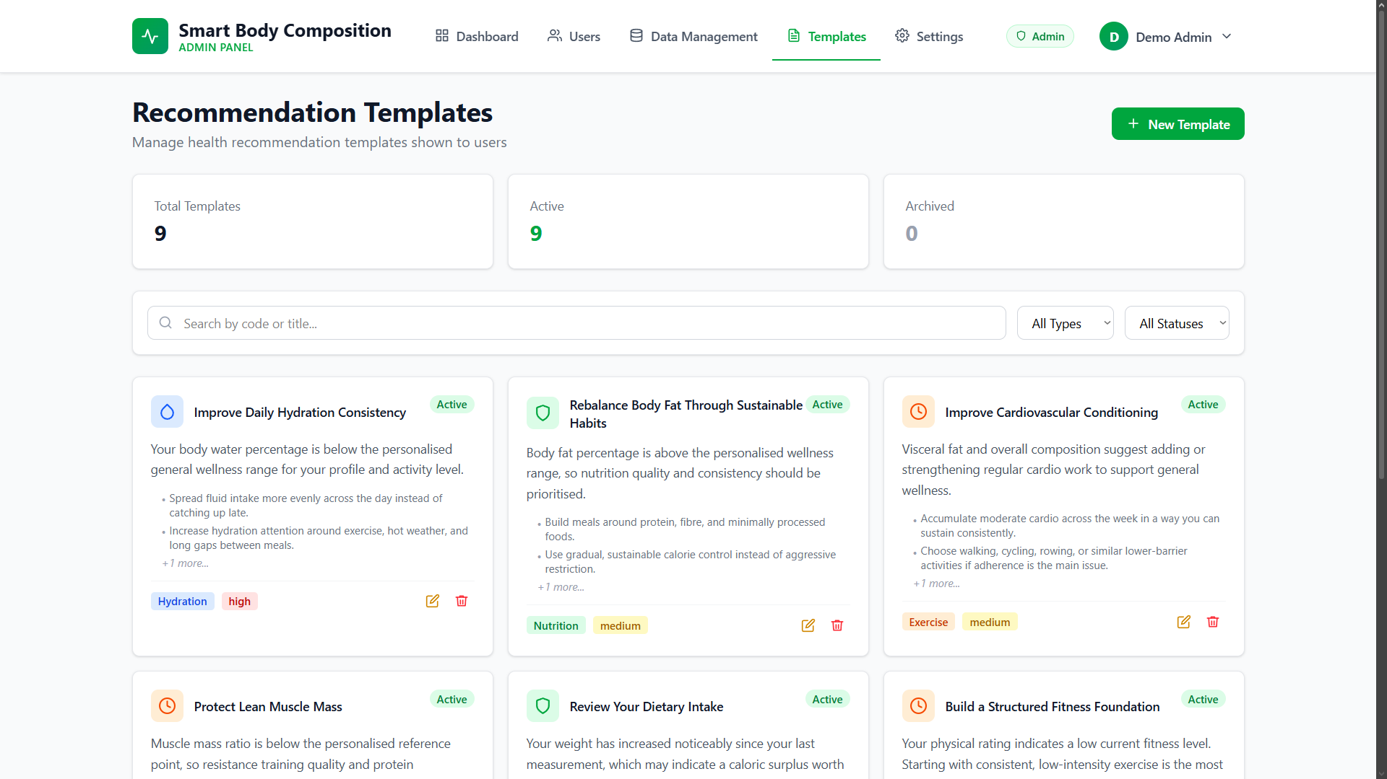

This is where the intelligence behind the recommendation engine lives. Each template defines a rule: if a user's metric falls into a particular range or shows a particular trend, serve this advice card with this severity level. Administrators can create new templates, edit the advice text and thresholds on existing ones, and toggle templates between active and archived states.
Each template contains the following fields:
- Code — a unique identifier (e.g., "HIGH_BODY_FAT").
- Type — the metric category (body_fat, muscle_mass, visceral_fat, hydration, etc.).
- Title — the short heading shown on the recommendation card.
- Summary — a single-line overview of the recommendation.
- Details — the full advice text in JSON format, which supports multiple paragraphs.
- Priority — the severity level assigned to this recommendation (Low / Moderate / High).
- Status — whether the template is Active or Archived.

System Settings
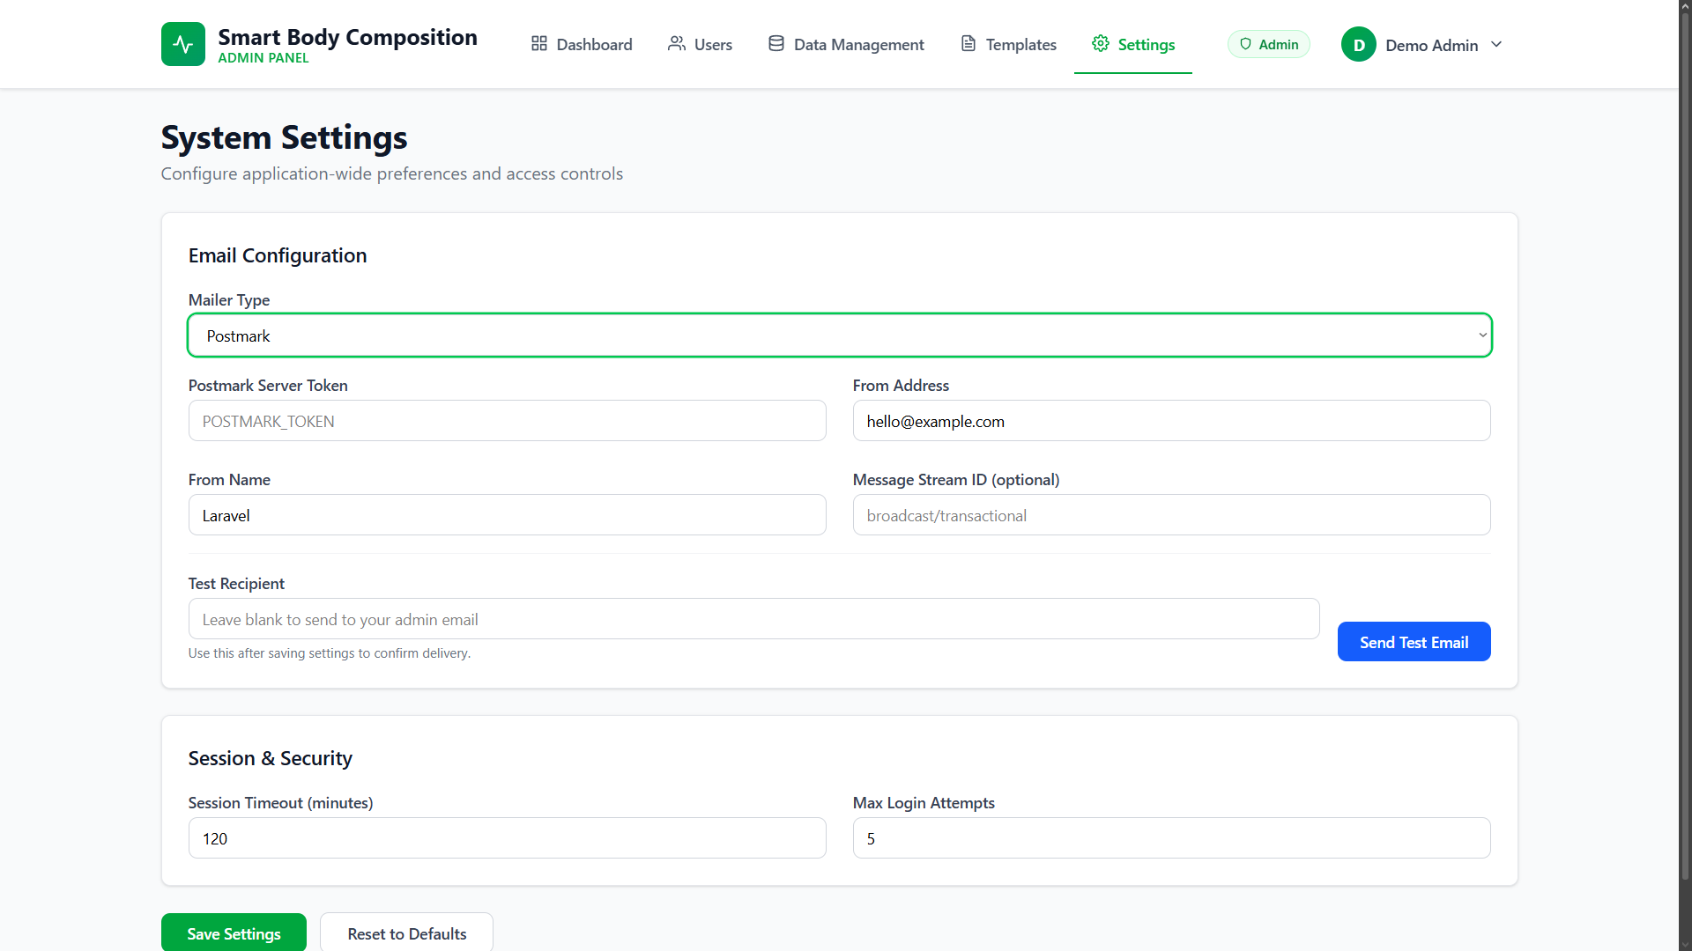

System-wide behaviour is configured here. The most relevant settings for a new deployment are:
- Session Timeout — how long the system waits before logging out an inactive user (default: 120 minutes).
- Max Login Attempts — the number of failed login attempts allowed before a lockout is triggered (default: 5).
- Email Configuration — SMTP server settings needed for the system to send notification emails.
- Test Email — a utility for verifying that the mail configuration is working correctly.

⚠ Important: Email notifications will only work once the SMTP mail settings are properly configured. Out of the box, the system uses MAIL_MAILER=log, meaning emails are written to the application log file rather than being sent — which is fine for local development but needs to be changed for a live deployment.

13. Troubleshooting
If something is not working as expected, this section is your first port of call. The issues listed here account for the vast majority of problems reported during development and testing. Work through the relevant solutions in order — most problems are resolved by the first or second step.

"Database connection refused" error
Symptoms: This error appears when running php artisan migrate or when trying to open the application in a browser.
Solutions:
- Make sure MySQL is running in the XAMPP Control Panel — both Apache and MySQL should show a green "Running" status.
- Double-check the database settings in your .env file:

DB_HOST=127.0.0.1
DB_PORT=3306
DB_USERNAME=root
DB_PASSWORD= (empty for default XAMPP)

- Confirm that the smartbodycomposition database has been created in phpMyAdmin at http://localhost/phpmyadmin.

"Vite manifest not found" or blank white page
Symptoms: The browser displays a completely blank page, or the application log contains a "Vite manifest not found" error.
The frontend assets have not been compiled yet — or need to be recompiled after a code change. Run:

npm run build

If you are actively developing and want the browser to reflect changes in real time without running a full build each time, use:

npm run dev

"Specified key was too long" error
Symptoms: The migration fails with an error message about key length.
This is caused by older versions of MySQL (below 5.7.7) that have smaller index key size limits. Add the following to app/Providers/AppServiceProvider.php inside the boot() method:

use Illuminate\Support\Facades\Schema;

public function boot(): void
{
Schema::defaultStringLength(191);
}

Port 8000 already in use
Symptoms: php artisan serve fails with "Failed to listen on 127.0.0.1:8000".
Another process on your machine is already using port 8000. Start the server on a different port instead:

php artisan serve --port=8080

Then access the application at http://127.0.0.1:8080.

Application shows "500 Server Error"
Symptoms: A generic 500 error page appears instead of the application.
The most reliable way to diagnose a 500 error is to inspect the Laravel log file directly:

# Windows (PowerShell)
Get-Content storage\logs\laravel.log -Tail 50

# Linux / macOS
tail -50 storage/logs/laravel.log

The most common root causes are: a missing .env file (fix with copy .env.example .env), a missing APP_KEY (fix with php artisan key:generate), incorrect database credentials in .env, or missing PHP extensions. You can check which extensions are loaded by running php -m and confirming that pdo_mysql, mbstring, zip, and gd are all present.

Cannot log in after registration
- Ensure the database has been seeded: php artisan migrate --seed
- Clear the application cache: php artisan cache:clear
- Check storage/logs/laravel.log for any authentication-related errors.
- If using the demo accounts provided in this manual, make sure the email address and password are entered exactly as shown — they are case-sensitive.

npm install fails with errors
- Verify your Node.js version is 20.x or higher: node --version
- If the version is correct but errors persist, delete the existing node_modules directory and lock file, then re-run the install:

Remove-Item -Recurse -Force node_modules # Windows
Remove-Item package-lock.json
npm install

- If issues continue, try clearing npm's local cache first: npm cache clean --force

Composer install takes too long or fails
- Check your internet connection — Composer downloads packages from external repositories and will fail or stall if connectivity is intermittent.
- If the download times out, increase Composer's timeout limit: composer config process-timeout 2000
- To see exactly where Composer is getting stuck, run with verbose output: composer install -vvv

Apache won't start in XAMPP
- Check whether another application is already using port 80 (common culprits include Skype, IIS, and VMware):

netstat -ano | findstr :80

- If port 80 is occupied, change Apache's listening port in XAMPP Control Panel → Config → Apache (httpd.conf) by updating Listen 80 to Listen 8080.

"class not found" or "permission denied" errors
- Regenerate Composer's autoload map:

composer dump-autoload

- Clear Laravel's cached configuration, cached application data, and compiled views in one pass:

php artisan config:clear
php artisan cache:clear
php artisan view:clear

— End of User Manual —
For further assistance, please open an issue on the GitHub repository (https://github.com/natd23111/Smart-Body-Composition-System) or contact the project author directly.

