Nathan Day

CS 501R – Deep Learing

Lab 6 – Write Up

October 17, 2017

**Lab 6 – Cancer Detection**

**What is the final classification accuracy on the test set before and after regularization?**

The following plot is of the training and test accuracy without an regularization:

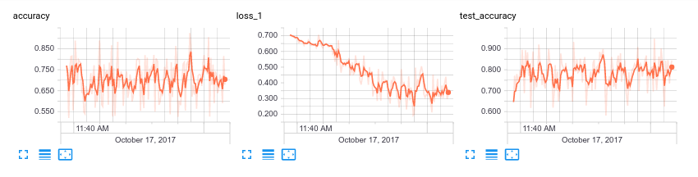Final Training Accuracy: 72%

Final Test accuracy: 82%

The following is a plot of training and test accuracy using the the dropout method with a dropout probability of 0.6:

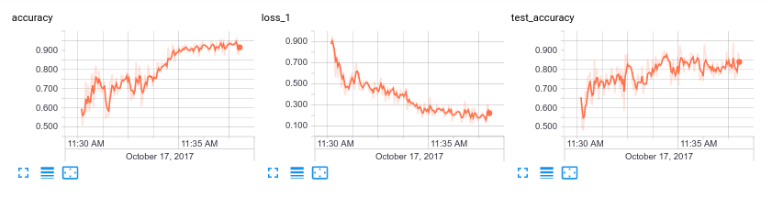

Final Training Accuracy: 92%

Final Test accuracy: 84%

The following is a plot of accuracy using L2 regularization with a lambda of 0.001:

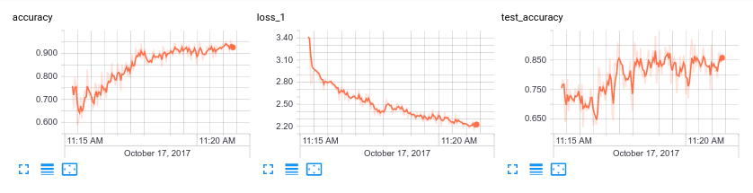Final Training Accuracy: 91%

Final Test accuracy: 86%

**Is the generalization error better or worse?**

The generalization error for the L2 regularization was better than the Dropout method. It seems that the dropout method should be more accurate, so it seems that there is a problem with me network that isn’t very apparent.

**If you used dropout, what dropout probability did you use?**

I used a dropout probability of 0.6.

**If you used L1/L2, how did you pick lambda?**

I used a lambda of 0.001. I chose 0.001 because anything larger lambdas made the output masks all black.

**What is the form of your network?**

I used the U-net structure recommended by Dr. Wingate. I ended up using an image size of 64x64 because of my lack of computing power. The form of the neural network can be seen on the following page. I also trained using 150 random images in batches of 10, and tested using 10 random images. I calculated the accuracy based on the accuracy of each pixel. The accuracy is somewhat high, because most of the images are black, so even a prediction of a completely black image would have high accuracy. The loss function was calculated using the softmax function on the labels and the last layer of the neural network.

**What does the final prediction for the specified image look like?**





