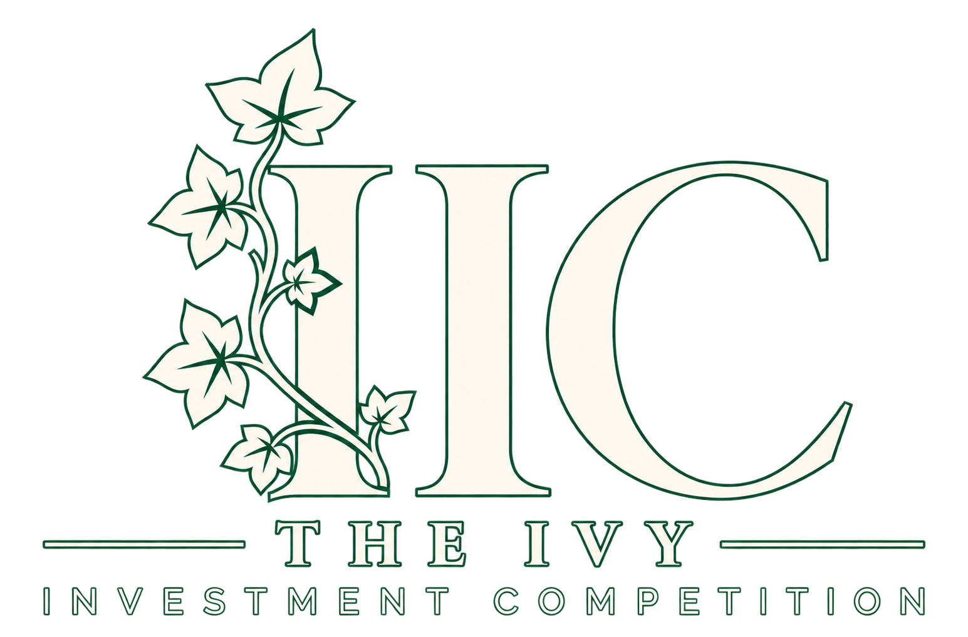
IIC 2026 Participant Guide
November 5–6, 2026 | Brown University, Providence, RI

REPLY BY THURSDAY, OCTOBER 29 AT NOON ET
Reply to your acceptance email to confirm your team has seen its acceptance and can attend both days. Include your school, Team ID, full names of all attendees, and any roster changes.

Travel and accommodations
Brown will cover transportation and hotel accommodations, with two participants per room. Amtrak tickets have not yet been booked. After your confirmation, we will coordinate your school’s departure station and itinerary for travel to Providence and share booking details.
Tickets and rooms will be booked in participants’ names. Notify us as soon as possible of any changes to your registered roster or travel plans.

Hotel and arrival
The Graduate · 11 Dorrance Street, Providence, RI 02903
Arrive for hotel check-in on Thursday, November 5 at 12:00 PM (noon) ET. Your school’s itinerary and any additional arrival instructions will follow once arrangements are confirmed.

Bring both IDs
Every participant must bring a government-issued ID for train travel and their student ID for check-in on arrival.

Prepare your pitch deck
Prepare a slide deck for your in-person pitch: 15–20 minutes presenting, followed by approximately 10 minutes of Q&A.
Translate as much of your written memo and financial model as possible into the deck, including your investment idea, research, valuation, and key assumptions. There is no slide limit or required structure. An appendix is welcome; organize the deck as you think best.
Questions? Reply to your acceptance email. We look forward to welcoming you to Brown.

