Project: International Expansion

## Step 1: Key Decisions

### Key Decisions:

*Answer these three questions*

1. What decisions needs to be made?

Which country (besides the US) would be best for the retail store chain to build a new store?

1. What data is needed to inform those decisions? Please include 2 examples in each of the following categories: Economic, Environment, Education

We will need demographic and economic data for other countries as well as the US. For example, percent of people with access to electricity, and proportion of people living in slums could be useful for weeding out very dissimilar countries. Total tax rate might be good to know for cost optimization, and total labor force might be good to know for how many potential customers there could be. The percent of people over 25 with a bachelor’s degree and the percent of people who have completed upper secondary education might also be good to know for marketing.

## Step 2: Explore and Cleanup the Data

*Answer these questions:*

1. *How many countries did you reduce your dataset to? Please include a bar chart of number of non-null data points by country, sorted from most to least.*

It was reduced to 144 countries.

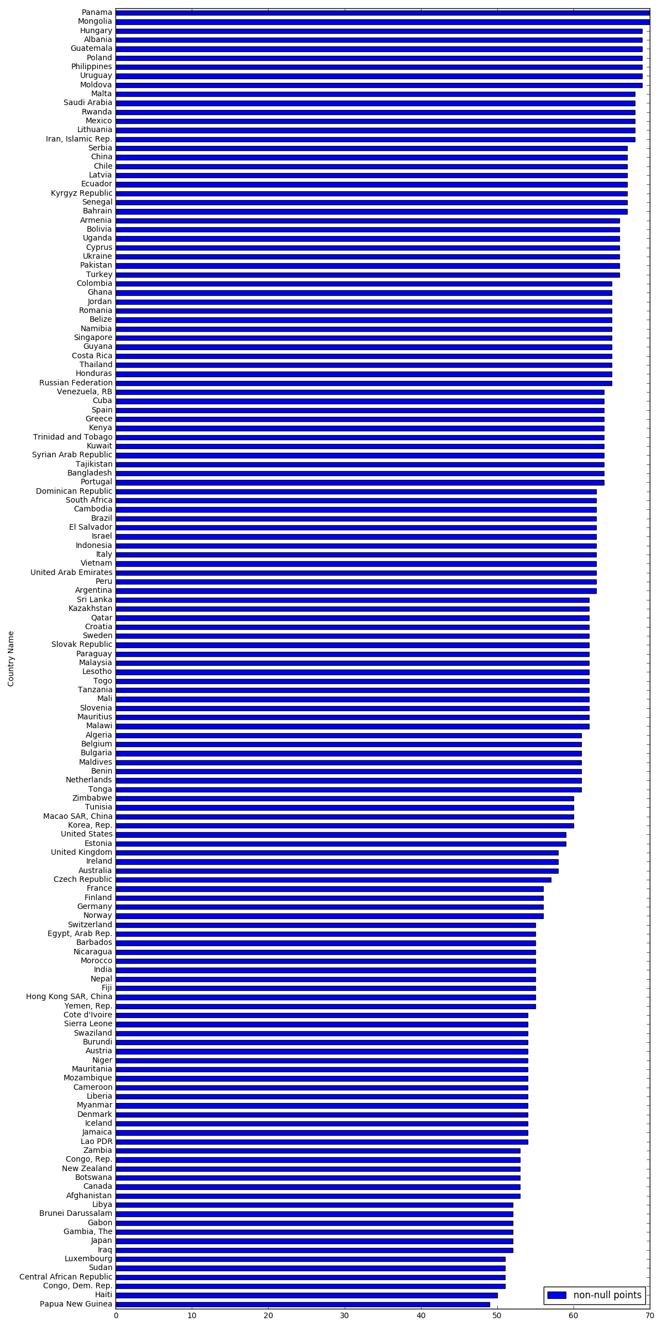

1. *Which data categories will be used for Principal Components Analysis (PCA)? There should be three categories that are targeted for PCA.*

Education_Avg Years, Education_Pct, and Education_Literacy

1. *Which variables did you decide to be irrelevant for this analysis? Only variables under the education, economic, and environment categories should be included. Hint: There should be a total of nine variables removed from the dataset.*

The variables in ‘Background’ and ‘Health’ were removed. The ‘background’ variables included internet users, HIV, under-5 death rates, and things like number of physicians and total health expenditure. These things didn’t seem relevant to a retail store’s performance.

Step 3: Determine Clusters and Methodology

*Determine the optimal clustering method and create four clusters. (100 word limit)*

*Answer this question:*

1. *What clustering method did you decide to use? Please justify your answer.*

I ended up using k-means, because it had the combination of the most reasonable-looking results, as well as the highest silhoutte score out of reasonable-looking results.

The silhoutte scores are as such:

k-means 0.10

SpectralClustering 0.08

Ward 0.08

AvgLinkage 0.28

CompleteLinkage 0.01

Birch 0.10

The birch algorithm had a similar silhoutte score to kmeans, but one cluster in the birch fit only had one point.

## Step 4: Run the Data and Visualize

1. Do the clusters make sense?

Yes. The results of the different clustering algorithms I tried look like this (the time in the corner is the time it took to fit to the data):

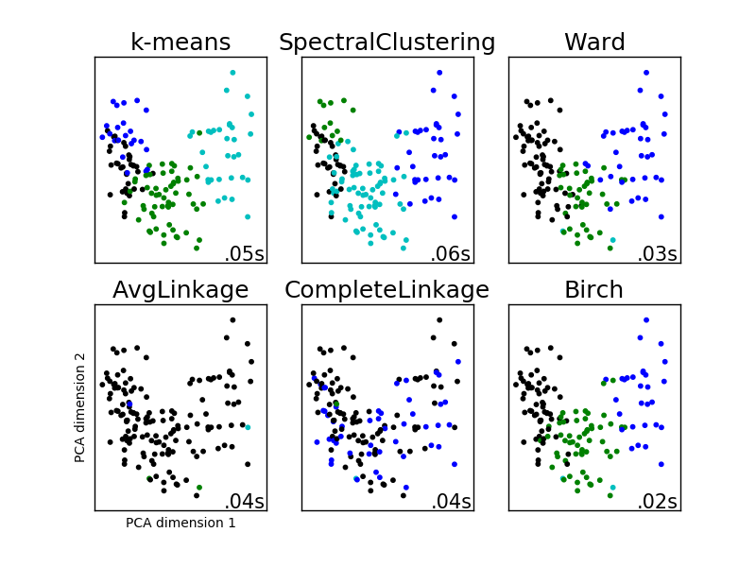

So k-means looks like it has a reasonable number of countries in each cluster, and they are decently separated in the first 2 PCA dimensions.

1. What are the four countries in USA’s cluster that are closest to the USA in terms of Total Tax Rate by ATM Machines? **Hint:** Create a scatterplot to graph the relationship between these two variables and color the markers by cluster.

Using Euclidean distances:

1. Portugal

2. Russian Federation

3. Australia

4. United Kingdom

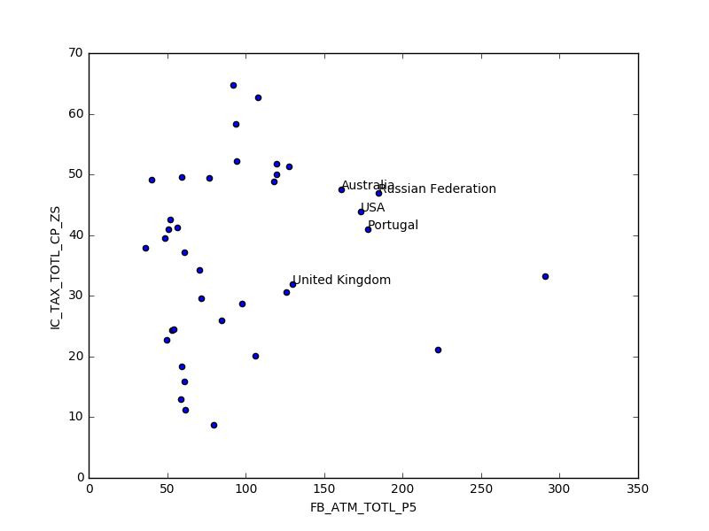

## Step 5: Recommendation

Recommended countries are:

Australia

Austria

Belgium

Brunei Darussalam

Canada

Cyprus

Denmark

Estonia

Finland

France

Germany

Greece

Hong Kong SAR, China

Iceland

Ireland

Israel

Italy

Japan

Korea, Rep.

Kuwait

Lithuania

Luxembourg

Malta

Netherlands

New Zealand

Norway

Panama

Portugal

Qatar

Russian Federation

Singapore

Spain

Sweden

Switzerland

Ukraine

United Arab Emirates

United Kingdom

*Answer this question:*

*1. Why did you decide to choose these countries?*

I chose these countries because they were the most similar to the USA based on economic and demographic data. The similarity was calculated with Euclidean distance (shortest-path distance between points), and the countries were clustered using an algorithm called k-means clustering. These countries fell within the same cluster as the USA.