**Step 1 - Understanding the Model:**

1. According to the model, if a diamond is 1 carat heavier than another with the same cut, how much more should I expect to pay? Why?

Holding all else equal, if a diamond is 1 carat higher, on average it will be worth $8,413 more. That is the coefficient in the equation given for carat’s relation to price. Fundamentally it’s because carat is a unit of weight (200mg), and so for each increase in 200mg of weight, on average and holding all else equal, a diamond is worth $8,413 more.

1. If you were interested in a 1.5 carat diamond with a *Very Good* cut (represented by a 3 in the model) and a *VS2* clarity rating (represented by a 5 in the model), how much would the model predict you should pay for it?

Plugging those numbers into the equation yields $10,094.80

**Step 2 - Visualize the Data:** Create two scatter plots. If you're not sure what a scatter plot is, see [**here**](https://www.mathsisfun.com/data/scatter-xy-plots.html).

* Plot 1 - Plot the data for the diamonds in the database, with carat on the x-axis and price on the y-axis.
* Plot 2 - Plot the data for the diamonds for which you are predicting prices with carat on the x-axis and predicted price on the y-axis.
* Note: You can also plot both sets of data on the same chart in different colors.
* What strikes you about this comparison? After seeing this plot, do you feel confident in the model’s ability to predict prices?

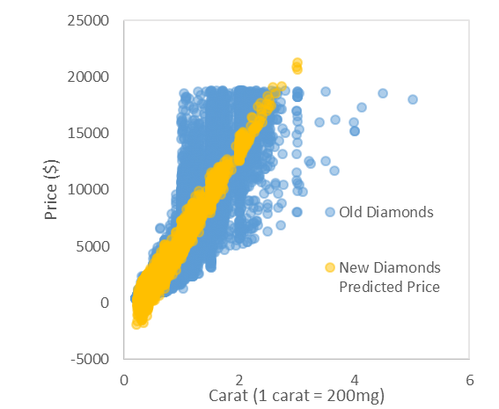

The predicted price of the new diamonds cuts right through the middle of the old diamonds. There seems to be a line that defines the minimum price at any given carat value. I feel confident in the model predicting value for diamonds with carats over 0.5.

**Step 3 - The Recommendation:** What bid do you recommend for the jewelry company? Please explain how you arrived at that number.

I recommend something around 75% of $12M ($9M) or lower. The sum of the predicted prices is $11,733,523, but to account for the negative value predictions, the bid should be increased a bit. The total predicted value of only positive price predictions is about $11.87M. I would discount the value by 25-50% because it’s a large purchase, and the vendor is going out of business.