PROJECT HANDBOOK
MAT099 Enhanced AI Racing
Creating, testing, comparing, and explaining autonomous racing agents in TORCS
A dissertation wiki-style reference for implementation, research workflows, and AI learning.
Project type | Solo dissertation research codebase
Primary platform | Windows desktop with bundled TORCS executable
Research focus | Rule-based control, racing-line control, reinforcement learning, and DRL extension planning
Learning focus | Making agent behaviour understandable through telemetry, review, comparison, and explanation
Last updated | 12 August 2026

Contents
How to use this handbook: Read the early sections for the plain-English explanation, then use the later sections as a wiki-style command and troubleshooting reference.

- 1. Executive Summary
- 2. Project Purpose and Scope
- 3. System Overview
- 4. AI Concepts for New Learners
- 5. Agent Guide
- 6. Running the Project
- 7. Training and Evaluation
- 8. Telemetry and Results
- 9. Reproducibility Workflow
- 10. Troubleshooting
- 11. Glossary
- 12. Code Map
- Appendix A. Command Reference

1. Executive Summary
MAT099 Enhanced AI Racing is a dissertation project that combines autonomous racing agent development with AI education. The system creates and evaluates agents in TORCS while presenting their behaviour through telemetry, comparison views, and explanation-oriented tooling.
The project is designed for two audiences: dissertation reviewers who need to inspect the implementation and learners who are not yet familiar with artificial intelligence but want to understand how agents observe, decide, learn, and improve.
Focus | What it means in this project
Research | Create and compare autonomous racing agents using rule-based control, racing-line logic, and reinforcement learning.
Learning | Use visible racing behaviour, telemetry, and review tools to explain AI concepts without assuming prior AI knowledge.
Reproducibility | Keep commands, outputs, policies, and troubleshooting notes in one reference so experiments can be repeated.

2. Project Purpose and Scope
The project is not only about making a car complete a lap. It is about building a controlled environment where different AI control strategies can be developed, measured, and explained.

Primary goals
- Create autonomous agents that can drive around a TORCS track.
- Research how rule-based control and reinforcement learning behave in the same simulated environment.
- Provide tooling that makes agent decisions understandable to AI newcomers.
- Record telemetry so that race behaviour can be reviewed after a run.
- Support dissertation evidence through repeatable commands, saved policies, and evaluation outputs.

Scope boundaries
Area | Included | Not the current focus
Simulator | TORCS with a local Python wrapper. | A general multi-simulator framework.
Agents | Random, rule-based, map-aware, Dyna-Q learning, and finalised Dyna-Q evaluation agents. | A complete production autonomous driving stack.
DRL | Treated as a research extension area. | Claiming a full DRL implementation before it exists.
Audience | Dissertation readers and people learning AI concepts. | A large open-source contributor community.

3. System Overview
The system follows the standard AI agent-environment loop. TORCS provides the environment, Python receives sensor data, the selected agent chooses an action, and the simulator updates the car state.
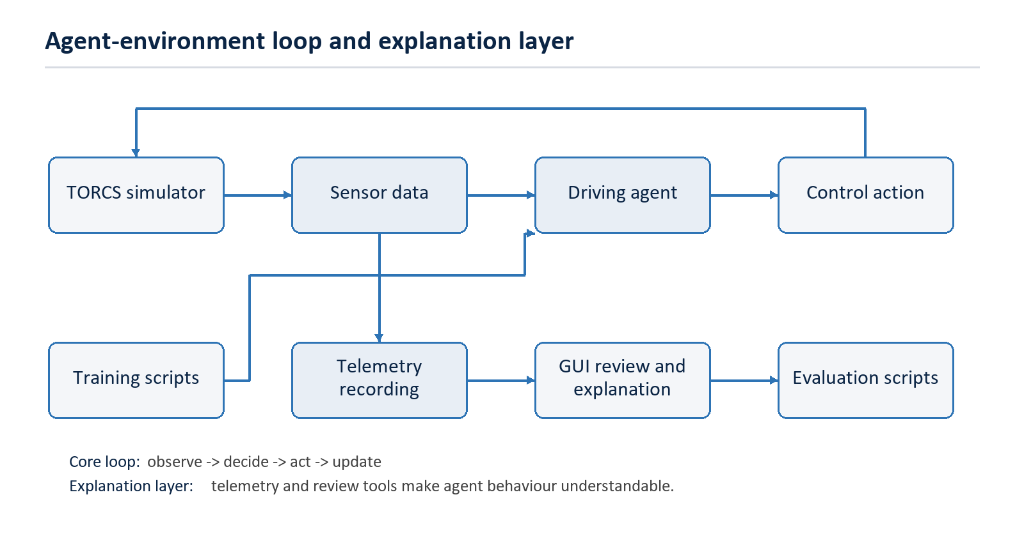
Figure 1. Project architecture and explanation loop.

Agent-environment loop
- TORCS runs the racing simulation.
- The Python runner connects to the TORCS SCR socket.
- The runner receives sensor data such as speed, angle, track position, and road sensor distances.
- The selected agent chooses steering, throttle, braking, and gear actions.
- TORCS applies the action and returns the next state.
- Telemetry and results are stored for review, comparison, training, or evaluation.

4. AI Concepts for New Learners
The racing domain makes AI easier to understand because every decision has a visible consequence. A good decision may keep the car stable through a corner. A poor decision may cause the car to leave the track, lose speed, or crash.
Concept | Plain-English meaning | Where it appears
Agent | The driver controlled by Python. | Files in src/agents/.
Environment | The world the agent interacts with. | TORCS simulator.
Observation | The information received before a decision. | TORCS sensor data.
Action | The control output chosen by the agent. | Steer, throttle, brake, and gear.
Reward | A score used to judge a learning decision. | Dyna-Q training.
Policy | Saved decision knowledge. | Files in data/policies/.
Telemetry | A record of what happened during a race. | GUI review and generated outputs.

Learning point: The same race can be viewed as a driving task, a data collection task, and a learning experiment.

5. Agent Guide
Agent | Approach | Learning value
Random Agent | Baseline control. | Shows what weak or uncontrolled decisions look like.
Rule-Based Anti-Spin Agent | Hand-written rules. | Demonstrates stable control logic and clear cause-and-effect behaviour.
Map-Aware Racing-Line Agent | Track-aware control. | Shows how adding map knowledge can improve decisions.
Dyna-Q Learning Agent | Reinforcement learning. | Shows how experience, reward, and saved policies affect behaviour.
Dyna-Q Finalised Agent | Read-only policy execution. | Separates training from evaluation so a learned policy can be tested fairly.

Research comparison
The agents are intentionally varied. This makes the project useful for comparison: a simple baseline can be compared with hand-written logic, then with map-aware control, then with reinforcement learning.
- Rule-based agents are easier to explain because each behaviour is explicitly programmed.
- Reinforcement learning agents are more experimental because behaviour emerges from rewards and repeated interaction.
- A finalised policy is important because it allows evaluation without ongoing exploration changing the result.
- Deep reinforcement learning is a future extension area where neural networks could replace or extend tabular policy logic.

6. Running the Project

Environment setup
The project is developed for Windows with Python 3.12 and the bundled TORCS executable.
python -m venv .venv

.\.venv\Scripts\Activate.ps1

python -m pip install --upgrade pip

python -m pip install numpy gym PySide6 pyqtgraph

Launch commands
Task | Command
Open the GUI | python src\gui\app.py
Open the console menu | python src\main.py
Run tests | python -m unittest discover -s tests

TORCS requirement: Live races require the bundled Windows executable at torcs\wtorcs.exe and use the default SCR UDP port 3001.

7. Training and Evaluation
Training and evaluation are separated so that the project can distinguish between learning behaviour and final performance. The learning agent updates a policy during training; the finalised agent loads a saved policy and evaluates it without further learning.

Dyna-Q training
python scripts\train_dyna_q_policy.py --episodes 5

Training writes and updates policy files under data\policies\. The latest, best, previous, and final policy files make it possible to compare progress and protect useful checkpoints.

Policy evaluation
python scripts\evaluate_dyna_q_policy.py --policy-path data\policies\dyna_q_g_track_3_best.json

Racing-line tools
python scripts\generate_racing_line.py torcs\tracks\road\g-track-3\g-track-3.xml data\racing_lines\g-track-3.json --measured-length 2843.0934

python scripts\replay_map_aware_telemetry.py --input data\generated\map_aware_telemetry.csv --output data\generated\map_aware_replay_eval.csv

python scripts\plot_raceline_tracking.py --input data\generated\map_aware_telemetry.csv --output data\generated\map_aware_tracking.svg

8. Telemetry and Results
Telemetry is central to both the research and educational parts of the project. It turns a race from a black-box result into something that can be inspected step by step.
Signal | What it helps explain
speedX | How fast the car is moving forward.
speedY | Whether the car is sliding sideways.
angle | How far the car is pointing away from the track direction.
trackPos | How far the car is from the centre of the track.
track sensors | How much road is available in different directions.
reward | Whether a learning decision was considered useful.
off_track | How often the car leaves the usable racing surface.
lap time | Whether the agent is completing laps efficiently.

Output | Location
Race database | data\generated\race_results.db
Dyna-Q policies | data\policies\
Evaluation outputs | data\evaluation\
Generated telemetry | data\generated\
Racing-line files | data\racing_lines\

9. Reproducibility Workflow
A good dissertation experiment should be repeatable. The following workflow keeps each run understandable and easier to compare.
- Start from a known branch and record the current code state.
- Confirm the Python environment and required packages.
- Confirm TORCS opens and Practice mode can start.
- Choose the agent, track, car, and training or evaluation settings.
- Run the experiment and save the generated outputs.
- Record the policy path, telemetry output, termination reason, lap result, and any unusual behaviour.
- Compare the run against a baseline or previous checkpoint.
- Keep durable dissertation evidence separate from temporary local files.
Good evidence: A useful result is not only a lap time. It should include the command used, the policy file, the run output, and a short explanation of what happened.

10. Troubleshooting
Problem | Likely cause | What to check
TORCS does not open | The executable path is missing or the project is not running on Windows. | Confirm torcs\wtorcs.exe exists.
Race does not start automatically | The TORCS menu did not advance into Practice mode. | Start Race > Practice > New Race manually while the runner waits.
Python import fails | The virtual environment is inactive or packages are missing. | Activate .venv and install numpy, gym, PySide6, and pyqtgraph.
No GUI run history | No saved race database or CSV fallback is available. | Run a race or check data\generated\race_results.db and latest_race_runs.csv.
Training appears slow | TORCS is a live simulator and the agent acts step by step. | Use fewer episodes for a quick check.
Evaluation files are missing | Telemetry saving was skipped or output path differs. | Check data\evaluation\ and script arguments.
Agent goes off track | The control policy may be unstable for the selected situation. | Review telemetry for speed, angle, trackPos, and sensor values.

11. Glossary
Term | Meaning
Agent | The software driver that decides what the car should do.
Environment | The simulated world the agent interacts with. In this project, that is TORCS.
Observation | The current information available to the agent before it acts.
Action | The output chosen by the agent, such as steering, throttle, braking, or gear.
Reward | A numeric signal used by reinforcement learning to judge a decision.
Policy | Saved decision-making knowledge used by a learning agent.
Telemetry | Recorded data from a race, used for review and explanation.
Rule-based control | Driving logic written as explicit rules by the developer.
Reinforcement learning | A learning method where an agent improves by receiving rewards from interaction.
Dyna-Q | A reinforcement learning method that combines real experience with planning from a learned model.
Deep reinforcement learning | Reinforcement learning using neural networks, treated here as a future extension area.
Racing line | A planned path around a track that helps guide cornering and speed decisions.
Evaluation | Testing an agent or saved policy and measuring the result.
Baseline | A simple comparison point used to judge whether another agent is better.

12. Code Map
Path | Role
src\agents\ | Agent implementations and decision-making logic.
src\gui\ | Desktop interface, telemetry review, comparison, and explanation views.
src\runner\ | TORCS startup, connection handling, lap tracking, and race execution.
src\racing_line\ | Track map parsing, racing-line generation, and helper control logic.
src\storage\ | SQLite persistence for agents, race runs, metrics, and telemetry.
scripts\ | Command-line utilities for training, evaluation, plotting, and replay.
tests\ | Automated tests for core behaviour and helper workflows.
data\policies\ | Saved Dyna-Q checkpoints.
data\racing_lines\ | Generated and reference racing-line data.
torcs\ | Bundled Windows TORCS simulator files.
torcs-wrapper\gym_torcs\ | Python wrapper used to communicate with TORCS.

Appendix A. Command Reference
Task | Command
Create virtual environment | python -m venv .venv
Activate environment | .\.venv\Scripts\Activate.ps1
Install packages | python -m pip install numpy gym PySide6 pyqtgraph
Run GUI | python src\gui\app.py
Run console menu | python src\main.py
Run tests | python -m unittest discover -s tests
Train Dyna-Q | python scripts\train_dyna_q_policy.py --episodes 5
Evaluate Dyna-Q | python scripts\evaluate_dyna_q_policy.py --policy-path data\policies\dyna_q_g_track_3_best.json
Generate racing line | python scripts\generate_racing_line.py torcs\tracks\road\g-track-3\g-track-3.xml data\racing_lines\g-track-3.json --measured-length 2843.0934
Replay telemetry | python scripts\replay_map_aware_telemetry.py --input data\generated\map_aware_telemetry.csv --output data\generated\map_aware_replay_eval.csv
Plot tracking | python scripts\plot_raceline_tracking.py --input data\generated\map_aware_telemetry.csv --output data\generated\map_aware_tracking.svg

Appendix B. Dissertation Use
This handbook can be used as the repository wiki for the dissertation project. It provides a single reference for what the system does, how the agents differ, how to run the main workflows, and how the project helps AI-new readers understand autonomous agent behaviour.
The Word format is intended for professional review and dissertation evidence. The Markdown source remains in the repository so that future changes can be tracked more easily.

