## **Creative Brief: Grad Project**

Development team: Nate Beard and Fuji Robledo (Nate will develop the app for iOS and Fuji will develop it for Android)

Description: The purpose of this mobile app will be able to send and receive messages via WiFi through a server. The point is to ping a server and the server to return something.

Goal: The goal is to create a simple mobile application user interface that pings a server via a URL/HTTP post (Swift 2: NSURL) when clicking on a button and can also get an HTTP request in return. This includes creating some sort of storage that can store those posts and send one back. This is the first step to connecting a mobile device to a raspberry pi, which will eventually be the electronic component of the ALS app, but this grad project we’re just going to learn how to ping a server and get a message in return.

Inspiration: The inspiration for this project is to build an understanding of how to create mobile apps that talk to other devices. The eventual goal is to develop a device to help people who have been diagnosed with ALS communicate with their caregivers.

Audience: The final mobile app will be designed for individuals who have ALS and their caregivers.

### Visual design:

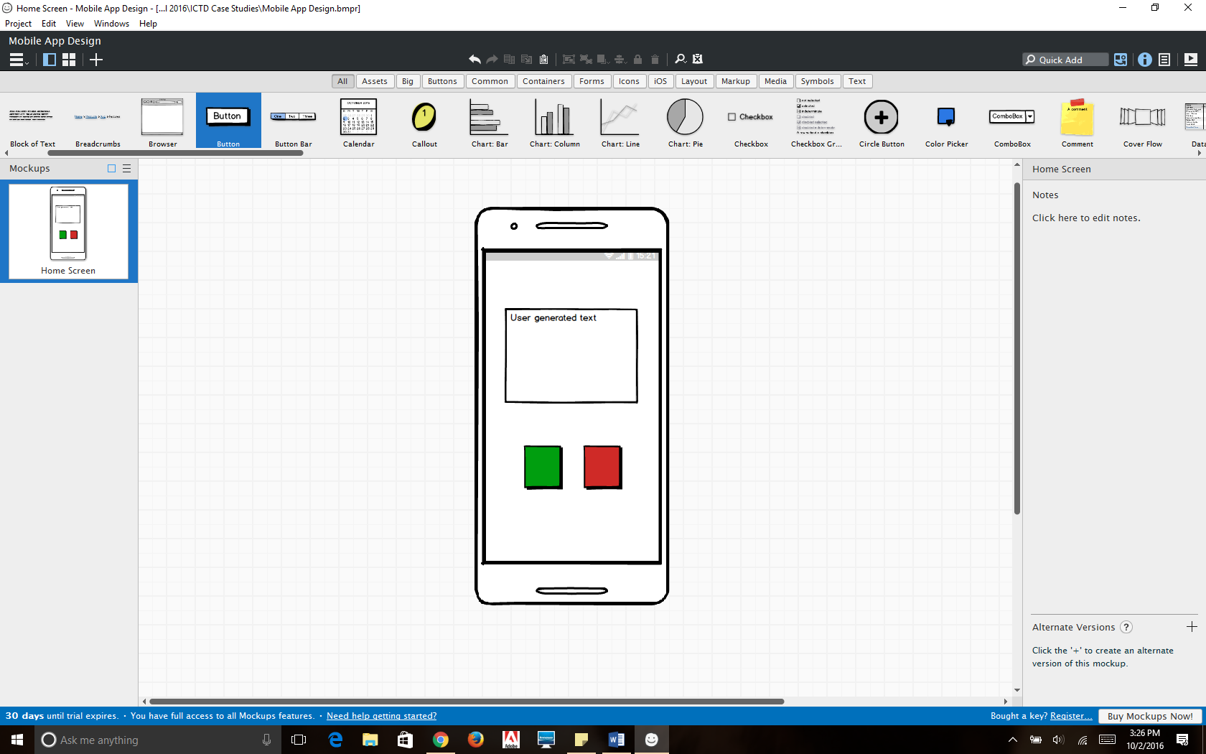

Details: When the user clicks the green button, a specific message will be returned in the label (text box) at the center/top of the view. The user receives a different message depending on whether they click on the green or red button. In theory, the user will be responding to the message by selecting one of the buttons. The message will then be submitted to the server.

The app will be adaptive to all supported device configurations.