Issue #2 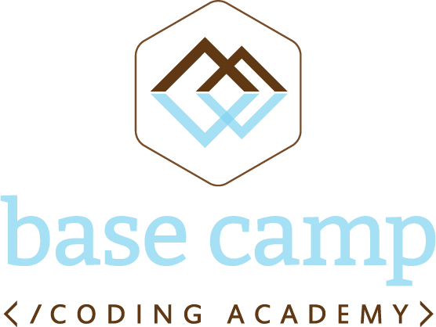

February 19, 2016

**Base Camp Coding Academy**

Newsletter

**Board Expansion:**

We are very pleased to welcome to the board Carla Lewis, Senior VP of IT at C Spire. Ms. Lewis has been leading the technological advances in Mississippi’s telecommunications, data storage and management, and connectivity through cellular and fiber optic channels for over 10 years. Her depth of experience and knowledge will be vital to guiding Base Camp’s curriculum towards practices and technology that Mississippi employers need now.

**Hiring Committee:**

We are also very pleased to welcome Sean Anthony as our Technical Director. Mr. Anthony will be the lead teacher at Base Camp, bringing a passion and energy for education that we know will inspire Base Camp students. Mr. Anthony has dedicated his career to improving education opportunities across Mississippi, both in the classroom teaching STEM classes at a high school level, and over the past 3 years creating the technical infrastructure for Teach for America.

Interviews to fill the second open position at Base Camp for this first year, the Program Director, are underway.

**Student Recruitment Activities:**

Student nominations have begun following the awareness campaigns at our area high schools. The first student interviews were conducted this week.

Presentations have been completed in front of the full high school staff at Grenada, Lafayette, Coffeeville, and Water Valley. Initial visits have been made to Panola, Calhoun, and Oxford schools, and time with the teaching staff is being scheduled. We have enjoyed an open and enthusiastic welcome everywhere we have been.

**Financial Update:**

Base Camp sponsorship pledges: $202,500

Budget to date: *We expect to spend the last of our seed capital in the coming week, and moving forward we will adopt our annual budget and begin regular reports.*

**Fundraising Activities:**

Kagan and Glen continue meeting with business and philanthropic leaders across Mississippi to ensure Base Camp has the resources to fully serve our students. Any warm introductions you can offer are greatly appreciated.

**Founding Sponsors:**

The C Spire Foundation, FNC Inc., Corelogic, generous/modest philanthropist #1, and generous/modest philanthropist #2.

**Community Sponsors:**

Trustmark National Bank