## Build the Lock Circuit

Once you successfully complete the blink example, grab the servo from the toolbox. Servo’s sticker should read TowerPro MicroServo. An example of a servo is shown in Figure 1.

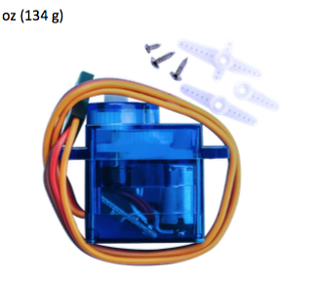

Figure Servo included with the Arduino set

|  |  |  |  |  |  |  |  |  |  |  |  |  |
| --- | --- | --- | --- | --- | --- | --- | --- | --- | --- | --- | --- | --- |
| We want to wire the system using the schematic given in Figure 2.  We can start by wiring the breadboard to the power pins provided by the Arduino.  We are then ready to connect the servo to the breadboard.  Grab 3 male to male pin extensions and wire them as described in Table 1.  Table Servo wiring color code   |  |  |  | | --- | --- | --- | | Servo Color | Extension  Color | Purpose | | Brown | Black | Gnd (-) | | Red | Red | +V (+) | | Orange | Yellow | Signal | |

I recommend that you unplug your Arduino while connecting the following parts.

Connect the servo signal, Yellow, to Arduino's Digital (PWM) pin: -9

Connect Black and Red to power on breadboard as shown in Figure 2.

Now, connect the rest of the system. You will need:

3x 220 $Ω$ resistors (4 color code: Red, Red, Brown, Gold; 5 color code: Red, Red, Black, Black, Brown)

1x 10k $Ω$ resistor (4 color code: Brown, Black, Orange, Gold;

5 color code: Brown, Black, Black, Red, Brown)

1x 100 $μ F$ capacitor (watch out for polarity! Negative side is shorter and connected to GND)

1x push button (hidden in your box)

Once you have wired everything, double check it.

You are now ready to have your circuit inspected.

After passing the inspection, continue to 1.4. **Program the Arduino with Lock Software**

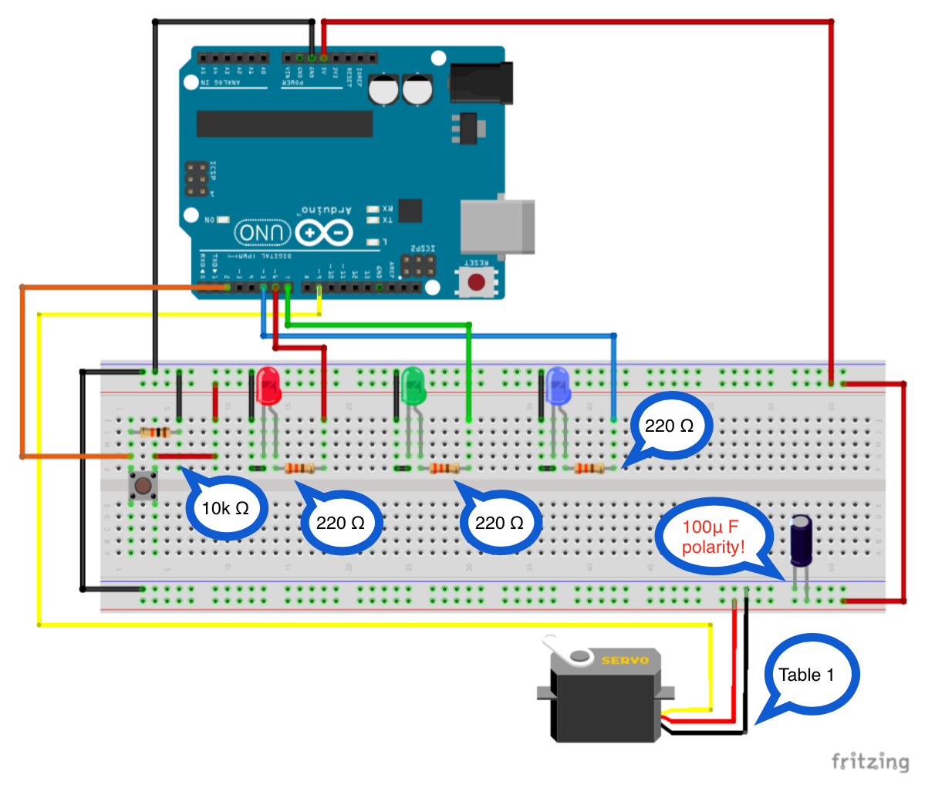

Figure System layout of the Arduino and the lock mechanism