**Wentworth Institute of Technology**

**HTMAA – Electronic Circuit Design and Instrumentation**

**___________________________________________________________________**

Name:___________________________

Date:____________________________

**___________________________________________________________________**

**Objectives:**

1. To learn how to connect voltmeters and ammeters in a circuit to measure DC voltages and currents.
2. To become familiar with the Electronics lab equipment.
3. Develop and test simple circuits on a breadboard

**___________________________________________________________________**

**Equipment:**

HP34401A DMM

9V battery

**Parts and Supplies:**

2 – 680 Ohm, ¼ W resistors

1 – 820 Ohm, ¼ W resistors

1 – Red LED

Analog Breadboard

2 sets banana/clip leads

Bag of wires

**Discussion:**

* In this laboratory, a digital multimeter (DMM) is used to measure DC voltage and current. The DMM can make many measurements, including
  + resistance (R, units of  -- ohms)
  + voltage (V, units of V -- volts)
  + current (I, units of A -- amps)
* Ohms law is V = IR, the voltage drop that occurs over a component is equal to the product of the current flowing through the component and the resistance value of the component. For certain components (resistors), R is constant, so a linear relation exists between V and I.
* In this lab, the voltage supplied (Vs) to 2 resistors in series (R1 and R2) will be provided by a 9V battery.
* When making measurements in a circuit, it is good practice to first connect the circuit without the meters, identify the quantities you want to measure, and then connect the meters accordingly.
  + To measure resistance or voltage, the existing circuit is not changed, just the two leads (+ and -) are positioned on either side of the component (see Fig. 1A). The DMM is placed in mode DC  or DC V by hitting the appropriate button on the front panel. The lead wires are attached as follows:
    - red (+) to  or V of DMM
    - black (-) to LO of DMM
  + To measure current, the circuit is disrupted. The wire (current pathway) going to the component is disconnected, such that all of the current going to the component must first pass through the DMM (see Fig. 1B). The DMM is placed in mode “DC I” by hitting the appropriate button on the front panel (use the blue shift key). The lead wires are attached as follows:
    - red (+) to  of DMM
    - black (-) to LO of DMM

|  |  |
| --- | --- |
| Vs  R1  820  R2  680  **DMM**  V  LO  *mode:* ***DC V***  **DMM**  V  LO  *mode:* ***DC V***  (+) red  (+) red  (-) black  (-) black  to measure **V1**  to measure **V2** | Vs  R1  820  R2  680  **DMM**  I  LO  *mode:* ***DC I***  I1  I2  (+) red  (-) black  to measure  **I1 or I2** |
| **Fig. 1A:** use DMM to measure V | **Fig. 1B:** use DMM to measure I |

**Procedure**

1. Although we are using specified resistor values, all resistors have a tolerance value associates with them. This means that if you select a random resistor, the true value of the resistor will most likely be slightly different. Therefore, it is important to test the true value of the resistance of any resistor prior to using it in a circuit.

In this experiment, use DMM to measure the actual resistance values of R1 and R2.

R1 (nominal 820 ) = ________________________(actual value)

R2 (nominal 680 ) = ________________________(actual value)

R3 (nominal 680 ) = ________________________(actual value)

1. Calculate the percentage error for manufacturer specification.

% Error of Manuf Spec = 100 * [| (nominal value) – (actual value) | ] / (nominal value)

% error for R1 = ________________________ within 5% tolerance? Yes/No

% error for R2 = ________________________ within 5% tolerance? Yes/No

% error for R3 = ________________________ within 5% tolerance? Yes/No

1. Build the circuit in Fig. 1A on your breadboard. In this circuit we will use a 9V battery for Vs. On the breadboard, this circuit should resemble Fig.2.

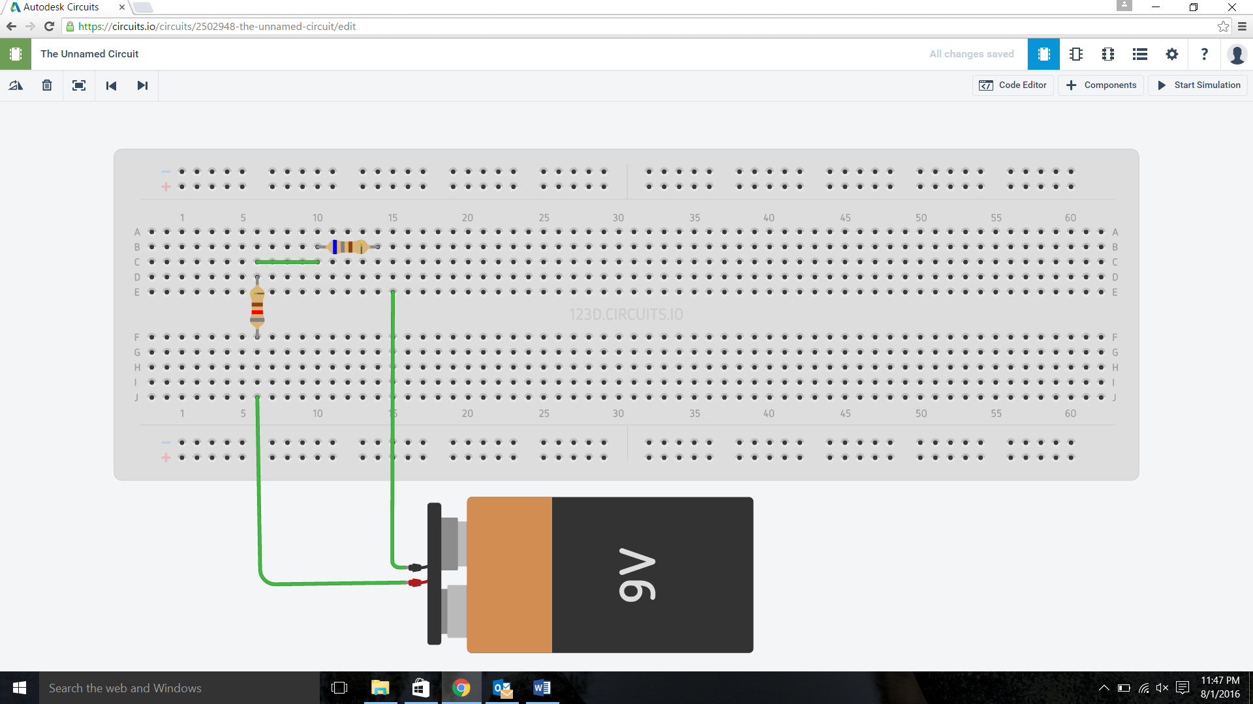

**Fig. 2:** Circuit 1 on the breadboard

1. Configure the DMM to measure voltage as illustrated by the instructor. Measure the voltage across R1 and R2  and record those values here:

VR1 = ________________________

VR2 = ________________________

How do the measurements made for both R1 and R2 relate to the applied voltage of 9 V?

1. Now configure the DMM to measure current (Recall that you have to press the required buttons for DCI and connect the leads to be measuring current). Measure the current going into R1 and the current going into R2. Remember you must break your circuit in order to do this measurement, if you do not feel comfortable doing this measurement, call the instructor over to assist.

IR1 = ________________________

IR2 = ________________________

How do the measurements made for the current going into both R1 and R2 relate to each other?

**Series and Parallel Circuits**

1. Now construct the circuit shown in Fig. 3. In this circuit you will have R1 in series with two parallel resistors (R2 and R3). On the breadboard, this should appear like the circuit shown in Fig.4.

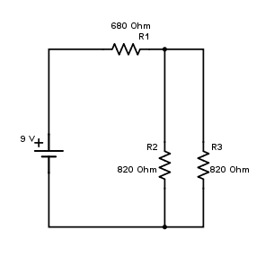

**Fig. 3:** Circuit 2

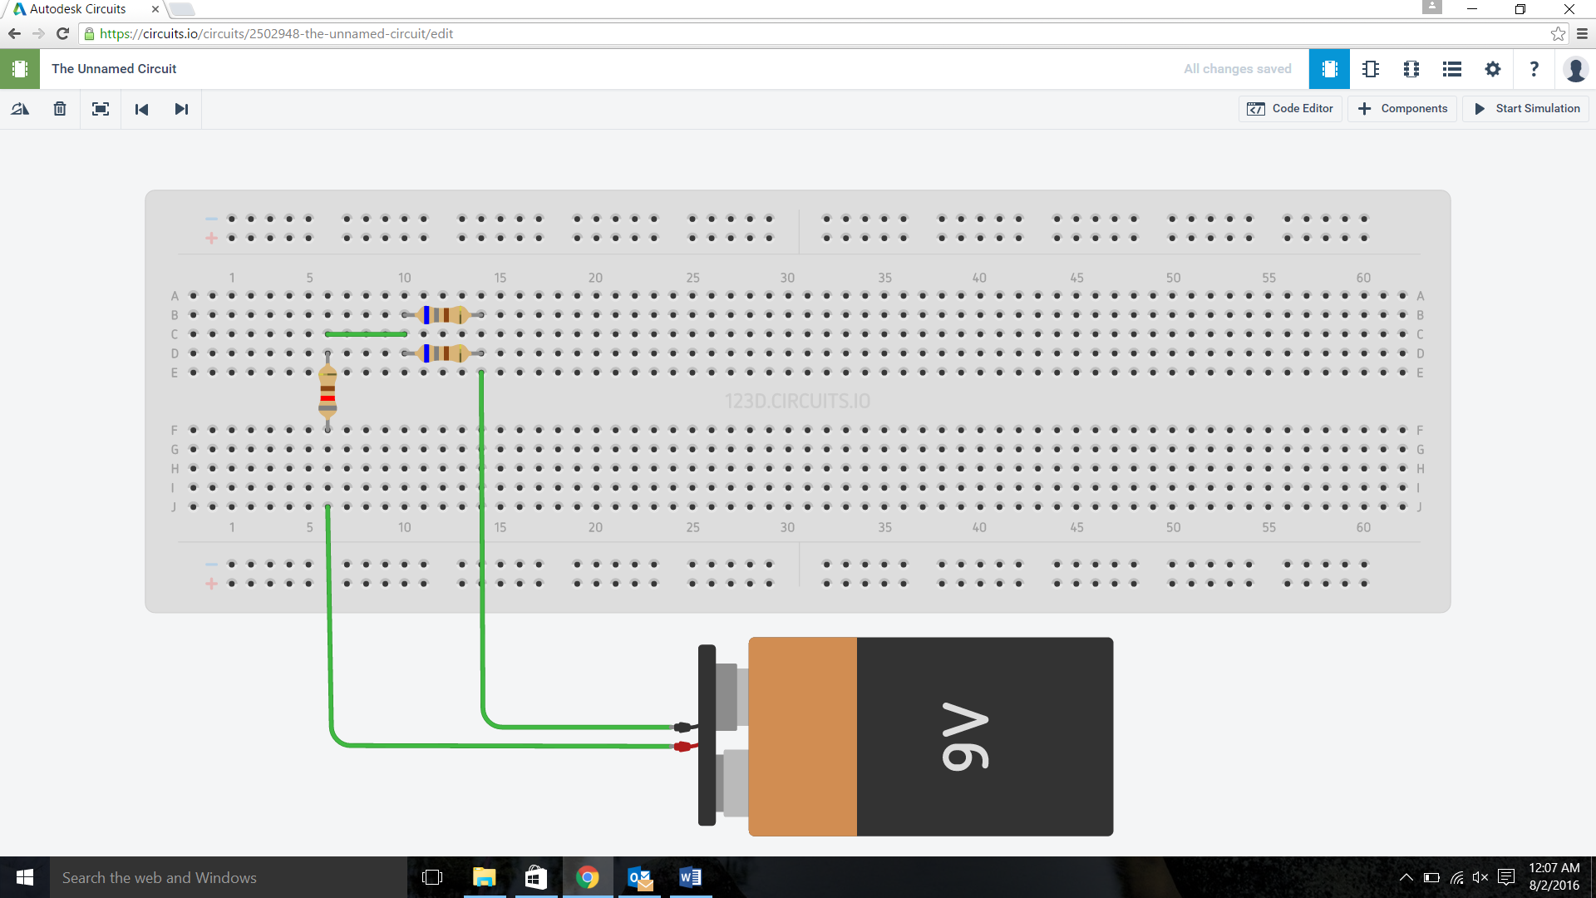

**Fig. 4:** Circuit 2 on the breadboard

1. Considering your understanding of the relationship between Voltage, Current, and Resistance, what do you anticipate will happen to the voltage and current measurements?

VR1 will go up/down(circle one)

Why?

VR2 will go up/down(circle one)

Why?

IR1 will go up/down(circle one)

Why?

IR2 will go up/down(circle one)

Why?

1. Configure the DMM to measure voltage. Measure the voltage across R1, R2, and R3. Record those values here:

VR1 = ________________________

VR2 = ________________________

VR3 = ________________________

How do the measurements made for R1, R2, R3 relate to each other and to the applied voltage of 9 V? How do these relate to your predictions in step 7?

1. Now configure the DMM to measure current (Recall that you have to press the required buttons for DCI and connect the leads to be measuring current). Measure the current going into R1, R2 and R3. Again, remember you must break your circuit in order to do this measurement, if you do not feel comfortable doing this measurement, call the instructor over to assist.

IR1 = ________________________

IR2 = ________________________

How do the measurements made for the current going into R1, R2, and R3 relate to each other and to your predictions in step 7?

**Diodes**

1. Now construct the circuit shown in Fig. 5. In this circuit you will have R1 in series with two parallel resistors (R2 and R3) and a LED. On the breadboard, this should appear like the circuit shown in Fig.6.

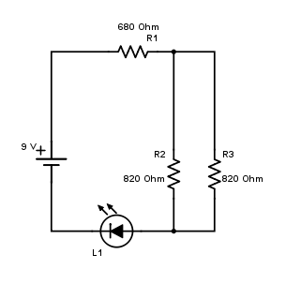

**Fig. 5:** Circuit 3

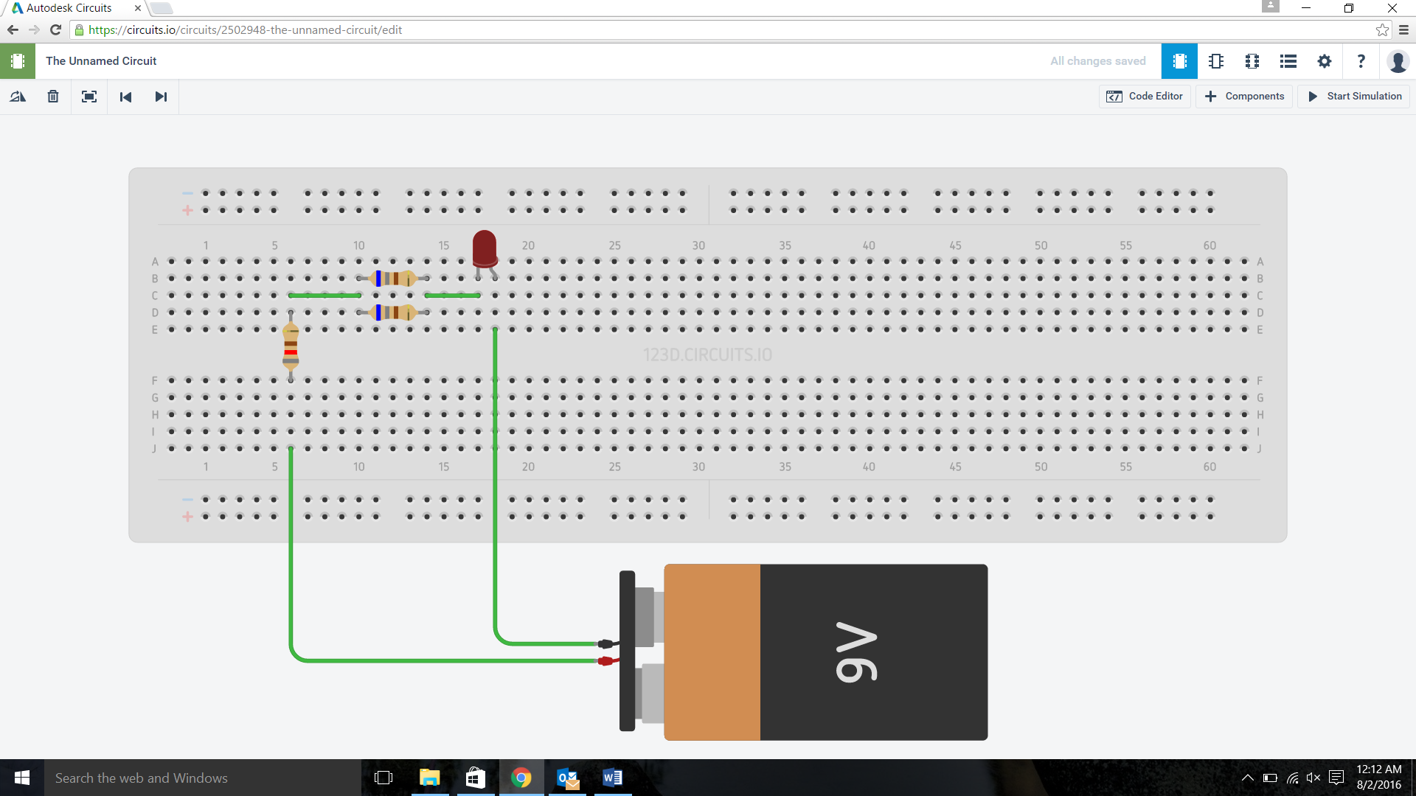

**Fig. 6:** Circuit 3 on the breadboard

1. What happens when you apply power to the circuit?
2. Measure both the voltage across the diode and the current going into it.

VD=_______________

ID=________________

1. Now reverse the diode and explain what happens.
2. Measure both the voltage across the diode and the current going into it.

VD=_______________

ID=________________

1. Explain what the diode is doing in your circuit