CS-4370-90: Par. Prog. Many GPUs

Nathan Dunn

Professor Liu

10/04/19

Project 1: Basic Matrix Multiplication and Addition

For this project, we were required to implement matrix multiplication and addition in parallel on a GPU. I was able to successfully implement both matrix operations and all of their requirements. I tested my programs with multiple different matrix sizes (8, 64, 128, 500, 1000, 1024) and block sizes (4, 16).

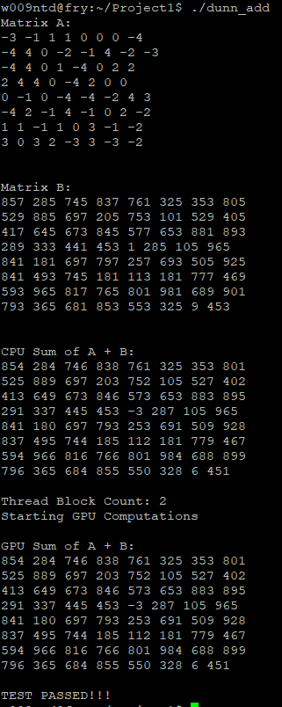

The above image depicts the output of my program when executing matrix addition with matrix size of 8x8 and block size of 4x4 (results in block count of 2). The program first prints both matrices A and B, displays their CPU sum and finally displays their GPU sum. If the GPU and CPU sum are identical, the test passes, as one can see above.

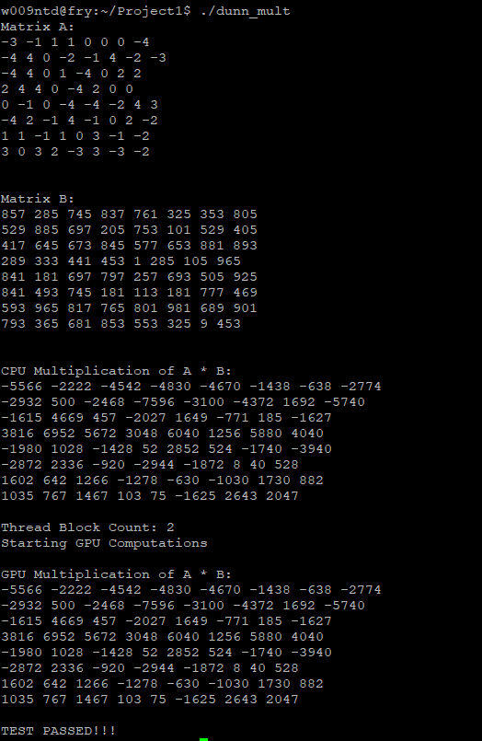

The above image depicts the output of my program when executing matrix multiplication with matrix size of 8x8 and block size of 4x4 (results in block count of 2). The program first prints both matrices A and B, displays their CPU product and finally displays their GPU product. If the GPU and CPU products are identical, the test passes, as one can see above.