

College of Natural and Computational Sciences
Department Of Information Systems
Information Storage and Retrieval Group
Assignment
NAME | ID
Nathnael Esatu | UGR/7514/17
Abener Girma | UGR/3691/17
Sofonias Asfaw | UGR/2435/17
Bisrat Anteneh | UGR/1484/17
Beakal Elias | UGR/5352/17
Abiy Getahun | UGR/5740/17

Submitted to:Dr. Demeke Ayele
Submission date:May 2,2026

Table of Contents:
Introduction 1
System Overview / Architecture 2
Retrieval Models : 3
Implementation Details 4
Evaluation Method and Results 6
Qualitative Analysis of Top 15 Retrieved Documents …………………………………………………………………………8
Screenshots of trec_eval result…………………………………………………………………………………………………….:...10
Discussion of Results………………………………………………………………………………………………………………………..11
Conclusion and Future Improvement……………………………………………………………………………………………….12

Introduction
Information Retrieval (IR) is the process of searching, retrieving, and ranking relevant information from large collections of unstructured or semi-structured data. As the volume of digital information continues to increase rapidly, efficient retrieval systems have become essential in many real-world applications such as web search engines, digital libraries, academic databases, and enterprise document management systems.
The primary goal of an information retrieval system is not simply to find documents containing query terms, but to rank documents according to their estimated relevance to a user's information need. Different retrieval models apply different mathematical and probabilistic strategies to achieve this ranking, and their effectiveness may vary depending on the nature of the dataset and query formulation.
In this project, a document collection was indexed using Elasticsearch, which serves as the underlying indexing and storage engine. Instead of relying entirely on Elasticsearch’s built-in ranking mechanism, custom retrieval models were implemented to compute ranking scores manually using information such as term frequency (TF), document frequency (DF), document length, and collection statistics extracted from the index.
The retrieval models implemented in this work include Elasticsearch built-in retrieval, TF-IDF, BM25, Unigram Language Model with Laplace smoothing, and Unigram Language Model with Jelinek-Mercer smoothing. These models represent both vector space approaches and probabilistic language modeling approaches, allowing a broader comparison of ranking methodologies.
The general workflow of the system begins with parsing the query file and extracting individual queries with their identifiers. Each query is then submitted to Elasticsearch to retrieve candidate documents. Statistical features required by each retrieval model are obtained from the indexed collection, after which relevance scores are calculated manually according to each model’s scoring formula. The ranked results are written into output files in TREC format for evaluation.
To measure and compare the effectiveness of the implemented retrieval models, the generated results are evaluated using the trec_eval tool with relevance judgments provided in the qrels file. Standard evaluation metrics such as Mean Average Precision (MAP), Precision at rank 10 (P@10), Reciprocal Rank, and R-Precision are used to analyze the ranking quality of each model.
The objective of this project is therefore to implement multiple retrieval models, compare their performance on a common dataset, and analyze the strengths and limitations of different ranking strategies in information retrieval.

System Overview / Architecture
The implemented information retrieval system follows a structured pipeline that integrates document indexing, query processing, retrieval model scoring, and evaluation. The architecture is designed to separate responsibilities between data storage, feature extraction, and ranking computation, allowing flexibility in experimenting with different retrieval models.
The system begins with the document indexing phase, where the Cranfield document collection is parsed and indexed using Elasticsearch. Each document is assigned a unique identifier (DOCNO), and the textual content is stored in a searchable field. Elasticsearch provides efficient inverted indexing, enabling fast retrieval of candidate documents and access to term-level statistics.
The query processing phase involves parsing the input query file, where each query is identified by a query ID and associated text. The queries are cleaned and prepared for retrieval. To ensure efficient execution and avoid system overload during development, a limited number of queries and candidate documents per query are processed.
Once a query is issued, the system retrieves a set of candidate documents from Elasticsearch using a basic match query. This step acts as a filtering mechanism, reducing the search space for subsequent ranking. For each candidate document, the system extracts necessary statistical features such as term frequency (TF), document frequency (DF), document length, and average document length across the collection.
The retrieval and scoring component is implemented separately from Elasticsearch’s built-in ranking mechanism. For each query-document pair, relevance scores are computed manually using the selected retrieval model. The models implemented include TF-IDF, BM25, and language models with Laplace and Jelinek-Mercer smoothing. This modular design allows switching between models easily and comparing their performance under the same conditions.
After computing scores, documents are sorted in descending order of relevance to produce a ranked list for each query. The top-ranked documents are then written to output files in standard TREC format, which includes the query ID, document ID, rank, score, and run identifier.
Finally, the evaluation component uses these output files along with a relevance judgment file (qrels) to assess retrieval effectiveness. Evaluation is performed using standard metrics such as Mean Average Precision (MAP) and Precision at rank K, providing a quantitative comparison between different retrieval models.
Overall, the system architecture emphasizes modularity, efficiency, and clarity, enabling systematic experimentation with multiple retrieval strategies while maintaining consistent evaluation conditions.
Retrieval Models
In this project, multiple retrieval models were implemented to rank documents based on their relevance to a given query. These models fall into two main categories: vector space models and probabilistic language models. Each model uses different assumptions and scoring strategies to estimate relevance.
Elasticsearch Built-in Model
Elasticsearch provides a built-in retrieval mechanism based on an optimized version of the BM25 algorithm. This model uses term frequency, document frequency, and document length normalization to compute relevance scores efficiently. It serves as a strong baseline in this project, as it is highly optimized and widely used in real-world search systems.
TF-IDF Model
The TF-IDF (Term Frequency–Inverse Document Frequency) model is a classic vector space model that evaluates the importance of a term in a document relative to the entire collection.
- Term Frequency (TF) measures how often a term appears in a document.
- Inverse Document Frequency (IDF) reduces the weight of common terms that appear in many documents.
In this implementation, TF is normalized using the Okapi formulation to account for document length differences. The final score is computed as the sum of TF-IDF weights for all query terms. This model emphasizes rare but important terms, making it effective for distinguishing relevant documents.
BM25 Model
BM25 is an advanced ranking function that improves upon TF-IDF by introducing better term frequency scaling and document length normalization. It is based on probabilistic retrieval theory and includes tunable parameters that control term saturation and length normalization.
Compared to TF-IDF, BM25:
- Prevents term frequency from growing too quickly
- Handles long and short documents more effectively
- Provides more stable and realistic scoring
Due to these improvements, BM25 is considered one of the most effective traditional retrieval models and is widely used in modern search engines.
Unigram Language Model with Laplace Smoothing
The language modeling approach treats each document as a probability distribution over terms and ranks documents based on the likelihood of generating the query.
Laplace smoothing (also known as add-one smoothing) is applied to handle zero probabilities for unseen terms. It adds a constant value to term counts, ensuring that all terms have non-zero probability.
However, this method tends to over-smooth the probabilities, especially in large vocabularies, which can reduce the model’s ability to discriminate between relevant and non-relevant documents.
Unigram Language Model with Jelinek-Mercer Smoothing
The Jelinek-Mercer (JM) model improves upon Laplace smoothing by combining the document-specific probability with a background probability from the entire collection.
This is controlled by a parameter λ (lambda), which balances:
- The document model (specific to the document)
- The collection model (general language usage)
By incorporating global term distribution, JM smoothing provides more accurate probability estimates and avoids the over-smoothing problem seen in Laplace. As a result, it generally performs better than Laplace in retrieval tasks.
Overall, these models provide a diverse set of ranking strategies, allowing for a comprehensive comparison between frequency-based and probability-based approaches to information retrieval.

Implementation Details
The system was implemented using Python in combination with Elasticsearch as the indexing and data retrieval backend. The implementation was designed to be modular, allowing independent development and testing of query processing and retrieval models.
Tools and Technologies
Elasticsearch was used to index the document collection and provide efficient access to documents and term statistics. Python was used to implement the query processing pipeline and all retrieval models. The evaluation of results was performed using the trec_eval tool, which computes standard information retrieval metrics.
Document Indexing
The Cranfield document collection was parsed and indexed into Elasticsearch. Each document was assigned a unique identifier based on its DOCNO field, and the document text was stored in a searchable field. Elasticsearch automatically created an inverted index, enabling efficient retrieval of documents and computation of document frequency statistics.
Query Processing
Queries were read from the query file and parsed based on their structure. Each query consists of a query identifier and a corresponding text description. The parsing function extracts and cleans the query text, preparing it for retrieval.
To ensure efficient execution and avoid system instability during development, constraints were applied:
- A limited number of queries (15) were processed
- A fixed number of candidate documents (100 per query) were retrieved from Elasticsearch
These limits significantly reduced computation time while still allowing meaningful evaluation and comparison between models.
Candidate Retrieval
For each query, an initial set of candidate documents was retrieved using a basic Elasticsearch match query. This step acts as a filtering stage, ensuring that only potentially relevant documents are considered for scoring. By restricting the number of candidates, the system avoids unnecessary computations over the entire document collection.
Feature Extraction
For each candidate document, the following features were computed:
- Term Frequency (TF): number of occurrences of a term in a document
- Document Frequency (DF): number of documents containing the term
- Document Length: total number of terms in the document
- Average Document Length: computed across the retrieved documents
These features were extracted using Elasticsearch queries and simple text processing functions implemented in Python.
Retrieval Model Implementation
All retrieval models were implemented manually in Python rather than relying on Elasticsearch’s internal scoring. This includes TF-IDF, BM25, and the language models (Laplace and Jelinek-Mercer). Each model computes a relevance score for a query-document pair based on its respective formula.
To maintain efficiency and prevent excessive computation:
- Only one retrieval model was executed at a time
- The number of processed queries and candidate documents was limited
This design ensured that the system remained stable and responsive during experimentation.
Output Generation
For each query, documents were ranked based on their computed scores in descending order. The top-ranked documents were written to output files in TREC format, which includes:
- Query ID
- Document ID
- Rank
- Score
- Run identifier
Each retrieval model generated a separate output file to enable independent evaluation.
Evaluation Setup
The generated result files were evaluated against a relevance judgment file (qrels) using the trec_eval tool. The qrels file was preprocessed to match the required format, including the addition of missing fields and normalization of relevance values.
Evaluation metrics such as Mean Average Precision (MAP), Precision at rank 10 (P@10), and Reciprocal Rank were used to assess and compare the effectiveness of the implemented retrieval models.
Overall, the implementation focuses on clarity, modularity, and efficiency, allowing systematic comparison of different retrieval strategies while maintaining manageable computational requirements.
Evaluation Method and Results
The performance of the implemented retrieval models was evaluated using standard information retrieval evaluation techniques. The evaluation process was conducted using the trec_eval, which compares system-generated ranked results against a set of human-annotated relevance judgments (qrels).
Evaluation Method
Each retrieval model generated a ranked list of documents for a set of queries. These results were saved in TREC format and evaluated against the qrels file, which contains relevance judgments indicating whether a document is relevant to a specific query.
The evaluation process measures how well each model ranks relevant documents higher in the result list. The following standard metrics were used:
- Mean Average Precision (MAP): Measures overall ranking quality across all queries.
- Precision at 5 and 10 (P@5, P@10): Measures how many relevant documents appear in the top results.
- R-Precision: Precision after retrieving R documents, where R is the number of relevant documents for a query.
- Reciprocal Rank: Measures how early the first relevant document appears in the ranking.
All models were evaluated under the same conditions to ensure fair comparison, using the same query set and relevance judgments.

Results
The evaluation results for each retrieval model are summarized below:

Mode | MAP | P@10 | R-Precison | Reciprocal Rank | Relevant Retrieved
ES Built-in | 0.3238 | 0.2067 | 0.3546 | 0.6500 | 65
TF-IDF | 0.2427 | 0.1600 | 0.2450 | 0.5439 | 61
BM25 | 0.2350 | 0.1667 | 0.2450 | 0.5407 | 60
Jelinek-Mercer | 0.2149 | 0.1533 | 0.2458 | 0.6250 | 45
Laplace | 0.0646 | 0.0667 | 0.0616 | 0.2288 | 33

Qualitative Analysis of Top 15 Retrieved Documents for query of Id 001 as a sample:

tfidf_results.txt bm25_results.txt
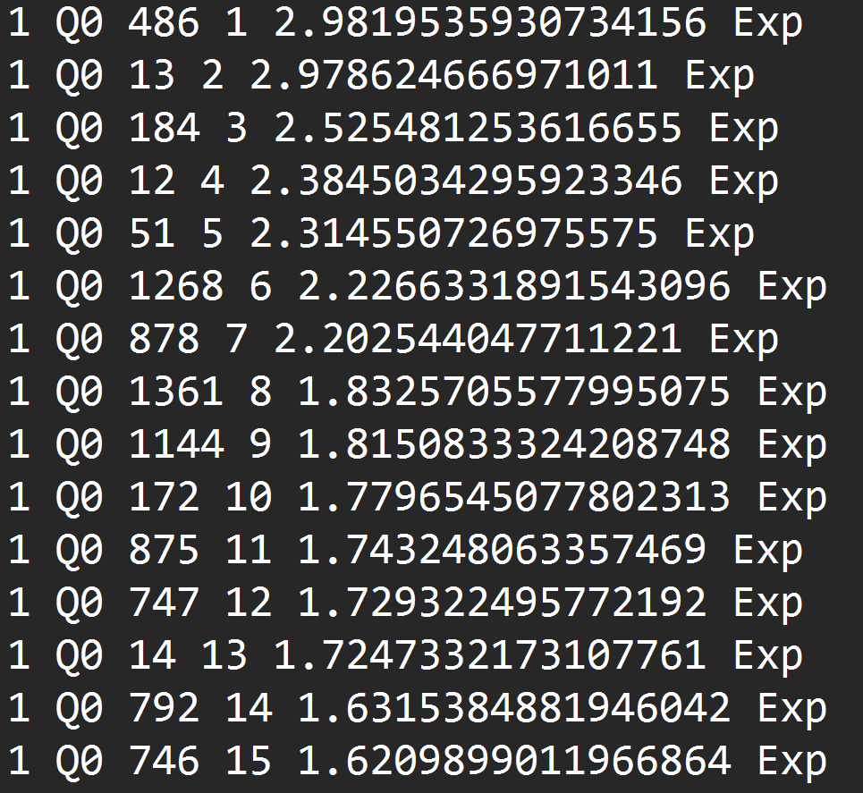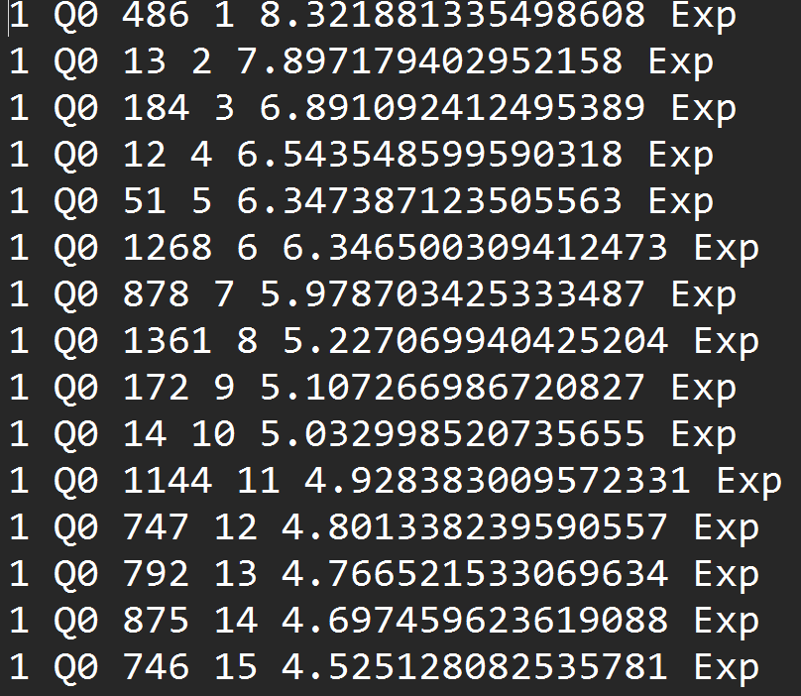
Es_results.txt laplace_results.txt

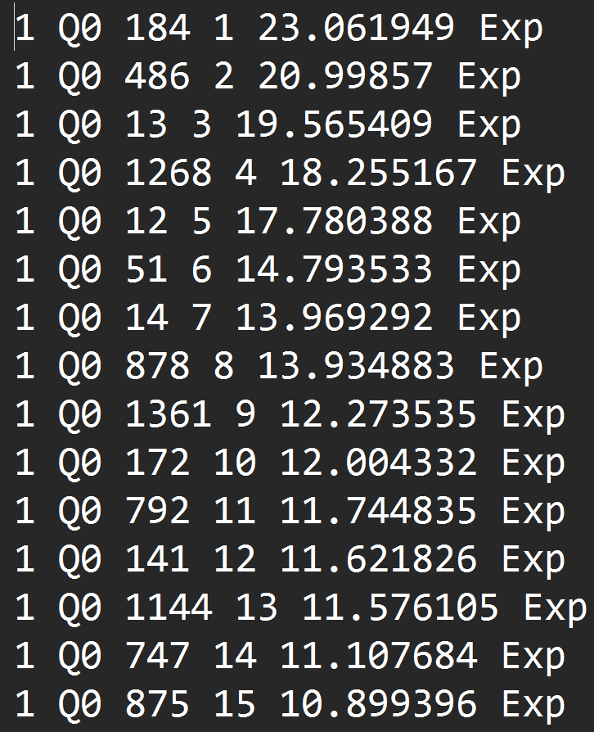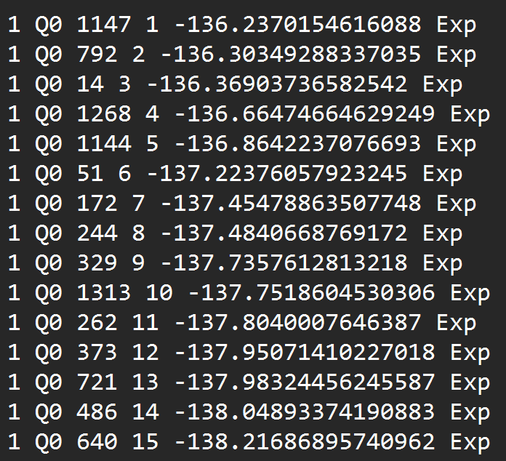

Jm_results.txt

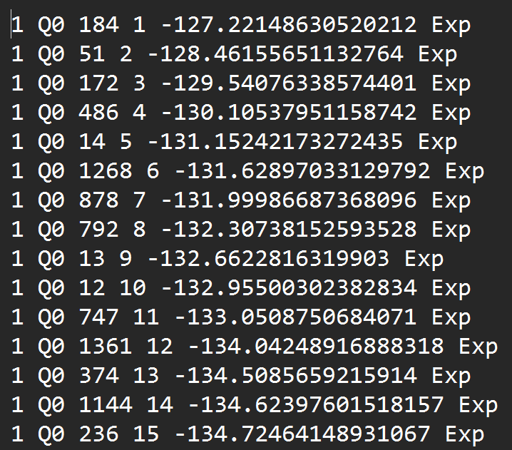

Screenshots of trec_eval results:

Evaluation result of tfidf_results.txt
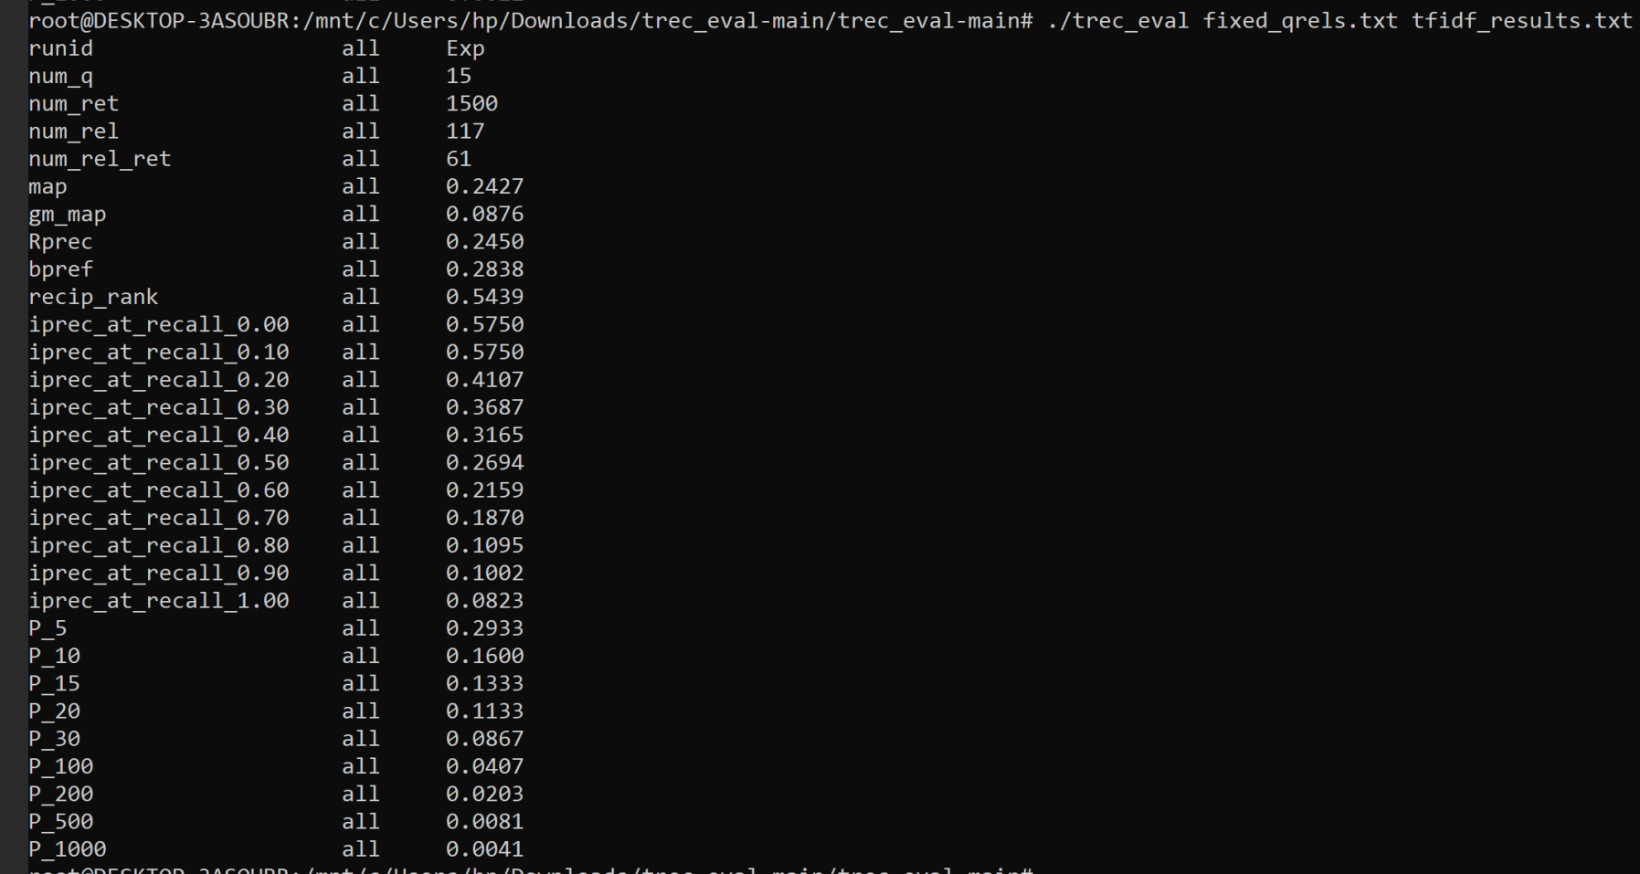

Evaluation results of bm25_results.txt

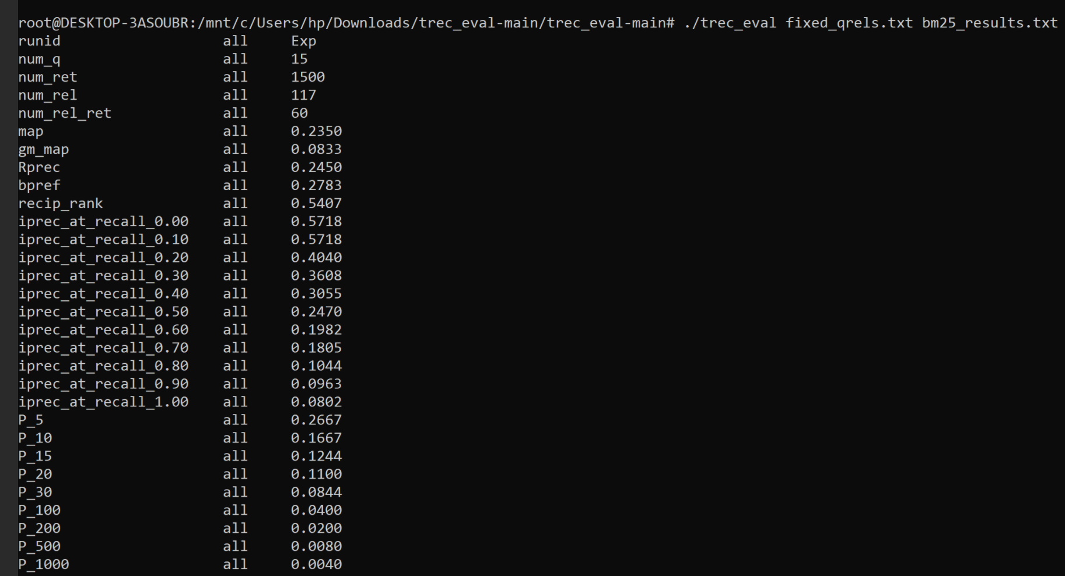

Evaluation of jm_results.txt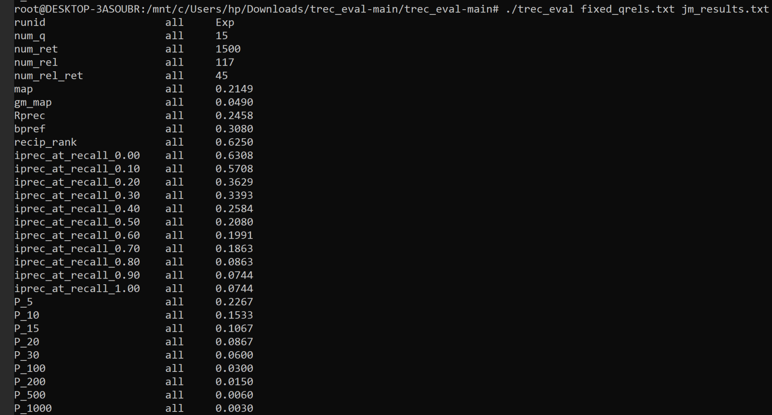

Evaluation of laplace_results.txt

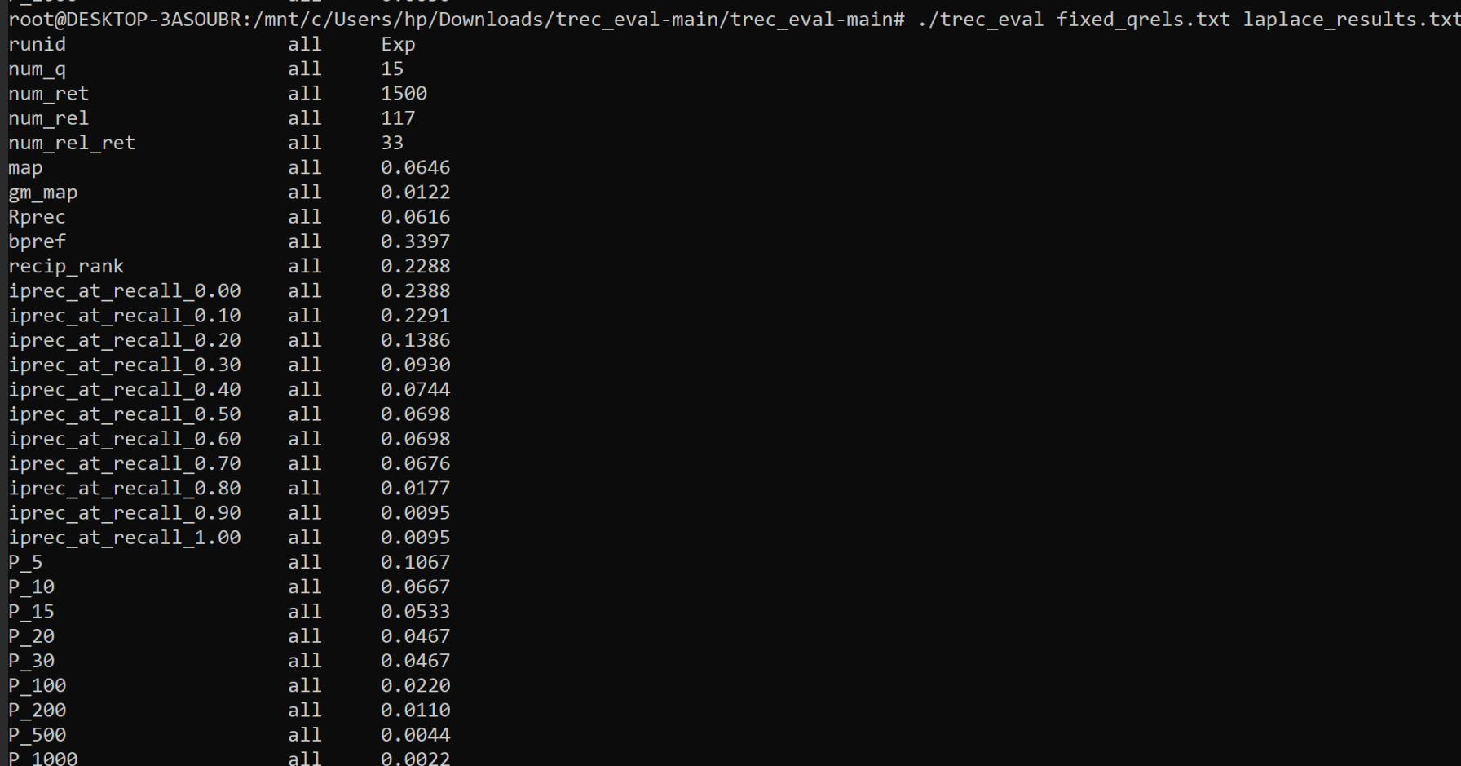

Evaluation of es_results.txt

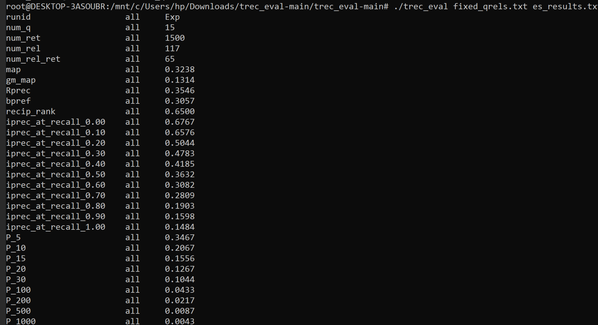

Discussion of Results
From the evaluation, the Elasticsearch built-in model achieved the highest overall performance in terms of MAP and Recall-based metrics. This is expected because it uses an optimized ranking mechanism similar to BM25 with additional tuning and internal optimizations.
Among the manually implemented models, TF-IDF and BM25 performed comparably, with TF-IDF slightly outperforming BM25 in MAP, while BM25 showed better precision at early ranks (P@10). This demonstrates that BM25 is more effective in ranking top results, while TF-IDF remains competitive for overall ranking quality.
The Jelinek-Mercer model showed moderate performance, retrieving fewer relevant documents compared to TF-IDF and BM25. However, it achieved relatively strong reciprocal rank, indicating that relevant documents often appear early in the ranking.
The Laplace smoothing model performed the weakest among all models. This is due to its tendency to over-smooth probabilities, which reduces its ability to distinguish between relevant and non-relevant documents in large vocabularies.
Overall Interpretation
The results clearly show that probabilistic and optimized retrieval models (BM25 and ES built-in) outperform simpler statistical models like Laplace smoothing. TF-IDF remains a strong baseline, while language models demonstrate varying performance depending on smoothing strategy.
This evaluation confirms the importance of model selection in information retrieval systems and highlights how different ranking strategies affect retrieval effectiveness.
Conclusion and Future Improvements
Conclusion
This project implemented and evaluated multiple information retrieval models, including TF-IDF, BM25, Unigram Language Models (Laplace and Jelinek-Mercer smoothing), and the Elasticsearch built-in retrieval model. The system was built using Elasticsearch for indexing and Python for query processing and custom scoring implementation. The evaluation was conducted using standard IR metrics through the trec_eval.
The experimental results demonstrate clear differences in retrieval effectiveness among the models. The Elasticsearch built-in model achieved the best overall performance in terms of Mean Average Precision (MAP) and early precision, indicating strong ranking capability due to its optimized BM25-based implementation. Among the manually implemented models, TF-IDF and BM25 showed competitive performance, with BM25 providing more stable ranking at early positions. The Jelinek-Mercer model performed moderately well, while the Laplace smoothing model showed the weakest performance due to excessive smoothing effects.
Overall, the results confirm that more advanced probabilistic and optimized ranking models outperform simpler statistical approaches in information retrieval tasks. The study also highlights the importance of term weighting, document length normalization, and smoothing techniques in improving retrieval quality.
Future Improvements
Although the current system demonstrates effective implementation and evaluation of multiple retrieval models, several improvements can be made to enhance performance and scalability:
- Full Corpus Processing:
The current implementation uses limited queries and candidate documents for efficiency. Processing the full dataset would provide more realistic and comprehensive evaluation results.
- Advanced Query Processing:
Incorporating query expansion techniques such as synonym expansion or relevance feedback could improve retrieval effectiveness.c
- Improved Candidate Retrieval Strategy:
Instead of simple match queries, more advanced Elasticsearch query formulations (such as multi-field queries or boosted scoring) could improve initial document selection.
- Optimization of Feature Extraction:
Caching document statistics such as term frequency and document length would reduce repeated computations and improve efficiency.
- Parameter Tuning:
Fine-tuning parameters such as BM25’s k1 and b, and Jelinek-Mercer’s λ, could lead to improved ranking performance.
- Incorporating Deep Learning Models:
Future work could explore neural ranking models such as BERT-based retrieval systems to compare traditional IR approaches with modern deep learning methods.
In conclusion, while the current system effectively demonstrates classical information retrieval techniques and their comparative performance, there is significant scope for enhancement using advanced retrieval strategies and optimization techniques.

