FC Barcelona Defensive Fault Lines
Interpretation Document — More than a Hack 2026

An analytical system that identifies defensive vulnerabilities in FC Barcelona matches using time-series event data, Bayesian pattern detection, and LLM-assisted tactical explanations. Built on Metrica Sports Smart Tagging data across 11 matches.

Tactical Question: When and how does Barcelona’s defensive structure break down, and which vulnerability patterns recur across matches?

Scope: Scope 2 (Game modeling and pattern detection) with elements of Scope 1 (Interpretation) and multi-match comparative analysis.

Contents
1. Data Sources and Limitations
2. Methodology: Risk Scoring Pipeline
3. Danger Moment Detection
4. Match-by-Match Findings
5. Cross-Match Pattern Analysis
6. LLM Integration
7. Interactive Dashboard
8. Limitations and Honest Disclosure
9. Coaching Recommendations
10. Suggestions for Metrica Nexus
11. Conclusion

1. Data Sources and Limitations

1.1 Available Data Per Match
Source | Format | Content | Coverage
Smart Tagging | *_pattern.xml | Team-level tactical phases | Full match, both teams
ATD Metadata | *_FifaData.xml | Team names, player IDs, pitch dims | Complete metadata
ATD Positions | *_FifaDataRawData.txt | Per-frame x/y/speed | Ball: good. Outfield: mostly NaN
Broadcast Video | *.mp4 | Full match recording | All 11 matches

1.2 Critical Limitation: Tracking Sparsity
The ATD tracking feed provides position data from broadcast camera footage. Because cameras follow the ball, players frequently go off-screen, resulting in NaN values. The ATD has identity fragmentation (40–60 extra IDs per match). This means:
- Individual player metrics (progressive carries, press resistance) are not feasible
- Defensive shape, compactness, or line height cannot be determined from tracking
- Ball position is usable and provides limited spatial context
- The system is built primarily on team-level event phase data

1.3 Smart Tagging Event Codes
Event Code | Description | Risk Weight (Opp / Barca)
GOALS | Goal scored | 10 / 0
BALL IN THE BOX | Ball enters penalty area | 8 / 0
CREATING CHANCES | Clear goal-scoring opportunity | 7 / 0
BALL IN FINAL THIRD | Ball in attacking third | 5 / 0
ATTACKING TRANSITION | Counter-attack initiated | 4 / 0
PROGRESSION | Ball advanced through lines | 3 / 0
SET PIECES | Corner, free kick, throw-in | 3 / 0
DEFENDING IN DEF. THIRD | Defending near own goal | 0 / 4
DEFENSIVE TRANSITION | Losing possession, recovering | 0 / 3
DEFENDING IN MID. THIRD | Defending in middle third | 0 / 2
DEFENDING IN ATK. THIRD | High press / defending forward | 0 / 1
LONG BALL | Direct long-distance pass | 0 / 0
BUILD UP | Possession from own half | 0 / 0
PLAYERS IN THE BOX | Attackers in penalty area | 0 / 0
Note: Smart Tagging is not manually ground-truthed. It may contain false positives and negatives.

1.4 Project Pivot
The original concept was individual player performance analysis. Due to tracking identity fragmentation and sparse position data, we pivoted to team-wide defensive analysis — a question fully answerable from the Smart Tagging data, which is clean and complete.

2. Methodology: Risk Scoring Pipeline
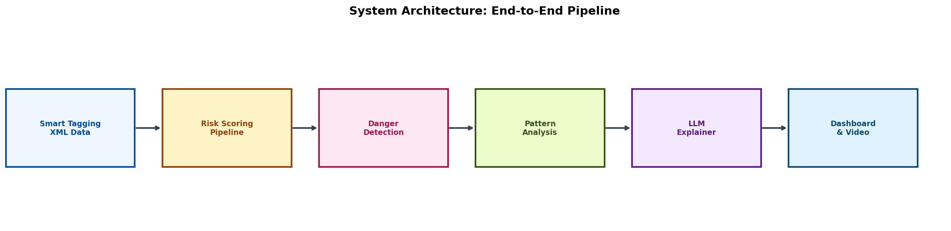
Figure 1: System Architecture — End-to-End Pipeline
The pipeline converts raw Smart Tagging annotations into a continuous per-second risk score (0–100) for each match. The end-to-end flow is: Smart Tagging XML → Risk Scoring → Danger Detection → Pattern Analysis → LLM Explanation → Dashboard with Video Seek.

2.1 Time Grid and Raw Score
Events are converted to integer seconds. For each second of the match, we identify all active events and sum their risk weights. Opponent attacking events contribute positive risk; Barca defensive-phase events add additional risk. Multiple overlapping events compound — this captures the combinatorial danger of simultaneous attacking and defensive breakdowns.

2.2 Smoothing and Normalization
Raw scores are smoothed with a 15-second centered rolling mean. Scores are normalized to 0–100 against the theoretical maximum (sum of all non-GOALS weights = 30):
- Dangerous play without a goal tops out around 70–80
- Only a GOALS event (+10) can push the score toward 100
- Goal moments are spiked to 100 in the final 5 seconds of the GOALS annotation window

2.3 Design Rationale
The weight system is intentionally transparent and interpretable. Each weight reflects the proximity-to-goal of the tactical phase: events closer to the goal (BALL IN THE BOX, CREATING CHANCES) receive higher weights than upstream events (PROGRESSION, BUILD UP). This produces risk scores that align with coaching intuition.

3. Danger Moment Detection
Danger moments are identified using scipy’s find_peaks algorithm on the risk timeline.

3.1 Detection Parameters
Parameter | Value | Purpose
Peak percentile | 70th | Dynamic threshold — peaks must exceed this
Threshold floor | 40.0 | Absolute minimum (avoids trivial peaks)
Min distance | 35 sec | Minimum gap between detected peaks
Prominence | 10.0 | Peak must rise 10+ above surrounding baseline
Goal lookback | 90 sec | Search window for risk peak before a goal
Merge window | 60 sec | Merge peaks within 60s into one sustained spell
These parameters were tuned using a grid search across all 11 matches, optimizing for: reasonable peak count per match (~10–20), window lengths between 20–60 seconds, and 100% goal coverage.

3.2 Severity Classification
Severity | Score Range | Meaning
Critical | 85–100 | Goal conceded or near-certain opportunity
High | 70–84 | Clear danger, multiple threatening events
Moderate | 40–69 | Elevated risk, territorial opponent advantage

3.3 Goal Anchoring
Every goal conceded is guaranteed to appear as a critical danger moment. The system looks back 90 seconds from the goal timestamp and takes the max-risk point. If within 5 seconds of an existing peak, it is promoted rather than duplicated. This ensures 100% goal coverage.

3.4 Merge Logic
Peaks within 60 seconds of each other are merged into a single sustained pressure spell. The merged moment keeps the highest peak score, the widest window, the union of active codes, and the maximum severity.

4. Match-by-Match Findings

4.1 Overview
The pipeline processed 11 FC Barcelona matches, detecting 144 danger moments across all matches.
Statistic | Value
Total matches analyzed | 11
Total goals: Barca scored | 32
Total goals: Opponents scored | 17
Total danger moments detected | 144
Critical severity | 21 (14.6%)
High severity | 22 (15.3%)
Moderate severity | 101 (70.1%)
Goal-anchored moments | 17/17 (100% coverage)
Average danger moments per match | 13.1

4.2 Match-by-Match Breakdown
# | Opponent | Score | Dangers | Crit | High | Mod | Goal-Anch | Avg Risk
1 | AC Milan (A) | 1-0 | 15 | 0 | 2 | 13 | 0 | 10.7
2 | Arsenal (A) | 3-5 | 22 | 6 | 1 | 15 | 5 | 12.6
3 | AC Milan (H) | 2-2 | 10 | 2 | 1 | 7 | 2 | 6.5
4 | AS Monaco (H) | 0-3 | 12 | 5 | 3 | 4 | 3 | 9.4
5 | Como (H) | 5-0 | 13 | 0 | 2 | 11 | 0 | 8.3
6 | Man City (H) | 2-2 | 20 | 3 | 5 | 12 | 2 | 14.5
7 | Real Madrid (H) | 3-0 | 21 | 0 | 3 | 18 | 0 | 13.3
8 | Daegu FC (A) | 5-0 | 3 | 0 | 1 | 2 | 0 | 3.0
9 | FC Seoul (A) | 7-3 | 10 | 3 | 1 | 6 | 3 | 6.4
10 | Real Madrid (A) | 2-1 | 15 | 1 | 2 | 12 | 1 | 9.3
11 | Vissel Kobe (A) | 3-1 | 3 | 1 | 1 | 1 | 1 | 4.8
(H) = Home, (A) = Away

4.3 Key Observations
High-danger matches: The Arsenal (5-3) and Manchester City (2-2) matches produced the most danger moments (22 and 20 respectively), reflecting their quality as opponents and the open, transitional nature of those games.
Monaco (0-3) — worst defensive performance: Despite only 12 danger moments, 5 were critical and all 3 goals were captured. The high critical-to-total ratio (42%) indicates concentrated, lethal attacks rather than sustained pressure.
Dominant wins still produce risk: Even in the 5-0 wins (Como, Daegu), the system detected moderate danger moments — consistent with the reality that even dominant teams face occasional counter-attacks.
Real Madrid (3-0 win) — high moderate count: 21 danger moments with 0 critical suggests a match where Barcelona controlled the outcome but faced consistent mid-level pressure.

4.4 Visualizations
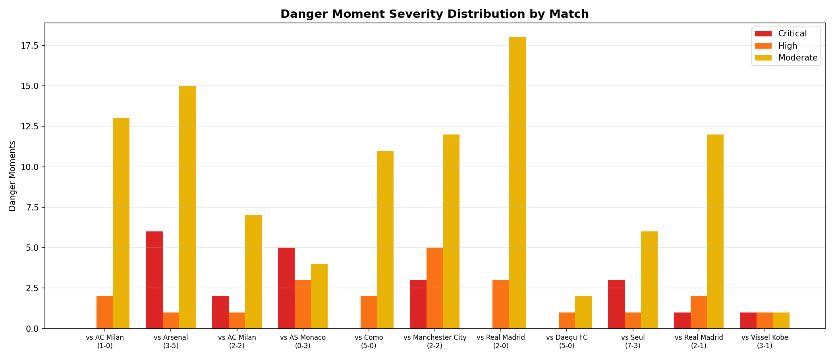
Figure 2: Danger Moment Severity Distribution by Match
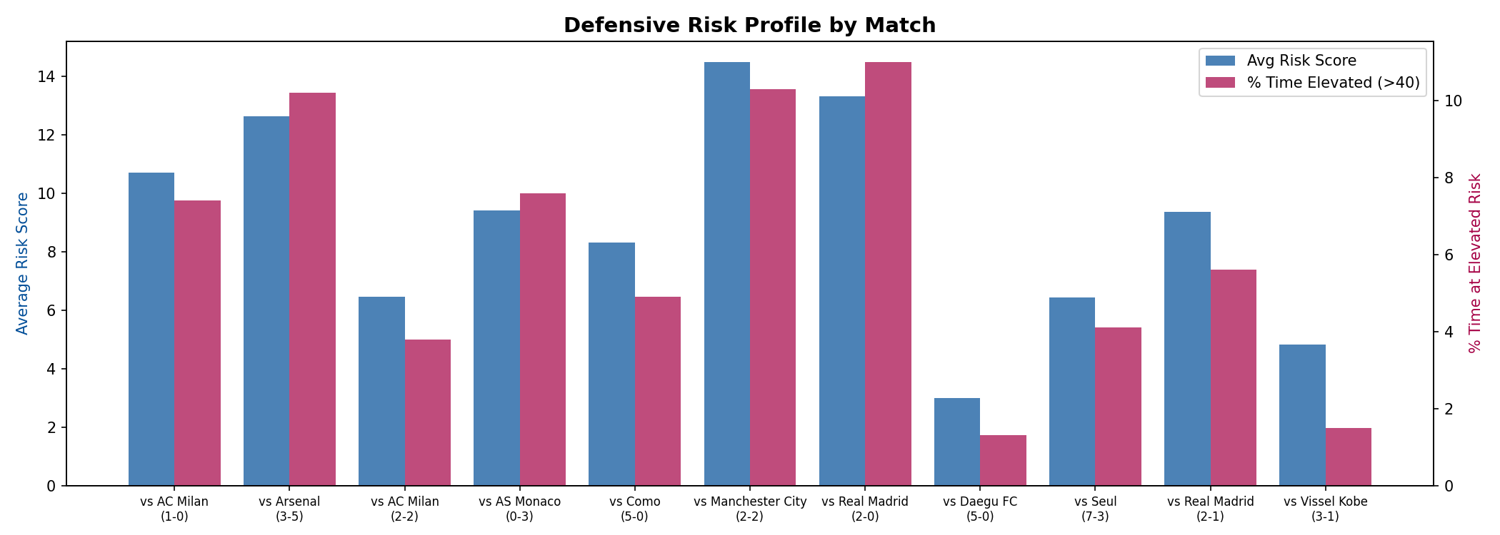
Figure 3: Defensive Risk Profile by Match — Average Risk and % Time at Elevated Risk

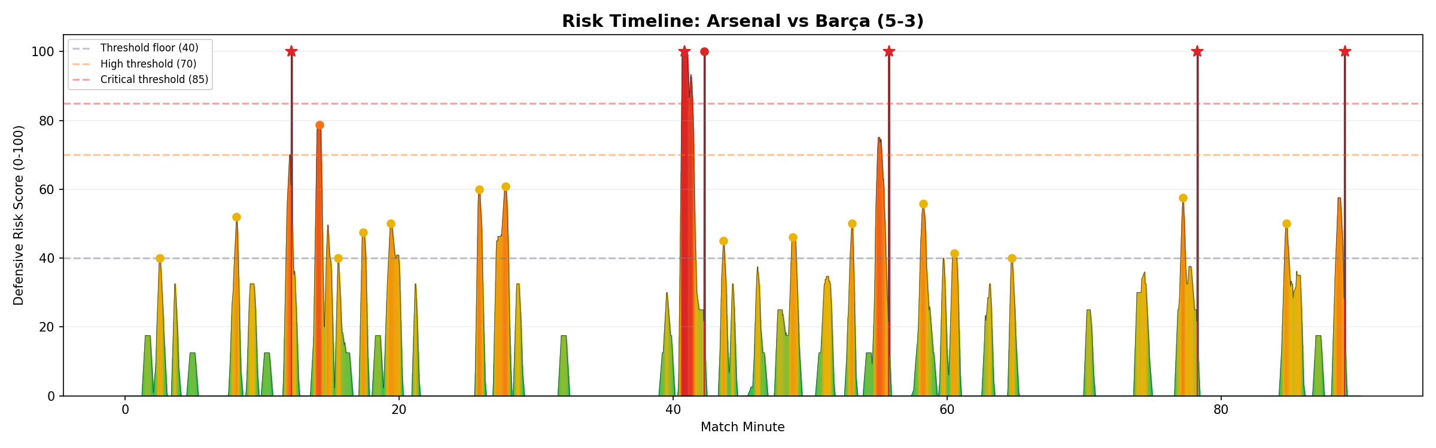
Figure 4: Risk Timeline — Arsenal vs Barca (5-3). Stars = goal-anchored moments.

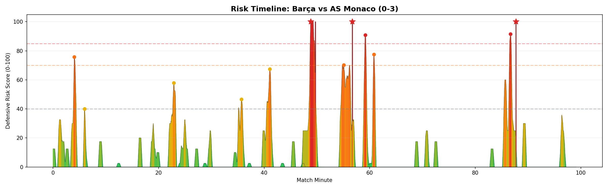
Figure 5: Risk Timeline — Barca vs AS Monaco (0-3). All 3 goals in the second half.

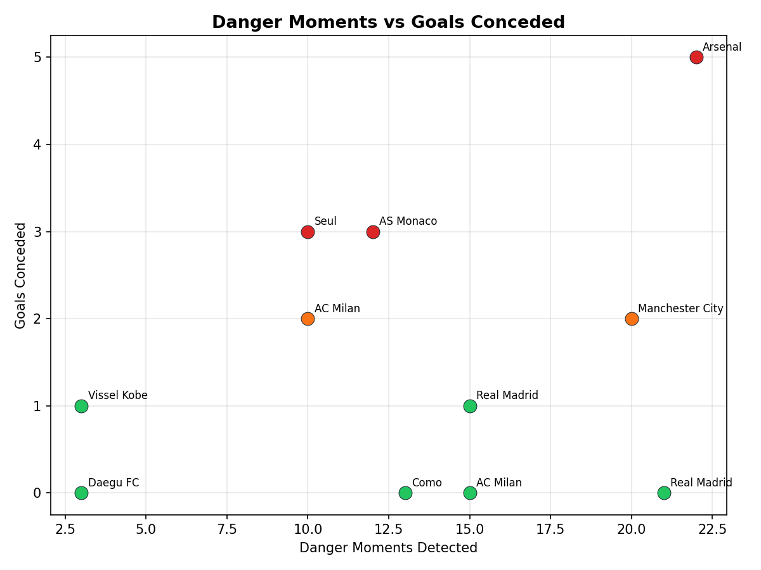
Figure 6: Danger Moments vs Goals Conceded — correlation between system output and results.

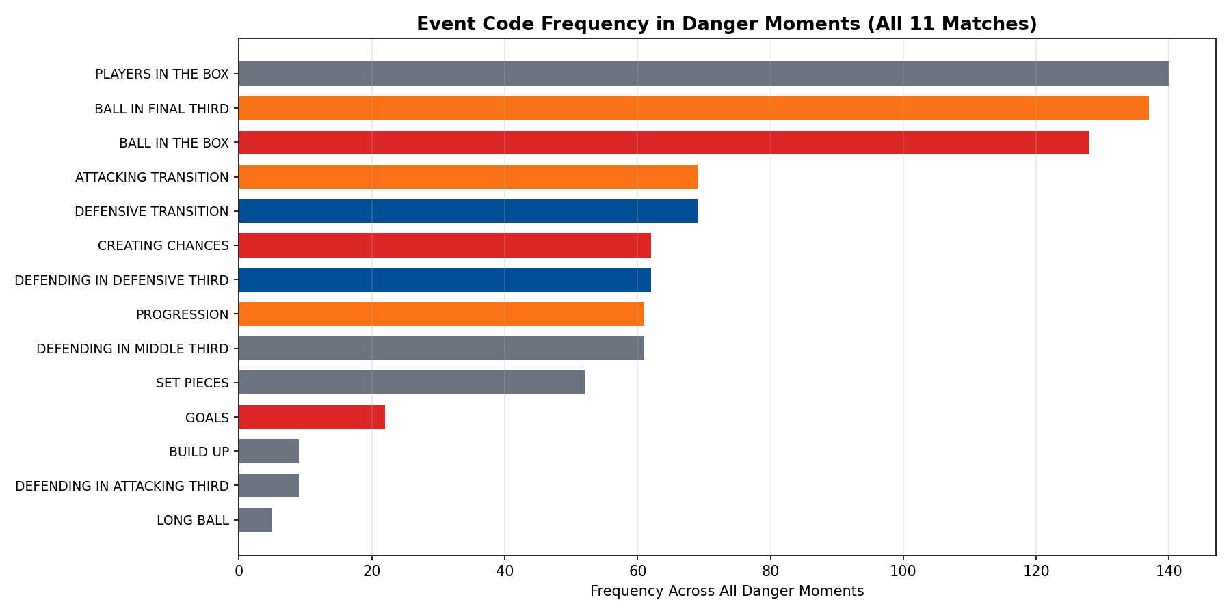
Figure 7: Event Code Frequency in Danger Moments (All 11 Matches)

4.5 Event Code Frequency in Danger Moments
Event Code | Frequency | % of Danger Moments
PLAYERS IN THE BOX | 140 | 97.2%
BALL IN FINAL THIRD | 137 | 95.1%
BALL IN THE BOX | 128 | 88.9%
ATTACKING TRANSITION | 69 | 47.9%
DEFENSIVE TRANSITION | 69 | 47.9%
CREATING CHANCES | 62 | 43.1%
DEFENDING IN DEF. THIRD | 62 | 43.1%
PROGRESSION | 61 | 42.4%
DEFENDING IN MID. THIRD | 61 | 42.4%
SET PIECES | 52 | 36.1%
The near-universal presence of PLAYERS IN THE BOX and BALL IN FINAL THIRD validates the weight system. The 48% co-occurrence of transitions highlights transition play as a primary vulnerability vector.

4.6 Half-by-Half Vulnerability Distribution
Period | Danger Moments | Critical | Goals Conceded
1st Half | 76 (52.8%) | 10 | 8
2nd Half | 68 (47.2%) | 11 | 9
Notable: Monaco went from 0 critical in H1 to 5 critical in H2 (all 3 goals conceded).
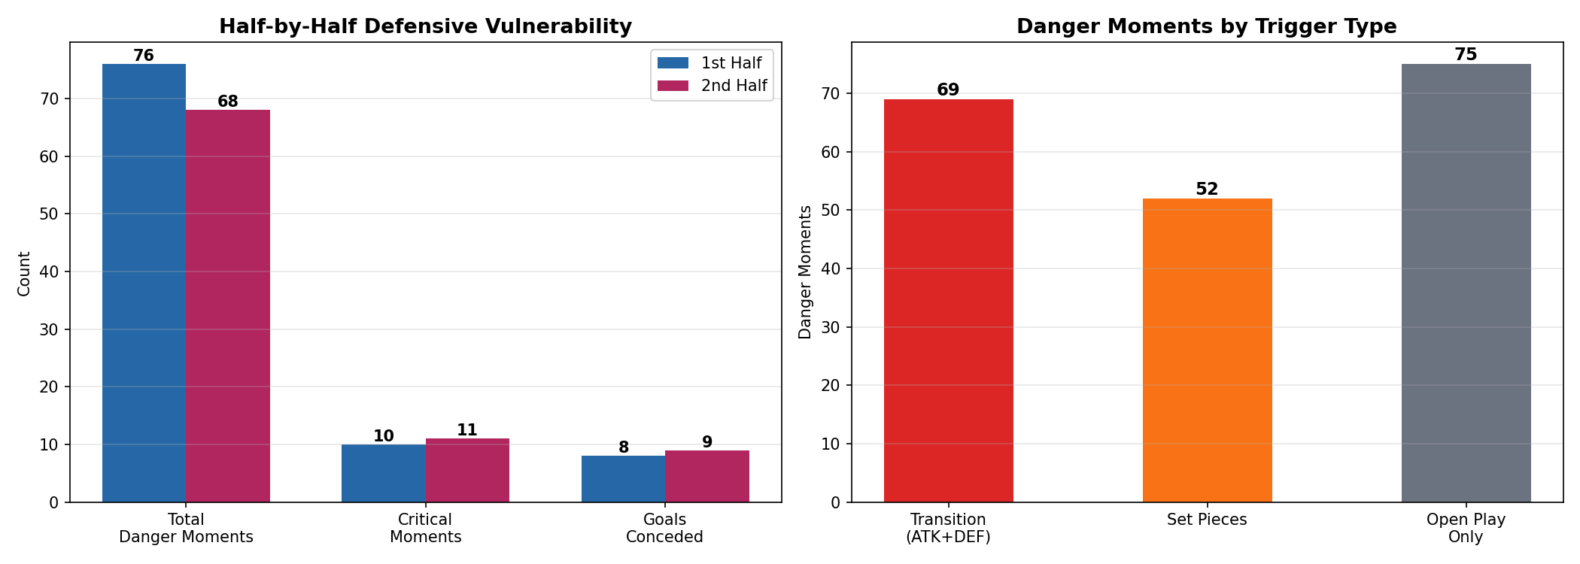
Figure 8: Half-by-Half Vulnerability and Danger Trigger Type Distribution

4.7 Transition Play: The Primary Vulnerability Vector
Transition moments are present in 47.9% of all danger moments (69/144) and account for 29.4% of goals conceded (5/17). Set pieces are involved in 36.1% of danger moments (52/144) and 23.5% of goals (4/17).

4.8 Deep Dive: Most Dangerous Matches
Arsenal (5-3) — highest total danger (22 moments, 6 critical): The most dangerous match in the dataset. Danger spread across both halves (12 in H1, 10 in H2) — sustained vulnerability, not a single-half collapse.
AS Monaco (0-3) — most concentrated lethality: 42% critical rate. All danger escalated in the second half (0 critical H1, 5 critical H2). Monaco’s half-time adjustment was decisive.
Manchester City (2-2) — highest sustained pressure: 20 danger moments with match-leading average risk of 14.5. First half especially intense (16 of 20 dangers).

5. Cross-Match Pattern Analysis

5.1 Fingerprinting Methodology
For each danger moment, we extract a fingerprint: the sequence of event codes that newly entered the active set during the preceding 60 seconds. Codes are filtered by stopwords, deduplicated while preserving order, and compressed to the top 4 by weight. Fingerprints are clustered using subsequence similarity (threshold 0.85). Patterns must appear in 2+ matches with 3+ occurrences and lift ≥1.15.

5.2 Bayesian Confidence Scoring
Each pattern’s goal rate is modeled as Bernoulli with a Beta(1,1) prior. Composite confidence score = P(pattern_rate > baseline_rate) × support_scaler.
Tier | Score | Coaching Guidance
High | ≥ 0.70 | Recurring vulnerability. Address in tactical sessions.
Medium | 0.45–0.69 | Notable pattern. Monitor in upcoming matches.
Low | < 0.45 | Candidate theme. Insufficient evidence to act on.

5.3 Detected Patterns
The pattern analyzer identified 3 recurring vulnerability patterns across the 11 matches:

Pattern 1: ATTACKING TRANSITION → DEFENSIVE TRANSITION
Confidence: 0.601 (Medium) | Lift: 2.66× | Occurrences: 10 (3 goals) | Matches: Arsenal, AC Milan (H), FC Seoul
This pattern captures moments where Barcelona loses the ball during an attacking move and the opponent immediately launches a counter-attack. The rapid transition from attack to defense — with players caught upfield — creates the most dangerous vulnerability. The 2.66× lift means this sequence is nearly 3 times more likely to result in a goal.

Pattern 2: CREATING CHANCES → DEFENDING IN DEFENSIVE THIRD
Confidence: 0.471 (Medium) | Lift: 1.97× | Occurrences: 9 (2 goals) | Matches: Arsenal, AS Monaco
The opponent’s chance creation directly pushes Barcelona into deep defending. The mid-block is bypassed — the opponent progresses from creating chances to box-area threats without an intermediate defensive phase, indicating a structural gap.

Pattern 3: PROGRESSION → DEFENDING IN MIDDLE THIRD
Confidence: 0.463 (Medium) | Lift: 1.48× | Occurrences: 12 (2 goals) | Matches: AS Monaco, FC Seoul
Opponent progression through midfield while Barcelona defends in the middle third. This pattern appeared in both heavy-defeat matches, indicating that when Barcelona’s midfield pressing is ineffective, the defensive line is exposed.

5.4 Baseline Statistics
Metric | Value
Total danger moments with valid fingerprints | 144
Baseline goal rate (any danger moment → goal) | 11.8%
Pattern 1 goal rate | 30.0% (2.66× baseline)
Pattern 2 goal rate | 22.2% (1.97× baseline)
Pattern 3 goal rate | 16.7% (1.48× baseline)

6. LLM Integration
The system uses GPT-4o-mini (via OpenRouter) to transform structured evidence packs into natural-language tactical explanations. The LLM never sees raw data — only curated context.

6.1 Prompt Architecture
Template | Input | Output
Moment prompt | Active codes, risk score, severity, goal flag | 3–5 sentence tactical explanation with [CODE] refs
Window prompt | Events in 5-min window, avg risk, team breakdown | Tactical summary of passage of play
Pattern prompt | Sequence, frequency, confidence stats | Structural vulnerability explanation + recommendations

6.2 Example LLM Outputs
Example 1 — High severity, open play: AC Milan vs Barca (0-1), 37:01–37:46, risk 77.17
During the critical window from 37:01 to 37:46, Barcelona’s defensive structure appeared to falter primarily due to poor organization during the [DEFENSIVE TRANSITION]. As AC Milan initiated an [ATTACKING TRANSITION], Barcelona’s players were slow to regroup, leading to unmarked opposition players in the [FINAL THIRD]. The lack of effective communication and commitment to closing down space in the [DEFENDING IN DEFENSIVE THIRD] allowed Milan to create multiple [BALL IN THE BOX] scenarios.
Example 2 — Moderate severity, set piece: AC Milan vs Barca (0-1), 28:32–29:30, risk 50.0
FC Barcelona faced a considerable threat due to failures in managing defensive transitions [DEFENSIVE TRANSITION] and positioning during attacks by AC Milan. The combination of ball in the box situations [BALL IN THE BOX] and set pieces [SET PIECES] indicates a lack of effective marking and organization during dead-ball scenarios.

6.3 Hallucination Mitigation
- Data-limitation-aware system prompt: Explicitly tells the LLM what data IS and IS NOT available.
- Code citation requirement: Event codes must be cited in [BRACKETS], making analysis verifiable.
- Confidence-gated language: Only patterns with confidence ≥ 0.60 are called “recurring.”
- Caching: SHA-256 of prompt → JSON file. Identical evidence packs produce identical explanations.

7. Interactive Dashboard
A React + FastAPI dashboard allows coaching staff to explore the analysis interactively:
- Match selector: Choose from all 11 matches
- Risk timeline chart: Color-coded risk score over match time with goal markers
- Danger moment list: Clickable cards ranked by severity with LLM explanations
- Video seek: Click a danger moment to jump to the corresponding broadcast timestamp
- Custom window analysis: Click two points on the timeline for on-demand LLM explanation
Video offset calibration (pre-match broadcast time, halftime extra time) is stored per match to enable accurate video seeking.

8. Limitations and Honest Disclosure

8.1 What the System CAN Do
- Identify specific time windows where Barca was most defensively vulnerable
- Quantify danger severity on a 0–100 scale with three tiers
- Detect recurring event sequences preceding danger across matches
- Provide Bayesian confidence levels for pattern recurrence
- Generate LLM explanations constrained to available evidence
- Link danger moments to broadcast video timestamps

8.2 What the System CANNOT Do
- Attribute defensive failures to individual players (events are team-level)
- Analyze defensive shape, compactness, or pressing structure (tracking too sparse)
- Compute player-level xG, progressive carries, or dribble success rates
- Determine causal relationships (patterns are correlational)
- Replace expert coaching judgment — the system is an analytical aid

8.3 LLM Output Caveats
LLM explanations are constrained to the evidence pack but are not infallible. Subtle inference errors may occur. All outputs should be reviewed by coaching staff before informing tactical decisions.

8.4 Sample Size
With 11 matches, pattern analysis has limited statistical power. The Bayesian framework accounts for this (small sample → wide credible intervals → lower confidence), but coaches should treat medium/low confidence patterns as hypotheses, not confirmed weaknesses.

8.5 Smart Tagging Accuracy
Smart Tagging data is not manually ground-truthed. It is inferred through automated processes and may contain both false positives and false negatives.

9. Coaching Recommendations
- Transition vulnerability (Pattern 1, confidence 0.60): Rapid defensive recovery drills and positional discipline when committing players forward should be prioritized.
- Mid-block bypass (Pattern 2, confidence 0.47): Reviewing pressing triggers and compactness between lines would address this.
- Midfield progression control (Pattern 3, confidence 0.46): Strengthening the midfield press and ensuring defensive cover during transitions.
- Second-half resilience: Monaco (0 → 5 critical in H2) suggests opponent half-time adjustments can be devastating.
- Use the video linkage: Every danger moment maps to a broadcast timestamp. Review footage alongside the LLM explanation.
- Monitor patterns in future matches: All three patterns are at medium confidence. Track whether they recur.

10. Suggestions for Metrica Nexus
- Smart Tagging timeline offset tool: Provide users with the option to offset timestamps so they match in-game time.
- Player ID merging: Allow users to merge fragmented player IDs in tracking data and connect them to known player names.
- Player recognition confidence scores: Include confidence values when correlating different player IDs.

11. Conclusion
This project demonstrates that meaningful tactical intelligence can be extracted from team-level Smart Tagging data alone, even without complete tracking data. The Defensive Fault Lines system transforms 11 matches of event annotations into a continuous risk timeline, detects 144 danger moments with 100% goal coverage, identifies 3 recurring vulnerability patterns with Bayesian confidence scoring, and produces LLM-assisted tactical explanations grounded in verifiable evidence.
The key tactical finding is that transition play is Barcelona’s primary vulnerability vector, appearing in nearly half of all danger moments and producing the highest-lift pattern in the dataset. The system provides an analytical foundation that coaching staff can use alongside their own observations, with every insight traceable to specific match moments, event codes, and broadcast timestamps.

This document was generated programmatically. Tactical explanations are assisted by GPT-4o-mini (via OpenRouter). All statistical analysis, risk scoring, pattern detection, and verification logic is deterministic Python code.

