Greg Blazek, Alec Steenbergen, David Garner, Nate Fore, Tyler Bujarski

Assignment 5

Class: ACC 368 001

10/27/16

<http://localhost:2941/Default.aspx>

Notes on Project 11/18/16

**Existing Tables – if you want to recreate them on your machines**

users table

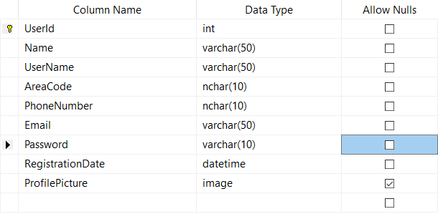

events table

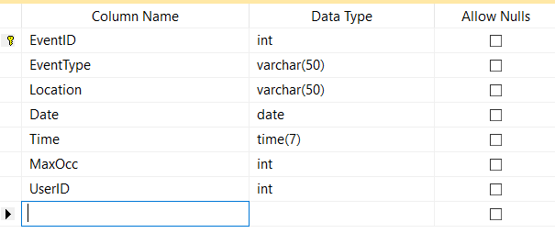

**We need to create a third table – something like attending???**

|  |  |  |
| --- | --- | --- |
| AttendingID | int |  |
| UserID | int |  |
| EventID | int |  |
| EventType | varchar |  |
| Date | Date |  |

(This is just what I picture, would love anyone else’s input)

user attending event

**Functionality to implement**

* **Ability to upload a picture from a form into database and ability to retrieve image**
* **Actual way to “attend” an event, this will require a new table. I pictured adding checkboxes to the gridview when you find events and based on those selections it will save to the new table but I haven’t figured it out and if someone has a better idea…huzzah**
* **Once the above is accomplished – we could display in users profile the events they are attending in the next week or however long**

**Bugs and Validation Stuff that needs to be done**

* **Validation for passwords – so far it just has to be eight characters so there is room for improvement**
* **On the find events page – the gridview the date column displays a bogus time as well as date, there should be no time displayed there.**
* **Probably more? Need more eyes though**

**Improvements**

* **Make it pretty?**
* **Maybe get rid of the dropdown list in find events and make it a searchable textbox?**