CS 499 Module One Assignment Template
Nathaniel Frazier

Complete this template by replacing the bracketed text with the relevant information.

- Self-Introduction: Address all of the following questions to introduce yourself.

  - How long have you been in the Computer Science program?

I have been in the Computer Science program for just over two years.

  - What have you learned while in the program? List three of the most important concepts or skills you have learned.

Programming skills
Operating systems and networking concepts
Software engineering and cybersecurity

  - Discuss the specific skills you aim to demonstrate through your enhancements to reach each of the course outcomes.

Employ strategies for building collaborative environments that enable diverse audiences to support organizational decision making in the field of computer science
- Effective communication and active listening to facilitate teamwork and understanding across diverse groups.
- Leadership and facilitation skills to foster inclusive, respectful, and productive team environments.
- Skill in converting technical ideas into easy to understand language for various stakeholders, including those without a technical background.

Design, develop, and deliver professional-quality oral, written, and visual communications that are coherent, technically sound, and appropriately adapted to specific audiences and contexts
- Visual communication skills, including creating diagrams, presentations, and dashboards that enhance understanding.
- Effective oral communication skills for confidently presenting intricate concepts to both technical and non-technical audiences.
- Critical editing and review processes to ensure clarity, accuracy, and professionalism.

Design and evaluate computing solutions that solve a given problem using algorithmic principles and computer science practices and standards appropriate to its solution, while managing the trade-offs involved in design choices
- Analyzing problems and gathering requirements to define the scope and limitations.
- Designing and implementing algorithms with a focus on efficiency, scalability, and maintainability.
- Applying industry standards and best practices in software development.

Demonstrate an ability to use well-founded and innovative techniques, skills, and tools in computing practices for the purpose of implementing computer solutions that deliver value and accomplish industry-specific goals
- Innovative approaches to tackle complex challenges through creativity.
- Ongoing education to keep up with new technologies and industry best practices.
- Capability to adjust and refine solutions in response to feedback and evolving needs.
- Expertise in using contemporary tools and frameworks pertinent to the field.

Develop a security mindset that anticipates adversarial exploits in software architecture and designs to expose potential vulnerabilities, mitigate design flaws, and ensure privacy and enhanced security of data and resources
- Identifying potential security risks through threat modeling and vulnerability assessment.
- Implementing secure coding practices to avoid common vulnerabilities like injection, buffer overflows, and data leaks.
- Utilizing critical thinking to foresee attack vectors and establish proactive defenses.
- Understanding legal and ethical aspects concerning data privacy and cybersecurity.

  - How do the specific skills you will demonstrate align with your career plans related to your degree?

Keeping up with industry tools and utilizing innovative techniques aligns with my goal to be at the leading edge of technology. These abilities allow me to create advanced solutions that offer competitive benefits and fulfill particular industry objectives.

Adopting a security first mindset is vital. My skill in identifying vulnerabilities, creating secure designs, and safeguarding data privacy will be key to protecting organizational resources and upholding user trust.

Working with diverse teams is crucial for creating and executing secure, dependable systems. Showcasing abilities in promoting inclusive and effective communication guarantees that all stakeholders can participate in and back security efforts and system enhancements.

Creating secure and efficient components for operating systems or cybersecurity tools involves crafting solutions that find a balance between performance, security, and usability. Proficiency in assessing trade-offs, utilizing algorithmic principles, and following industry standards will empower me to develop solutions that tackle real-world security issues while preserving system integrity and performance.

  - How does this contribute to the specialization you are targeting for your career?

Utilizing advanced tools and innovative methods keeps me at the leading edge of cybersecurity developments. This expertise guarantees that my contributions to operating systems not only uphold essential functions but also deliver strong security features crucial for safeguarding data and resources.

Developing a security mindset and techniques to foresee adversarial exploits allows me to spot and tackle vulnerabilities early in the OS development lifecycle. This emphasis is vital for cybersecurity expertise, as it enables me to proactively guard against attacks and create systems that are fundamentally resistant to exploitation.

Exhibiting professionalism in communication and assessing solutions is in line with the ethical duties associated with cybersecurity and operating system development. This dedication ensures that my work complies with legal, ethical, and industry standards, thereby enhancing the credibility and influence of my specialization.

Enhancing my skills in designing and assessing secure computing solutions significantly boosts my capability to develop operating systems that withstand threats. This focus allows me to construct or refine OS architectures with integrated security measures, including access controls, secure boot processes, and sandboxing, in accordance with industry standards.

- ePortfolio Set Up:

  - Submit a screen capture of your ePortfolio GitHub Pages home page that clearly shows your URL.
    - You already have a repository in GitHub where you uploaded projects in previous courses. Your ePortfolio will reside in GitHub but can link to work at other sites, such as Bitbucket.

  - Use the GitHub Pages link in the Resource section for directions on:
    - How to create your GitHub website and publish code to GitHub Pages
    - Issues, such as adding links to other sites

  - Paste a screenshot of your GitHub Pages home page with your URL clearly showing in the space below.

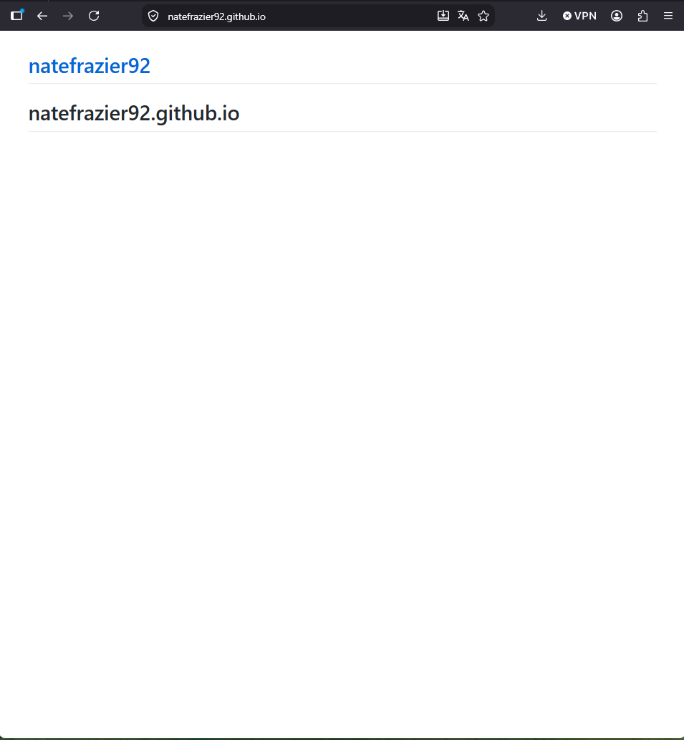
- Enhancement Plan:

  - Category One: Software Engineering and Design
    - Select an artifact that is aligned with the software engineering and design category and explain its origin. Submit a file containing the code for the artifact you choose with your enhancement plan.

The final project artifact AppointmentService.java from CS 320: Software Testing, Automation, and Quality Assurance is a good choice to demonstrate software engineering and design proficiency. This artifact is a medical application is designed for gathering contact details, scheduling appointments, and offering a checklist of tasks. The objective of this class was to develop an application that streamlines the information collection process and includes module testing with JUnit tests to ensure the correctness of the entered data and prevent errors.

    - Describe a practical, well-illustrated plan for enhancement in alignment with the category, including a pseudocode or flowchart that illustrates the planned enhancement.

The objective is to transform the AppointmentService from a data-container into a pure business logic orchestrator by delegating storage to a Repository and fixing the string comparison logic.
- Define an Abstraction: Create an AppointmentRepository interface. This allows the switch from an ArrayList to a Database (SQL/NoSQL) in the future without changing a single line of code in AppointmentService.
- Replace == with .equals() to ensure ID comparisons are content-based.
- Pass the repository into the service constructor. This makes unit tests much faster and more reliable because they can "mock" the database.

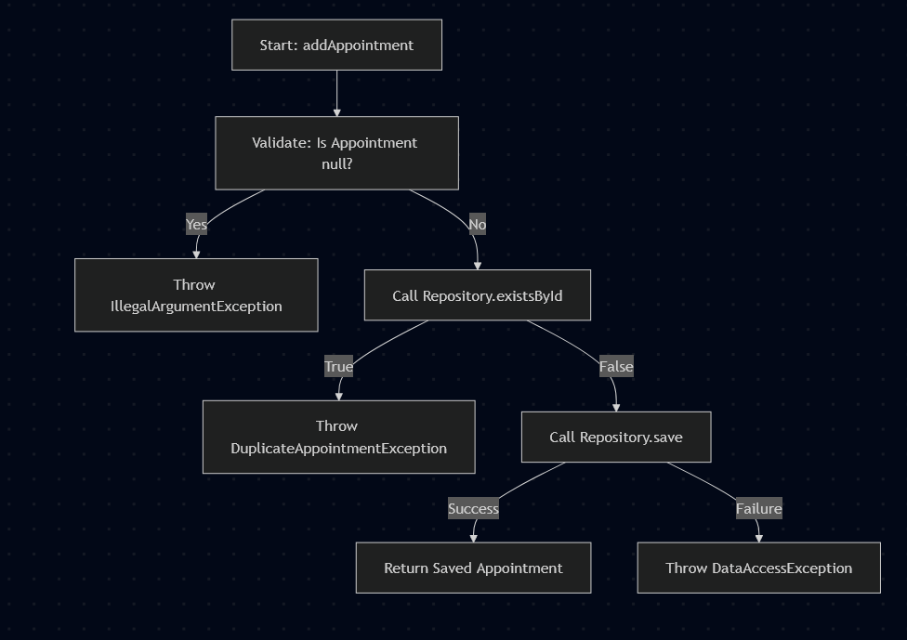

    - Explain how the planned enhancement will demonstrate specific skills and align with course outcomes.

      - Identify and describe the specific skills you will demonstrate that align with the course outcome.

The shift to the Repository Pattern enhances organizational decision-making by separating "what the business does" (Service) from "how data is stored" (Repository). In a professional collaborative setting, this enables a Backend Engineer to focus on business logic while a Database Administrator or Data Engineer manages the persistence layer at the same time, avoiding merge conflicts. By outlining this strategy in structured documentation, this help stakeholders grasp the architectural roadmap and make informed choices about resource allocation and technology stacks.

The plan shows a capability to assess and address design trade-offs. It transitions from a Low-Complexity/Low-Robustness design to a High-Abstraction/High-Robustness design. The plan recognizes that although the new architecture adds more "boilerplate" code, it greatly enhances the system's capacity to scale and manage complex data needs. This represents the better engineering decision for enterprise-level software.

The plan moves the implementation toward Industry Standards by implementing Dependency Injection and Interface-Based Programming. Substituting basic boolean return types with custom Exceptions is a recognized industry practice for conveying state changes. This approach adds real value by ensuring the software behaves predictably and its logs are informative for DevOps and SRE teams.

The enhancement plan directly addresses a critical security and stability flaw: Input Validation and Data Integrity. The introduction of Guard Clauses prevents common exploits. Transitioning to a formal Repository layer paves the way for future implementation of transactional integrity, which guarantees that data stays consistent and is safeguarded against partial writes or corruption.

      - Select one or more of the course outcomes below that your enhancement will align with.
- • Employ strategies for building collaborative environments that enable diverse audiences to support organizational decision making in the field of computer science
- • Design, develop, and deliver professional-quality oral, written, and visual communications that are coherent, technically sound, and appropriately adapted to specific audiences and contexts
- • Design and evaluate computing solutions that solve a given problem using algorithmic principles and computer science practices and standards appropriate to its solution, while managing the trade-offs involved in design choices
- • Demonstrate an ability to use well-founded and innovative techniques, skills, and tools in computing practices for the purpose of implementing computer solutions that deliver value and accomplish industry-specific goals
- • Develop a security mindset that anticipates adversarial exploits in software architecture and designs to expose potential vulnerabilities, mitigate design flaws, and ensure privacy and enhanced security of data and resources

1, 3, 4, 5

Course Outcomes:

- Employ strategies for building collaborative environments that enable diverse audiences to support organizational decision-making in the field of computer science.
- Design, develop, and deliver professional-quality oral, written, and visual communications that are coherent, technically sound, and appropriately adapted to specific audiences and contexts.
- Design and evaluate computing solutions that solve a given problem using algorithmic principles and computer science practices and standards appropriate to its solution while managing the trade-offs involved in design choices.
- Demonstrate an ability to use well-founded and innovative techniques, skills, and tools in computing practices for the purpose of implementing computer solutions that deliver value and accomplish industry-specific goals.
- Develop a security mindset that anticipates adversarial exploits in software architecture and designs to expose potential vulnerabilities, mitigate design flaws, and ensure privacy and enhanced security of data and resources.

  - Category Two: Algorithms and Data Structures

- Select an artifact that is aligned with the algorithms and data structures category and explain its origin. Submit a file containing the code for the artifact you choose with your enhancement plan. You may choose work from the courses listed under Category One.

The final project artifact RescueAnimal.java from IT 145: Foundation in Application Development is a good choice to show algorithm and data structure proficiency.

- Describe a practical, well-illustrated plan for enhancement in alignment with the category, including a pseudocode or flowchart that illustrates the planned enhancement.

The most significant enhancement will be transitioning from a Linear Search (which is inefficient for large datasets) to a Hash-Based Lookup or a Categorized Map structure. Currently, reserveAnimal and printAnimals uses Linear Search. Implementing a HashMap-based Indexing system will be the proposed solution. Instead of searching through one giant list, it is best to maintain a Map where the Key is the Country and the Value is a List of animals located in that country.

Add a new instance variable: private static HashMap<String, ArrayList<Dog>> dogsByCountry = new HashMap<>()

Every time intakeNewDog is called, the dog is added to both the main dogList AND the dogsByCountry map.

Instead of looping through all dogs, the reserveAnimal method will jump directly to the list associated with the requested country.
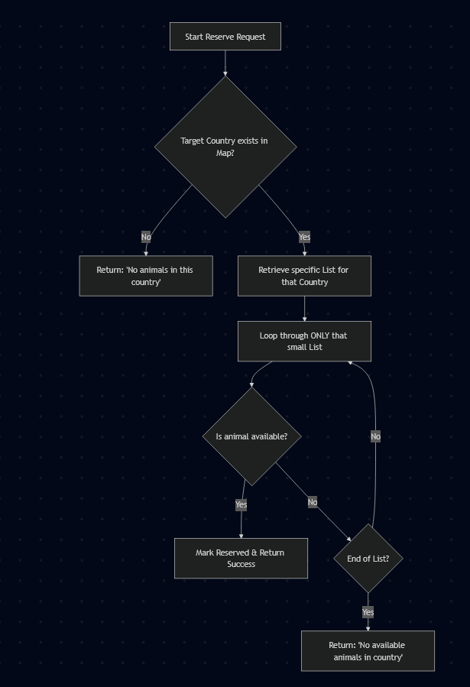

For this category of enhancement, consider improving the efficiency of a project or expanding the complexity of the use of data structures and algorithms for your artifact. These are just recommendations. Consider being creative and proposing an alternative enhancement to your instructor. Note: You only need to choose one type of enhancement per category.

Think about what additions to include to complete the enhancement criteria in this category. Since one example option is to port to a new language, that is the kind of scale that is expected. Perhaps you might increase the efficiency and time complexity of an algorithm in an application and detail the logic of the increased time complexity. Remember, you do not need to port to a new language but instead have an equivalent scale of enhancement. Underlying expectations of any enhancement include fixing errors, debugging, and cleaning up comments, but these are not enhancements themselves.

- Explain how the planned enhancement will demonstrate specific skills and align with course outcomes.

  - Identify and describe the specific skills you will demonstrate to align with the course outcome.

This is the optimal method to showcase the skill of designing computing solutions by assessing the trade-offs among various algorithmic methods. This will involve a comparison between a Linear Search algorithm and a Hash-Map Indexing strategy. It illustrates the capacity to handle the trade-off between memory usage (utilizing additional RAM for the Map) and time complexity.

This will showcase the application of industry-standard methods by utilizing Object-Oriented Programming (OOP) principles, including Inheritance and Polymorphism, to create a scalable and maintainable codebase. Suggesting an indexing improvement illustrates how to leverage innovative data structures to achieve the industry-specific objective of developing high-performance, scalable enterprise software that provides value to users via quick data retrieval.

This approach will implement a security mindset by assessing the system's architecture for possible vulnerabilities. This involves examining Data Integrity (making sure that the reserved status cannot be circumvented or altered through incorrect input) and Input Validation (stopping malicious exploits such as injection or faulty data entry during the 'Intake' phase). The emphasis will be on creating a strong architecture that guarantees the privacy and accuracy of animal records, reducing design weaknesses that might result in data corruption.

  - Select one or more of the course outcomes listed under Category One that your enhancement will align with.
1,3,4,5

  - Category Three: Databases

    - Select an artifact that is aligned with the databases category and explain its origin. Submit a file containing the code for the artifact you choose with your enhancement plan. You may choose work from the courses listed under Category One.

The Project 2 artifact from CS 340: Advanced Programming Concepts is a good choice to display further prowess in databases. This used CRUD operations and MongoDB to make a web-based dashboard for a fictional company to assess animal available animals from a shelter.

    - Describe a practical, well-illustrated plan for enhancement in alignment with the category, including a pseudocode or flowchart that illustrates the planned enhancement.

First is to ensure the app doesn't crash and follows industry standards. Move Secrets to .env. Never hardcode password = "password". Use the python-dotenv library to load credentials from an external file. Implement the Singleton pattern to prevent exhausting MongoDB connections during high traffic. Use a library to validate the data coming out of MongoDB before it hits the Pandas DataFrame. This prevents "KeyErrors" if a record is missing a breed or location_lat. Instead of a blank screen when no records match a filter, display a friendly message.

Next is to make the dashboard intuitive and visually appealing. Integrate Dash Bootstrap Components. Instead of raw html.Div with manual styles, use a Grid system to ensure the dashboard looks good on tablets and mobile phones. Replace the fixed age filters with dcc.RangeSlider so users can choose their own age ranges. Allow users to select multiple breeds at once using dcc.Dropdown. Also add heatmaps and cluster markers.

Last is to move from showing data to providing insights. Add a Time-Series Chart showing the number of animal intakes per month. Add a Stacked Bar Chart showing the relationship between breed and outcome. Integrate a simple Scikit-learn model. A user selects an animal's age, breed, and sex, and the dashboard predicts the probability of a "Successful Adoption" vs. "Return to Shelter."

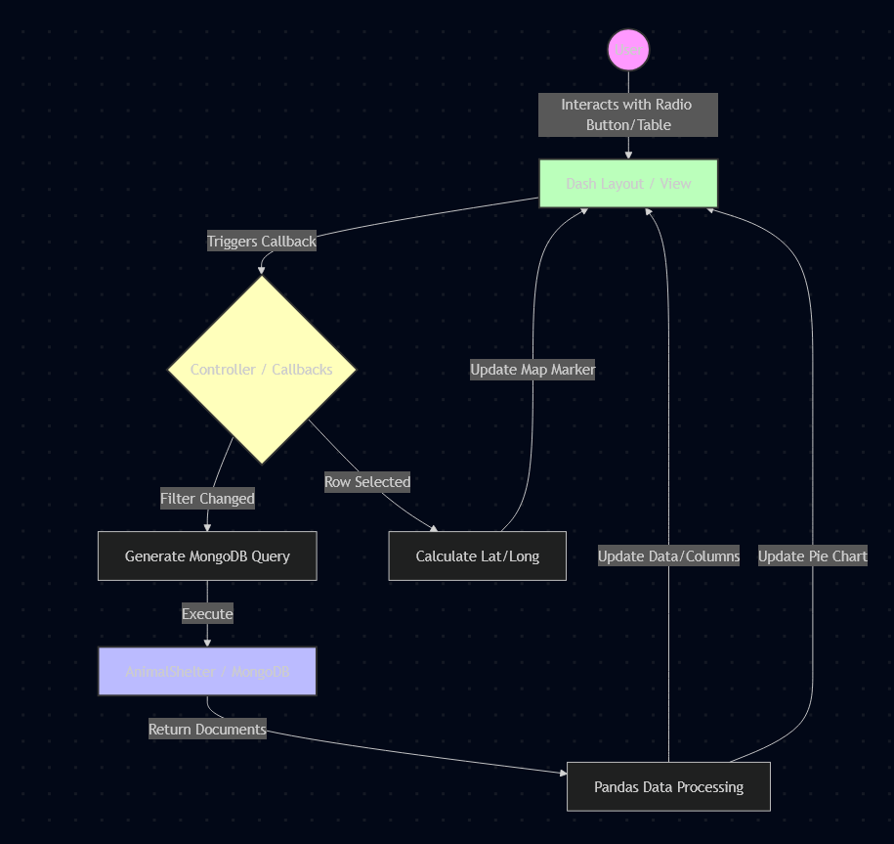
For this category of enhancement, consider adding more advanced concepts of MySQL, incorporating data mining, creating a MongoDB interface with HTML/JavaScript, or building a full stack with a different programming language for your artifact. These are just recommendations; consider being creative and proposing an alternative enhancement to your instructor. Note: You only need to choose one type of enhancement per category.

Think about what additions to include to complete the enhancement criteria in this category. Since one example option is to port to a new language, that is the kind of scale that is expected. Perhaps you might increase the efficiency and time complexity of an algorithm in an application and detail the logic of the increased time complexity. Remember, you do not need to port to a new language but instead have an equivalent scale of enhancement. Underlying expectations of any enhancement include fixing errors, debugging, and cleaning up comments, but these are not enhancements themselves.

      - Identify and describe the specific skills you will demonstrate that align with the course outcome.

Converting raw shelter data into predictive insights equips decision-makers with actionable intelligence. This fosters a collaborative atmosphere where data scientists, animal caretakers, and organizational leaders can operate from a unified source of truth, allowing them to make informed, data-driven choices about resource allocation and animal care.

Transitioning from a simple layout to a refined, responsive dashboard showcases the skill to provide visual communications that are tailored to particular audiences. A professional manager needs a clear, user-friendly interface and organized charts to swiftly grasp intricate shelter trends, instead of feeling inundated by unprocessed data tables.

Implementing singleton patterns and optimized query logic shows the capability to handle design trade-offs. Choosing the Singleton pattern utilizes computer science principles to address the issue of resource depletion, reflecting a deep comprehension of how algorithmic efficiency affects system stability.

Moving credentials from hardcoded strings to .env files and implementing a structured authentication layerdemonstrates a security mindset. Proactively mitigating design flaws and anticipating adversarial exploits ensures the privacy and security of data.

      - Select one or more of the course outcomes listed under Category One that your enhancement will align with.

1,2,3,5

- ePortfolio Overall Skill Set

  - Accurately describe the skill set to be illustrated by the ePortfolio overall.
    - Skills and outcomes planned to be illustrated in the code review

[Insert your answer here.]

    - Skills and outcomes planned to be illustrated in the narratives

[Insert your answer here.]

    - Skills and outcomes planned to be illustrated in the professional self-assessment

[Insert your answer here.]

