Server Manual

1. Compile ServerTester with eclipse. DO NOT USE COMMAND-LINE
   1. Run ServerTester

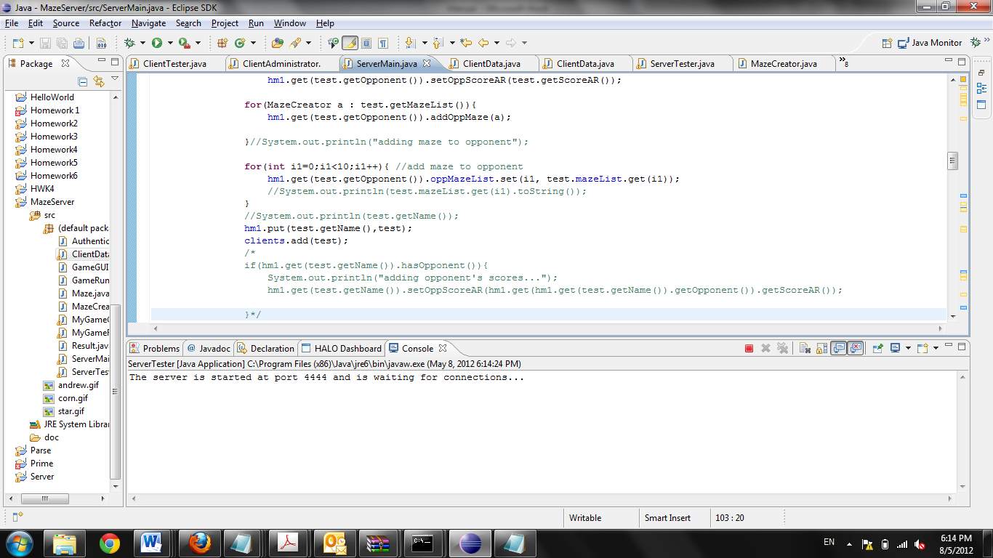

Game/Client Manual

1. In separate file directory, compile ClientTester.java
   1. Run ClientTester

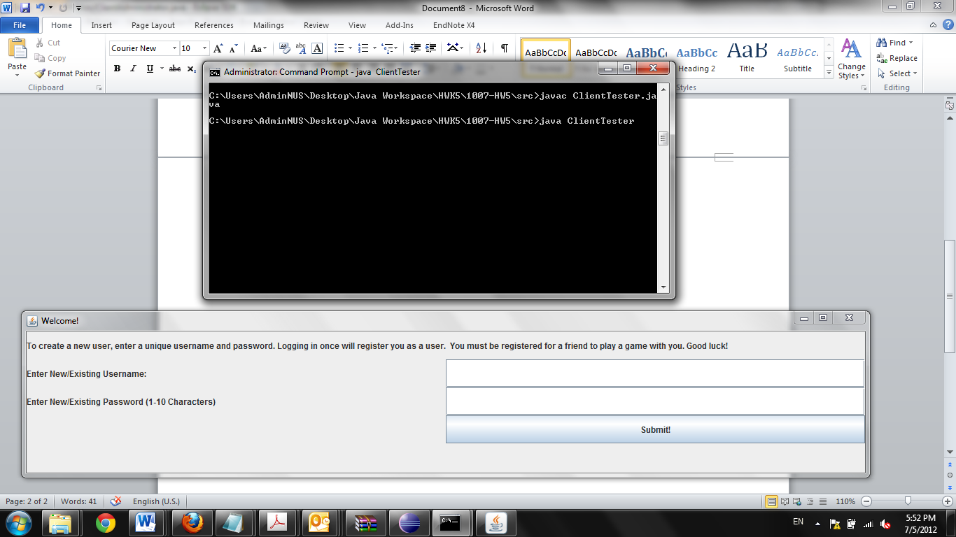

1. This is the login screen
   1. To create new user, just type in username, and remember your password
   2. Existing users that can be used for testing
      1. Username: Andrew; Password: Andrew
      2. Username: t; Password: t
      3. Username: testuser; Password: testuser

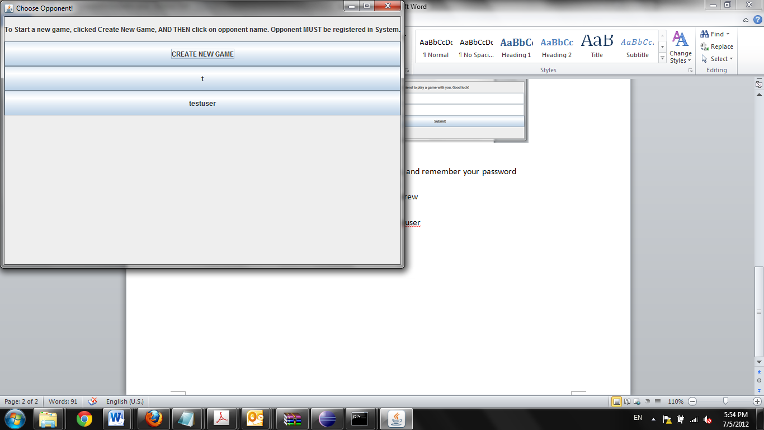

1. This is the choose opponent screen
   1. To create a new game (which you have to since there are no pending games), click create new game. If you do not, you will not be able to start the game (try this out!)
   2. After clicking create new game, select opponent

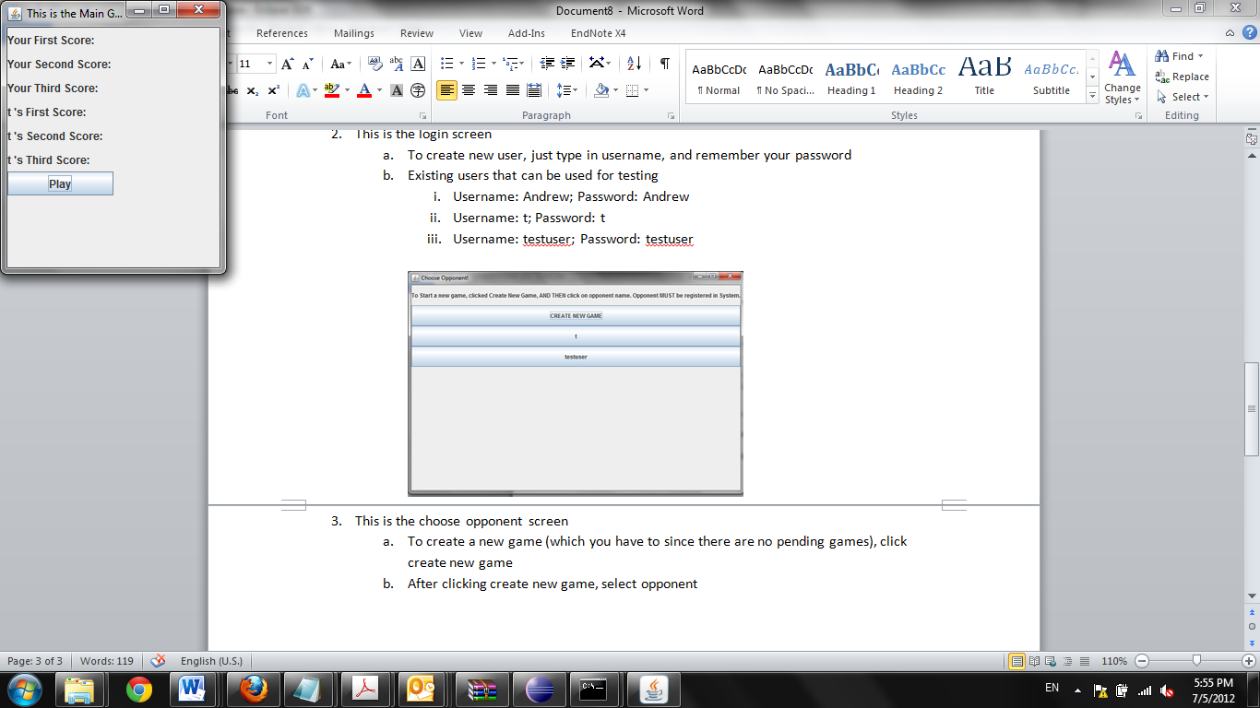

1. This is a window that will pop up with the scores
   1. Click play to start your first of three rounds
   2. The game will continue for three rounds, with the score updating after each round. The game will then CLOSE.

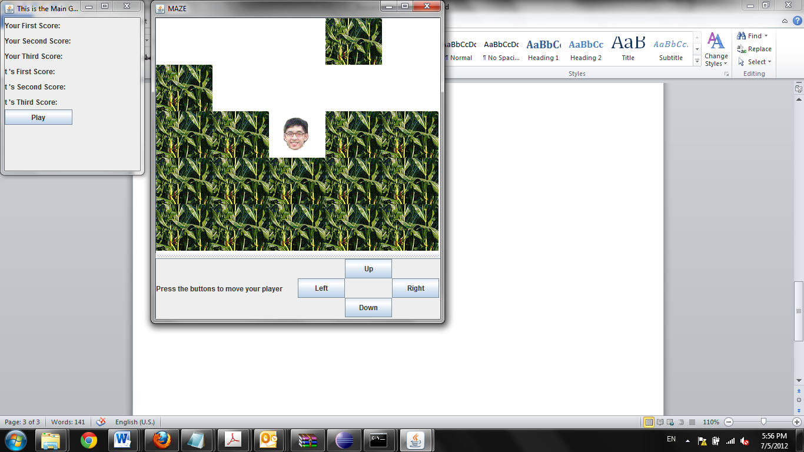

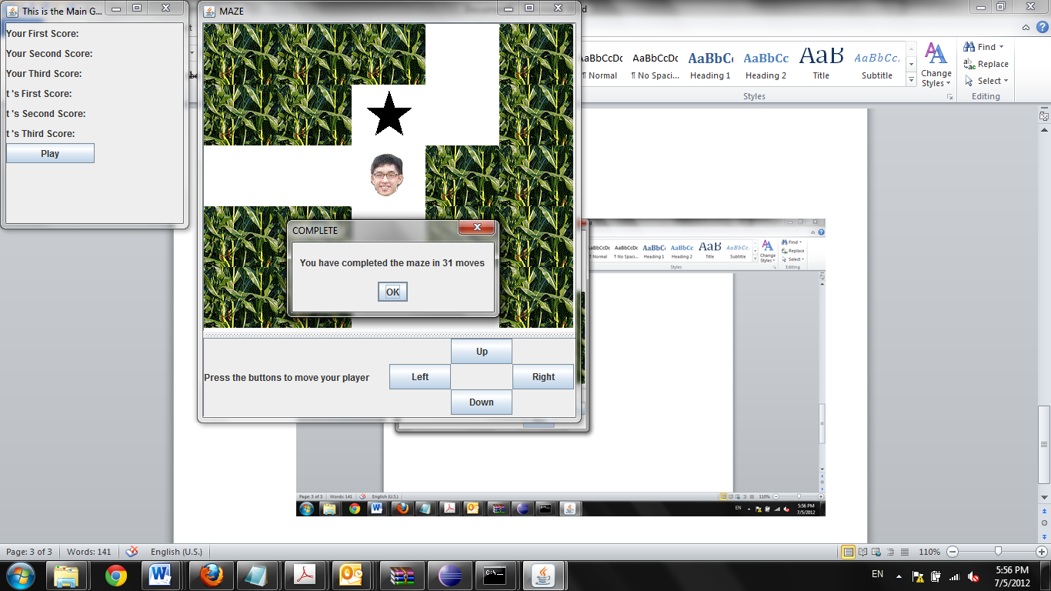

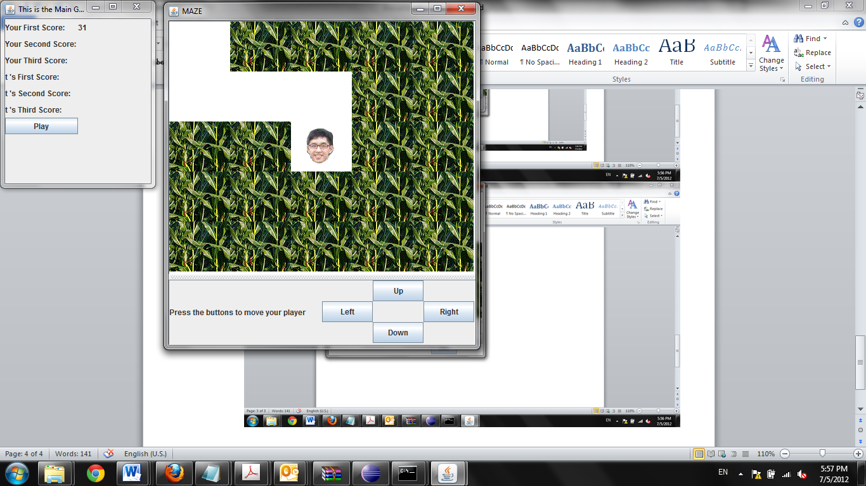

1. Logging in as an Opponent (In this case Andrew had started a game with t, and now t will login)

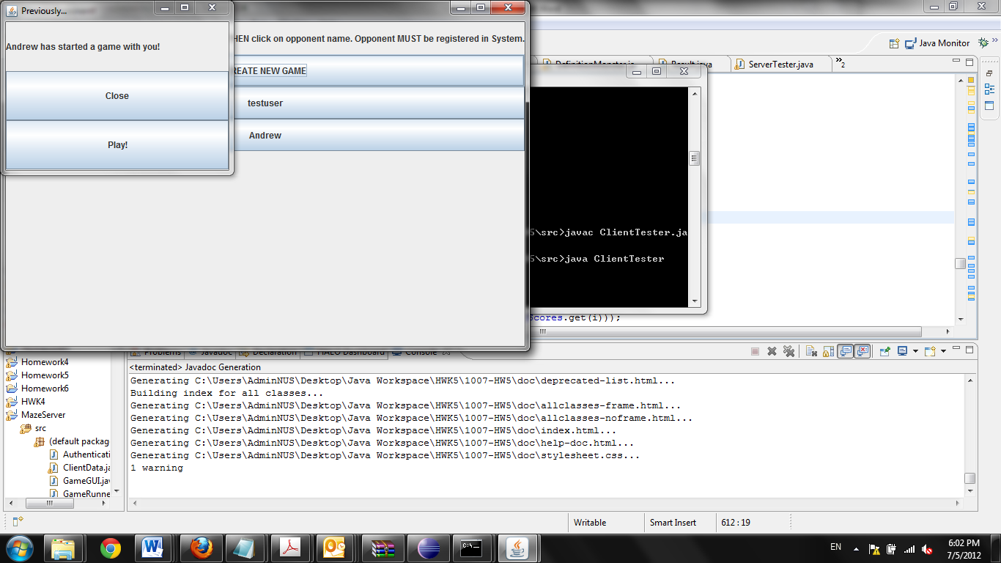

* 1. A new window will open if someone has started a game with you. Click play to play!
  2. The scores will update accordingly. For the purposes of this manual, the scores do not match up because a second game was started before taking this round of screenshots)
  3. BEWARE! HE WILL BE WAITING FOR YOU! (this is meant to add user picture functionality later)

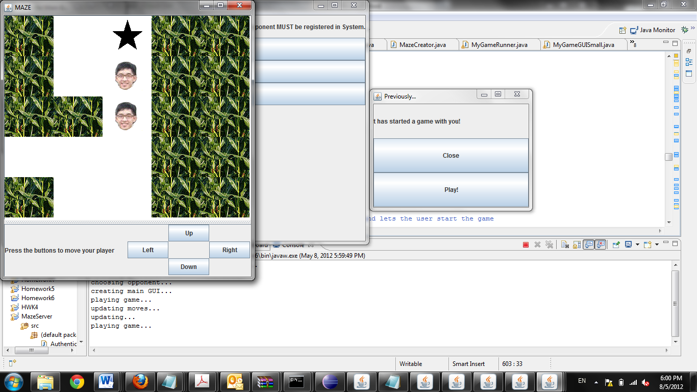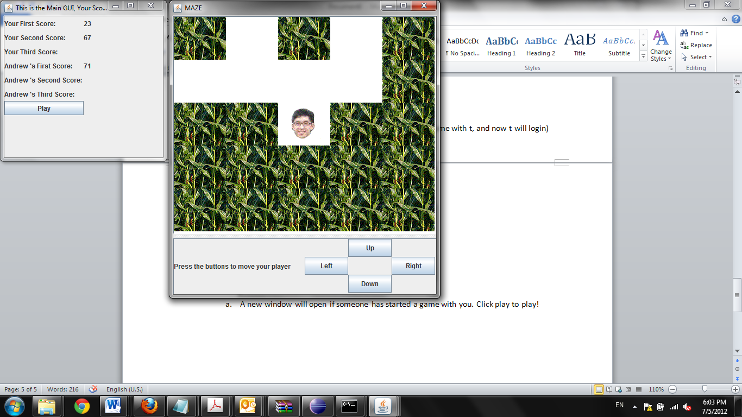

* 1. On completion, a winner window will open. When closed, the window will close

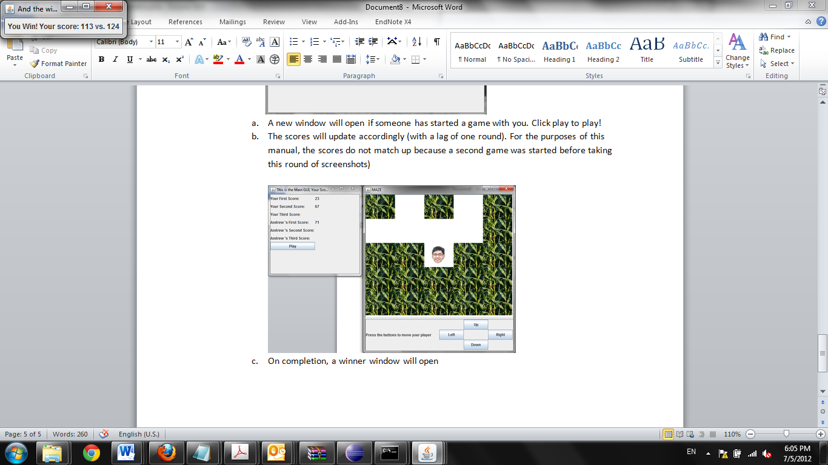

1. Now, when the first user (Andrew) logs back in, he will be given notification of his win/loss.

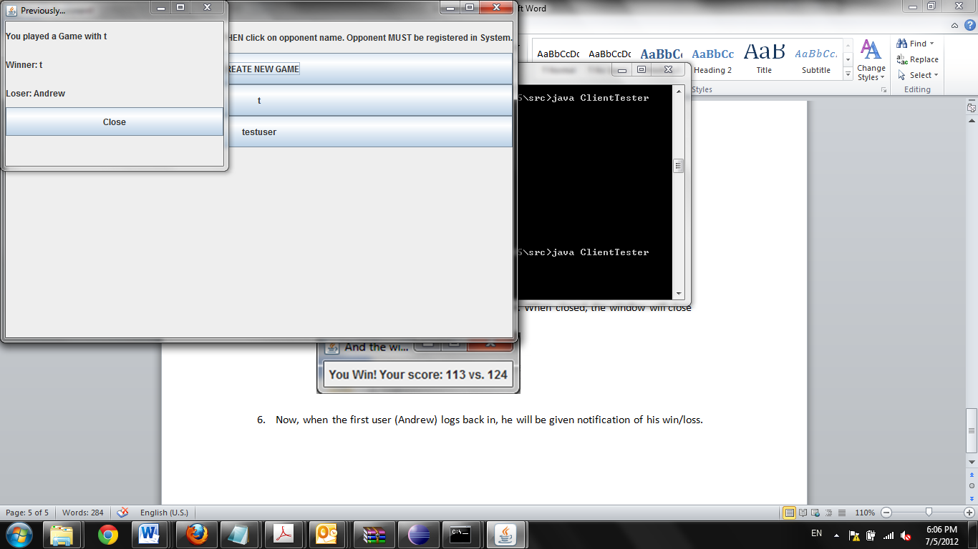

Appendix 1: Client command-line output (for debugging)

