

Functional Safety Concept Lane Assistance

**Document Version: 1.0**



# Document history

|  |  |  |  |
| --- | --- | --- | --- |
| Date | Version | Editor | Description |
| 11.03.2018 | 1.0 | Nathan Greco | First Draft |
|  |  |  |  |
|  |  |  |  |
|  |  |  |  |
|  |  |  |  |

# Table of Contents

Document history

Table of Contents

Purpose of the Functional Safety Concept

Inputs to the Functional Safety Analysis

Safety goals from the Hazard Analysis and Risk Assessment

Preliminary Architecture

Description of architecture elements

Functional Safety Concept

Functional Safety Analysis

Functional Safety Requirements

Refinement of the System Architecture

Allocation of Functional Safety Requirements to Architecture Elements

Warning and Degradation Concept

# Purpose of the Functional Safety Concept

The functional safety concept is a high level plan that defines both the architecture being implemented and the safety goals necessary to ensure the system satisfies ISO 26262.

# Inputs to the Functional Safety Concept

## Safety goals from the Hazard Analysis and Risk Assessment

|  |  |
| --- | --- |
| **ID** | **Safety Goal** |
| Safety_Goal_01 | The oscillating steering torque from the lane departure warning function shall be limited |
| Safety_Goal_02 | The lane keeping assistance function shall be time limited, and the additional steering torque shall end after a given time interval so that the driver cannot misuse the system for autonomous driving |
| Safety_Goal_03 | Alert driver by other means (audible or visual) when LDW cannot detect lane lines |
| Safety_Goal_04 | Alert driver by other means (audible or visual) when LDW cannot detect lane lines |

## Preliminary Architecture

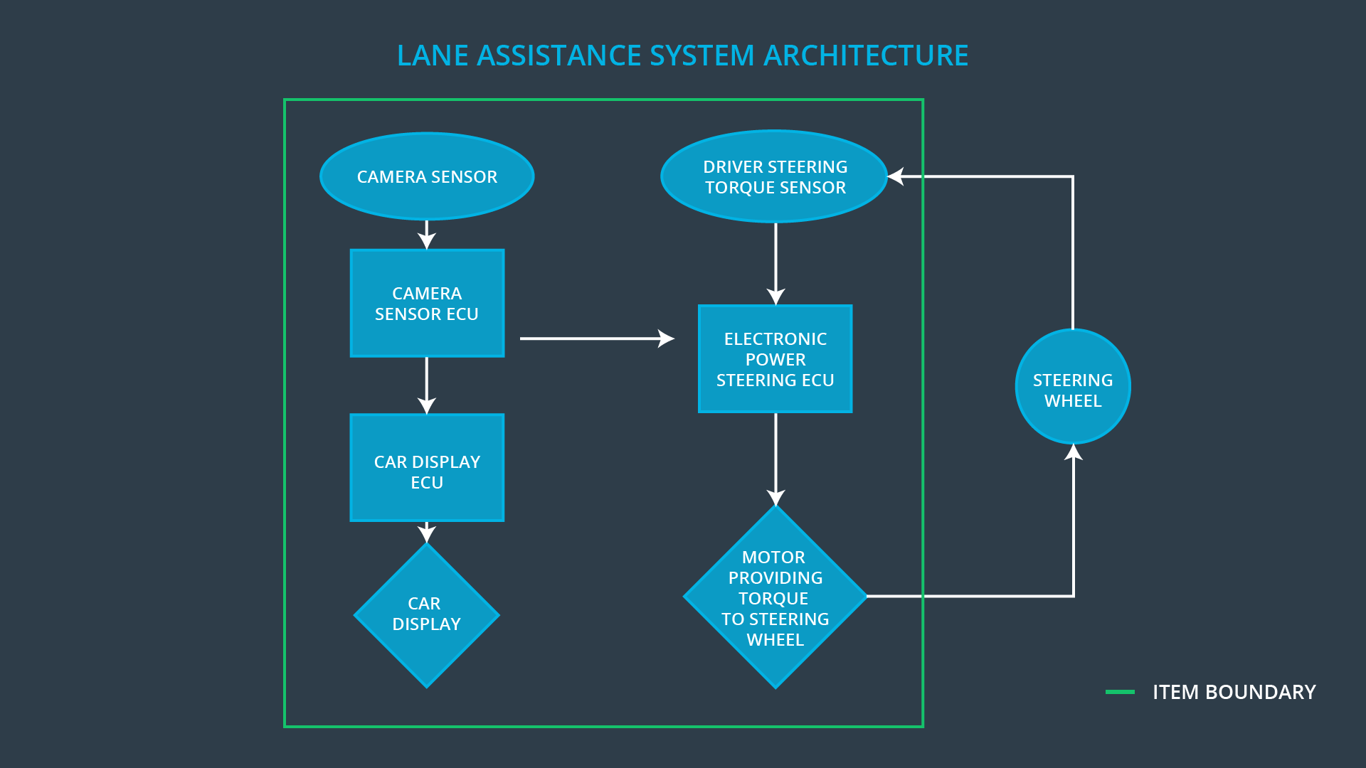

**Figure 1** – System Architecture

### Description of architecture elements

The system can be broken down into main components as shown in figure 1, defined as:

|  |  |
| --- | --- |
| **Element** | **Description** |
| Camera Sensor | Camera device that retrieves images of the road in front of the vehicle |
| Camera Sensor ECU | Device which interfaces with camera, steering ECU, and camera display. It is also the processor of the image and interprets the road images with computer vision algorithms to determine the vehicles position relative to the road. |
| Car Display ECU | An informative display to display the road lines and their orientation, display warning and alert messages, and is the primary GUI for the vehicle operator. |
| Car Display | Controller for the camera display. Receives information from the camera ECU regarding the road line positions and any error or warning messages necessary to indicate. |
| Driver Steering Torque Sensor | A sensor that measures that amount of effort the driver is making to steer the vehicle. This is important so that we do not interfere with intentional steering commands from the driver and impede his ability to control the vehicle. |
| Electronic Power Steering ECU | The controller of steering assist motor. It takes input from the camera ECU and steering torque sensor and determines how much of a torque correction, if any, is necessary to correct the current vehicle path. |
| Motor | The actuator that directly influences the steering of the vehicle. It receives its command from the power steering ECU. |

# Functional Safety Concept

The functional safety concept consists of:

* Functional safety analysis
* Functional safety requirements
* Functional safety architecture
* Warning and degradation concept

## Functional Safety Analysis

|  |  |  |  |
| --- | --- | --- | --- |
| **Malfunction ID** | **Main Function of the Item Related to Safety Goal Violations** | **Guidewords (NO, WRONG, EARLY, LATE, MORE, LESS)** | **Resulting Malfunction** |
| Malfunction_01 | Lane Departure Warning (LDW) function shall apply an oscillating steering torque to provide the driver a haptic feedback | NO | Systems fails to alert the driver about unintentional lane departure |
| Malfunction_02 | Lane Departure Warning (LDW) function shall apply an oscillating steering torque to provide the driver a haptic feedback | LESS | Driver fails to notice alert regarding unintentional lane departure |
| Malfunction_03 | Lane Keeping Assistance (LKA) function shall apply the steering torque when active in order to stay in ego lane | LATE | LKA fails to correct the vehicle trajectory, possibly sending it on a worse trajectory |
| Malfunction_04 | Lane Departure Warning (LDW) function shall apply an oscillating steering torque to provide the driver a haptic feedback | LATE | Systems fails to alert the driver about unintentional lane departure in sufficient time to correct |
| Malfunction_05 | Lane Keeping Assistance (LKA) function shall apply the steering torque when active in order to stay in ego lane | NO | LKA fails to prevent an unintentional vehicle lane depature |

## Functional Safety Requirements

Lane Departure Warning (LDW) Requirements:

|  |  |  |  |  |
| --- | --- | --- | --- | --- |
| **ID** | **Functional Safety Requirement** | **ASIL** | **Fault Tolerant Time Interval** | **Safe State** |
| Functional  Safety  Requirement  01-01 | The LDW safety component shall ensure that both the amplitude and frequency of the 'LDW_Torque_Request' sent to the 'Final electronic power steering Torque' component is below 'Max_Torque_Amplitude’ and ‘Max_Torque_Frequency’. | C | 50 ms | LDW Disabled with visual indication |
| Functional  Safety  Requirement  01-02 | As soon as the LDW function deactivates the LDW feature, the 'LDW Safety' software block shall send a signal to the car display ECU to turn on a warning light. | C | 50 ms | LDW Disabled with visual indication |

Lane Departure Warning (LDW) Verification and Validation Acceptance Criteria:

|  |  |  |
| --- | --- | --- |
| **ID** | **Validation Acceptance**  **Criteria and Method** | **Verification Acceptance**  **Criteria and Method** |
| Functional  Safety  Requirement  01-01 | Perform controlled study with multiple drivers to determine thresholds for noticeable feedback and feedback that interferes with driver control | Verify that in conditions are established limits exceeded |
| Functional  Safety  Requirement  01-02 | Perform study for best means of indication to a driver that the LDW system fails to detect road lane | Verify that in any scenario where the road lane cannot be determine indication appears within a set time window |

Lane Keeping Assistance (LKA) Requirements:

|  |  |  |  |  |
| --- | --- | --- | --- | --- |
| **ID** | **Functional Safety Requirement** | **ASIL** | **Fault Tolerant Time Interval** | **Safe State** |
| Functional  Safety  Requirement  02-01 | Create a response window that if 'LDW_Torque_Request' is not achieved within a set time the LKA system is disabled. | C | 50 ms | LKA Disabled with visual indication |
| Functional  Safety  Requirement  02-02 | As soon as the LKA function deactivates the LKA feature, the ‘LKA Safety' software block shall send a signal to the car display ECU to turn on a warning light. | C | 50 ms | LKA Disabled with visual indication |

Lane Keeping Assistance (LKA) Verification and Validation Acceptance Criteria:

|  |  |  |
| --- | --- | --- |
| **ID** | **Validation Acceptance**  **Criteria and Method** | **Verification Acceptance**  **Criteria and Method** |
| Functional  Safety  Requirement  02-01 | Evaluate typical controller response time and tuning to determine what an acceptable response time is. | Verify that the actuator will always be disabled if it doesn’t respond to the time within that window |
| Functional  Safety  Requirement  02-02 | Perform study for best means of indication to a driver that the LDW system fails to detect road lane | Verify that in any scenario where the road lane cannot be determine indication appears within a set time window |

## Refinement of the System Architecture

## 

**Figure 2** – Detailed system architecture with ASIL ratings

## Allocation of Functional Safety Requirements to Architecture Elements

|  |  |  |  |  |
| --- | --- | --- | --- | --- |
| **ID** | **Functional Safety Requirement** | **Electronic Power Steering ECU** | **Camera ECU** | **Car Display ECU** |
| Functional  Safety  Requirement  01-01 | Apply limits to frequency and magnitude of haptic feedback to steering wheel to prevent interference with driver control | **X** |  | **X** |
| Functional  Safety  Requirement  01-02 | Provide a visual indication when the system is enabled but not able to detect the road lanes and correct vehicle position |  | **X** | **X** |
| Functional  Safety  Requirement  02-01 | Evaluate typical controller response time and tuning to determine what an acceptable response time is. | **X** |  | **X** |
| Functional  Safety  Requirement  02-02 | Perform study for best means of indication to a driver that the LDW system fails to detect road lane |  | **X** | **X** |

## Warning and Degradation Concept

|  |  |  |  |  |
| --- | --- | --- | --- | --- |
| **ID** | **Degradation Mode** | **Trigger for Degradation Mode** | **Safe State invoked?** | **Driver Warning** |
| WDC-01 | Disable LDW and alert | Malfunction_01 | Yes | Driver indication of fault in LDW system |
| WDC-02 | Disable LDW and alert | Malfunction_02 | Yes | Driver indication of fault in LDW system |
| WDC-03 | Disable LKA and alert | Malfunction_03 | Yes | Driver indication of fault in LKA system |
| WDC-04 | Disable LDW and alert | Malfunction_04 | Yes | Driver indication of fault in LDW system |
| WDC-05 | Disable LKA and alert | Malfunction_05 | Yes | Driver indication of fault in LKA system |