**Pittsburgh Auto Dealership & Population Analysis**

**By: Nate Guio**

**Introduction**

Pittsburgh, Pennsylvania is a post-industrial giant turned tech city in the US. At one time Pittsburgh was home to booming steel mills and coal mines, which boomed in the 50s, 60s, and 70s. Today these industries still live in area, but at much less capacity. Today tech companies like Uber call Pittsburgh home. Pittsburgh has roughly 1.2 million people in Allegheny County, and the surrounding area. This city's unique culture and terrain leads us to explore the automotive dealerships in the town. Today Bowser Automotive, and Bobby Rahal Automotive Group are giants in the Pittsburgh auto dealership landscape. With dealerships like these controlling several locations around the city, it strikes the question: where would the best location be to open a car dealership in Pittsburgh? Auto dealers of all sizes constantly worry about be crushed by the well-known car dealerships in Pittsburgh. By providing information on population data as well as median-housing prices across the city, the best location to open a new car dealership can be found no matter if the business is new, or if an existing dealer wants to expand into a new neighborhood. By overlaying population and housing price data over the existing dealership structure, possible locations for a new dealership can be revealed.

**Data Collection / Sources**

1. A list of all zip codes in Allegheny County used to split up each neighborhood. Beautiful Soup is used to convert the zip codes into a data frame. https://www.zip-codes.com/county/pa-allegheny.asp
2. The 'uszipcode' library is imported to look up the following in each zipcode: "MajorCity","PostOfficeCity","CommonCityList","County","State","Latitude","Longitude","timezone","radius_in_miles","area_code_list","population","population_density","land_area_in_sqmi","water_area_in_sqmi","housing_units","occupied_housing_units","median_home_value", and "median_household_income".
3. The Foursquare API is used to retrieve the following venue categories for the search query: 'car': 'Auto Dealership', 'Automotive Shop', 'Gas Station', 'Rental Car Location', 'Car Wash', and 'Auto Workshop'. These venue types other than 'Auto Dealership' were retrieved to view more of the automotive scene in the city and to aid in clustering to find a location that would appeal to all automotive customers.

**Methodology**

Ninety six zip codes were found representing each neighborhood. Finding the optimal location combined a combination of clustering the neighborhoods together as well as visualizing these clusters on the Folium maps. The Elbow Method show to the right was used to determine the correct number of clusters for the data set. The map displays the neighborhoods before clustering.

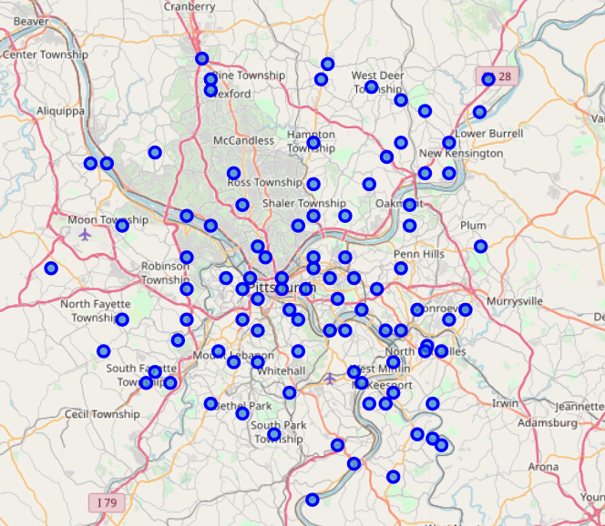

*Map Before Clustering*

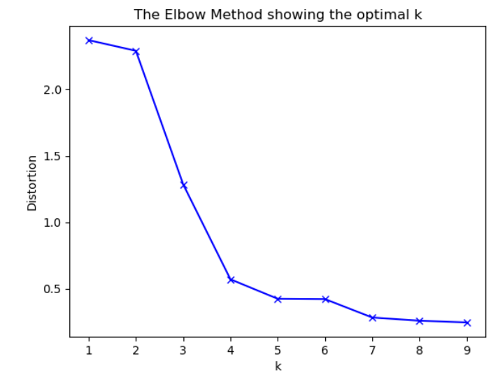

*Elbow chart to find optimal K number of clusters*

**Discussion**

After Clustering with k=5, the map shows all the clusters lumped next to one another. The Light blue cluster indicates the most populated region of the map, while the other clusters float on the outskirts of the city.

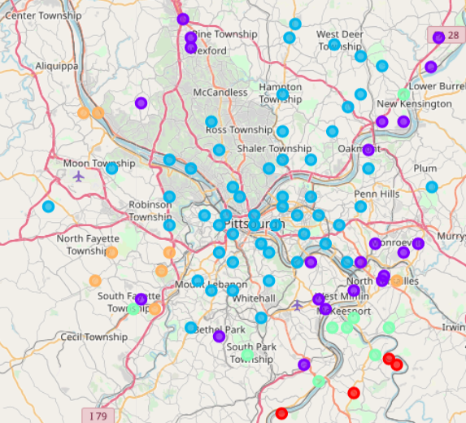

*City after clustering*

**Conclusion**

The cluster labeled in Red was selected after careful consideration of the population found in the neighborhoods of this cluster. This location had the 2nd lowest population, but an average median household income compared to other clusters. With the Red Cluster having room to grow for the future and potential for plenty of buyers from the household income, Elizabeth, Pa was selected as the best location in Pittsburgh to build a new car dealership no matter if it is an existing dealer or an up and comer.

Improvements for this analysis would be adding an overlay of population and/or income on the map with a choropleth map. This would have been a great visual for any audience to see the trends in demographics compared to the location of existing dealers / auto repair shops.