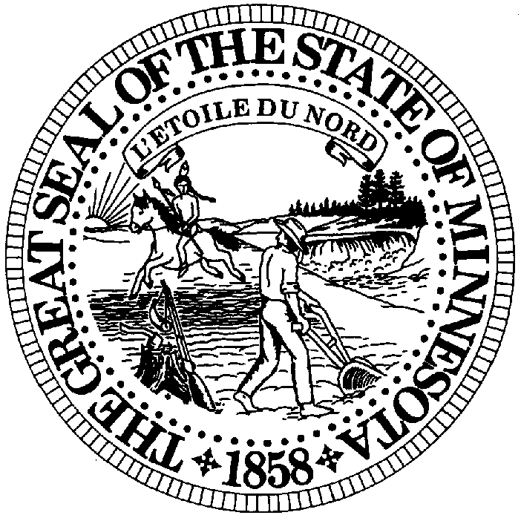
Absentee Ballot Application
Office of the Minnesota
Secretary of State
Read instructions on back before completing.

I hereby apply for an absentee ballot for: (check one) |  |  |  | I will need an absentee ballot for the following reason: (check one)
Both primary and general elections  Primary only  General election only  Special election (date) / /  Special general (date) / /  Other (date) / / |  |  |  | Absence from the precinct  Illness or disability  Religious discipline or observance of religious holiday  Service as election judge in another precinct  Eligible emergency declared by the governor or quarantine  declared by federal or state government
Name (please print)

Date of birth |  |  |  | Phone number
My legal residence address is:

Street Address |  |  | Apt. No. | City | State MN | Zip Code
Mail my absentee ballot to me at the following address:
Street Address |  | Apt. No. | Rural/Box No. | City/Township | State | Zip Code
Date | Signature X
Return this application as soon as possible, ballots must be returned by Election Day to be counted.

Office Use Only
REG □  NON REG □ | Received Date | Ballots Issued Date | Type  M C HCF | School District # | Precinct
REG □  NON REG □ | Initials | Ballots Issued Date | Type  M C HCF | School District # | Precinct

Instructions for Completing the Absentee Ballot Application

- To vote by absentee ballot:
- you must be an eligible voter, and
- you must reside at the legal residence address you give on this application on election day.
- if you are not currently a registered voter, you will be sent a voter registration card with your materials- be sure to include it when you return your ballot.

It is a felony to make a false statement in an application for an absentee ballot, to apply for an absentee ballot more than once in an election with the intent to cast an illegal ballot, to show a ballot marked by a person to another person, or to violate an absentee ballot provision for the purpose of casting an illegal vote or to help anyone to cast an illegal vote.

- Be sure to check the appropriate box indicating why you cannot go to your polling place on Election Day; these are the only reasons that entitle you to vote by absentee ballot.

- Your date of birth and telephone number are optional

- Be sure to give your correct legal residence address as completely as possible, since this is used to verify your precinct.

- Be sure to sign the application. If you cannot sign your name, you may make a mark.

- Return the completed application as soon as possible to the election official from whom you received it.

Remember:
- You must indicate whether you are requesting ballots for the primary or general election, or both.
- Do not submit more than one application for each election.
- Your absentee ballots will be mailed or delivered to you as soon as they are available.
County Phone Number Fax Number
Mahnomen 218-935-5669 218-935-5946
Marshall 218-745-4851 218-745-5089
Martin 507-238-3211 507-238-3259
Meeker 320-693-5212 320-693-5217
Mille Lacs 320-983-8310 320-983-8336
Morrison 320-632-0132 320-632-0139
Mower 507-437-9535 507-437-9471
Murray 507-836-6148 507-836-8904
Nicollet 507-931-6800 507-931-0856
Nobles 507-372-8231 507-372-8390
Norman 218-784-5471 218-784-4531
Olmsted 507-328-7650 507-328-7964
Otter Tail 218-998-8030 218-998-8042
Pennington 218-683-7000 218-683-7026
Pine 320-629-5629 320-629-5679
Pipestone 507-825-6740 507-825-6741
Polk 218-281-2554 218-281-3801
Pope 320-634-5705 320-634-3087
Ramsey 651-266-2171 651-266-2177
Red Lake 218-253-2598 218-253-4894
Redwood 507-637-4013 507-637-4072
Renville 320-523-3624 320-523-3679
Rice 507-332-6104 507-333-3754
Rock 507-283-5060 507-283-1343
Roseau 218-463-1282 218-463-4283
St Louis 218-726-2385 218-725-5060
Scott 952-496-8560 952-496-8174
Sherburne 763-241-2861 763-241-2869
Sibley 507-237-4070 507-237-4073
Stearns 320-656-3900 320-656-3916
Steele 507-444-7410 507-444-7470
Stevens 320-589-7409 320-589-2036
Swift 320-843-4069 320-843-2275
Todd 320-732-4414 320-732-4001
Traverse 320-563-4242 320-563-4424
Wabasha 651-565-2648 651-565-2774
Wadena 218-631-7650 218-631-7652
Waseca 507-835-0610 507-835-0633
Washington 651-430-6790 651-430-6178
Watonwan 507-375-1210 507-375-3547
Wilkin 218-643-7165 218-643-7169
Winona 507-457-6320 507-457-6454
Wright 763-682-7578 763-682-7873
Yellow Medicine 320-564-3132 320-564-3670

County Phone Number Fax Number
Aitkin 218-927-7354 218-927-7324
Anoka 763-323-5275 763-422-7526
Becker 218-846-7301 218-846-7257
Beltrami 218-333-8448 218-333-4246
Benton 320-968-5027 320-968-5337
Big Stone 320-839-6366 320-839-6370
Blue Earth 507-304-4341 507-304-4396
Brown 507-233-6613 507-359-1430
Carlton 218-384-9127 218-384-9116
Carver 952-361-1910 952-361-1919
Cass 218-547-7281 218-547-7278
Chippewa 320-269-7447 320-269-7412
Chisago 651-213-8500 651-213-8510
Clay 218-299-5006 218-299-5195
Clearwater 218-694-6520 218-684-6244
Cook 218-387-3000 218-387-3043
Cottonwood 507-831-1905 507-831-4553
Crow Wing 218-824-1045 218-824-1046
Dakota 651-438-4380 651-438-4391
Dodge 507-635-6239 507-635-6265
Douglas 320-762-3881 320-762-2389
Faribault 507-526-6211 507-526-6290
Fillmore 507-765-4701 507-765-4571
Freeborn 507-377-5121 507-377-5175
Goodhue 651-385-3032 651-385-3196
Grant 218-685-4520 218-685-4521
Hennepin 612-348-5151 612-348-2151
Houston 507-725-5803 507-725-2647
Hubbard 218-732-3196 218-732-3645
Isanti 763-689-1644 763-689-8210
Itasca 218-327-2860 218-327-7426
Jackson 507-847-2763 507-847-4718
Kanabec 320-679-6430 320-679-6431
Kandiyohi 320-231-6202 320-231-6263
Kittson 218-843-2655 218-843-2656
Koochiching 218-283-1102 218-283-1104
Lac qui Parle 320-598-7444 320-598-3125
Lake 218-834-8317 218-834-8358
Lake of the Woods 218-634-2836 218-634-2509
Le Sueur 507-357-2251 507-357-6375
Lincoln 507-694-1529 507-694-1198
Lyon 507-537-6727 507-537-6091
McLeod 320-864-1210 320-864-1295

