Student: Nicholas Higueros

Course: ECE 3110

Subject: Lab 1 Basic Tools

Date: 9/12/2022

**Submission 1:**

Actual Values of R, L, C: 98.4 ohms, 4.3uF, 890uH

Specified Values of R, L, C: 100 ohms, 4.7uF, 1000uH

Resonant Frequency: 2.57e3 Hz

**Submission 2:**

We plotted the circuit in LtSPICE, and we found that the expected resonant frequency was within tolerance. So, it agreed with our calculation.

**Submission 3:**

Below is the plot from LtSPICE.

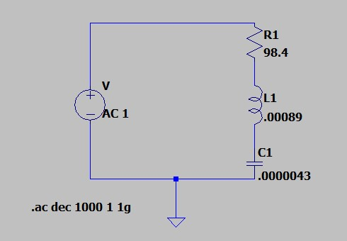

**

**Submission 5:**

The measurements agree. There was hardly any phase shift, so we assumed that the phase shift was zero. We measured around the resonant frequency. We saw that the magnitude would grow as frequency increased but when near the resonant frequency it would have a very similar magnitude for a long time. We were taking note of phase shift and pk-pk voltage to measure both magnitude and phase.

**Submission 6:**

Below is the Bode plot.

**Submission 7:**

Below is the python code for the hammer test waveform.

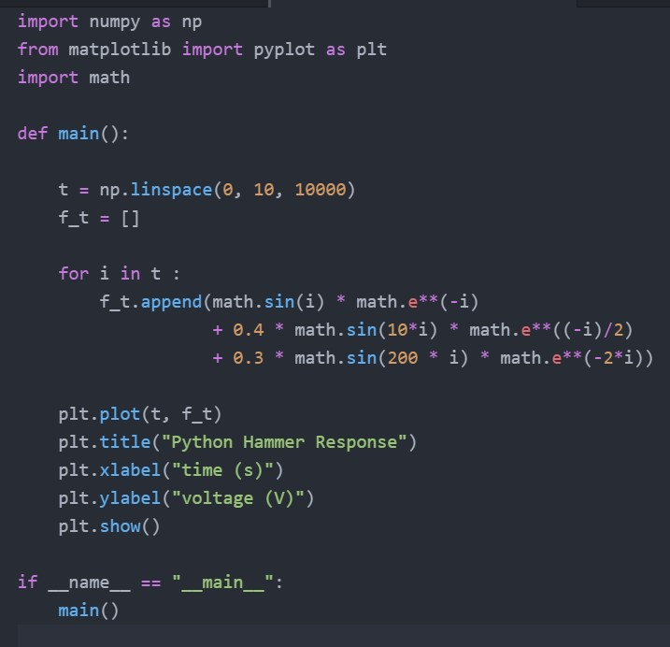

**Submission 8:**  
Below is a picture of the oscilloscope with the hammer test waveform.

